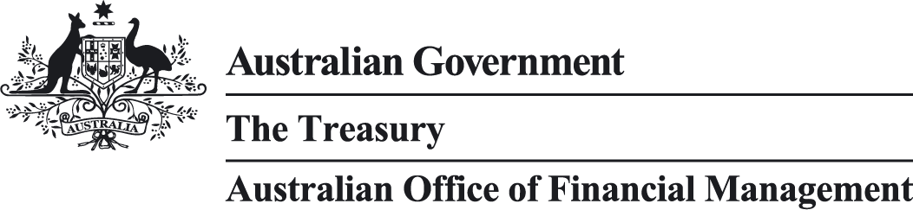

Australian Government Green Treasury Bond Allocation and Impact Report
  - February 2025

© Commonwealth of Australia 2025
ISBN: 978-1-923278-11-0
This publication is available for your use under a Creative Commons Attribution 4.0 International licence, with the exception of the Commonwealth Coat of Arms, the Commonwealth of Australia logo, photographs, images, third party materials, materials protected by a trademark, signatures and where otherwise stated. The full licence terms are available from creativecommons.org/licenses/by/4.0/legalcode.
Use of Commonwealth of Australia material under a Creative Commons Attribution 4.0 International licence requires you to attribute the work (but not in any way that suggests that Commonwealth of Australia endorses you or your use of the work).
Commonwealth of Australia material used ‘as supplied’
Provided you have not modified or transformed Commonwealth of Australia material in any way including, for example, by changing the Commonwealth of Australia text; calculating percentage changes; graphing or charting data; or deriving new statistics from published Commonwealth of Australia statistics – then Commonwealth of Australia prefers the following attribution:
Source: The Commonwealth of Australia.
Derivative material
If you have modified or transformed Commonwealth of Australia material, or derived new material from those of the Commonwealth of Australia in any way, then Commonwealth of Australia prefers the following attribution:
Based on Commonwealth of Australia data.
Use of the Coat of Arms
The terms under which the Coat of Arms can be used are set out on the Department of the Prime Minister and Cabinet website (see www.pmc.gov.au/government/commonwealth-coat-arms).
Other uses
Enquiries regarding this licence and any other use of this document are welcome at:
Manager
Media Unit
The Treasury
Langton Crescent
Parkes ACT 2600
Email: media@treasury.gov.au

Acknowledgement of Country
In the spirit of reconciliation, the Treasury acknowledges the Traditional Custodians of country throughout Australia and their connections to land, sea and community. We pay our respect to their Elders past and present and extend that respect to all Aboriginal and Torres Strait Islander peoples.
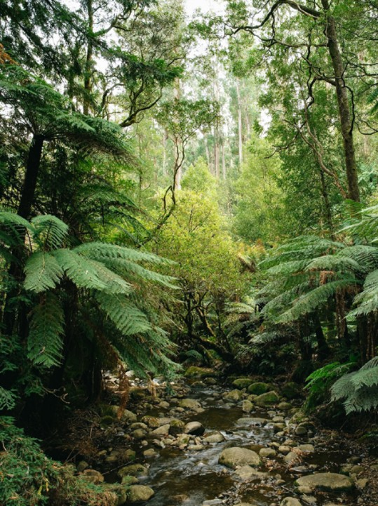

Contents
Contents iv
Executive Summary vii
Chapter 1 : Australia’s Climate and Environmental Priorities 1
Australia’s climate change mitigation goals and supporting policies 2
Australia’s climate change adaptation policies and programs 7
Australia’s environmental policies and programs 9
Chapter 2 : Financing Australia’s Net Zero Transition 11
Sustainable Finance Roadmap 11
Australian green bond market 13
Green Treasury Bonds 13
Chapter 3 : Allocation of Green Bond Proceeds 15
Approach to allocation reporting 15
Classification of Eligible Green Expenditures 15
Eligible Green Expenditure selection and governance 16
Allocation reporting methodology 17
Summary of allocation 17
Chapter 4 : Impacts of Eligible Green Expenditures 22
Approach to impact reporting 22
Summary of impacts 22
Chapter 5 : Climate Change Mitigation Reporting 25
Renewable energy 26
Energy efficiency 43
Clean transportation 47
Chapter 6 : Climate Change Adaptation Reporting 58
Chapter 7 : Improved Environmental Outcomes Reporting 67
Environmentally sustainable management of living natural resources and land use 67
Biodiversity conservation (terrestrial and aquatic) 70
Sustainable water and wastewater management 78
Assurance Reports 83
Disclaimer 86
Endnotes 88

List of figures
Figure 1: Tracking against the 2030 target 4
Figure 2: Sustainable finance reforms in Australia 12
Figure 3: Australian-dollar green bond issuance by year 13
Figure 4: Investor allocation of the first Green Treasury Bond issue 14
Figure 5: Eligibility window 16
Figure 6: Allocation of Green Treasury Bond proceeds by ICMA Green Projects categories 21
Figure 7: Location of Regional Hydrogen Hubs in Australia 35
Figure 8: Australian climate finance in the Indo-Pacific 59
Figure 9: Locations of projects managed by the Saving Koalas Fund 73

List of tables
Table 1: Green Treasury Bond contributions to climate change mitigation 5
Table 2: Green Treasury Bond contributions to climate change adaptation 8
Table 3: Green Treasury Bond contributions to improved environmental outcomes 10
Table 4: Total allocated proceeds over 2022–23 and 2023–24 18
Table 5: Allocation of proceeds against Australian Green Bond Framework’s Green Goals, ICMA Green Projects categories, and UN Sustainable Development Goals 19
Table 6: Headline impacts of 2022–23 and 2023–24 Eligible Green Expenditures 23
Table 7: Allocation to CEFC Renewable Energy Investments 27
Table 8: Impacts of CEFC Renewable Energy Investments 28
Table 9: Allocation to Rewiring the Nation 31
Table 10: Impacts of Rewiring the Nation 31
Table 11: Social co-benefits of Rewiring the Nation 32
Table 12: Allocation to Regional Hydrogen Hubs 34
Table 13: Impacts of Regional Hydrogen Hubs 36
Table 14: Allocation to Community Batteries 38
Table 15: Impacts of Community Batteries 39
Table 16: Allocation to the Advancing Renewables Program 40
Table 17: Impacts of the Advancing Renewables Program 42
Table 18: Allocation to the Household Energy Upgrades Fund™ 45
Table 19: Impacts of the Household Energy Upgrades Fund™ 46
Table 20: Allocation to Electric Rail Infrastructure Investments 48
Table 21: Impacts of Electric Rail Infrastructure Investments 50
Table 22: Social co-benefits of Electric Rail Infrastructure Investmentsª 50
Table 23: Allocation to the Driving the Nation Fund 56
Table 24: Impacts of the Driving the Nation Fund 57
Table 25: Allocation to International Climate Finance projects 61
Table 26: Impacts of International Climate Finance projects 63
Table 27: Further information on International Climate Finance sub-projects 63
Table 28: Allocation to the Urban Rivers and Catchments Program 68
Table 29: Allocation to the Saving Koalas Fund 71
Table 30: Impacts of the Saving Koalas Fund 72
Table 31: Allocation to Reef 2050 75
Table 32: Impacts of Reef 2050 76
Table 33: Allocation to the Murray–Darling River Basin Plan 80
Table 34: Impacts of the Murray–Darling River Basin Plan 81

Executive Summary
The Australian Government’s green bond program demonstrates the Government’s commitment to reduce the impact of climate change and protect the environment. Green Treasury Bonds finance public programs linked to climate change mitigation, climate change adaptation and improved environmental outcomes to support Australia’s pathway to net zero emissions.
Issuing sovereign green bonds is a key priority under Australia’s Sustainable Finance Roadmap. Green Treasury Bonds help to mobilise the significant private capital required to achieve net zero and maximise the economic opportunities associated with energy, climate and sustainability goals. The green bond program deepens sustainable finance markets and signals the Government’s commitment to climate, energy and environmental objectives. The Green Bond Program is delivered by the Australian Treasury in partnership with the Australian Office of Financial Management (AOFM).

Australia’s key climate objectives
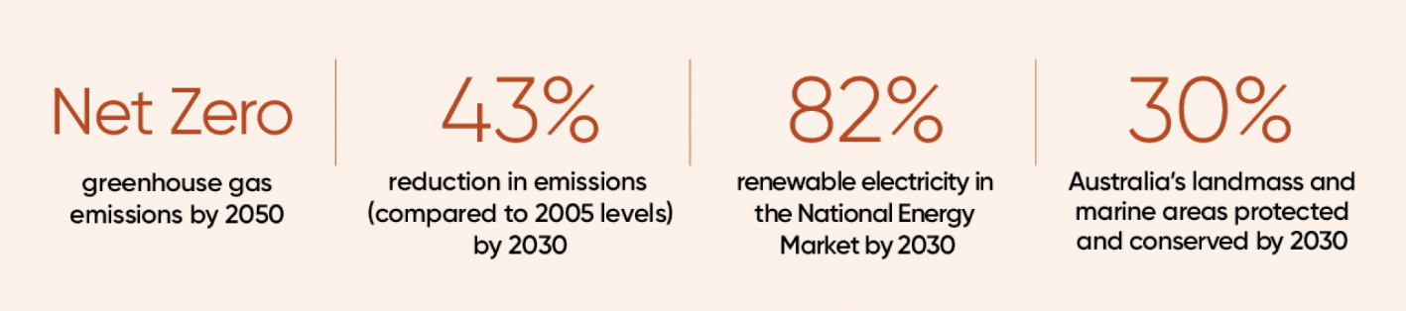

The program was launched on 5 December 2023, with the release of the Australian Government Green Bond Framework (the Framework). On 4 June 2024, the AOFM issued the first Green Treasury Bond. The $7.0 billion issue was well supported by domestic and offshore investors, attracting $22.9 billion worth of bids.
The principles of the program are set out in the Framework, which includes guidelines on Eligible Green Expenditures and commits the Government to annual reporting on the allocation of proceeds and their climate and environmental impacts.
Publication of this inaugural Green Treasury Bond Allocation and Impact Report delivers on these annual reporting commitments. This report presents allocation data for 13 Eligible Green Expenditures across Australian financial years 2022–23 and 2023–24, and associated impact data. This report has been endorsed by the interdepartmental Green Bond Committee. The allocation reporting has been reviewed by the Australian National Audit Office and the impact reporting has been reviewed by ISS Corporate Solutions.
Of the $7.0 billion raised, $2.5 billion has been allocated to Eligible Green Expenditures in 2022–23, and $2.9 billion has been allocated to Eligible Green Expenditures in 2023–24. The remaining $1.6 billion will be allocated to Eligible Green Expenditures in 2024–25 and 2025–26.
Green Treasury Bond proceeds have contributed to a range of climate and environmental impacts:
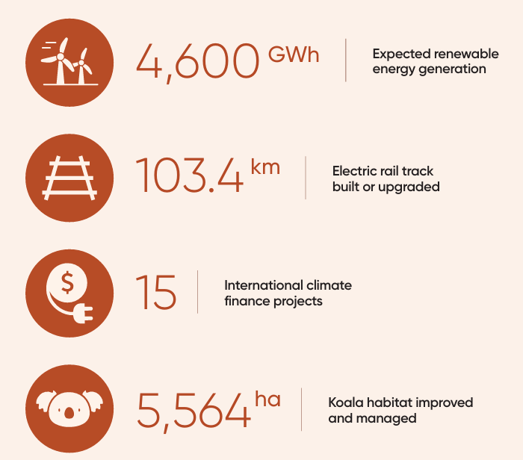

- Australia’s Climate and Environmental Priorities
Australia’s environment is a vital part of its national identity. The diverse and unique environment not only provides habitat for nearly 600,000 native species but is also home to one of the oldest living cultures on earth. For over 60,000 years, First Nations people have cared for Country.
The impact of climate change on Australia is intensifying, with communities experiencing more frequent, intense and prolonged extreme weather events. Sea levels around Australia are rising, while oceans are acidifying and have warmed by around 1°C since 1900. Extreme fire weather events and fire season duration has increased across large parts of the country since the 1950s.
The Australian Government recognises the urgent need to limit temperature increases and transition to a net zero economy and is committed to investing in a range of targeted climate change mitigation and adaptation solutions. Green Treasury Bonds help finance high-quality Australian Government projects that reduce the impact of climate change and protect Australia’s unique environment.
This report is divided into 7 chapters. This chapter highlights Australia’s efforts to implement policies pursuing climate change mitigation, climate change adaptation and improved environmental outcomes. Chapter 2 outlines how Australia is financing its net zero transition. Chapters 3 and 4 outline Australia’s approach to allocation and impact reporting, respectively. Chapters 5 to 7 detail allocation and impact data for each individual Eligible Green Expenditure and highlight case studies for specific projects. A limited assurance report for allocation reporting from the Australian National Audit Office is available at the end of this report and a review of impact reporting from ISS Corporate Solutions is available on the AOFM website.

Australia’s climate change mitigation goals and supporting policies
Australia, along with all parties to the Paris Agreement, has committed to the global goal of holding the increase in global average temperatures compared to pre-industrial levels to well below 2°C and pursuing efforts to keep warming to less than 1.5°C.
Australia submitted its first Nationally Determined Contribution (NDC) to the United Nations Framework Convention on Climate Change (UNFCCC) in 2015. An updated NDC was submitted in 2022 and embedded in the Climate Change Act 2022, which commits Australia to reducing its emissions to 43 per cent below 2005 levels by 2030 and net zero by 2050. The 2030 target is Australia’s commitment to not only achieve net zero by 2050 but to also reduce its contribution to emissions accumulated in the atmosphere on the path to net zero. Australia is expected to submit its next NDC in advance of the Conference of Parties (COP) 30 in 2025.
Australia’s climate change commitments
As reflected in Australia’s NDC under the Paris Agreement and the Climate Change Act 2022, Australia is committed to:
- a single year target to reduce greenhouse gas emissions to 43 per cent below 2005 levels by 2030
- a multi-year emissions budget from 2021–2030.
Based on a 43 per cent reduction by 2030, Australia’s emissions budget for 2021–2030 is 4,353 Mt CO₂-e.

To guide Australia’s transition to the legislated target of net zero emissions by 2050 and realise the opportunities presented by the global transition, the Australian Government is developing a Net Zero Plan. Work on the Net Zero Plan is supporting the development of Australia’s 2035 emissions reduction target. This target will be informed by the Climate Change Authority’s (CCA) independent advice, which will reflect public consultation undertaken by the CCA.
The 2035 target and the Government’s Net Zero Plan will be underpinned by 6 sectoral decarbonisation plans that outline the role of each sector in supporting Australia’s transition to net zero and limiting global temperature increases. The sectoral plans will be informed by the CCA’s Sector Pathways Review, released on 5 September 2024, and will incorporate existing emissions reduction policies, including:
- The Safeguard Mechanism – this policy requires Australia’s highest greenhouse gas emitting facilities to reduce their greenhouse gas emissions in line with Australia’s emission reduction targets of 43 per cent below 2005 levels by 2030 and net zero by 2050. The policy sets legislated limits — known as baselines – on the emissions of these facilities, which will decline predictably and gradually.
  - The Safeguard Mechanism commenced in 2016 and was reformed in 2023 to ensure that covered facilities contribute to meeting these targets.
- The Capacity Investment Scheme (CIS) – a national framework to encourage new investment in renewable capacity, such as wind and solar, as well as clean dispatchable capacity, such as battery storage.
  - Recognising the key role the electricity sector will play in achieving emissions reduction goals, the Australian Government has set a target of 82 per cent renewable electricity in the National Electricity Market by 2030. The CIS supports this by seeking competitive tender bids for renewable capacity and clean dispatchable capacity projects to deliver an additional 32 GW of capacity by 2030 and fill expected reliability gaps as ageing coal power stations exit.
- The New Vehicle Efficiency Standard – this regulatory measure, which commenced on 1 January 2025, sets a carbon dioxide (CO₂) emission target for new passenger and light commercial vehicles sold in Australia. This standard incentivises the provision of more fuel efficient, and low or no emissions vehicles into the Australian market.
For a comprehensive overview of Australia’s decarbonisation progress and reporting on the Government’s initiatives, programs and plans to support Australia’s path to net zero emissions, please see the Annual Climate Change Statement 2024.
In addition to domestic decarbonisation policies, Australia also has an important role in the global transition to net zero and is in a strong position to benefit from the opportunities it presents. The majority of Australia’s exports go to economies with net zero commitments, and competition to attract investment in net zero industries is increasing. With abundant renewable energy and mineral resources, a highly skilled population and a track record as a reliable trading partner, Australia is well-positioned to be a major beneficiary of these global shifts.
The Future Made in Australia agenda takes steps to encourage the significant private sector investment needed to harness global net zero transformation opportunities and ensure Australia’s future prosperity (see Box 1: Future Made in Australia).

Australia’s progress towards climate change commitments
Australia’s Emissions Projections 2024 shows that emissions in 2024 were 441 Mt CO₂-e, 28.2 per cent below 2005 levels. In the year to June 2024, emissions decreased by 2.9 Mt CO₂-e or 0.7 per cent. This reflects a decline in electricity and agriculture sector emissions, partially offset by rising transport sector emissions caused by a continued return to pre-COVID levels of transport activity.
As seen in Figure 1, the baseline projections, which include policies that have been implemented, project Australia’s emissions will be 42.6 per cent below 2005 levels in 2030 - just shy of the national point-in-time target of 43 per cent. This is an improvement from last year, when the baseline scenario projected emissions would fall to 37 per cent below 2005 levels in 2030, and an improvement on the projections from a year before that too. Australia’s emissions outlook continues to improve as more climate mitigation policies are implemented.

Figure 1: Tracking against the 2030 target
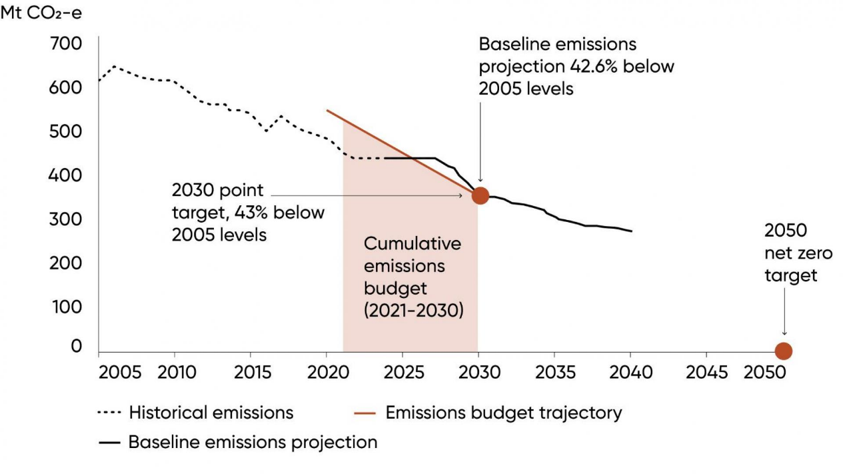
Source: DCCEEW (2024), Annual Climate Change Statement 2024
The CCA has the view that while the Government has made significant progress over the past year in implementing and delivering new policies designed to reduce emissions, it is important to hold course on delivering these policies, to reach the 2030 target.
Australia has also committed to a cumulative emissions budget from 2021 to 2030. On this basis, Australia is projected to beat its target, with cumulative emissions projected to be 3 per cent (or 152 Mt CO₂-e) below the budget for this period. This is equivalent to the total emissions from on-grid electricity generation in 2024.

The role of Green Treasury Bonds
Table 1 outlines how 8 Eligible Green Expenditures financed through Green Treasury Bonds are linked to climate mitigation policies that contribute to Australia’s net zero transformation and NDC.

Table 1: Green Treasury Bond contributions to climate change mitigation
ICMA Green Projects Categories | Project(s) | Government priorities and policies
Renewable energy | Clean Energy Finance Corporation Renewable Energy Investments | Renewable energy investments contribute to the 82 per cent renewable energy by 2030 target, the 43 per cent emissions reduction by 2030 target, and the net zero by 2050 target.
Renewable energy | Rewiring the Nation | Rewiring the Nation is a major government investment to modernise the electricity grid and deliver new and upgraded transmission infrastructure. It is a key part of how Australia will expand its renewable energy sector and achieve emission reduction targets.
Renewable energy | Regional Hydrogen Hubs | Hydrogen hubs support the renewable hydrogen industry to grow and form a key element of the 2024 National Hydrogen Strategy. The strategy provides the framework to guide production, use and export of hydrogen, and position Australia as a global hydrogen leader.
Renewable energy | Community Batteries | Delivering community batteries that store excess solar is part of Australia’s renewable energy strategy.
Renewable energy | Advancing Renewables Program | The Advancing Renewables Program supports a range of development, demonstration and pre-commercial deployment projects that explore opportunities to optimise the transition to renewable electricity, commercialise clean hydrogen and support the transition to low emissions metals.
Energy efficiency | Household Energy Upgrades FundTM | With Australia’s existing 11 million homes driving more than 10 per cent of national emissions, making homes more sustainable plays a role in achieving net zero emissions by 2050. Household energy upgrades align with the Government’s National Energy Performance Strategy, which seeks to provide all Australians with access to the economic, climate and health benefits of improved energy performance.
Clean transportation | Electric Passenger Rail Projects | The 10-year infrastructure investment pipeline commitment is investing over $120 billion through a rolling program of land transport infrastructure projects. This includes the Infrastructure Investment Program, which includes investing in electrification of the public transport fleet.  Passenger rail generates lower emissions per passenger than road travel and plays a role in reducing road transport emissions.
Clean transportation | Driving the Nation Fund | Driving the Nation Fund is part of the National Electric Vehicle Strategy. The Fund will help enable Australia’s shift to electric vehicles (EVs) and reduce road transport emissions.

Box 1: A Future Made in Australia
In the 2024–25 Budget, the Government announced $22.7 billion for a Future Made in Australia agenda. The focus is on attracting private sector investment to maximise the economic and industrial benefits of the move to net zero and secure Australia’s place in a changing global economic and strategic landscape.
The Future Made in Australia Act 2024 (the Act) commenced on 10 December 2024. The Act establishes a National Interest Framework to support the Australian Government’s consideration and decision-making in relation to significant public investment that unlocks private investment in the national interest.
The National Interest Framework’s Net Zero Transformation Stream relates to industries:
- that are expected to have a sustained comparative advantage in a net zero global economy
- where public investment is likely to be needed for the sector to make a significant contribution to emissions reduction at an efficient cost.
Three industries have been identified as being aligned with the net zero Transformation Stream:
- Renewable hydrogen
- Green metals
- Low carbon liquid fuels
Future Made in Australia initiatives did not commence in this reporting period (2022–23 and 2023–24). Elements of the package may be financed through Green Treasury Bonds in future years subject to meeting program requirements.

Australia’s climate change adaptation policies and programs
Climate change impacts are imposing social and economic costs on Australia. Even with strong global action to reduce emissions, the impacts of climate change will continue to increase over the coming decades due to past emissions of greenhouse gases. Practical action to adapt to climate change will protect individuals, communities, organisations and natural systems.
The Australian Government is currently developing the first National Climate Risk Assessment and National Adaptation Plan. These will provide analysis to guide decisions on how Australia should adapt to its significant climate risks.
The National Climate Risk Assessment will identify and prioritise the things that Australians value most, focusing on issues of national significance that are at risk of impacts from climate change. It will provide an objective evidence base for decision making. It will help Government, industry and communities conduct their own climate risk assessments and take adaptation actions.
The National Adaptation Plan will establish a framework for adapting to the risks identified in the Risk Assessment. It will provide guidance on how Australia can adapt to climate risks and build national resilience to climate impacts. It will create the framework to drive change and respond to climate risks in key areas by:
- ‘Mainstreaming’ adaptation action
- Driving private sector investment
- Supporting people and communities in disproportionately vulnerable situations
The Plan will also help further embed management of climate risks as part of business-as-usual work in government, organisations and communities and by individuals across Australia.
Australian state, territory and local governments are also taking significant steps to advance adaptation actions. All Australian states and territories have progressed adaptation plans, either as standalone strategies or part of a broader climate plan. State and territory governments are primarily responsible for delivering adaptation responses in service delivery and infrastructure, including emergency services, health systems, the natural environment, planning and transport.

The role of Green Treasury Bonds
In this first allocation report, proceeds directed towards adaptation policies are focused on international adaptation action (Table 2). Identifying adaptation expenditures to finance through Green Treasury Bonds (or other Australian Government Securities) can be challenging due to the need to separate the climate adaptation component from a broader investment or program. For example, a new building may use more heat resistant materials to withstand higher temperatures due to climate change.
Furthermore, many adaptation policies are also funded and delivered by state and territory governments. Although the Australian Government funds disaster resilience and risk reduction in partnership with the state and territory governments through the Disaster Ready Fund, this Fund is not debt financed and so cannot be financed through Green Treasury Bonds. Over time, the domestic and international policy environment around adaptation will continue to mature, and there is expected to be more information available in future iterations of this report.

Table 2: Green Treasury Bond contributions to climate change adaptation
ICMA Green Projects Categories | Project(s) | Government priorities and policies
Climate change adaptation | International Climate Finance | Australia supports climate change action through its development assistance program, guided by the International Development Policy. It commits Australia to strengthening climate resilience across the development assistance program by considering climate risk in development partnership plans, aligning bilateral programs with partners’ NDCs and National Adaptation Plans.

Australia’s environmental policies and programs
Australia is committed to protecting and conserving its unique biodiversity and ecosystems through key reforms and programs.
Australia’s main national environmental legislation, the Environment Protection and Biodiversity Conservation Act 1999 (EPBC Act), provides the legal framework to help protect and manage matters of national environmental significance.
An independent review of the EPBC Act (the Samuel Review), released in January 2021, recommended key reforms to prevent the decline of nature. Australia’s Nature Positive Plan was developed in response to the Samuel Review with the goal of creating a nature positive Australia, in which nature is being repaired and is regenerating rather than continuing to decline. This vision is a key focus of the work being done to reform the EPBC Act.
In 2022, Australia adopted the Kunming-Montreal Global Biodiversity Framework under the Convention on Biological Diversity, which sets the global agenda to halt and reverse biodiversity loss by 2030 and to live in harmony with nature by 2050.
Australia’s Strategy for Nature 2024–2030 serves as a roadmap to achieve this vision and has been agreed by all jurisdictions. It identifies priority areas of the Global Biodiversity Framework of particular importance to Australia. This includes 6 national targets to address the key drivers of biodiversity decline:
- Protect and conserve 30 per cent of Australia’s landmass and 30 per cent of Australia’s marine areas by 2030
- Priority degraded areas are under effective restoration by 2030
- Minimise the impact of climate change on biodiversity
- No new extinctions
- Increase Australia’s circularity rate and reduce pollution and its impact on biodiversity by 2030
- Eradicate or control invasive species in priority landscapes and further minimise their introduction by 2030.

The role of Green Treasury Bonds
Green Treasury Bonds support 4 Eligible Green Expenditures aligned with improved environmental outcomes to achieve Australia’s biodiversity targets and nature positive objective (Table 3).

Table 3: Green Treasury Bond contributions to improved environmental outcomes
ICMA Green Projects Categories | Project(s) | Government priorities and policies
Environmentally sustainable management of living natural resources and land use | Urban Rivers and Catchments Program | Projects funded under the Urban Rivers and Catchments Program will help restore the health of Australia’s urban waterways for native plants, animals, and local communities.
Biodiversity conservation (terrestrial and aquatic) | Saving Koalas Fund | Threatened fauna and flora in Australia may be listed under Section 178 of the EPBC Act. In 2022, the combined koala populations in Queensland, New South Wales and the Australian Capital Territory were up listed from ‘vulnerable’ to ‘endangered’ under the EPBC Act. The Saving Koalas Fund is one of the programs to support the recovery and long-term conservation of the koala and its habitats.
Biodiversity conservation (terrestrial and aquatic) | Reef 2050 | Climate change is the biggest threat for the Great Barrier Reef, and reefs worldwide.  The Reef 2050 Long-Term Sustainability Plan is the Australian and Queensland Government’s overarching framework to protect and manage the Great Barrier Reef to 2050.
Sustainable water and wastewater management | Murray–Darling Basin Plan | The Murray–Darling Basin is the largest and most complex river system in Australia. The aim of the Murray–Darling Basin Plan is to bring the Basin back to a healthier and more sustainable level, while continuing to support farming and other industries for the benefit of the Australian community. The Plan forms part of Australia’s national water policy.

- Financing Australia’s Net Zero Transition
Achieving Australia’s climate and environmental objectives will require a significant amount of private and public investment. Publicly reported estimates of the total investment required for the transition to net zero vary, but are all large: from around 1 per cent of GDP per year for industrial and energy transformations, to around 10 per cent of GDP economy wide. Demand is growing from individual and institutional investors to drive decarbonisation, leverage the opportunities of a net zero economy, improve climate adaptation measures and protect the environment. The Government has a role in supporting and leveraging private sector investment by establishing and maintaining a strong enabling environment for that investment.
In addition, public sector spending can crowd in the private sector by de-risking investments. The Government has a number of specialist investment vehicles that leverage private sector capital and help tailor financing solutions, such as the Clean Energy Finance Corporation (CEFC) and the Australian Renewable Energy Agency (ARENA). Green Treasury Bonds have helped finance specialist investment vehicles to crowd in private financing to support the net zero transformation.

Sustainable Finance Roadmap
Sustainable finance reforms will help build the enabling environment to mobilise private sector investments. Firms around the world are increasingly seeking to align their investment with sustainable outcomes, including activities aligned with net zero. The Government has developed sustainable finance reforms outlined under the Sustainable Finance Roadmap (the Roadmap) to help markets access high-quality, credible and comparable information that mobilises private capital. Issuance of Green Treasury Bonds is Priority 9 of the Roadmap under the Australian Government Leadership and Engagement pillar.
Key sustainable finance reform milestones are outlined in Figure 2. These focus on international alignment to attract global investors, and reducing information barriers. Key initiatives include:
- New climate-related financial disclosure requirements for large entities from 1 January 2025 that improve the transparency and comparability of reporting on climate related risks and opportunities for investors and businesses, based on International Sustainability Standards Board (ISSB) standards. Best practice guidance for entities preparing climate transition plans is planned to be delivered by the end of 2025.
- The draft Australian sustainable finance taxonomy provides a definition set for ‘green’ and ‘transition’ economic activities for voluntary use by investors to mobilise private capital towards sustainable outcomes. The Roadmap anticipates that the Government will look at opportunities to align the Green Bond Framework and Eligible Green Expenditure screening criteria with the Australian sustainable finance taxonomy, noting that the taxonomy has only tackled the climate mitigation objective so far
- Establishing a labelling regime for investment products marketed as ‘sustainable’ or similar, to help retail investors understand how sustainability considerations are factored into investment products and strategies.

Figure 2: Sustainable finance reforms in Australia
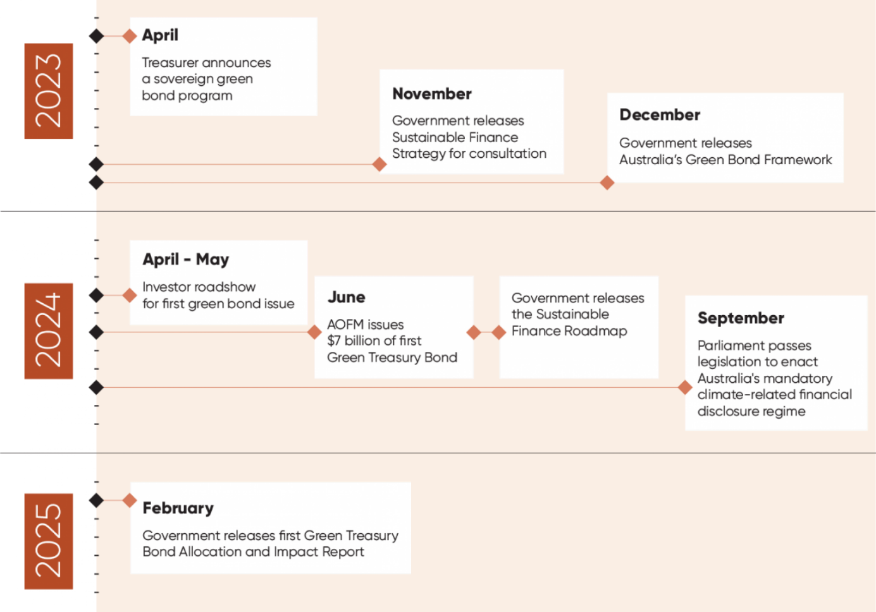

Australian green bond market
The Australian green bond market has grown steadily over time, with 2024 being the biggest year to date for issuance. The launch of the Australian Government’s green bond program in 2024 made a significant contribution to the market: the initial issue and 2 subsequent tenders – in October and December 2024 – totalling $7.6 billion represent 36 per cent of total Australian-dollar denominated green bond issuance for the year. The Australian Government is now one of the largest issuers of Australian-dollar denominated green bonds. Other Australian-dollar green bond issuers include Australian state treasury corporations, the major Australian banks, and non-resident organisations (‘kangaroo issuers’) (Figure 3).

Figure 3: Australian-dollar green bond issuance by year
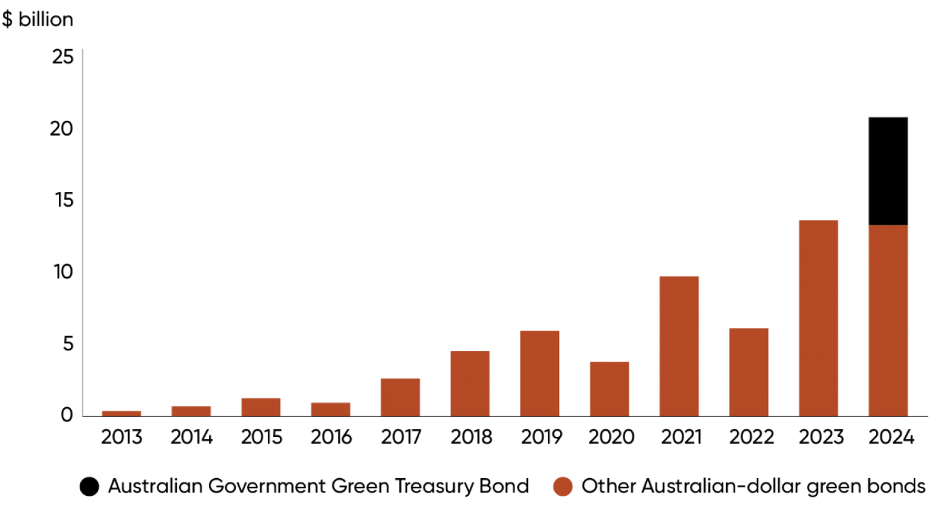
Source: Bloomberg

Green Treasury Bonds
On behalf of the Australian Government, the AOFM issued the first Green Treasury Bond on 4 June 2024. The $7.0 billion June 2034 Green Treasury Bond attracted strong demand from investors, with a final orderbook of $22.9 billion. The bond issue was well supported by both domestic and offshore investors, with around 35 per cent allocated to offshore investors (Figure 4). The largest offshore allocations were to the United Kingdom (12 per cent) and Europe (11 per cent). The highest allocation by investor type was to fund managers (63 per cent) including asset managers, insurance, and pension funds. 105 institutional investors were allocated bonds, of which 17 were new to AOFM syndicated issues.

Figure 4: Investor allocation of the first Green Treasury Bond issue
Investors by Geography
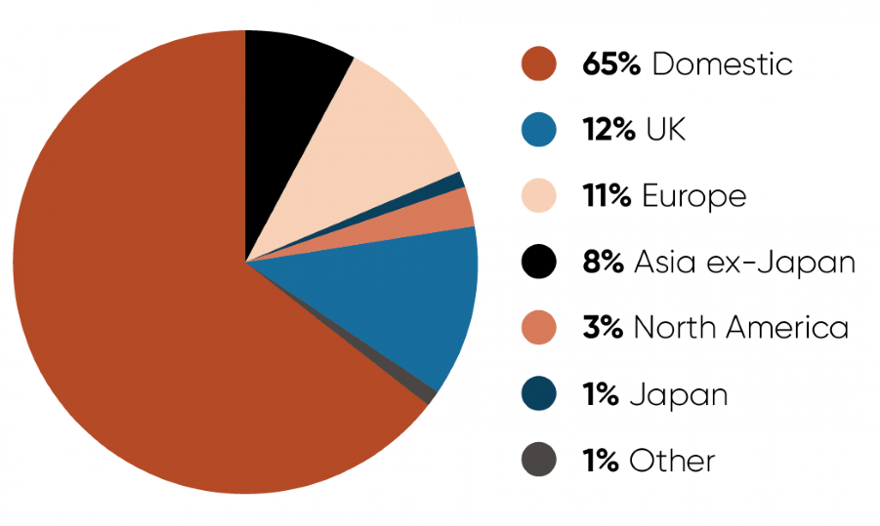
Investors by Type
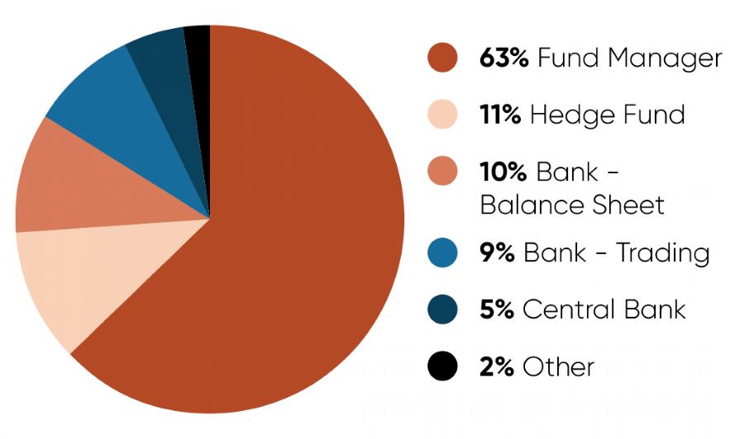
Source: AOFM
The AOFM plans to issue around $2 billion of the June 2034 Green Treasury Bond through competitive tenders over 2024–25. Two of these tenders totalling $600 million had been issued by the end of 2024. The next Allocation and Impact Report will report on Green Treasury Bonds issued in 2024–25.
Over time, the AOFM plans to introduce new green bond lines through large syndicated issues and will build liquidity through tenders of existing lines. Ongoing issuance will increase the size of the overall Australian labelled bond market, which may attract a wider range of investors.
- Allocation of Green Bond Proceeds
The Australian Government allocates the net proceeds of Green Treasury Bond issuance to finance (or refinance) Eligible Green Expenditures. This chapter provides an overview of how green bond proceeds are allocated, and details how proceeds of issuance in 2023–24 have been allocated.

Approach to allocation reporting
The International Capital Market Association’s (ICMA) ‘Green Bond Principles’ outline that proceeds from green bond issuance should fund projects that have clear environmental benefits. The proceeds of Green Treasury Bond issuance are allocated to expenditures on eligible projects, which include operating, capital and balance sheet expenditures. This aligns with other sovereign green bond issuers, including New Zealand and the United Kingdom. State government and bank issuers usually take a slightly different approach – allocating proceeds to a pool of assets. The report has been prepared in accordance with Commonwealth Government accounting processes.
The Australian Government Budget process determines the programs and activities that the government will fund. The Green Bond Committee then endorses which programs and projects may be financed through Green Treasury Bonds. Issuance proceeds are then allocated to programs and projects once funding has been spent by the Australian Government.
Reporting change from the Green Bond Framework
This report does not provide the value of proceeds yet to be expended for each Eligible Green Expenditure, as referenced in the Green Bond Framework. Future expenditures are subject to government decisions and contracting arrangements. Projecting future allocation of Green Treasury Bond proceeds to Eligible Green Expenditures is not feasible, as allocations are made at the time of expenditure.

Classification of Eligible Green Expenditures
All Eligible Green Expenditures support a government program or project that is strongly aligned with one or more of the Australian Government’s 3 key Green Goals for the green bond program:
- Climate change mitigation
- Climate change adaptation
- Improved environmental outcomes.
Eligible Green Expenditures may include operating, capital and balance sheet expenditures. Grants, loans, subsidies, and tax expenditures are used to support climate and environmental projects.
Projects in some sectors are expressly excluded from consideration as Eligible Green Expenditures. For example, projects that relate to the development, refining and transportation of fossil fuels, as well as programs that predominately assist Australia’s highest greenhouse gas emitting facilities are excluded. This is why some major emissions reductions policies, such as the Safeguard Mechanism, are ineligible for the green bond program.
Eligible Green Expenditures can occur in the financial year prior to issuance, the financial year of issuance, or in the following 2 financial years (Figure 5). However, at least 50 per cent of proceeds must be allocated to expenditures in the financial year of issuance and future years. This provides a balance between ensuring there is sufficient known eligible expenditure to sustain the green bond program and including forward looking expenditures that support new initiatives.
This report outlines the allocated proceeds of Green Treasury Bond issuance in 2023–24 to Eligible Green Expenditures in 2022–23 and 2023–24.

Figure 5: Eligibility window
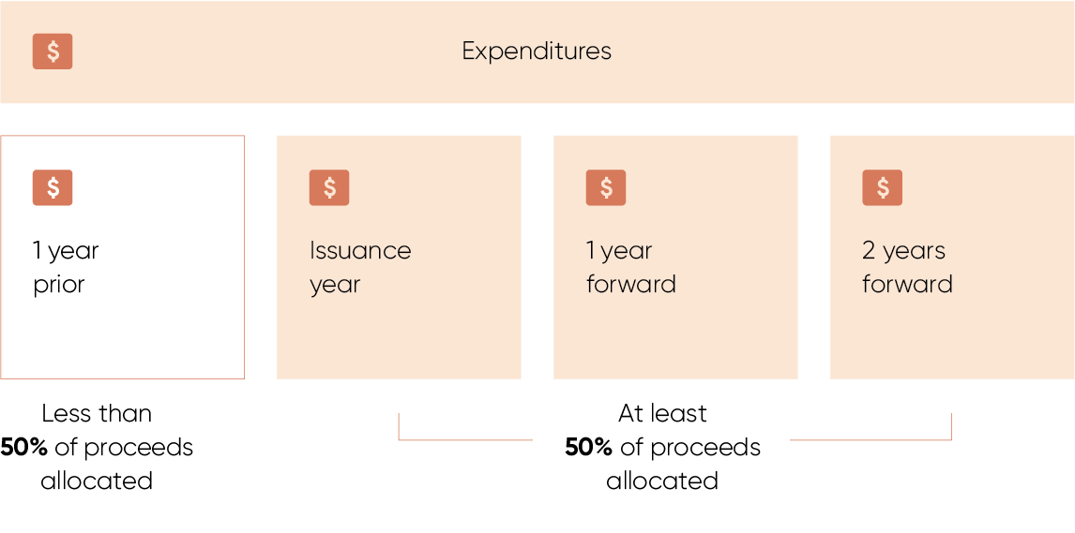
Note: Years relate to financial years.

Eligible Green Expenditure selection and governance
Treasury reviews Australian Government spending decisions made through the Budget process and identifies projects that are likely to align with the Green Bond Framework (the Framework) and the Second-Party Opinion on the Framework. The interdepartmental Green Bond Committee endorses Eligible Green Expenditures to be financed through Green Treasury Bonds.
International best practice is considered when selecting projects to be financed through Green Treasury Bonds. In particular, taxonomy screening thresholds of the Climate Bond Initiative and the European Union have been applied where relevant. Following the release of the draft Australian sustainable finance taxonomy, the Government is considering whether to align screening criteria of Eligible Green Expenditures to the Australian taxonomy, which has an initial focus of climate mitigation.
Treasury, informed by the interdepartmental Green Bond Committee, has an ongoing responsibility to update the list of Eligible Green Expenditures and review existing Eligible Green Expenditures. A list of indicative Eligible Green Expenditures is available on the AOFM website.
Projects selected as Eligible Green Expenditures and financed through Green Treasury Bonds are managed and delivered by a range of government agencies. These government agencies are responsible for monitoring their expenditures and project impacts, including identifying, managing and reporting any political, legal, climate, environmental or social risks.

Allocation reporting methodology
The Green Bond Framework outlines allocation reporting requirements and processes. The allocation data in this report has been sourced from the Australian Government agencies that manage and deliver Eligible Green Expenditures. Chief Financial Officers of these agencies have signed off on the relevant financial information, and the Australian National Audit Office has performed a limited assurance of the allocation reporting under ASAE3000.
The allocation of Green Treasury Bond proceeds occurs at the point when the Australian Government provides funding to a program or project classified as an Eligible Green Expenditure. For example, allocation occurs when money has been provided to project proponents - which may include state or territory governments, private companies, and community organisations. This occurs later than when funding is first committed by Government through the Budget process. Complex policies involving multiple proponents or requiring legislative changes can take a longer time to deploy funding.
Decisions regarding when and how to spend this money on project activities may be at the discretion of the project proponents. As a result, the allocation of proceeds may occur in a different financial year to actual expenditure on project activities.
Where Eligible Green Expenditures are co-financed, either with state and territory governments, private companies or community organisations, only the Australian Government’s portion of the expenditures are included. For each project, Chapters 5, 6 and 7 outline the actual allocation of proceeds from Green Treasury Bonds, the total commitment from the Australian Government over the project’s lifetime, and the total lifetime cost of the project.

Summary of allocation
The proceeds from the Australian Government’s first Green Treasury Bond issue totalled $6,968.9 million, as outlined in Table 4. No other green bonds were issued in 2023–24. 77.6 per cent of proceeds have been allocated to expenditures in 2022–23 and 2023–24. $1,559.7 million of proceeds will be allocated in the next 2 years.
Green Treasury Bond proceeds are considered to refinance Eligible Green Expenditures if proceeds are allocated to expenditures that occurred in the financial year prior to the financial year of issuance. 35.7 per cent of proceeds have been allocated to refinancing expenditures that occurred in 2022-23. The remaining 64.3 per cent of proceeds will be allocated to current and future financial year expenditures, including 41.9 per cent to expenditures in 2023-24 (the issuance year). This is consistent with the commitment in the Green Bond Framework that at least 50 per cent of total proceeds will be allocated to current and future financial year expenditures.

Table 4: Total allocated proceeds over 2022–23 and 2023–24
Issuance proceeds | 2022–23 expenditures |  | 2023–24 expenditures |  | Unallocated
$ million | $ million | per cent of issuance | $ million | per cent of issuance | $ million | per cent of issuance
6,968.9 | 2,487.2 | 35.7 | 2,922.0 | 41.9 | 1,559.7 | 22.4
More detail on allocations is provided in Table 5, which maps Eligible Green Expenditures to key Australian Government green goals, ICMA Green Bond Principles project categories and UN Sustainable Development Goals (SDG).
Table 5 shows the actual expenditure in 2022–23 and 2023–24 for Eligible Green Expenditures. In some cases, actual expenditure may not align with measures in the Australian Government Budget or other public sources. This may be due to a difference between projected and actual expenditure, or an exclusion of some elements of Eligible Green Expenditures from Green Treasury Bond financing where they do not meet the Green Bond Criteria or are commercially sensitive. Total costs of projects may be estimates from project proponents and not the Australian Government. Where available, the source of figures for project costs has been provided.
Proceeds have been allocated to a broad range of activities, in 7 different categories (Figure 6). The largest allocation is to clean transportation projects, including electric rail projects. This is consistent with other sovereign and Australian state government issuers, noting the costs of large infrastructure projects and government’s role in delivering transport networks.
Allocations to comparatively larger new Eligible Green Expenditures such as Rewiring the Nation and the Household Energy Upgrades Fund™ are expected to accelerate materially in coming years as projects are contracted and funding is deployed. Funding for these programs has been committed by Government through the Budget process.

Table 5: Allocation of proceeds against Australian Green Bond Framework’s Green Goals, ICMA Green Projects categories, and UN Sustainable Development Goals
 |  |  | Allocation of Green Treasury Bond proceeds ($ million)
ICMA Green Projects categories | Eligible Green Expenditures | UN SDG mapping | 2022-23 | 2023-24
Climate change mitigation
Renewable energy | CEFC Renewable Energy Investments | 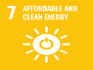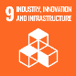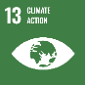 | 154.9 | 267.2
Renewable energy | Rewiring the Nation |  | - | 5.0
Renewable energy | Regional Hydrogen Hubs |  | 15.5 | 20.0
Renewable energy | Community Batteries |  | 4.0 | 9.7
Renewable energy | Advancing Renewables Program |  | 178.5 | 127.1
Energy efficiency | Household Energy Upgrades Fund™ | 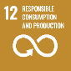 | - | 5.0
Clean transportation | Electric Trains in the Infrastructure Investment Program |  | 1,548.3 | 1,817.6
Clean transportation | Driving the Nation Fund | 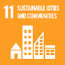 | 11.6 | 25.7
Climate change adaptation
Climate change adaptation | International Climate Finance |  | 125.4 | 107.5
Improved Environmental Outcomes
Environmentally sustainable management of living natural resources and land use | Urban Rivers and Catchments Program | 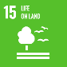 | - | 1.6
Biodiversity conservation  (terrestrial  and aquatic) | Saving Koalas Fund |  | 5.2 | 19.6
Biodiversity conservation  (terrestrial  and aquatic) | Reef 2050 | 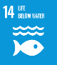 | 52.1 | 36.1
Sustainable water and wastewater management | Murray–Darling Basin Plan | 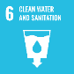 | 391.7 | 479.9
Total |  |  | 2,487.2 | 2,922.0

Figure 6: Allocation of Green Treasury Bond proceeds by ICMA Green Projects categories
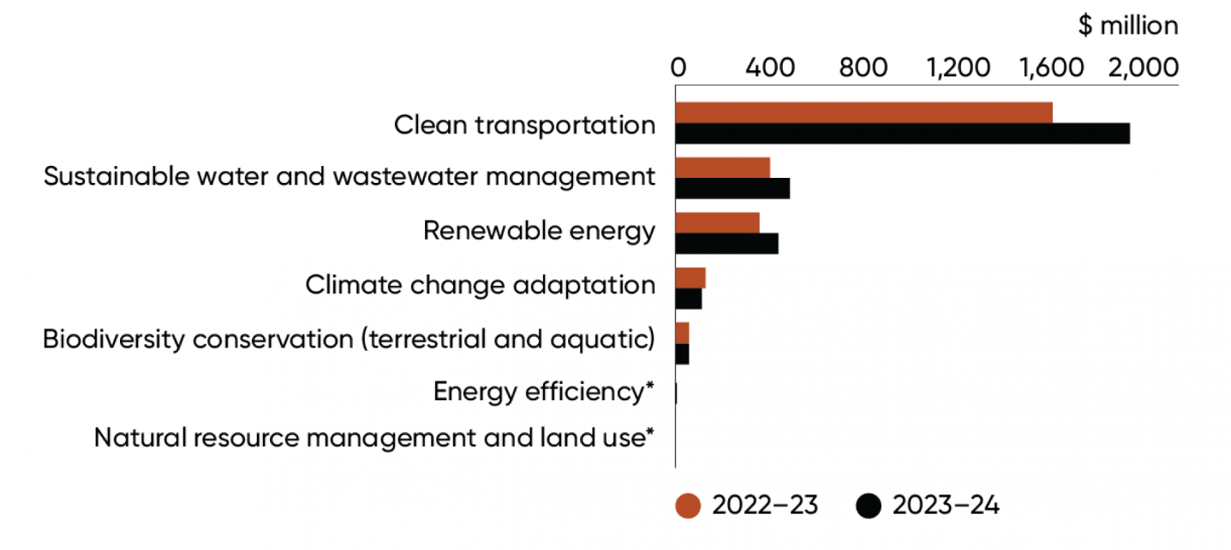
*No funding was allocated to these categories in 2022–23. In 2023–24, the natural resource management and land use category was allocated $1.6 million, and the energy efficiency category was allocated $5.0 million.

- Impacts of Eligible Green Expenditures

Approach to impact reporting
Projects financed through Green Treasury Bonds aim to achieve Australia’s policy objectives linked to climate change mitigation, climate change adaptation and improved environmental outcomes. Some projects will directly reduce emissions and have measurable impacts for Australia’s decarbonisation goals. Other projects, such as research and development for new renewable technologies, may not have immediate measurable impacts, but still play a critical role to support Australia’s path to net zero.
Australian Government agencies that manage and deliver Eligible Green Expenditures have sourced and provided data for impact reporting. Each Eligible Green Expenditure has its own impact indicator(s) depending on the circumstances of the project. The respective methodologies are outlined throughout this report where possible. Subject to data availability, impact indicators align with the ICMA Handbook - Harmonised Framework for Impact Reporting.
Many projects financed through the first Green Treasury Bond issue are in the construction stage and are yet to have realised impacts. Where possible, expected impacts for these projects have been reported (Table 6).
Climate policies can have unintended economic and social costs, particularly for regional communities or underrepresented groups. Climate policies in Australia consider the economic and social benefits and costs of the net zero transition. Social co benefits of projects financed through Green Treasury Bonds have been included in this report to capture benefits beyond the primary climate and environmental objectives.
This publication is the Australian Government’s first impact report and provides as much information as possible based on currently available data. Impact data are based on the best available information at the time of publishing, noting that project impacts are varied and may be subject to change. The availability of impact data are expected to improve in future reports as reporting standards improve and quantifiable results become available for more projects. Where quantitative data are not available, the report presents qualitative impacts and case studies. Treasury and the Green Bond Committee will work with agencies to embed impact data requirements in new programs that are expected to be financed through Green Treasury Bonds.
For co-financed projects, due to timing differences in financing by the Australian Government and co-financiers, it is not possible to accurately represent the impacts solely attributable to Green Treasury Bond financing. Impacts can be pro-rated based on the allocation of Green Treasury Bond or Australian Government contributions as a proportion of the total lifetime cost of the project.

Summary of impacts
Table 6 outlines the headline impacts for Eligible Green Expenditures in 2022–23 and 2023–24. Chapters 5, 6 and 7 provide detailed impact reporting, including case studies and social co-benefits.

Table 6: Headline impacts of 2022–23 and 2023–24 Eligible Green Expenditures
Eligible Green Expenditures | Impact metrics | Data | Recorded/ Projected
Climate change mitigation
CEFC Renewable Energy Investments | Annual GHG emissions reduced/avoided | 500 kt CO₂-e | Projected
CEFC Renewable Energy Investments | Annual renewable electricity generation | 4,600 GWh | Projected
CEFC Renewable Energy Investments | New storage capacity | 319 MW / 1,076 MWh | Projected
Rewiring the Nation | Increase in network capacity | 6.4 GW | Projected
Regional hydrogen hubs | Hydrogen produced annually | 191.7 kt H₂ | Projected
Community Batteries | Capacity installed | 0.82 MW / 1.9 MWh | Recorded
Community Batteries | Number of community batteries deployed | 4 | Recorded
Advancing Renewables Program | Number of projects funded | 96 | Recorded
Household Energy Upgrades Fund™ | Number of concessional loans financed | 6 | Recorded
Household Energy Upgrades Fund™ | Number of energy efficient technologies financed | 7 | Recorded
Electric Trains in the Infrastructure Investment Program | Length of rail built or upgraded | 103.4 km | Projected
Driving the Nation Fund | Number of EV charging sites delivered | 15 | Recorded
Climate change adaptation
International Climate Finance | Number of bilateral, regional and multilateral investments financed for environmental protection, biodiversity conservation and climate protection | 15 | Recorded
Improved Environmental Outcomes
Urban Rivers and Catchment Program | Aquatic area restored/re naturalised, aquatic area with improved eco hydrological management, riparian areas habitat restored or improved. | Data not available at this stage. Impacts will be made available in future reports.
Saving Koalas Fund | Number of grants made to community organisations | 59 | Recorded
Saving Koalas Fund | Additions and improvements to, and management of, land used as koala habitat | 5,564 ha | Projected
Saving Koalas Fund | Number of koala population surveys conducted | 335 | Recorded
Reef 2050 | Per cent reduction of anthropogenic dissolved inorganic nitrogen load leaving Great Barrier Reef catchments | 28.4 per cent | Recorded
Reef 2050 | Per cent reduction of anthropogenic fine sediment load leaving Great Barrier Reef catchments | 16.0 per cent | Recorded
Reef 2050 | Per cent reduction of anthropogenic particulate nitrogen load leaving Great Barrier Reef catchments | 15.4 per cent | Recorded
Reef 2050 | Per cent reduction of anthropogenic particulate phosphorus load leaving Great Barrier Reef catchments | 18.5 per cent | Recorded
Reef 2050 | Pesticide risk condition - aquatic species unlikely to experience harmful effects from pesticides | 95 per cent | Recorded
Reef 2050 | Grazing lands with greater than 70 per cent ground cover in the late dry season | 92 per cent | Recorded
Murray–Darling Basin Plan | Water registered for environmental use | 23.9 GL/y | Recorded
Murray–Darling Basin Plan | Surface water registered to Commonwealth | 20.0 GL/y | Recorded
Murray–Darling Basin Plan | Per cent of surface water allocation (in Commonwealth accounts) forfeited | 0.18 per cent | Recorded

- Climate Change Mitigation Reporting
Australia and the world are undergoing the biggest and fastest economic transformation since the Industrial Revolution. Action to reduce emissions will help prevent the worst impacts of climate change. The Australian Government’s Net Zero Plan will lay out and extend Australia’s action on climate change. The Net Zero Plan will guide Australia’s transition to the legislated target of net zero greenhouse gas emissions by 2050.
The Net Zero Plan will set out government priorities, establish policies and measures to drive down emissions, and support ongoing and new investment in low emissions and renewable activities. As part of the Net Zero Plan, the Australian Government will set an ambitious and achievable 2035 emissions reduction target. This will mean Australia is accelerating climate action, consistent with its global peers.
The Australian Government delivers climate change mitigation projects through various channels and organisations, and in partnership with state and local governments. Funding mechanisms include grant financing through the Department of Climate Change, Energy, the Environment and Water (DCCEEW) and ARENA, and through corporate Commonwealth entities, such as the CEFC.
- The CEFC is established under the Clean Energy Finance Corporation Act 2012 (CEFC Act). The objective of the CEFC is to ‘facilitate increased flows of finance into the clean energy sector and to facilitate the achievement of Australia’s greenhouse gas emissions reduction targets’.
- ARENA is established under the Australian Renewable Energy Agency Act 2011 (ARENA Act) to improve the competitiveness of renewable energy technologies and increase the supply of renewable energy in Australia. Additionally, ARENA is helping to achieve the Australian Government’s climate change and energy objectives, anchored by emissions reduction goals of 43 per cent by 2030 and net zero by 2050.
Most Green Treasury Bond proceeds are allocated to climate change mitigation projects, reflecting the scale of financing required for the net zero transition.

Renewable energy
Decarbonising the electricity sector - Australia’s largest source of emissions, representing 34.6 per cent of emissions in 2024 - is vital to reaching Australia’s 2030 emissions reduction target. Australia aims to increase the share of on grid national renewable electricity to 82 per cent by 2030, from 36 per cent in 2021–22.
Electricity sector emissions have declined by 22.4 per cent since 2005 and are down by 0.4 per cent between 2023 and 2024, reflecting continuing renewable deployment and the displacement of fossil fuel power.
In the 2023 calendar year, around 35 per cent of Australia’s electricity generation came from renewable sources, a 3 percentage point increase from 2022. This includes around 28 per cent of Australia’s total generation coming from wind and solar. This has partly been driven by the rapid take-up of rooftop solar PV systems – around 3.7 million Australian households had these systems at the end of 2023. Generation from gas declined by 8.2 per cent in 2023 to its lowest level in over a decade.
Renewable hydrogen can play an essential complementary role to electrification in decarbonising the global economy, particularly in hard-to-abate sectors. Renewable hydrogen is a substitute for, and complement to, natural gas-based power generation, able to be used as fuel for peaking power plants during periods of high demand. It is also a source of new load and load flexibility, and long duration energy storage.
Green Treasury Bonds finance large scale renewable and storage projects through CEFC Renewable Energy Investments, Rewiring the Nation, Regional Hydrogen Hubs, Community Batteries and the Advancing Renewables Program.

Clean Energy Finance Corporation Renewable Energy Investments
CEFC capital is playing a leading role in helping develop large-scale renewables across Australia. Large-scale solar and wind generation is critical to delivering the clean energy that will power the low emissions economy of the future. Renewable energy will also underpin the electrification of a vast range of existing commercial, industrial and residential activities, such as enabling the electric vehicle transition and laying the foundations for Australia’s emerging green hydrogen industry.
Green Treasury Bonds are contributing to a variety of large-scale renewable energy and energy storage projects. All projects are aligned with relevant Climate Bond Initiative or European Union taxonomy technical thresholds as outlined in Sustainalytics’ Second Party Opinion.

Green Treasury Bond allocation
Green Treasury Bonds contributed $422.1 million in 2022–23 and 2023–24 towards 13 CEFC Renewable Energy Investments (Table 7).
The total government contribution refers to the financing committed towards the 13 CEFC Renewable Energy Investments, including the commitments that have been funded prior to
2022–23. The total cost of projects refers to the combined funding from the Government as well as other non-government sources.
To maintain commercial confidentiality, allocation reporting reflects all CEFC investment into renewable energy projects over the reporting period on an aggregated basis.

Table 7: Allocation to CEFC Renewable Energy Investments
Projects supported | Allocation ($ million) |  |  | Total Government Contribution ($ million) | Total Cost of Project ($ million)
Projects supported | 2022–23 | 2023–24 | Total | Total Government Contribution ($ million) | Total Cost of Project ($ million)
Renewable Energy Investments | 154.9 | 267.2 | 422.1 | 845.3 | 6,184.5

Co-financing arrangements
Projects are co-financed with private proponents and private investment funds. Green Treasury Bond proceeds are only allocated to CEFC contributions and not private co-financing. The CEFC aims to catalyse and leverage an increased flow of private finance for renewable energy projects in Australia as part of the net zero transition.

Material risks
In its most recent Annual Report, the CEFC observed that the renewable energy investment landscape was characterised by ongoing capital expenditure cost challenges, planning approval bottlenecks (particularly for wind), and the investment market absorbing finalised details of the CIS revenue support arrangements.
CEFC Renewable Energy Investment commitments are subject to inherent risks and uncertainties, which can include external inputs such as those related to the regulatory environment and market conditions, meaningful local community and First Nations engagement, obtaining grid connection approvals, environmental approvals or resolving legal challenges, all of which can delay projects significantly and impact the timing of deployment.

Project impacts
Green Treasury Bonds will contribute to projects that are expected to enable 4,600 GWh of new renewable energy generation per annum on average (Table 8). This is equivalent to around 500 kilotons of carbon dioxide avoided per annum. CEFC storage projects financed through Green Treasury Bonds are expected to contribute to 319 MW / 1,076 MWh of new storage capacity.

Table 8: Impacts of CEFC Renewable Energy Investments
Metric | Project | Value | Recorded / Projected | Time Period
Projected emissions avoided (kt CO₂-e p.a.) | Renewable Energy Investments | 500 | Projected | From operation (25+ years)
Projected annual renewable energy generation (GWh) | Renewable Energy Investments | 4,600 | Projected | From operation (25+ years)
New storage capacity  (MW / MWh) | Renewable Energy Investments | 319 / 1,076 | Projected | 20 years
Annual energy generation has been calculated as the estimated lifetime generation divided by the estimated number of operational years.
Estimated projected emissions avoided per annum are lifetime greenhouse emissions divided by the estimated number of operational years. Emissions Intensity Factors, which estimate the CO₂ avoided per GWh of renewable generation, are based on DCCEEW projections published in 2023 (scope 2, ‘with additional measures’ scenario). Emissions Intensity Factors are available to 2035 only. The CEFC has estimated Emissions Intensity Factors from 2036 onward by applying the average percentage decline in Emissions Intensity Factors up to 2035.

Social co-benefits
CEFC investments in the renewables energy sector have a long track record of delivering additional benefits to local and regional communities, in addition to the employment and economic activity associated with the planning, development and operational phases.
The energy transition requires a large skilled workforce across every discipline, with particular opportunities in rural and regional areas. While the CEFC does not directly make employment decisions at the project level, since this is a matter for project proponents, as a specialist investor on behalf of the Australian Government it seeks to use its capital to influence positive community and employment outcomes, including through the application of Australian Industry Participation Plans, the Buy Australian Plan and First Nations Investment Screening processes. Green Treasury Bonds related projects are estimated to create 90-100 full-time equivalent jobs, and more than 1,500 jobs during construction periods.
Case Study 1: Walla Walla Solar Farm
The CEFC has committed $100 million in finance toward the construction of the 300 MW Walla Walla Solar Farm. Green Treasury Bonds have contributed to this project in the reporting period.
The estimated capital value of the project is $400 million, and the remainder of the finance will be co-financed through ING and a green loan from Export Development Canada. The project will be managed by Fotowatio Renewable Ventures (FRV), a renewable energy development company co-owned by Abdul Latif Jameel Energy and the OMERS pension fund.
The solar farm is situated 40km north of Albury and is projected to produce 724,000 MWh of electricity annually. It will consist of approximately 700,000 solar panels across 605 hectares, producing enough energy for 90,000 households in New South Wales and connecting to the network via the existing Jindera-Wagga Wagga transmission line and an onsite substation.
In 2022, FRV Australia entered into an agreement with Gransolar Group for construction of the plant, while Transgrid is responsible for the design and construction of the onsite substation.
During construction, the project is forecast to generate 250 new jobs for the local economy. FRV has also committed to providing sustainable returns and benefits to the region, through a Voluntary Planning Agreement signed with the Greater Hume Shire Council.

Rewiring the Nation
Through the Rewiring the Nation Fund, the CEFC is charged with investing $19 billion on behalf of the Australian Government in a range of projects essential to the achievement of its net zero emissions ambitions. These investments are expected to lower Australia’s emissions by enabling the transition of the energy system to one based on at least 82 per cent renewables by 2030.
The Australian Energy Market Operator’s (AEMO) Integrated System Plan (ISP) forecasts that by 2050 the National Electricity Market needs an estimated:
- 10,000 km of transmission lines
- 6 times the utility scale wind and solar that the country currently has to ensure the supply of reliable and secure energy.
This major investment in the renewable energy sector will help enable Australia to deliver even more affordable and reliable renewable energy. Rewiring the Nation is critical to achieve Australia’s 82 per cent renewables target and 43 per cent emissions reduction target by 2030, and net zero emissions by 2050.
The project is focusing on investments that facilitate the timely delivery of grid and transmission projects and make clean energy more accessible and affordable for Australian consumers. It aims to accelerate investment in a range of essential projects, including transmission infrastructure, long-duration storage, electricity distribution network infrastructure and distributed energy resources.
In line with the European Union taxonomy, transmission and distribution infrastructure projects are only included as Eligible Green Expenditures if more than 67 per cent of newly enabled generation capacity in the system is below 100g CO₂-e/kWh over a rolling five-year period.

Green Treasury Bond allocation
Green Treasury Bonds contributed $5 million in 2023–24 towards Rewiring the Nation (Table 9).
The total Government contribution represents the total Rewiring the Nation Fund investment capital at 31 December 2024. Funding in future financial years is anticipated to be financed through Green Treasury Bonds.
As of 31 December 2024, the CEFC has committed to the following projects:
- $490 million to Central-West Orana Renewable Energy Zone
- $120 million to VNI West (early works in Victoria)
- $100 million to NSW Scheme Financial Vehicle
- Up to $1.92 billion to Transgrid for funding of the Humelink (NSW) and VNI West (NSW section) energy infrastructure projects, with the final size of the CEFC commitment subject to market and other conditions as the projects progress.
As projects progress, including reaching final investment decisions, the rollout of Rewiring the Nation capital is expected to continue. New eligible investments financed from the Rewiring the Nation Fund will be reported in future Allocation and Impact Reports.
To maintain commercial confidentiality, allocation reporting reflects all CEFC Rewiring the Nation Fund projects over the reporting period on an aggregated basis.

Table 9: Allocation to Rewiring the Nation
Projects supported | Allocation ($ million) |  |  | Total Government Contribution ($ million) | Total Cost of Project ($ million)
Projects supported | 2022–23 | 2023–24 | Total | Total Government Contribution ($ million) | Total Cost of Project ($ million)
Rewiring the Nation | - | 5.0 | 5.0 | 19,000.0 | N/A

Co-financing arrangements
The Australian Government is working with state and territory governments to deliver significant transmission projects. Projects may be co-financed with state and territory governments and the private sector.

Material risks
Rewiring the Nation projects are subject to inherent risks and uncertainties, which can include external inputs such as those related to the regulatory environment and market conditions. These may impact the timing of future deployment.
Large infrastructure projects such as those being targeted by the CEFC’s Rewiring the Nation Fund are particularly dependent on external inputs to reach completion, including earning social licence and securing critical energy assets and workforce. Delays in the acquisition of these external inputs has the potential to delay project completion, and corresponding investment deployment.

Project impacts
Green Treasury Bonds are expected to contribute to an additional 6.4 GW of network capacity for renewable energy once all currently committed funds are deployed and projects are operational (Table 10). Network capacity has been determined and publicised by the relevant network planning authority.
Impact reporting reflects all projects where financing has been committed by the CEFC over the reporting period. This may include projects which have not yet received financing from the CEFC over the reporting period. Reported projects will receive Green Treasury Bond allocations in future years.

Table 10: Impacts of Rewiring the Nation
Metric | Project | Value | Recorded/ Projected | Time Period
Increase in network capacity (GW) | Central-West Orana Renewable Energy Zone | 4.5 | Projected | From completion
Increase in network capacity (GW) | VNI West | 1.9 | Projected | From 2031

Social co-benefits
Rewiring the Nation projects will seek to positively impact the regions where projects are proposed. For example, EnergyCo NSW estimates that the Central-West Orana Renewable Energy Zone could bring up to $20 billion in private investment to towns including Bathurst, Orange, and Parkes, and the region more broadly by 2030 and will create approximately 5,000 jobs (Table 11). Bringing renewable energy to more homes will also have a direct consumer benefit.
The investment mandate of the Rewiring the Nation Fund requires the CEFC to consider, where practical, the essential role of social licence matters in the successful deployment of clean energy technologies as part of the transaction process.
CEFC investment proposals are screened for impacts on Aboriginal and Torres Strait Islander communities and peoples through the CEFC First Nations Screening Approach. These considerations also form part of CEFC’s Rewiring the Nation-related investment decisions.

Table 11: Social co-benefits of Rewiring the Nation
Metric | Project | Value | Recorded/ Projected | Time Period
Jobs Created | Central-West Orana Renewable Energy Zone | 5,000 | Projected | Peak construction
Consumer benefit ($) | Central-West Orana Renewable Energy Zone | 240 million | Projected | Over 20 years

Case Study 2: Central-West Orana Renewable Energy Zone (REZ)
The CEFC has committed $490 million to the Central-West Orana REZ, a transformative project for Australia’s low emissions future. It will deliver an additional 4.5 GW in network capacity, and unlock new low-cost solar and wind generation, backed up by battery storage.
EnergyCo estimates the finance agreement has the potential to deliver as much as a nominal $240 million in benefits to NSW electricity consumers in the form of lower project costs over the 20-year tenure of the loan.
The CEFC finance:
- enables EnergyCo to separately finance the capital expenditures related to land acquisition within the Central-West Orana REZ, as well as the purchase of biodiversity offsets, at a government cost of funds. This will ease the overall financing task across the broader REZ for the Network Service Provider.
- includes the provision of CEFC concessional finance to EnergyCo on more favourable terms than otherwise available in the market, lowering the overall project financing cost to NSW electricity consumers.
AEMO has identified the Central-West Orana REZ as a priority project in its Integrated System Plan for the National Energy Market. The first REZ to be declared in Australia, it is one of 5 designated REZs in NSW, alongside the New England, Hunter-Central Coast, South-West and Illawarra REZs.
The Central-West Orana REZ transmission project secured planning approval in June 2024 and was the first REZ in Australia to achieve this critical step.
The project is anticipated to enable renewable energy generators participating in the REZ to export to the grid, as well as bring up to $20 billion in private investment to the Central-West Orana region by 2030.

Regional Hydrogen Hubs
Hydrogen hubs are locations where hydrogen producers, users and potential exporters can co-locate and collaborate to drive innovation, share infrastructure, create demand and scale up the industry.
The Australian Government has invested around $500 million to support the development of hydrogen hubs in regional Australia as well as design and development studies. Hydrogen hubs form a key element of the 2024 National Hydrogen Strategy to support clean hydrogen industry growth and development at scale. This will enable Australia’s net zero transition and position the country as a global green hydrogen leader.
Hubs will give Australia’s green hydrogen industry an early-stage springboard to scale, which will help support other industrial sectors in the regions. These industrial clusters will lower the cost of production, encourage innovation, and enhance skills and training efforts.
All Regional Hydrogen Hubs projects financed through Green Treasury Bonds will produce green hydrogen only. Hydrogen projects are limited to production processes by electrolysis powered by renewables or grid electricity.

Green Treasury Bond allocation
Green Treasury Bonds contributed to 6 sub-projects totalling $35.5 million over 2022–23 and 2023–‍24 (Table 12) across NSW, Queensland, Tasmania, and Western Australia (Figure 7).
The total Government contribution represents the expected funding of each sub-project as of the 2024–25 Mid-Year Economic and Fiscal Outlook (MYEFO). Funding in future financial years is expected to be financed through Green Treasury Bonds.
The total cost of the project refers to the project proponent’s estimates of lifetime project cost.

Table 12: Allocation to Regional Hydrogen Hubs
Projects supported | Allocation ($ million) |  |  | Total Government Contribution ($ million) | Total Cost of Project ($ million)
Projects supported | 2022–23 | 2023–24 | Total | Total Government Contribution ($ million) | Total Cost of Project ($ million)
Euroa Hydrogen Project Gladstone | 1.5 | - | 1.5 | 3.0 | 6.0
Central Queensland H2 Hub | - | 14.2 | 14.2 | N/A | N/Aª
H2Kwinana Clean Energy Hub | 6.0 | - | 6.0 | 70.0 | 403.1
Tasmanian Green Hydrogen Hub | - | 5.8 | 5.8 | 70.0 | 300.0
George Town Green Hydrogen Project | 2.0 | - | 2.0 | 5.0 | N/Aª
Hunter H2 Hub | 6.0 | - | 6.0 | 70.0 | 207.6
Total | 15.5 | 20.0 | 35.5 | 218.0^{b} | 916.7^{b}
- Total project costs for Central Queensland Hydrogen Hub and George Town Green Hydrogen Project cannot be published due to commercial sensitivities.
- Totals do not include projects where data are unavailable or cannot be reported (N/A).

Figure 7: Location of Regional Hydrogen Hubs in Australia
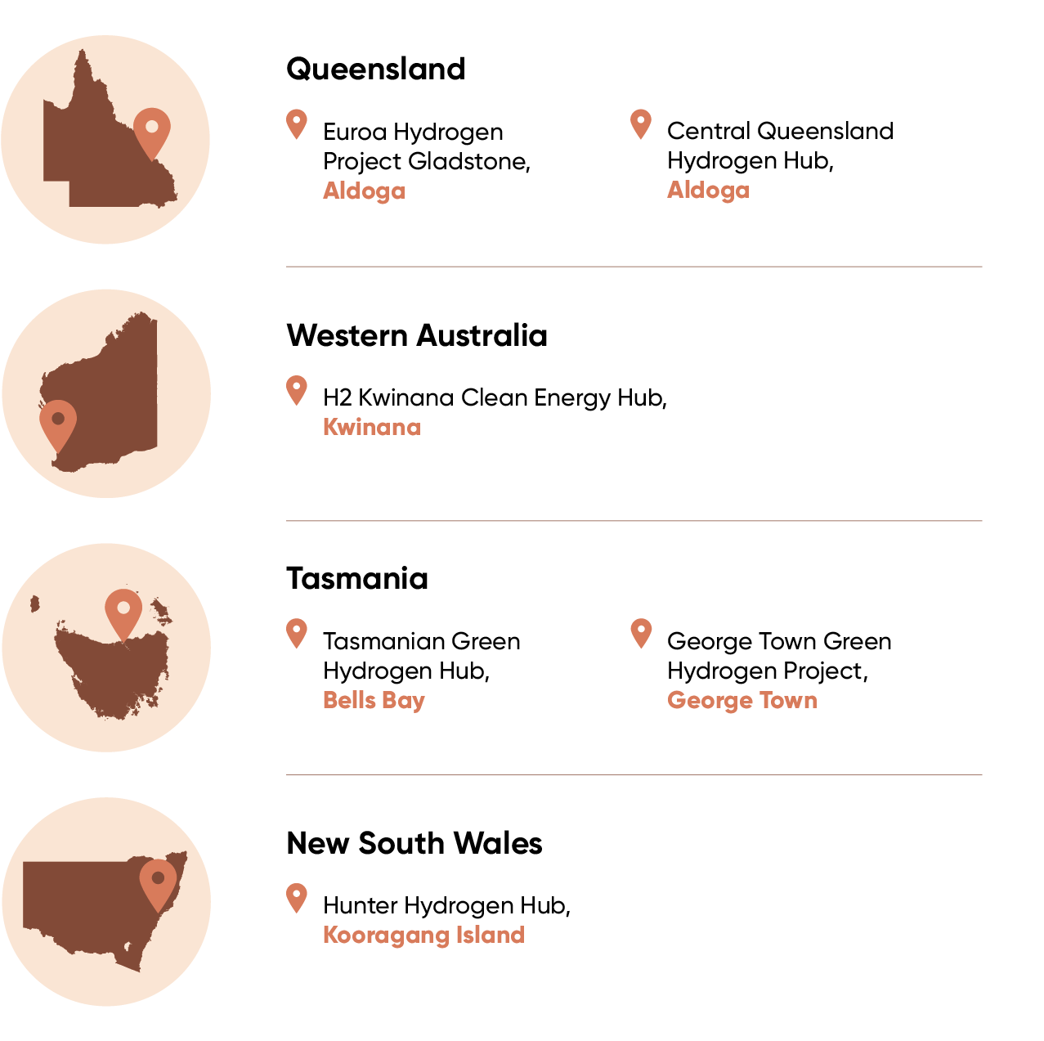

Co-financing arrangements
Projects are co financed by private proponents and/or state and territory governments.
Although Green Treasury Bond proceeds can only be used for green hydrogen activities, in line with the Framework, some proceeds have been allocated to entities that also operate in the fossil fuel industry. Allocated proceeds cannot be used for any other activities. Further information on eligible activities and ongoing monitoring is available in the Grant Opportunity Guidelines for the Activating a Regional Hydrogen Industry - Clean Hydrogen Industrial Hubs program.

Material risks
Projects supported under the program are subject to technical and commercial risk. All Regional Hydrogen Hub implementation projects are working towards a final investment decision.
On 3 October 2024, Origin Energy announced that it will exit the Hunter Hydrogen Hub. Origin cited commercial factors for its decision, including uncertainty surrounding the pace and timing of the development of the hydrogen market and the risk associated with capital intensive projects. The Government is talking to another party who may be interested in taking over the project.
On 3 February 2025, the Queensland Government announced it would end its support for the Central Queensland Hydrogen Project (CQ-H2), led by Stanwell Corporation alongside domestic and international partners. The project consortium is reviewing the future of project and whether it is possible to continue to deliver the project under another entity.
The Government remains committed to its 2024 National Hydrogen Strategy and positioning Australia as a global hydrogen leader by 2030. The Government is delivering a range of other policy initiatives to support early hydrogen projects including the Hydrogen Headstart Program and Hydrogen Production Tax Incentive.

Project impacts
Renewable projects financed through Green Treasury Bonds are projected to contribute to 191.7 kilotons of hydrogen production per annum once projects are operational (Table 13).

Table 13: Impacts of Regional Hydrogen Hubs
Metric | Project | Value | Record/ Projected | Time Period
Hydrogen produced (kt H₂/year) | Euroa Hydrogen Project Gladstone | 56 | Projected | Annually from early 2030
Hydrogen produced (kt H₂/year) | H2Kwinana Clean Energy Hub | 14 | Projected | Annually from completion
Hydrogen produced (kt H₂/year) | Central Queensland Hydrogen Hub | 70 | Projected | Annually from early 2029
Hydrogen produced (kt H₂/year) | Tasmanian Green Hydrogen Hub | 45 | Projected | Annually from early 2028
Hydrogen produced (kt H₂/year) | Hunter Hydrogen Hub | 5.5 | Projected | Annually from completion
Hydrogen produced (kt H₂/year) | George Town Green Hydrogen Project | 1.2 | Projected | Annually from completion
Hydrogen produced (kt H₂/year) | Total | 191.7
The Australian Government contributes to Regional Hydrogen Hubs projects through grants to state and territory government and/or industry proponents. Projected hydrogen production has been identified by project proponents of individual projects as part of feasibility studies. Projections have not been produced by the Australian Government. Methodology may differ between projects.
Once each project is operational, emissions avoided data will be available by comparing the energy sources displaced by green hydrogen. Projected emissions avoided data are unavailable at this stage.

Social co-benefits
Regional Hydrogen Hubs will support employment opportunities for regional communities. Data for regional job creation will be available when individual projects are complete. For example, the H2Kwinana Hydrogen Hub is expected to create 150 jobs.

Case Study 3: Tasmanian Green Hydrogen Hub
The Australian Government has committed $70 million in funding to the Tasmanian Green Hydrogen Hub in Bell Bay through the Regional Hydrogen Hub program. Green Treasury Bonds contributed $5.8 million to this project over 2022–23 and 2023–24 and are expected to finance the Australian Government contribution in future years. The combined investment by the Australian Government, Tasmanian Government and partners is $300 million.
Tasmania has a natural advantage in the production of green hydrogen, due to its long history of renewable power generation from hydroelectricity. Tasmania is 100 per cent self-sufficient in renewable electricity and was the first Australian jurisdiction to achieve net zero emissions.
As both an industrial centre and port, Bell Bay is well situated to be a significant location for hydrogen production, use, storage and export. The first stage of the Hub will include a hydrogen production plant of up to 300MW located within the Bell Bay Advanced Manufacturing Zone.
Construction activities are anticipated to be complete in 2028. Once complete, the Hub will support:
- the production of up to 45,000 tonnes of green hydrogen per year - enough to fuel over 2,200 heavy vehicles
- 740 jobs for energy specialists such as engineers and technicians, while hub construction will provide work for local skilled trades like concreters, plumbers, fitters and electricians
- the manufacture of green metals and alloys like iron, aluminium and steel.

Community Batteries
The Community Batteries for Household Solar program will install more than 420 community batteries across Australia. The batteries will store excess solar energy for consumers to use during peak times, put downward pressure on household electricity costs, contribute towards lowering emissions, provide network benefits and support further solar installations.
The $200 million program, led by DCCEEW, delivers grants through the Department of Industry, Science and Resources’ Business Grants Hub and ARENA Community Batteries Funding.
The Business Grants Hub is administering $29 million of grants to install batteries in up to 57 locations.
ARENA is administering $171 million of grants for community batteries through 2 rounds. In June 2024, Round 1 conditionally approved $143 million to support up to 370 batteries across Australia. No grant funding was paid out by ARENA in the reporting period. ARENA will launch Round 2, which will have at least $28 million of available grants, in 2025.

Green Treasury Bond allocation
Green Treasury Bonds contributed $13.7 million to Community Batteries over 2022–23 and 2023–24 (Table 14).
The total Government contribution represents the expected funding of the program over its lifetime as of the 2024–25 MYEFO. Funding in future financial years is anticipated to be financed through Green Treasury Bonds.
The total cost of projects is not reported in this grant program.

Table 14: Allocation to Community Batteries
Projects supported | Allocation ($ million) |  |  | Total Government Contribution ($ million) | Total Cost of Project ($ million)
Projects supported | 2022–23 | 2023–24 | Total | Total Government Contribution ($ million) | Total Cost of Project ($ million)
Community batteries ª | 4.0 | 9.7 | 13.7 | 29.0 | N/A
- Program includes an additional $171.0 million in grant funding being administered by ARENA, which is not being financed through 2023–24 Green Treasury Bond issuance.

Co-financing arrangements
Sub-projects under Community Batteries can be co-financed with project proponents.

Material risks
ARENA has identified no material risks to deliver Community Batteries.

Project impacts
Once online, the batteries will have a tangible impact on local network constraints and will expand rooftop solar capacity, reduce emissions and reduce electricity costs for consumers. The batteries will also reduce pressure on the electricity grid and absorb excess energy that might cause voltage spikes.
The Department of Climate Change, Energy, the Environment and Water records the number of community batteries delivered as part of its program delivery. Capacity installed is reported by project proponents as part of the grant process.
Green Treasury Bonds have financed 4 community batteries which added 1.9 MWh of energy storage capacity (Table 15).

Table 15: Impacts of Community Batteries
Metric | Value | Record/ Projected | Time Period
Capacity installed (MW / MWh) | 0.82 /1.9 | Recorded | 2023–2024
Number of community batteries deployed | 4 | Recorded | 2023–2024

Social co-benefits
A range of energy consumers will benefit from these batteries, including households, hospitals, schools and tertiary education institutions, council facilities, housing developments, social and community housing, sports facilities, libraries, aquatic centres, shopping centres, and regional and remote communities.

Case Study 4: Edwardstown and Magill Community Batteries
Social housing tenants will get energy bill relief with the launch of the Edwardstown and Magill Community Batteries in South Australia. The two 405 kWh battery energy storage systems have been installed by the South Australian Department for Energy and Mining. These batteries received grant funding from the Australian Government as part of the Community Batteries for Household Solar Program, with financing contribution from Green Treasury Bonds proceeds.
The first in a fleet of community batteries planned for installation across metropolitan and regional South Australia, these 2 batteries will see 600 eligible SA Housing Trust households that take part in the exclusive energy plan save around $550 a year through a retail tariff 25 per cent below the Default Market Offer in SA.
Around 10,000 SA Housing Trust tenants will ultimately benefit from the tariff reduction through community batteries.
For further information see the South Australian Department of Energy and Mining website.

Advancing Renewables Program
The Advancing Renewables Program (ARP) supports a range of development, demonstration, and pre commercial deployment projects. This includes opportunities to:
- optimise the transition to renewable electricity
- commercialise clean hydrogen
- support the transition to low emissions metals
- enable ultra-low cost solar
- decarbonise transport.
ARP funds only low-emissions projects that involve renewable energy technology or improve upon existing mechanisms to facilitate renewable energy technologies in Australia.

Green Treasury Bond allocation
Green Treasury Bonds have contributed $305.6 million to the ARP in 2022–23 and 2023–24 (Table 16).
The total Government contribution to projects represents contracted funding for individual projects (both past and expected funding). Most projects were established prior to issuance of Green Treasury Bonds.
The total cost of projects includes co-financing with project partners.

Table 16: Allocation to the Advancing Renewables Program
Projects supported | Allocation ($ million) |  |  | Total Government Contribution ($ million) | Total Cost of Project ($ million)
Projects supported | 2022–23 | 2023–24 | Total | Total Government Contribution ($ million) | Total Cost of Project ($ million)
Renewable hydrogen | 114.3 | 31.1 | 145.4 | 189.7 | 512.0
Decarbonise land transport | 8.7 | 2.5 | 11.2 | 26.7 | 109.6
Optimising the transition to renewable electricity | 43.5 | 50.5 | 94.0 | 242.1 | 1,266.9
Supporting the transition to low emissions metals | 2.0 | 33.3 | 35.3 | 36.5 | 120.1
Other | 10.0 | 9.7 | 19.7 | 49.4 | 145.4
Total | 178.5 | 127.1 | 305.6 | 544.4 | 2,154.0

Co-financing arrangements
ARP funding is deployed by ARENA through grants. ARENA typically funds up to 50% of project costs, where the remaining costs are met by grant recipients and potentially other funding sources. ARENA funded projects are required to openly share lessons learned to accelerate the renewable energy transition.
Green Treasury Bond proceeds can only be used for renewable energy activities, in line with the Framework. Proceeds cannot be used for any other activities. Some Green Treasury Bond proceeds have been allocated to entities in high-emitting industries, strictly for the purposes of developing renewable energy projects. ARENA provides clear direction on eligible activities and monitors grant funding per the Advancing Renewables Program Guidelines.

Material risks
No material risks have been identified to deliver the ARP.

Project impacts
ARENA tracks the number of projects financed through the Advancing Renewables Program. Green Treasury Bonds have contributed to 96 development, demonstration, and pre-commercial deployment projects under the ARP (Table 17). Given the varied nature of the program, it is difficult to aggregate the climate and environmental impact of the ARP. Projects the ARP has contributed to include:
- The $777 million Kidston Pumped Hydro Energy Storage project, to which ARENA contributed $47 million. The project will be able to store 250 MW of electricity, equivalent to 8 hours of energy storage. The project is expected to generate 500 jobs during construction and a further 20 ongoing operation roles
- The $337 million Neoen Big Battery Deployment Project in Blyth, to which ARENA has committed $17 million in funding. Once complete, the 200 MW/ 400 MWh grid-forming battery will be tuned such that the project improves system stability in South Australia
- Vast Solar’s proposed $203 million Port Augusta Concentrated Solar Thermal Power Project, to which ARENA has committed $65 million in funding. The planned 30 MW concentrated solar power plant is expected to create up to 450 jobs in the construction phase, and will enable the creation of up to 70 ongoing jobs in long-term.
Projects under the ARP have varied timeframes given they are at a pre-commercial stage.

Table 17: Impacts of the Advancing Renewables Program
Metric | Project priority area | Value | Projected/Recorded | Time Period
Number of projects funded | Renewable hydrogen | 15 | Recorded | N/A
Number of projects funded | Decarbonise land transport | 7 | Recorded | N/A
Number of projects funded | Supporting the transition to low emissions metals | 4 | Recorded | N/A
Number of projects funded | Optimising the transition to renewable electricity | 64 | Recorded | N/A
Number of projects funded | Other | 6 | Recorded | N/A
Number of projects funded | Total | 96

Social co-benefits
The ARP will aid in the development of industry capacity and capability, including new renewable energy jobs and companies. It aims to generate a positive economic impact in regional areas, through the creation of new jobs and by increasing economic activity.
The program is expected to reduce electricity costs for consumers and reduce air pollution as part of the transition to renewable energy.

Energy efficiency
Increasing energy efficiency cuts energy bills, reduces demand on the grid, and allows Australians to contribute to effective climate action.
Australia’s National Energy Performance Strategy outlines the Government’s coordinated action to improve energy performance across the country to make businesses more competitive, and homes more comfortable and cheaper to run. The Strategy considers the ways in which energy performance can be integrated into Net Zero Planning across sectors and accelerate the transition to net zero.
The Government is progressing several measures aimed at improving the energy performance of residential buildings, including:
- partnering with state and territory governments to provide $300 million to improve the energy performance of Australia’s social housing stock
- expanding energy ratings under the Nationwide House Energy Rating Scheme (NatHERS) to existing homes from mid-2025
- giving $1 billion to the CEFC to establish the Household Energy Upgrades Fund™, financed through Green Treasury Bonds.
Key measures targeting commercial properties are also being implemented, including:
- expanding the National Australian Built Environment Ratings System (NABERS) to schools, retail, and private medical facilities
- providing $310 million for the Small Business Energy Incentive, which funds a 20 per cent tax reduction on expenditure for electrification and energy efficiency upgrades
- providing $100 million for the Community Energy Upgrades Fund, helping councils cut emissions and reduce energy bills through energy efficiency and electrification upgrades
- providing $56.7 million for the Energy Efficiency Grants for Small and Medium Enterprises program.

Household Energy Upgrades Fund™
The $1 billion CEFC Household Energy Upgrades Fund™ (HEUF™) is designed to fast-track the retrofit of greener and more sustainable homes Australia-wide. By ‘crowding in’ additional private capital, alongside HEUF™ capital, the CEFC aims to deliver a catalytic outcome, providing low-cost financing together with private financial institutions for home upgrades that improve energy performance.
The HEUF™ is structured so that the CEFC can leverage the consumer reach and lending capability of Australian financiers to offer discounted consumer loans direct to their customers. Accordingly, the CEFC is not offering discounted consumer loans directly to consumers. The preferred minimum CEFC investment per HEUF™ co-financing transaction has been set at $20 million. The CEFC does not have a preferred maximum investment size. CEFC HEUF™-related investment activity is likely to be limited to debt financing, investing on market terms and returns, with any discounts to be passed on to the end customer and towards unlocking barriers to the uptake of clean energy technologies. Other forms of finance may be considered where there is potential to unlock concessional loan finance for consumers.
Making Australia’s homes more sustainable is a big part of how the country will get to net zero emissions by 2050. With the majority of existing Australian homes built before sustainability measures were included in construction standards, many will benefit from measures to reduce their heating, cooling and other energy needs, protecting households from extreme temperatures and fluctuating energy prices.
The CEFC has prioritised technologies with the potential to deliver the largest energy or emissions reduction benefits for households.
A sample of eligible technologies that can be financed through the HEUF™ include:
- Energy generation and storage: solar PV systems and batteries, solar hot water systems
- Heating and cooling: double-glazed windows, insulation, air-conditioners, ceiling fans and hot water heat pumps
- Miscellaneous: EV chargers, energy monitoring systems, pool pumps and induction cooktops.

Green Treasury Bond allocation
The Green Treasury Bond contributed $5 million to the HEUF™ in 2023–24 (Table 18).
The total Government contribution refers to the total HEUF™ investment capital. As a new program, deployment of HEUF™ finance is expected to accelerate in future years. New projects under the HEUF™ will be reported in future Allocation and Impact Reports.
As of 31 December 2024, the CEFC has committed:
- $60 million to support solar PV, home batteries and other energy efficiency upgrades with fintech lender Plenti
- $160 million to support the installation of energy efficient clean technologies with Westpac
- up to $75 million to help finance the $150 million ING Green Upgrade Loan program
- $50 million to Bank Australia to support energy performance upgrades of existing homes.
To maintain commercial confidentiality allocation reporting reflects all CEFC HEUF™ projects over the reporting period on an aggregated basis.

Table 18: Allocation to the Household Energy Upgrades Fund™
Projects supported | Allocation ($ million) |  |  | Total Government Contribution ($ million) | Total Cost of Project ($ million)
Projects supported | 2022–23 | 2023–24 | Total | Total Government Contribution ($ million) | Total Cost of Project ($ million)
Household Energy Upgrades Fund™ | - | 5.0 | 5.0 | 1,000.0 | N/A

Co-financing arrangements
Through the HEUF™, the CEFC is working with co-financiers to develop a range of flexible finance options that aim to support consumers and help them make informed choices with long-term benefits. These may include:
- Green home loans: To back renovation and retrofits using clean energy technologies to significantly improve energy performance levels determined through credible home energy assessments
- Green personal loans: Used for home energy improvements and clean energy technologies
- Innovative concessional financial offerings: Products with a focus on unlocking energy savings for borrowers including rental and strata property customers through access to energy efficiency and clean energy technologies.
As part of the Government’s Investment Mandate issued to the CEFC, the CEFC must aim to leverage at least an amount equal to the HEUF™ Amount (i.e. $1 billion) from the private sector across the portfolio of investments made under this fund.

Material risks
Projects are subject to inherent risks and uncertainties, which can include external inputs such as those related to the regulatory environment and market conditions, including the level of market interest rates, consumer finance regulation, inflationary pressures on both equipment costs and consumer budgets, and the rate of adoption of new technologies. Each of these may impact the timing of deployment.

Project impacts
The Clean Energy Finance Corporation records the number of loans and technologies financed through the Household Energy Upgrades Fund. Given the first HEUF™ investment was confirmed toward the end of the reporting period, Green Treasury Bonds only financed 6 loans and 7 energy efficient technologies in 2023–24 (Table 19).
Home improvements through energy efficient technologies will reduce home energy use and cut household emissions.

Table 19: Impacts of the Household Energy Upgrades Fund™
Metric | Project | Value | Recorded/ Projected | Time Period
Concessional loans financed | Household Energy Upgrades Fund™ | 6 | Recorded | 2023–24
Energy efficient technologies financed | Household Energy Upgrades Fund™ | 7 | Recorded | 2023–24

Social co-benefits
Over the life of the program, the HEUF™ is expected help more than 110,000 households lower their energy bills, ensuring homes are warmer in winter and cooler in summer.
Expert modelling suggests Australian households could save as much as $1,600 per year on the average home energy bill by improving their energy efficiency.

Clean transportation
In 2024, the transport sector made up 22.4 per cent of Australia’s emissions. Without further action, transport will be the highest emitting sector in 2030 and 2035.
As part of the Net Zero Plan, the Government is developing a Transport and Infrastructure Net Zero Roadmap and Action Plan in consultation with industry to support reducing transport emissions. The Roadmap and Action Plan will provide a clear strategy to:
- reduce emissions across the transport and infrastructure sectors
- support national and international commitments to reduce greenhouse gas emissions
- maximise economic and productivity opportunities
- reduce investment uncertainty for investors
- deliver a nationally consolidated approach to accelerate decarbonisation for key sectors.
The National Electric Vehicle Strategy is part of the Australian Government’s Powering Australia plan to improve affordability, create jobs, and reduce emissions. It provides a nationally consistent framework to get Australia’s road transport sector on a pathway to net zero emissions.
A net zero transport pathway can be supported by an increase in the use of public and active transport. Public and active transport options can make a significant contribution to reducing road transport emissions, generating lower emissions per passenger, per kilometre compared to private car use.
Rail plays an important role in alleviating transport congestion on urban transport networks. Weekday commuting around city areas is a key role for passenger rail. Across Australia’s capital cities, rail carries 68 per cent of mass transport passenger kilometres. The Australian Government is investing in the electrification of the public transport network through the Infrastructure Investment Program.
Through the Driving the Nation Fund, the Australian Government is also expanding the national rollout of EV charging and hydrogen refuelling infrastructure. The Fund will support several initiatives to enable Australia’s transition to electric vehicles.
Green Treasury Bonds are financing clean transportation in Australia through electric rail in the Infrastructure Investment Program, and the shift to electric vehicles in Driving the Nation Fund.

Electric Trains in the Infrastructure Investment Program
Green Treasury Bonds are used to finance the following electric intracity rail projects:
- Sydney Metro – Western Sydney Airport: A new 23 kilometre railway that links the Western Parkland City area and the new Western Sydney International (Nancy-Bird Walton) Airport with central business hubs and the broader Sydney public transport system.
- METRONET: The METRONET package of works encompasses 72 kilometres of new passenger lines and 23 new stations expanding Perth’s existing metropolitan rail network. Financing from Green Treasury Bonds will be directed towards five METRONET projects: Byford Extension; Victoria Park Canning Level Crossing Removal; Morley Ellenbrook Line; Thornlie Cockburn Link; and the Yanchep Rail Extension
- Gold Coast Light Rail (Stage 3): A 6.7 kilometre extension south of the existing tram network to link Broadbeach South and Burleigh Heads
- Canberra Light Rail (Stage 2A): A 1.7 kilometre extension of the existing light rail to Commonwealth Park. The Canberra Light Rail will be powered by 100 per cent renewable energy.
These rail projects are aligned with the Climate Bond Standard Low Carbon Transport Criteria.

Green Treasury Bond allocation
Green Treasury Bonds have contributed $3.4 billion in 2022–23 and 2023–24 towards 4 electric rail projects across Australia (Table 20). Green Treasury Bond issuances in future years are also expected to contribute to these projects.
The total government contribution and total cost of project refers to the current commitment by the Australian Government as of the 2024–25 MYEFO.

Table 20: Allocation to Electric Rail Infrastructure Investments
Projects supported | Allocation ($ million) |  |  | Total Government Contribution ($ million) | Total Cost of Project ($ million)
Projects supported | 2022–23 | 2023–24 | Total | Total Government Contribution ($ million) | Total Cost of Project ($ million)
Sydney Metro - Western Sydney Airport | 1,064.1 | 1,074.0 | 2,138.1 | 5,190.0 | 10,380.0
METRONETª | 336.1 | 639.1 | 975.2 | 3,907.2 | 7,753.7
Gold Coast Light Rail - Stage 3 | 128.1 | 99.5 | 227.6 | 395.6 | 1,549.0
Canberra Light Rail - Stage 2A | 20.0 | 5.0 | 25.0 | 343.9 | 687.8
Total | 1,548.3 | 1,817.6 | 3,365.9 | 9,836.7 | 20,370.5
- Only includes Byford Extension; Victoria Park Canning Level Crossing Removal; Morley Ellenbrook Line; Thornlie Cockburn Link; and the Yanchep Rail Extension.

Co-financing arrangements
Electric rail projects in the Infrastructure Investment Program have been co-financed with state and territory governments and/or local governments. Green Treasury Bond proceeds are only allocated to Australian Government contributions. The proceeds are allocated when Australian Government contributions have been released to a state or territory. This timing may differ from the allocation of funds through State green bond programs.
- Sydney Metro - Western Sydney Airport is co funded with the New South Wales Government, with the Australian Government committing $5.2 billion
- The METRONET package of works is co funded with the Western Australian Government. The Australian Government has committed $3.9 billion to the 5 selected initiatives, with the Western Australian Government committing $3.8 billion. Western Australian Government contributions to METRONET may be financed through Western Australia Treasury Corporation Green Bonds. Further information on Western Australia Treasury Corporation Green Bonds’ contribution to this project can be found in the Sustainability Bond Framework Annual Report.
- The Canberra Light Rail Stage 2A is being co-funded with the Australian Capital Territory Government. The funding will be split equally across the Australian Government and the ACT Government, with each committing $343.9 million to the delivery of the project.
- Gold Coast Light Rail Stage 3 is co-funded with the Queensland Government and City of Gold Coast local government. The Australian Government has committed $395.6 million, the Queensland Government has committed $1.04 billion, and the City of Gold Coast has committed $110.1 million, totalling $1.55 billion. Queensland Government contributions to this project are financed through Queensland Treasury Corporation (QTC) Green Bonds. Further information on QTC Green Bonds’ contribution to this project can be found in the QTC Green Bond Annual Report 2024.

Material risks
No material risks have been identified for the electric rail projects financed through Green Treasury Bonds. Sydney Metro - Western Sydney Airport, METRONET projects and Gold Coast Light Rail – Stage 3 have commenced construction. Canberra Light Rail - Stage 2A is scheduled to start construction in early 2025. As with all large-scale infrastructure projects, funding for these projects may change in future years to better align with construction market conditions and project delivery timeframes.

Project impacts
Electric rail projects financed through Green Treasury Bonds are expected to build or upgrade 103.4 km of rail (Table 21).
Emissions avoided projections are not available for electric rail projects. Once rail projects are operational, state and territory operators may publish emission data and passenger numbers for those projects. Future Allocation and Impact Reports may report operational emissions and passenger data (where available) for rail projects financed through Green Treasury Bonds.
The METRONET data are projected for all METRONET projects expected to be financed using Green Treasury Bond proceeds. Data for the Gold Coast Light Rail is only for Stage 3 of the project. Data for the Canberra Light Rail is only for Stage 2A of the project.
Reflecting the size of investments for those projects, individual case studies are provided in this report for each rail project.

Table 21: Impacts of Electric Rail Infrastructure Investments
Metric | Projects | Value | Recorded/ Projected | Time Period
Anticipated length of rail built or upgraded (km) | Sydney Metro - Western Sydney Airport | 23.0 | Projected | 2020–26
Anticipated length of rail built or upgraded (km) | METRONET | 72.0 | Projected | 2018–25
Anticipated length of rail built or upgraded (km) | Gold Coast Light Rail – Stage 3 | 6.7 | Projected | 2022–25
Anticipated length of rail built or upgraded (km) | Canberra Light Rail – Stage 2A | 1.7 | Projected | 2023–28
Anticipated length of rail built or upgraded (km) | Total | 103.4

Social co-benefits
Once operational, electric rail projects will facilitate increased use of public transportation, enabling population growth in surrounding suburbs. They will directly and indirectly contribute to supporting around 28,685 jobs at the local, state, and national level across the projects. (Table 22).
Job creation data for Sydney Metro - Western Sydney Airport is projected for the construction phase only. Job creation data for METRONET is projected for Victoria Park-Canning Level Crossing Removal, Morley-Ellenbrook Line, Thornlie-Cockburn Link and Yanchep Rail Extension only. Job creation for METRONET and Gold Coast Light Rail is projected over the project lifetime.

Table 22: Social co-benefits of Electric Rail Infrastructure Investmentsª
Metric | Projects | Value | Recorded/ Projected | Time Period
Projected number of jobs created | Sydney Metro - Western Sydney Airport | 14,000 | Projected | 2020–26
Projected number of jobs created | METRONET^{b} | 13,925 | Projected | Project lifetime
Projected number of jobs created | Gold Coast Light Rail – Stage 3 | 760 | Projected | Project lifetime
Projected number of jobs created | Total | 28,685
- Projected number of jobs created is not available for Canberra Light Rail Stage 2A. Canberra Light Rail Stage 2A and 2B combined is expected to support up to 6,000 jobs.
- Only recorded for Victoria Park-Canning Level Crossing Removal, Morley-Ellenbrook Line, Thornlie Cockburn Link and Yanchep Rail Extension projects.

Case Study 6: Sydney Metro - Western Sydney Airport
The new Sydney Metro - Western Sydney Airport metro railway will become the transport spine for Greater Western Sydney, connecting communities and travellers with the new Western Sydney International (Nancy Bird Walton) Airport and the growing region. The Australian Government and NSW Government have jointly funded the project and is targeted to be completed in line with the opening of the new airport. $2.1 billion of the inaugural Australian Government’s Green Treasury Bond issuance is allocated to Sydney Metro – Western Sydney Airport.
The project will build 23 km of track with six metro stations, twin metro tunnels and new rail bridges, and set up 12 new metro trains. The project will support over 14,000 jobs during construction, including 250 new apprenticeships. As of December 2024, several project components have been completed. All major tunnelling and excavation work for the project has been completed, including 9.8 kilometres of twin tunnels and five station boxes. The 3.5km of elevated viaduct between Orchard Hills and the Airport Business Park has also been completed, paving the way for track installation to begin in 2025.
Sydney Metro is committed to minimising the project’s carbon footprint through reducing energy intensity, improving energy efficiency, using on site and off site renewables and offsetting residual carbon, to strive towards a net zero carbon emissions approach.
The project has also been meeting its sustainability targets throughout the construction process. In the 2023–24 financial year, the project successfully offset 100 per cent of the electricity and fuel used in construction by using renewable energy and purchasing approved offsets. This is significantly larger than its target to offset 25 per cent of its carbon emissions during construction. The project also reused or recycled 98 per cent of construction and demolition waste, and is on track or exceeding performance against almost all its sustainability targets.
Once operational, the project will deliver an integrated transport system for the Western Parkland City, covering Greater Penrith, Liverpool and Campbelltown Macarthur. By 2056, it is expected to have removed 110,000 car trips every day from local roads.
Sydney Metro - Western Sydney Airport is the first rail infrastructure project in Australia to commit to carbon neutral certification and has set goals aligned with the Carbon Neutral Commitment. All carbon emissions generated during the project, including embodied emissions, will be reduced and offset, including 100 per cent of Scope 1 and 2 emissions resulting from on site energy consumption. To June 2024, the project has recorded 125,596 tonnes CO₂-e of emissions, which it has committed to offsetting completely.
Further information on sustainability measures can be found in the Sydney Metro Annual Report 2024.

Case Study 7: METRONET
METRONET is the single largest investment in public transport Perth has seen, with a vision of a well connected Perth with more transport, housing and employment choices. With approximately 72 kilometres of new passenger rail and 23 new stations, METRONET is a catalyst to turn more than 8,000 hectares of land around new stations into desirable places to live, work and play.
METRONET aims to create a sustainable legacy for Perth through planning, design, procurement, and construction of transport infrastructure, stations and precincts. METRONET’s Sustainability Strategy is aligned to independent sustainability certification schemes including the Green Building Council of Australia Green Star ratings, and Infrastructure Sustainability Council Ratings.
The Australian Government has committed $3.9 billion of funding to the below five METRONET projects. Of this, $975.2 million has been allocated through the Australian Government’s Green Treasury Bond proceeds in 2022–23 and 2023–24.
- Byford Rail Extension
- Victoria Park-Canning Level Crossing Removal
- Morley-Ellenbrook Line
- Thornlie-Cockburn Link
- Yanchep Rail Extension.
The Byford Rail Extension project aims to connect residents in Byford and the wider Serpentine Jarrahdale area to the Perth CBD. The project will replace existing stations and crossings with elevated stations and elevated rail to improve traffic flow and ease road congestion. The project is also installing an 8 km shared bike and pedestrian path, along with 2 pedestrian bridges, to facilitate greater pedestrian access in city centres.
The Victoria Park Canning Level Crossing Removal is removing 6 level crossings along the Armadale Line by raising the rail over the road and building elevated stations. Across these stations, the project will create over 600 parking bays, storage space for nearly 300 bicycles, 24 bus stands, and is also expected to result in 4,375 new jobs.
The Morley Ellenbrook Line is a 21 km development increasing public transport in Perth’s northeastern suburbs. The project, which completed construction in November 2024, will cut public transport travel time by 50 per cent, and create 6,500 jobs over its lifetime.
The Thornlie Cockburn Link will be Perth’s first east-west cross line connection, making travel more flexible and easier for residents in the city’s south eastern suburbs. The 2 new stations being constructed are expected to cater to 4,335 daily boardings by 2031, and the project will create 1,680 new jobs through the construction process.
The Yanchep Rail Extension project delivered a 14.5 km section of the Joondalup Line from Butler to Yanchep, to support ongoing growth in the region and reduce congestion. The project was completed in July 2024, and supported around 1,370 jobs over its construction.
Further information about the various METRONET projects can be found at the METRONET website.

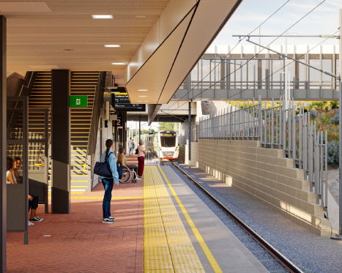
Ranford Road Station (artist impression), Perth, WA. Courtesy of METRONET

Case Study 8: Gold Coast Light Rail (Stage 3A)
The Gold Coast Light Rail is the largest transport infrastructure project ever undertaken on the Gold Coast and has been designed to be delivered in stages in response to the city’s forecasted population growth. Following on from the successful delivery and operation of Stages 1 and 2, the third stage of the project involves a southern extension from Broadbeach South to Burleigh Heads using the existing road transport corridor.
The project includes 6.7 km of new dual-track light rail, 8 new light rail stations and additional light rail vehicles running from Broadbeach South Station to Burleigh Heads. To date, the Gold Coast Light Rail has proven hugely successful, with more than 82 million passenger journeys as of March 2024, and a one third increase in passenger numbers since the opening of Stage 2.
The total commitment towards the project is $1,549.0 million, of which the Australian Government has committed $395.6 million. $227.5 million of the Australian Government’s Green Treasury Bonds have been allocated to the project over 2022–23 and 2023–24. The Queensland Government has committed $1.04 billion and the Gold Coast City Council has committed $110.1 million.
Construction on Stage 3A of the project began in July 2022 with excavations, essential utility relocation and upgrades to lay the groundwork for track installation in 2024 and 2025. Once complete, the project is expected to help reduce the cost of congestion and bus delays. The increase in population attributable to the project is estimated to be an additional 26,000 people by 2041, with 760 additional jobs created.
Additional information on the project can be found on the Queensland Government website.

Case Study 9: Canberra Light Rail (Stage 2A)
Planning for Canberra’s growth, reducing congestion and enhancing its liveability requires a convenient, efficient and reliable modern transport system that includes buses, light rail and active transport options such as cycling and walking. Light rail will underpin the city’s modern public transport system as it connects major population areas, employment centres, educational institutions, social and cultural hubs across Canberra. Operation of the Gungahlin to City light rail alignment commenced in 2019, with more than one million passenger boardings in the first 3 months. The Canberra Light Rail operates on 100 per cent renewable energy.
The Light Rail Stage 2A will extend the light rail system a further 1.7 km from the current stop at Alinga St to Commonwealth Park. The project reached a major milestone in late 2023 with the signing of a contract with long-term delivery partner Canberra Metro. Construction is expected to start on the project in early 2025.
The total project commitment is $687.8 million, jointly funded by both the Australian Government and ACT Government. The Australian Government will contribute $343.9 million, of which $25 million will come from Green Treasury Bond proceeds.
The Stage 2A extension will help reduce road traffic congestion at peak times, moving an extra 2,500 to 3,000 people each day. An expanded light rail depot in Mitchell will house an enlarged light rail fleet and provide space for the existing fleet to be fitted with battery technology. This technology will enable the light rail to run wire free between Alinga Street and Commonwealth Park.
The light rail corridor will include sections of green track, the prototype for which was monitored throughout 2024 to test for:
- the suitability of certain grass, ground cover and tree species for Canberra’s climate
- different types of green track irrigation systems
- green track finishes including turf and cobblestones.
Construction of the Stage 2A extension is expected to finish in late 2026. Testing will take place throughout 2027, and the line is scheduled to open to the public in early 2028.
Additional information can be found on the ACT Government's website.

Driving the Nation Fund
The $500 million Driving the Nation Fund aims to enable Australia’s shift to electric vehicles (EVs). It supports transformational infrastructure by expanding the national rollout of EV charging and hydrogen refuelling infrastructure, as well as the electrification of heavy vehicle fleets and innovation in electric vehicle charging solutions across Australia.
Two elements of the Driving the Nation Fund are financed through Green Treasury Bonds in this report:
- Driving the Nation Program: to co-fund initiatives that will reduce Australia’s road transport emissions (ARENA)
- National EV charging network: to help deliver 117 EV chargers on key highway routes across Australia (DCCEEW).

Green Treasury Bond allocation
Green Treasury Bonds contributed $37.3 million to Driving the Nation Fund expenditure during 2022–23 and 2023–24 (Table 23).
The total Government contribution to projects represent contracted funding for individual projects (both past and expected funding). Most ARENA projects were established prior to issuance of Green Treasury Bonds.
The total cost of project includes co-financing with project partners.

Table 23: Allocation to the Driving the Nation Fund
Projects supported | Allocation ($ million) |  |  | Total Government Contribution ($ million) | Total Cost of Project ($ million)
Projects supported | 2022–23 | 2023–24 | Total | Total Government Contribution ($ million) | Total Cost of Project ($ million)
Driving the Nation Program (ARENA) | 0.2 | 16.5 | 16.7 | 71.4 | 180.0
National EV charging network (DCCEEW) | 11.4 | 9.2 | 20.6 | 39.3 | 78.6
Total | 11.6 | 25.7 | 37.3 | 110.7 | 258.6

Co-financing arrangements
Funding for the Driving the Nation Program is delivered by ARENA through grants.
The Australian Government has partnered with the NRMA to fund the $78.6 million National EV charging network project. The Australian Government and the NRMA will each contribute 50 per cent ($39.3 million).

Material risks
No material risks have been identified to deliver the Driving the Nation Fund.

Project impacts
The Department of Climate Change, Energy, the Environment and Water records the number of EV chargers delivered as part of its program delivery. Financing through Green Treasury Bonds will contribute to the 117 EV charging sites that will be delivered under the National EV charging network. As of 30 September 2024, 15 of these 117 have been delivered (Table 24).
Funding for the National EV Charging Network was announced on 26 April 2023, including a list of confirmed and potential locations for charging infrastructure roll-out, with all chargers expected to be rolled out within 3 years.

Table 24: Impacts of the Driving the Nation Fund
Metric | Project | Value | Recorded/ Projected | Time Period
EV charging sites delivered | National EV Charging Network | 15 | Recorded | August 2023 – September 2024
Through ARENA, funding over the reporting period has contributed to the Depot of the Future Vehicle Electrification Project, led by Team Global Express, and the Automating EV Charging in line with Wholesale Pricing led by Amber Electric Pty Ltd.
The Depot of the Future Vehicle Electrification Project will procure and deploy 60 heavy battery electric vehicles (BEVs), the associated depot charging infrastructure, and a battery energy storage system. It will demonstrate the impact of large-scale BEV integration in fleet operations, creating between 50 and 70 jobs in the construction stage.
The project being led by Amber Electric Pty Ltd will develop a software solution to facilitate BEV smart charging and vehicle-to-grid (V2G) bi-directional charging in line with wholesale energy prices. The project also includes a subsidy arrangement for the purchase and installation of 100 smart chargers and 50 V2G bi-directional chargers for the project trial participants. This technology, at scale, aims to support grid stability by adapting charging sessions in response to the levels of variable renewable energy in the grid and discharging energy during periods of high demand across distribution networks.

Social co-benefits
The National EV charging network project will raise current and future EV driver confidence by establishing a nation-wide network of chargers. The fast chargers will be compatible with all EVs and accessible by all motorists.
New sites will complement existing and planned EV charging infrastructure. Site selection for new EV chargers will target known blackspots, prioritising regional and remote communities.

- Climate Change Adaptation Reporting
Even with strong global action to reduce emissions, the impacts of climate change are already being felt and will continue to increase over the coming decades due to past emissions of greenhouse gasses.
To be better prepared for and manage increasing risks arising from climate change, Australia needs to ‘mainstream’ adaptation action, enable private sector investment and support people and communities in disproportionately vulnerable situations.
Successful climate adaptation should be place-based, community-led and values-driven. Governments, households, businesses, and community organisations all have a role, and decisions should be underpinned by science and analysis.
In Australia, domestic climate adaptation action takes many forms. It can include:
- protecting species and managing resources so that Australia’s natural environment can endure and overcome the impacts of climate change
- upgrading infrastructure, including buildings and transport systems, to better withstand heatwaves and extreme weather event
- supporting the wellbeing of Australians most impacted by climate change, especially those who face increasing disasters, extreme temperatures and severe weather events.
The Australian Government’s role in assisting Australians to build resilience to the impacts of climate change includes:
- providing national leadership on climate adaptation
- ensuring the availability of nationally authoritative climate science and information
- managing climate risks to government assets and services.
The Government is developing the National Climate Risk Assessment and National Adaptation Plan to identify and prioritise the things that Australians value the most that are at risk from climate change. The National Climate Risk Assessment will deliver a shared national framework to inform Australia’s national priorities for climate adaptation and resilience actions.
The Government is also supporting the Indo-Pacific region to increase its adaptive capacity in line with Australia’s international climate change commitments, including the Paris Agreement. Green Treasury Bonds are financing climate adaptation projects in the Pacific, Southeast Asia, along with Australia’s contributions to multilateral climate funds.

International Climate Finance projects
Australia’s international climate finance supports countries in the Indo Pacific region to adapt to the increasing impacts of climate change and to reduce their emissions by investing in renewables and clean technologies to meet their net -zero transition goals.
Australia’s climate finance is focused on the Pacific and Southeast Asia (Figure 8). Australia’s climate finance includes bilateral and regional programs, along with contributions to multilateral development banks’ climate programming, and multilateral climate funds. Australia also mobilises private finance into new climate investments in developing countries through initiatives such as the Australian Climate Finance Partnership.
Australia has strengthened its climate finance commitment and expects to deliver $3 billion over the period 2020–2025.
Only projects highly focused on addressing climate change and the environment are financed through Green Treasury Bonds. The projects selected for the Green Bond project pool are a subset of Australia’s climate finance investments. Australia reports climate finance to the UNFCCC in the Biennial Transparency Report, in line with its obligations. Australia’s 2022–23 and 2023–24 climate finance data will be reported by the end of 2026. The selected investments have been counted in accordance with the Green Bond Framework - the amount of adaptation and mitigation finance reported to the UNFCCC may differ due to methodological differences for accounting.

Figure 8: Australian climate finance in the Indo Pacific
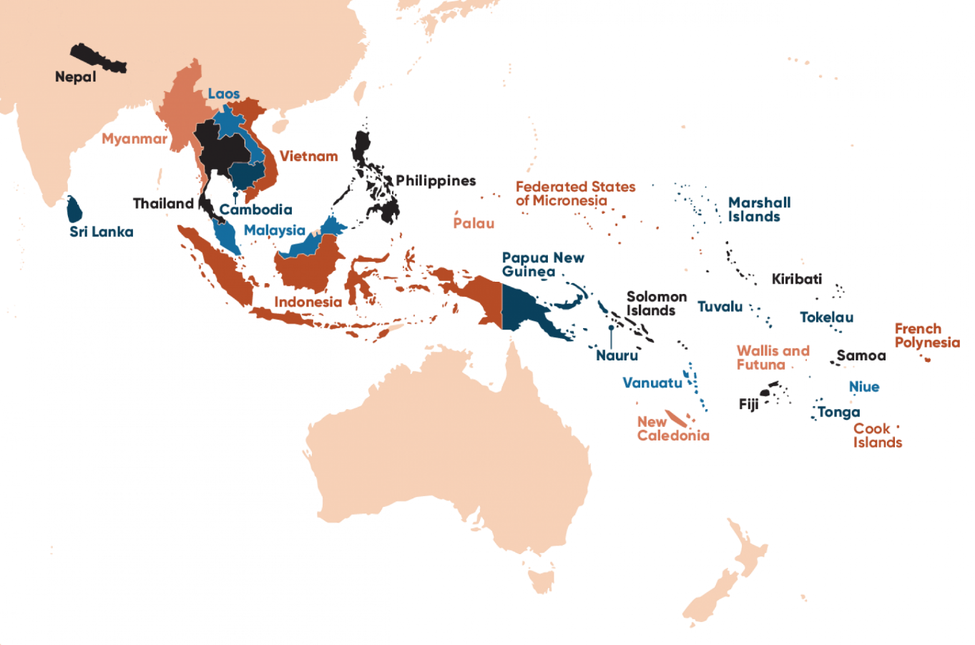
These 15 projects are:
- The Australia Pacific Climate Partnership supported Australian aid investments across the Pacific to integrate climate and disaster resilient activities
- Climate Resilient Communities is financed and delivered by the Australian Government
- The Strengthening Institutions and Empowering Localities against Disasters and Climate Change (SHIELD) initiative implemented in coordination with the Philippines Government
- Inclusive Water Governance and Strengthening Climate Resilience in the Mekong Region is delivered by Oxfam and one component is co financed with the Swiss Government
- The program to build community resilience to disasters in the Lower Koshi River Basin is delivered in partnership with the International Centre for Integrated Mountain Development, a regional inter-governmental organisation
- Phase 3 of the Climate and Oceans Support Program in the Pacific is co-financed with the New Zealand Government and delivered in partnership with 14 Pacific island countries
- The Partnership for Climate, Renewable Energy and Infrastructure is delivered in partnership with the Government of Indonesia
- The Australia-Vietnam Energy Transition Platform is delivered by the Private Infrastructure Development Group which is funded by seven governments and the International Finance Corporation
- The Commonwealth Climate Finance Access Hub is co financed and co delivered with 14- partners, consisting of sovereign governments, non governmental organisations and multinational organisations
- Australia’s funding towards Pacific Climate Finance Access and Effectiveness finances the UN Development Programme’s Governance for Resilient Development in the Pacific project, delivered with six Pacific island countries, and the Climate Finance Access Network delivered by the Global Green Growth Facility with eight Pacific island countries
- Australia provides core support for the Secretariat of the Pacific Regional Environment Programme (SPREP) which supports its Pacific island country and territory members
- The PNG Climate Finance Initiative for Resilience and Sustainable Transition is financed by Australia and co delivered with the Papua New Guinean Government and the Global Green Growth Institute
- The Australian Climate Finance Partnership is managed by the Asian Development Bank
- The Global Environment Facility is financed by 40 donor countries, with projects delivered in partnership with government and non government organisations in recipient countries
- The Montreal Protocol Multilateral Fund (MLF) is co financed by countries globally, and delivered by the MLF Secretariat in partnership with agencies from recipient countries.

Green Treasury Bond allocation
Green Treasury Bonds contributed $232.9 million to 15 sub-projects under International Climate Finance over 2022–23 and 2023–24 (Table 25).
Government contributions for individual sub-projects are not fixed and are subject to change. Please refer to the AusDevPortal for the total estimated Government funding for each project based on current available data.
Due to the nature of international climate financing, it is not possible to determine the total cost of projects including co contributions from other parties, including foreign governments and international organisations. The Co financing Arrangements section below notes where the Australian Government is co financing or co delivering a project.

Table 25: Allocation to International Climate Finance projects
Projects supported | Allocation ($ million)ª |  |  | Total Government Contribution ($ million) | Total Cost of Project ($ million)
Projects supported | 2022–23 | 2023–24 | Total | Total Government Contribution ($ million) | Total Cost of Project ($ million)
Australia Pacific Climate Partnership | 5.1 | 5.1 | 10.2 | N/A | N/A
Climate Resilient Communities | 0.4 | 9.9 | 10.3 | N/A | N/A
SHIELD Against Disasters and Climate Change (Philippines) | 3.0 | 6.6 | 9.6 | N/A | N/A
Inclusive Water Governance and Strengthening Climate Resilience in the Mekong Region | 2.2 | 1.4 | 3.6 | N/A | N/A
Building Capabilities for Green, Climate Resilient and Inclusive Development in the Lower Koshi River Basin | 1.0 | 1.0 | 2.0 | N/A | N/A
Climate and Oceans Support Program in the Pacific Phase 3 | 1.0 | 14.9 | 15.9 | N/A | N/A
Partnership for Climate, Renewable Energy and Infrastructure (Indonesia) | 0.4 | 16.9 | 17.3 | N/A | N/A
Australia-Vietnam Energy Transition Platform | 17.0 | 3.0 | 20.0 | N/A | N/A
Commonwealth Climate Finance Access Hub (Pacific) | 1.0 | 0.7 | 1.7 | N/A | N/A
Pacific Climate Finance Access and Effectiveness | 3.5 | 2.0 | 5.5 | N/A | N/A
Support for the Secretariat of the Pacific Regional Environment Programme | 3.7 | 5.2 | 8.9 | N/A | N/A
Papua New Guinea Climate FIRST | 0.2 | 2.0 | 2.2 | N/A | N/A
Australian Climate Finance Partnership | 45.0 | - | 45.0 | N/A | N/A
Global Environment Facility 6, 7, 8 | 31.4 | 26.5 | 57.8 | N/A | N/A
Montreal Protocol Multilateral Fund | 10.5 | 12.2 | 22.7 | N/A | N/A
Total | 125.4 | 107.5 | 232.9 | N/A | N/A
- Due to rounding, discrepancies may occur between sums of the component items and totals.

Co--financing arrangements
Australia’s international climate finance programs include those funded jointly with other countries or global organisations such as the United Nations or development finance institutions such as the Asian Development Bank.
Projects which include elements of co-financing are:
- Inclusive Water Governance and Strengthening Climate Resilience in the Mekong Region
- Climate and Oceans Support Program in the Pacific
- Australia-Vietnam Energy Transition Platform
- Commonwealth Climate Finance Access Hub
- Pacific Climate Finance Access and Effectiveness
- Secretariat of the Pacific Regional Environment Programme
- Global Environment Facility
- Montreal Protocol Multilateral Fund.

Material risks
No material risks have been identified to finance International Climate Finance projects through Green Treasury Bonds. The Department of Foreign Affairs and Trade (DFAT) takes into account any risks that may hinder its ability to achieve its development program objectives and implements measures to increase the likelihood of success. DFAT manages development risk throughout the lifespan of any investment.

Project impacts
Green Treasury Bonds have contributed to 5 bilateral initiatives, 8 global and regional initiatives, and 2 multilateral initiatives (Table 26).

Table 26: Impacts of International Climate Finance projects
Metric | Project | Value | Record/ Projected | Time Period
No. of bilateral investments | Total project pool | 5 | Recorded | Various
No. of global and regional investments | Total project pool | 8 | Recorded | Various
No. of multilateral investments | Total project pool | 2 | Recorded | Various
International climate finance projects report impacts on a case by case basis. These cannot be aggregated as impact metrics differ between sub projects and methodology may differ between project owners. Table 27 outlines the qualitative and quantitative impacts from each international climate finance project, including social co-benefits.
The Department of Foreign Affairs and Trade’s AusDevPortal provides additional details on contributions to UN Sustainable Development Goals and performance ratings in 2022–23 for some sub-projects. Links towards specific projects are provided in Table 27. The AusDevPortal is updated periodically with new data.

Social co-benefits
Australia supports various community led- ecosystem restoration and conservation programs in the Indo-Pacific. This improves biodiversity and helps make communities resilient against climate change and natural disasters. These projects also generate opportunities for employment and upskilling, helping build institutional knowledge and expertise to continue to support communities. Table 27 outlines social co-benefits for individual projects, where available.

Table 27: Further information on International Climate Finance sub-projects
Project | Outcomes
Australia Pacific Climate Partnership | Supported community resilience projects to prepare for climate change in Kiribati.  Implemented climate-smart agricultural technologies to improve food security.
Climate Resilient Communities | Enhanced the integration of climate change across Australia’s development program to help deliver on the climate commitments in the International Development Policy.
SHIELD Against Disasters and Climate Change | Accelerated resilience-building efforts by collaborating with multiple stakeholders to unlock financing and implement risk-informed and inclusive resilience actions at the local level.  Supported Philippine Government policy engagement and worked with both Philippine and Australian scientific agencies to produce tailored and accessible information that will inform local resilience actions.
Inclusive Water Governance and Strengthening Climate Resilience in the Mekong Region | Ensured water resources governance processes at the national and regional levels in the Mekong subregion were more inclusive of civil society, women and marginalised social groups, and that local communities implement inclusive disaster risk reduction and climate adaptation strategies.  Local authorities across project sites are supporting communities through information on disaster risk management and Climate Change Adaptation, building capacity for initiatives, conducting vulnerability assessments, and incorporating action plans into investment plans and budgets.
Building Capabilities for Green, Climate Resilient and Inclusive Development in the Lower Koshi River Basin | Strengthened community-based flood early warning systems and provided training to local communities.  Ensured the evacuation of over 74,000 people due to flooding during the 2024 monsoon period.
Phase 3 of the Climate and Oceans Support Program in the Pacific | Support national climate services in Pacific countries to use sea level monitoring, tide predictions and real-time data to produce tailored agrometeorological and fisheries bulletins for use in agriculture and fisheries sectors, and support government planning and budgeting.  Advance climate and ocean predictions, ensure secure and accessible meteorological data, and integrate traditional knowledge for culturally relevant forecasts.
Partnership for Climate, Renewable Energy and Infrastructure (Indonesia) | Encourages increased investment in the energy transition by supporting Indonesia-led policy and regulatory reform.  Unlock financing for climate-focused small and medium-sized enterprises.  Incentivise investment in larger scale green infrastructure projects.  Promote a just transition in which women, people with disabilities and the marginalised participate in and benefit from the shift to net zero.
Australia-Vietnam Energy Transition Platform | Support high-quality infrastructure projects including renewable energy generation and distribution, access to energy, water sanitation and hygiene, e-mobility, and nature-based solutions.  Provide a demonstration effect to the market, so that the private sector will then replicate similar projects with less or no concessional capital.
Commonwealth Climate Finance Access Hub | Deployed advisers to 22 Commonwealth countries, including in the Pacific to assist government departments to support with climate finance grant applications, capacity building and policy support.  Supported 98 projects and 146 capacity-building initiatives to train officials in climate finance.
Pacific Climate Finance Access and Effectiveness | Delivery of workshops across countries in the Pacific to provide capacity building for officials on climate finance, gender and social inclusion.  Recruitment of five positions in the Fijian government, in the climate change division, strategic planning office, and budget division to assist with accessing climate finance.
Support for the Secretariat of the Pacific Regional Environment Programme | Support all Pacific island countries preparations for international climate change meetings.  Support over 90 projects worth more than US$ 160 million.
PNG Climate Finance Initiative for Resilience and Sustainable Transition | Develop investment proposals and partnerships with key stakeholders to enable PNG’s access to large-scale climate finance.  Seek input from provincial stakeholders through regular workshops
Australian Climate Finance Partnership | Mobilise private sector investment in low emission, climate resilient solutions.  Catalysing development of a geothermal power plant in Indonesia.  Investment in high-quality sustainably managed commercial forest plantations.  Construction of electric bus manufacturing facilities and electric vehicle charging stations in Vietnam.
Global Environment Facility 6, 7, 8 | 3,000 projects supported since inception.
Montreal Protocol Multilateral Fund | Since commencement (1991–2021), reduction in greenhouse gas emissions by 2.2Gt CO2-e.  Since commencement (1995–2021), 51.1 Gt CO2-e in avoided greenhouse gas emissions.  9,321 projects funded across 144 developing countries as of 2022, with 85 per cent completed.

Case Study 10: Strengthening Institutions and Empowering Localities Against Disasters and Climate Change
The Australian Government is investing in the Strengthening Institutions and Empowering Localities Against Disasters and Climate Change (SHIELD) Program to support the Government of the Philippines in building institutional and community resilience to climate change and natural hazards, while taking into account the systemic nature of risks.
The Australian Government has committed $18.6 million to the project. Green Treasury Bonds have contributed $15.2 million.
The goal of the SHIELD program is to make all people in target communities safer and more resilient to the impacts of natural hazard events and climate change. This will be realised by achieving three interdependent outcomes:
- Government, private sector, and civil society stakeholders in targeted local government units are collaborating to unlock funding and implementing informed and inclusive resilience actions.
- Relevant national government agencies are prioritising action on local climate and disaster resilience.
- Philippine scientific agencies are producing tailored and accessible information for local resilience action.
The project is aligned with the UN Sustainable Development Goals, specifically 11.b and 13.1. This means that it will contribute to increasing the number of cities adopting and implementing integrated policies and plans towards inclusion of vulnerable community members, improved resource efficiency, mitigation and adaptation to climate change, disaster resilience, and holistic disaster risk management. It will strengthen resilience and adaptive capacity to climate-related hazards and natural disasters in the Philippines.
The program has officially enacted strategic partnerships with several provincial governments, designed to accelerate resilience-building efforts at the local level through collaboration with stakeholders. It will help the provinces develop Climate and Disaster Risk Assessments and create Comprehensive Land Use Plans prioritising the economic, social and physical clusters of the provinces.

Case Study 11: Climate and Oceans Support Program in the Pacific
The Australian Government is supporting Pacific island countries to adapt to and mitigate the impacts of climate variability. A major part of Australia’s assistance is the Climate and Oceans Support Program in the Pacific (COSPPac).
COSPPac works with Pacific island stakeholders to analyse and interpret climate, oceans and tidal data to produce valuable services for island communities. This information helps island communities to prepare for, and mitigate the impacts of severe climate, tidal and oceanographic events.
Over 4 years, COSPPac Phase 3 will continue the development path of the Pacific National Meteorological and Hydrological Services (NMHSs) and Land Survey Departments. The program will enable these organisations to deliver climate and ocean information services, in partnership with their priority stakeholders, that are useful to, and used by government, businesses and communities.
Green Treasury Bonds have contributed $31 million to this project.
The program has 3 targets for NMHS performance, and will ensure that:
- NMHSs will be operating and maintaining an enhanced set of observation and data management infrastructure in line with global standards, and sharing related data
- NMHSs will actively generate and refine climate and ocean information products/services utilising consolidated portals and COSPPac supported models and tools
- two way communications of COSPPac products and services are coordinated with priority stakeholders, utilising inclusive processes, and evaluate these products and services as necessary.
The project also seeks to combine the traditional knowledge from Pacific island communities with conventional forecasts to produce a valuable forecast product for improved decision making, risk management and disaster prevention. COSPPac is partnering with the following meteorological services to document existing traditional knowledge and produce an integrated forecast:
- Vanuatu Meteorological and Geo-hazard Department
- Samoa Meteorological Service
- Niue Department of Meteorology and Climate Change
- Solomon Islands Meteorological Service.
The program is also developing the Traditional Knowledge database to provide partner countries with a central register to manage and store their climate-related traditional knowledge records. In the future, collected traditional data will be able to be integrated with conventional seasonal forecasts.

- Improved Environmental Outcomes Reporting
Australia’s natural environment and iconic places are under increasing threat. The pressures on the environment are significant - including land-use change, habitat loss and degradation, and feral animals and invasive plant species. The impact of climate change on the environment will exacerbate pressures and contribute to further decline.
The Government has set targets and outlined its actions to improve environmental outcomes through the Strategy for Nature and the Nature Positive Plan.
- Australia’s Strategy for Nature 2024–2030 sets ambitious national targets to tackle the drivers of biodiversity decline, to protect and repair precious places and put nature on a path to recovery
- The Nature Positive Plan sets out the Government’s commitment to reform Australia’s environmental laws to better protect, restore and manage its unique environment.

Environmentally sustainable management of living natural resources and land use
Australia is committed to protecting its unique ecosystems from the impacts of climate change, use of natural resources, habitat loss, invasive species and pollution.
To keep these complex and dynamic ecosystems functioning and biodiversity healthy, a holistic approach that brings together land, water and living resources management practices including adaptive management is important.
Land uses also have a major effect on Australia’s natural resources through their impacts on water, soil, nutrients, plants and animals. There are strong links between changing patterns of land use and economic and social conditions, particularly in regional Australia.
Objective 5 of the Australian Government’s Strategy for Nature is to improve conservation management of Australia’s landscapes, waterways, wetlands and seascapes. This includes targets of protecting and conserving 30 per cent of Australia’s landmass and marine areas by 2030, and ensuring priority degraded ecosystem areas are under effective restoration by 2030. The Strategy also includes targets to use and develop natural resources in an ecologically sustainable way.
Green Treasury Bonds are supporting Australia’s urban waterways through the Urban Rivers and Catchments Program.

Urban Rivers and Catchments Program
The Urban Rivers and Catchments Program (URCP) is restoring the health of Australia’s urban waterways for native plants, animals, and local communities.
Nearly half of all nationally listed threatened animals and a quarter of threatened plants occur in urban areas. They share these areas with 96 per cent of Australia’s population.
Projects funded will help conserve native plants and animals such as birds, platypus and native fish. They will also improve access to waterways which provide benefits for health and social wellbeing.

Green Treasury Bond allocation
Green Treasury Bonds contributed $1.6 million under URCP in 2023–24 (Table 28).
The total government contribution represents the expected funding over the life of the program as at the 2024–25 MYEFO. Funding in future financial years is anticipated to be financed through Green Treasury Bonds.
- In the 2022–23 October Budget, $91 million of funding was committed to deliver Round 1 of URCP.
- In the 2023–24 Budget, an additional $109 million of funding was committed under URCP to deliver Round 2.
The total cost of projects is not reported in this grant program.

Table 28: Allocation to the Urban Rivers and Catchments Program
Projects supported | Allocation ($ million) |  |  | Total Government Contribution ($ million) | Total Cost of Project ($ million)
Projects supported | 2022–23 | 2023–24 | Total | Total Government Contribution ($ million) | Total Cost of Project ($ million)
Urban Rivers and Catchments Program | - | 1.6 | 1.6 | 200.0 | N/A

Co-financing arrangements
The Program is delivered through specific purpose payments to the States and Territories (Round 1) and competitive grants (Round 2). Round 2 grant recipients delivering large projects between $2 million to $10 million in grant funding per project must contribute (at least) matching co-investment.
Round 2 grant recipients delivering small to medium projects, under $2 million, and organisations funded under Round 1, may also contribute co-investment towards the delivery of their projects (co-financing amounts vary per project).

Material risks
No material risks have been identified to deliver the Urban Rivers and Catchments Program.

Project impacts
URCP is made up of approximately 100 projects spread across all Australian states and territories, delivering riparian and aquatic restoration and improvement works.
The program will produce environmental outcome reporting through MERIT - a publicly available reporting product delivered through CSIRO’s Atlas of Living Australia (MERIT website).
Recorded impacts of URCP are currently not available. Future Green Treasury Bond reporting metrics for this program may include hectares of aquatic area restored/re naturalised, hectares of aquatic area with improved eco hydrological management, or hectares of riparian areas habitat restored or improved.

Social co-benefits
Social co-benefits of URCP include the improvement of urban ‘green’ and ‘blue’ space, including improved community access to nature, improved water quality to benefit public health, and increased shading to help reduce urban heat-related impacts due to climate change.
The majority of Round 1 and Round 2 projects include First Nations organisations in project delivery including engagement and/or employment opportunities.
Many projects are also actively involving local community volunteers and organisations, providing opportunities to improve mental and physical health, social connections, skills and abilities.

Biodiversity conservation (terrestrial and aquatic)
Australia is home to between 600,000 and 700,000 species - 9.6 per cent of all known species. 84 per cent of Australian plant species, 83 per cent of mammals, and 45 per cent of birds are endemic, or unique to Australia. An isolated island location and low rainfall has given Australia the highest reptile diversity in the world.
Over the last 200 years Australia has suffered the largest documented decline in biodiversity of any continent. The Australian Government is committed to preventing this decline by managing threats and pressures to biodiversity in Australia.
The main threats to biodiversity are:
- loss, fragmentation and degradation of habitat from land and sea use change
- the spread of invasive species
- unsustainable use of natural resources
- climate change
- pollution.
The Australian Government recognises the importance of biodiversity conservation and, in collaboration with states and territories, has set a national framework for biodiversity conservation over the next decade. Australia’s Strategy for Nature guides how governments, First Nations peoples, industry, scientists and the general community will manage and protect Australia’s plants, animals and ecosystems to 2030.
Green Treasury Bonds are financing biodiversity conservation in Australia through the Saving the Koala Fund and the Reef 2050 Plan.

Saving Koalas Fund
The Saving Koalas Fund supports the recovery and long-term conservation of the koala and its habitats. Green Treasury Bonds contribute to 3 aspects of the Fund:
- Community grants
- Large habitat restoration projects
- The National Koala Monitoring Program.
The Saving Koalas Fund is delivered in partnership with First Nations people, the community, conservation organisations, governments, scientists and land managers, and is also helping to deliver actions in the National Recovery Plan for the Koala.

Green Treasury Bond allocation
Green Treasury Bonds contributed $24.8 million to the Saving Koalas Fund over 2022–23 and 2023‍–‍24 (Table 29). The total Government contribution represents the expected funding of each sub-program over its lifetime as of the 2024–25 MYEFO. Funding in future financial years is anticipated to be financed through Green Treasury Bonds.
The total cost of projects is not reported in this grant program.

Table 29: Allocation to the Saving Koalas Fund
Projects supported | Allocation ($ million) |  |  | Total Government Contribution ($ million) | Total Cost of Project ($ million)
Projects supported | 2022–23 | 2023–24 | Total | Total Government Contribution ($ million) | Total Cost of Project ($ million)
Community grants | 3.0 | 4.6 | 7.6 | 9.8 | N/A
Koala habitat restoration and protection projects | 1.2 | 11.0 | 12.2 | 25.5 | N/A
National Koala Monitoring Program | 1.0 | 4.0 | 5.0 | 10.0 | N/A
Total | 5.2 | 19.6 | 24.8 | 45.3 | N/A

Co-financing arrangements
The Saving Koalas Fund is delivered through grants and procurements through the Department of Climate Change, Energy, the Environment and Water. Grant recipients, including government agencies, educational institutions, and community organisations, may also contribute financially to sub-projects.

Material risks
No material risks have been identified to deliver the Saving Koalas Fund.

Project impacts
Data for the Saving Koalas Fund is recorded on the program website. The number of projects that received funding from community grants consists of the total between Round 1 and Round 2 of the program. The land improved and managed for koala habitat restoration is the sum of land used across all large habitat restoration projects financed through Green Treasury Bonds. The number of koala population surveys conducted is recorded by the National Koala Monitoring Program as of June 2024.
Green Treasury Bonds will contribute to the preservation of 5,564 hectares of koala habitat (Table 30).
Community grants support various organisations in their efforts to restore koala habitats, reduce environmental degradation, help manage koala populations and increase biodiversity throughout the Australian landscape.
The investment in research and monitoring is also expected to have long term benefits for koala populations.

Table 30: Impacts of the Saving Koalas Fund
Metric | Project | Value | Recorded / Projected | Time period
Number of grants made to community organisations | Community grants | 59 | Recorded | 2022–2026
Additions and improvements to, and management of, land used as koala habitat (ha) | Koala habitat restoration and protection projects | 5,564 | Projected | 2022–2026
Number of koala population surveys conducted | National Koala Monitoring Program | 335 | Recorded | 2022–2024

Figure 9: Locations of projects managed by the Saving Koalas Fund
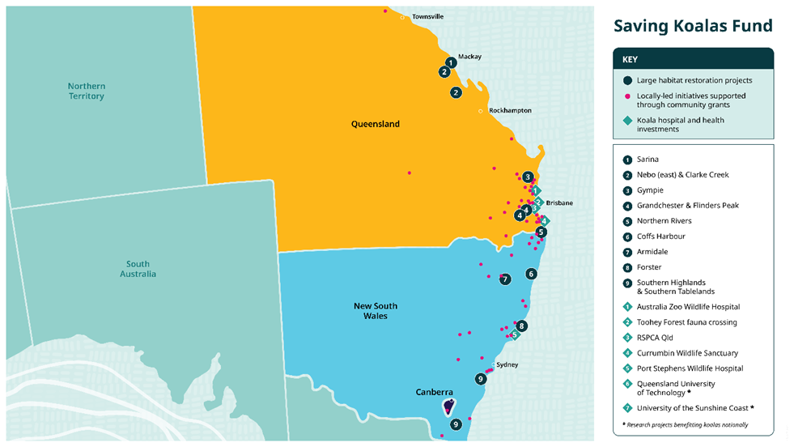
Source: DCCEEW (2024), Saving Koalas Fund

Social co-benefits
The Saving Koalas Fund collaborates with First Nations communities in delivering projects. Several large habitat restoration projects engage First Nations peoples to understand land management and share knowledge on land and wildlife conservation practices. First Nations organisations have also been involved in habitat restoration and cultural burning activities.
Community grant programs also partner with First Nations organisations and communities to provide guidance regarding land management and conservation and educate communities about First Nations cultural heritage, including 3 First Nations led projects.

Reef 2050
The Great Barrier Reef is one of the world’s natural wonders, the largest coral reef on Earth, and an Australian icon. While the Reef faces significant threats, including from climate change, the Government is investing in its resilience and restoration to protect the Reef now and into the future.
The Australian and Queensland governments released the Reef 2050 Long-Term Sustainability Plan in response to the World Heritage Committee’s recommendation that Australia develop a long-term plan for sustainable development to protect the Outstanding Universal Value of the Great Barrier Reef.
The Reef 2050 Plan is Australia’s overarching strategy to improve the Reef’s health and resilience by delivering coordinated local, national and global action in key areas. The most recent Reef 2050 Plan was released in December 2021 with the vision that ‘The Great Barrier Reef is sustained as a living natural and cultural wonder of the world.’
The Reef 2050 Plan has 5 priority areas for action:
- limit the impacts of climate change by contributing to global efforts to reduce emissions and supporting the Reef and communities to adapt
- improve water quality by working with landholders, industries and communities to accelerate action to reduce the impacts from land-based activities
- reduce impacts from water-based activities by strengthening partnerships with Reef industries and delivering strong marine park management
- influence the reduction of international sources of impact to reduce marine debris entering the Reef from outside Australia and protect migratory species
- protect, rehabilitate, and restore Reef habitat, species and heritage sites by minimising impacts from disturbances and assisting with their recovery.

Green Treasury Bond allocation
Green Treasury Bonds contributed $88.2 million over 2022–23 and 2023–24 to the Reef 2050 Plan (Table 31).
Projects are funded through a range of mechanisms, including grants, procurements, partnerships and other financial arrangements. Detailed allocation by sub-project is not available at this stage.
The total Government contribution reflects Australian Government funding from 2014–15 to 2030. The total cost of project reflects total Australian Government and Queensland Government funding commitments.

Table 31: Allocation to Reef 2050
Projects supported | Allocation ($ million) |  |  | Total Government Contribution ($ million) | Total Cost of Project ($ million)
Projects supported | 2022–23 | 2023–24 | Total | Total Government Contribution ($ million) | Total Cost of Project ($ million)
Reef 2050 | 52.1 | 36.1 | 88.2 | 3,700.0 | 5,000.0

Co-financing arrangements
Together with the Queensland government, investment in the Reef is more than $5 billion from 2014 to 2030. Of this, more than $3.7 billion is from the Australian Government.

Material risks
No material risks have been identified to deliver the Reef 2050.

Project impacts
The Reef 2050 Activities Report 2022–2023 provides a summary of investments and contains case studies which highlight the results achieved through the Australian Government’s significant long term investment in the health of the Great Barrier Reef.
The Australian Government has 2025 targets to improve water quality in the Reef, including:
- 60 per cent reduction of anthropogenic dissolved inorganic nitrogen load leaving Great Barrier Reef catchments
- 25 per cent reduction of anthropogenic fine sediment load leaving Great Barrier Reef catchments
- 20 per cent reduction of anthropogenic particulate nitrogen load leaving Great Barrier Reef catchments
- 20 per cent reduction of anthropogenic particulate phosphorus load leaving Great Barrier Reef catchments
- At least 99 per cent of aquatic species protected from the harmful effects from pesticides
- 90 per cent of grazing lands will have greater than 70 per cent ground cover.
Reporting against these targets is included in Table 32. Detailed progress towards targets and regional project impacts can be found in the Australian and Queensland Governments’ Reef Water Quality Report Card. The most recent Reef water quality data were released in May 2024 and contain data for 2021 and 2022. There is significant work that goes into data collection, validation, analysis, review and reporting to ensure the integrity and quality of the Reef Water Quality Report Card results. Each modelling process as part of the assessment takes several months to run on high performance computers.
Activities relate to Work Area 2 of the Reef 2050 Plan 2021-25 which contribute to improving water quality in the Great Barrier Reef. The Reef 2050 Water Quality Improvement Plan sets out 2025 water quality targets and land management and catchment targets.

Table 32: Impacts of Reef 2050
Metric | Projects | Value | Projected/Recorded | Time Period
Reduction of anthropogenic dissolved inorganic nitrogen load leaving Great Barrier Reef catchments (per cent) | Projects in Work Area 2 of Reef 2050 | 28.4 | Recorded | as at June 2022
Reduction of anthropogenic fine sediment load leaving Great Barrier Reef catchments (per cent) | Projects in Work Area 2 of Reef 2050 | 16.0 | Recorded | as at June 2022
Reduction of anthropogenic particulate nitrogen load leaving Great Barrier Reef catchments (per cent) | Projects in Work Area 2 of Reef 2050 | 15.4 | Recorded | as at June 2022
Reduction of anthropogenic particulate phosphorus load leaving Great Barrier Reef catchments (per cent) | Projects in Work Area 2 of Reef 2050 | 18.5 | Recorded | as at June 2022
Pesticide risk condition - aquatic species unlikely to experience harmful effects from pesticides (per cent) | Projects in Work Area 2 of Reef 2050 | 95.0 | Recorded | 2022
Grazing lands with greater than 70 per cent ground cover in the late dry season (per cent) | Projects in Work Area 2 of Reef 2050 | 92.0 | Recorded | 2022

Social co-benefits
The Reef is an intrinsic part of culture for Traditional Owners, who continue to care for their Sea Country and benefit from use of the Reef’s resources and places of cultural significance. More than 70 Traditional Owner groups have long, continuing relationships with the Reef and its catchment stretching back over 60,000 years. For Traditional Owners, its value is immeasurable – intertwined with identity, self, and culture. Strong social and economic connections with the Reef are also evident among the broader community. People rely on or use the Reef for their livelihoods, recreation and wellbeing.
The Reef supports a range of Reef-dependent commercial (e.g. tourism, fishing) and non-commercial (e.g. recreation, research) uses that collectively form an important part of the social and economic fabric of communities in the catchment. Other industries, while not directly dependent on Reef health for their economic sustainability, operate within the Reef (e.g. ports, shipping) or adjacent to it (e.g. agriculture) and have an important relationship with the Reef.

The Reef 2050 Plan objectives include specific indigenous heritage and social elements to achieve a ‘Healthy Reef, and Healthy People’, including:
- Traditional knowledge about the Great Barrier Reef is owned and managed by Traditional Owners and is protected and retained for future generations
- Traditional Owners’ rights are genuinely recognised and prioritised and inform and drive how benefits are shared
- Uses of the Reef are ecologically sustainable as the system changes, in turn sustaining economic and social benefits.
The Reef 2050 Traditional Owner Implementation Plan was released in November 2022. The Implementation Plan is designed to build more effective partnerships and grow capacity to empower Traditional Owners to lead, co-design and co-deliver management programs.

Case Study 12: Kolan River
On-ground rehabilitation works along the Kolan River are expected to deliver long-term benefits to the environment and improve farm productivity.
The project was funded by the Australian Government’s Reef Trust - the flagship investment program to support the delivery of the Reef 2050 Long-Term Sustainability Plan 2021–25.
Burnett Mary Regional Group led a three-year program in partnership with the landholder, Bundaberg Sugar, to stabilise riverbank erosion, revegetate the banks and restore habitat.
One of the key objectives of the project was to reduce sediment flowing to the Great Barrier Reef. It is estimated that these works prevent more than 7000 tonnes of sediment entering the Great Barrier Reef each year.
Indigenous-owned enterprise Gidarjil Development Corporation revegetated the site using mangrove plants and seed stock grown at their Burnett Heads nursery. Gidarjil’s Ranger Coordinator Brendan Fletcher said that ‘this project is important for both the preservation of the natural value of the Kolan River and the repair of native country and the culturally important sites within it.’
Beyond the environmental outcomes and cultural aspects of the project, Bundaberg Sugar will also benefit from erosion control that prevents further loss of sugarcane production.

Sustainable water and wastewater management
Australia faces challenges to ensure a sustainable water supply for agriculture, the environment and communities in the face of climate variability, water scarcity and growing demand for water.
Agencies at different levels of government in Australia have a role in the management of Australian water resources. State and territory governments are primarily responsible for managing water within their jurisdictions. The Australian Government provides national coordination and leadership to drive policy and law reforms to manage the country’s water resources sustainably and productively for future generations of Australians.
To drive water reform, the Department of Climate Change, Energy, the Environment and Water collaborates and consults with state and territory governments, other Australian Government agencies with an interest in water management, scientists, councils and committees of experts, and communities. Key to this has been the work being undertaken to develop the new National Water Agreement, an intergovernmental agreement between the Commonwealth, States and Territories to guide water reform into the future. The Australian Government also engages in multilateral discussions on international water policy issues, sharing its knowledge and experiences of sustainable water management for all water users and the environment.
Australia’s water policies aim to improve the sustainable management of Australia’s water resources, and increase water security for communities, agriculture, and the environment so they have a reliable supply of water into the future. This includes promoting all sources of water, including recycled water, treated wastewater, stormwater, groundwater.
Green Treasury Bonds finance programs that support the Murray–Darling Basin - a basin which covers 75 per cent of New South Wales, more than 50 per cent of Victoria, 15 per cent of Queensland, 8 per cent of South Australia and all of the Australian Capital Territory.

Murray–Darling Basin Plan
The Murray–Darling Basin is Australia’s largest river system of waterways. It comprises interconnected rivers and lakes and is home to 16 wetlands of international significance under the Ramsar Convention, 35 endangered species, and 120 different species of native birds. It covers an area of over 1 million square km, the size of France and Germany combined.
Over the years, the combination of droughts and increasing human use of the waterways for agriculture, manufacturing, and communities has led to a decline in the environmental health of the Basin. The Basin Plan 2012 (Basin Plan) sets the amount of water that can be taken from the Basin rivers for industry, agriculture and community use, while aiming to leave enough to restore a healthy environment. Key elements of the Basin Plan include:
- limiting the amount of water taken from the Basin each year (sustainable diversion limits) and water management through local watering plan
- giving water back to the environment to improve the health of Australia’s rivers and wetlands including through water recovery
- managing infrastructure development, operation and maintenance to ensure environmental water flows to where it is needed and programs to modernise how Australia save and manage its water efficiently.
Other important elements of the Basin Plan include groundwater management, managing water quality, water markets and trade, mechanisms to enforce compliance with water rules, monitoring and evaluation, and adaptive management.
Green Treasury Bonds are used to finance 3 program steams for activities across the Basin:
- Water for the Environment Special Account (WESA): funding the recovery of environmental water in the Basin to increase the volume of water resources available for environmental use by 450 gigalitres (GL) and to help ease or remove constraints to deliver the water
- Environmental Water Holdings Special Account (EWHSA): funding to pay for the costs of managing the Commonwealth’s portfolio of water entitlements to protect or restore rivers, wetlands and floodplains in the Basin and to give effect to international agreements
- Sustainable Rural Water Use and Infrastructure Program (SRWUIP): this is a national program that invests in rural water use, management and efficiency, including improved water knowledge and market reform, and water purchase for the environment. SRWUIP is the key mechanism to bridge the gap to the sustainable diversion limits under the Basin Plan.

Green Treasury Bond allocation
Green Treasury Bonds have contributed $871.6 million to expenditure over 2022–23 and 2023–24 on activities across the Basin including the Basin Plan (Table 33). The program of works across the Basin commenced in 2007 and is currently funded until 2027–28.

The total Government contribution represents the expected funding of each sub-program as of the 2024–25 MYEFO. Funding in future financial years will be financed through Green Treasury Bonds.
It is not possible to record the total cost of projects at this stage as different sub-projects may have contributions by other parties, including state and territory governments.

Table 33: Allocation to the Murray–Darling River Basin Plan
Projects supported | Allocation ($ million) |  |  | Total Government Contribution ($ million) | Total Cost of Project ($ million)
Projects supported | 2022–23 | 2023–24 | Total | Total Government Contribution ($ million) | Total Cost of Project ($ million)
Water for the Environment Special Accountª | 190.0 | 63.4 | 253.4 | 1,434.0 | N/A
Sustainable Rural Water Use and Infrastructure Programª | 164.7 | 367.8 | 532.5 | 6,990.0 | N/A
Environmental Water Holdings Special Account | 37.0 | 48.7 | 85.7 | 429.3 | N/A
Total | 391.7 | 479.9 | 871.6 | 8,853.3^{b} | N/A
- The Total Government Contribution to the Water for the Environment Special Account and the Sustainable Rural Water Use and Infrastructure Program cover the full measure value including departmental funds and cover programs with and without water recovery components.
- The Total Government Contribution amount does not include funding allocated to measures that have been noted as ‘not for publication’ by the Australian Government.

Co-financing arrangements
The Murray–Darling Basin Agreement is a long-standing arrangement that has been signed by Basin state governments and the Australian Government. State governments may contribute to projects financed through the Basin Plan.

Material risks
Basin Plan water recovery programs may be delayed by Basin state governments not submitting water recovery proposals on time or proposals not meeting Basin Plan requirements. Basin state governments may have insufficient resourcing to deliver projects throughout the Basin. The costs of program delivery may be higher than anticipated and funding may prove insufficient.
The Water Amendment (Restoring Our Rivers) Act 2023 commenced in December 2023. It amended the Water Act 2007 and the Basin Plan to provide more time, options, funding and accountability to deliver the Basin Plan and remaining water recovery targets in full.

Project impacts
The Basin Plan, funded under WESA and SRWUIP, seeks to recover water towards achieving 2 targets (Table 34):
1. Bridging the Gap to sustainable diversion limits (2,075 GL/y)
2. To recover an additional 450 GL/y for enhanced environmental outcomes.
As of 30 June 2024, Green Treasury Bonds have contributed to the registration of 20.0 GL/y towards the Bridging the Gap target and 23.9 GL/y towards the 450 GL/y target of enhanced environmental water. This investment plus historic water recovery efforts leaves 22.0 GL/y to be recovered against the Bridging the Gap target and 422.5 GL/y to be recovered against the 450 GL/y target, as at 30 June 2024.
The EWHSA targets a metric that less than 5 per cent of surface water allocations are forfeited.

Table 34: Impacts of the Murray–Darling River Basin Plan
Metric | Project | Value | Projected/Recorded | Time Period
Water registered for environmental use (GL/y)ª | Water for the Environment Special Account | 23.9 | Recorded | 2022–23 and 2023–24 financial year
Surface water registered to Commonwealth (GL/y)^{b} | Sustainable Rural Water Use and Infrastructure Program | 20.0 | Recorded | 2022–23 and 2023–24 financial year
Surface water allocation (in Commonwealth accounts) forfeited (per cent)^{c} | Environmental Water Holdings Special Account | 0.18 | Recorded | June 2022
- Contribution to 450 GL/y target, in the financial year the entitlement was registered with the Commonwealth.
- Contribution to 2,075 GL/y target, in the financial year the entitlement was registered with the Commonwealth.
- The data sources and methodology are documented internally. The data sources include state registers that have accounts of annual water allocations; and water entitlements of all water holders, including the Commonwealth.
Water recovery data are validated between the Department of Climate Change, Energy, the Environment and Water and the Murray–Darling Basin Authority. Relevant details and data sources are regularly updated by DCCEEW in progress updates on the Murray–Darling Basin water recovery.
Information on the management of Commonwealth environment water is recorded by DCCEEW as part of regular updates on water holdings.

Social co-benefits
The Australian Government knows from experience that there may be adverse socio-economic impacts associated with water recovery. Current programs are being designed to minimise the potential for adverse impacts, and the Australian Government is also working with the Basin governments to deliver the Sustainable Communities Program. This program provides funding to communities affected by water recovery to help them diversify their economies, build resilience, build capacity, prepare for a future with less water, and respond to local challenges and priorities.
As part of the Basin Plan, the Australian Government is fulfilling its commitment to increase First Nations Peoples’ ownership and access to water through the Murray–Darling Basin Aboriginal Water Entitlements Program (AWEP). In the Murray–Darling Basin, water is a vital part of the connection to Country. However, the impacts of colonisation have deeply affected these communities’ access to water.
Statement by the Co-Chairs of the Green Bond Committee
In our opinion, the Australian Government Green Treasury Bond Allocation and Impact Report, for Green Treasury Bonds issued in the year ended 30 June 2024, is prepared in accordance with section 6.1 of the Australian Government Green Bond Framework.

………………………..
Alex Heath
First Assistant Secretary
The Treasury
13 February 2025
………………………..
Miranda Lello
Assistant Secretary
Department of Climate Change, Energy, the Environment and Water
13 February 2025

Assurance Reports
Third party verification
The Australian Government is committed to complying with its Green Bond Framework and ensuring the use of proceeds are appropriately allocated. The allocation reporting has been reviewed by the Australian National Audit Office and the impact reporting has been reviewed by ISS Corporate Solutions. The Australian National Audit Office’s report is available below and the ISS Corporate Solutions report is available on the AOFM website.
INDEPENDENT LIMITED ASSURANCE REPORT

To the Australian Government Green Treasury Bond Holders

Conclusion
Based upon the procedures performed and the evidence I have obtained, nothing has come to my attention that causes me to believe that the allocation of Green Bonds issued in the year ended 30 June 2024 in the Australian Government Green Treasury Bond Allocation and Impact Report is not prepared, in all material respects, in accordance with section 6.1 of the Australian Government Green Bond Framework.
Basis for conclusion
I have undertaken a limited assurance engagement of the Green Bond allocation reporting (allocation reporting) as presented in:
- Ch 3: Allocations of Green Bond Proceeds; and
- The ‘Green Treasury Bond Allocation’ section of each program within Chapters 5, 6 and 7.
of the accompanying Australian Government Green Treasury Bond Allocation and Impact Report (the report).
The other information in the report is not included in the scope of this review engagement and accordingly I do not express a conclusion on the other information.
I believe that the evidence I have obtained is sufficient and appropriate to provide a basis for my conclusion.
Responsibility for the allocation reporting
The Treasury has established and Co-Chairs an Interdepartmental Committee, the Green Bond Committee. The Green Bond Committee is responsible for the preparation and presentation of the allocation reporting in accordance with section 6.1 of the Australian Government Green Bond Framework (the Framework). This responsibility includes the design, implementation and maintenance of internal control relevant to the preparation of allocation reporting that is free from material misstatement, whether due to fraud or error.
My Independence and Quality Management
I have complied with the relevant ethical requirements relating to assurance engagements, which is founded on fundamental principles of integrity, objectivity, professional competence and due care, confidentiality and professional behaviour.
The Australian National Audit Office Auditing Standards (ANAO Auditing Standards) adopt Auditing Standard ASQM 1 Quality Management for Firms that Perform Audits or Reviews of Financial Reports and Other Financial Information, or Other Assurance or Related Services Engagements, which requires the ANAO to design, implement and operate a system of quality management including policies or procedures regarding compliance with ethical requirements, professional standards and applicable legal and regulatory requirements.

Responsibilities of the Auditor-General
My responsibility is to express a limited assurance conclusion on the allocation reporting, based upon the procedures I have performed and the evidence I have obtained. I conducted my limited assurance engagement in accordance with the ANAO Auditing Standards, which include the Standard on Assurance Engagements ASAE 3000 Assurance Engagements Other than Audits or Reviews of Historical Financial Information issued by the Auditing and Assurance Standards Board (ASAE 3000). ASAE 3000 requires that I plan and perform this engagement to obtain limited assurance about whether the allocation reporting is free from material misstatement.
In a limited assurance engagement, the assurance practitioner performs procedures, primarily consisting of discussion and enquiries of management and others within the entity, as appropriate, the examination of documentation, the evaluation of evidence obtained and the presentation of the allocation reporting. The procedures selected depend on my judgment, including identifying areas where the risk of material misstatement, whether due to fraud or error, is likely to arise. In making these risk assessments, I obtain an understanding of internal controls relevant to the preparation of the allocation reporting in order to design procedures that are appropriate in the circumstances.
The procedures performed in a limited assurance engagement vary in nature and timing from, and less in extent than those performed for, a reasonable assurance engagement. Consequently, the level of assurance obtained in a limited assurance engagement is substantially lower than the assurance that would have been obtained had a reasonable assurance engagement been performed. Accordingly, I do not express a reasonable assurance opinion on whether the allocation reporting is prepared in all material respects in accordance with the Framework.
Other information
The Green Bond Committee is responsible for the other information in the report. The other information comprises the information included in the report that is not in the scope of this review engagement, including the impact reporting for the period ended 30 June 2024.
In connection with the limited assurance engagement, my responsibility is to read the other information and, in doing so, consider whether the other information is materially inconsistent with the allocation reporting or my knowledge obtained in the review or otherwise appears to be materially misstated.
Australian National Audit Office

Dr Caralee McLiesh PSM
Auditor-General for Australia
Canberra
14 February 2025

Disclaimer
Legal considerations
This 2025 Australian Government Green Treasury Bond Allocation and Impact Report (Report) has been prepared by the Treasury on behalf of the Australian Government. The allocation reporting has been reviewed by the Australian National Audit Office and the impact reporting has been reviewed by ISS Corporate Solutions. This Report is a requirement under the Australian Government Green Bond Framework (the Framework) and should be read in conjunction with the Framework, including the Disclaimer.
The Treasury and Australian Office of Financial Management (AOFM) are not licensed in Australia to provide financial product advice in relation to green bonds. This Report is not a product disclosure statement, disclosure document or other offer document under Australian law or any other law. The Report is not suitable for financial, environmental, and social due diligence and the obligation to conduct any due diligence.
This Report does not form part of the contractual terms of any green bonds. An investor in the green bonds will not have cooling off rights.
There is no legal obligation to allocate the proceeds of Green Treasury Bonds in the manner described in this Report or to comply with this Report or the ICMA Green Bond Principles on an ongoing basis. Bonds may cease to be labelled as green, in which case investors may consider that the bonds or loans no longer align with their intentions or requirements and may (as applicable) have increased difficulty finding interested buyers or obtaining an acceptable price. If Green Treasury Bonds cease to be labelled as ‘green’, the Treasury intends to notify investors by publication on the AOFM’s website and via an Australian Securities Exchange notice system. Any failure to give any such notice will not constitute an event of default or any other breach under the terms of any relevant bonds.
No representation or warranty is given, and Treasury, the AOFM and the Australian Government do not provide any guarantee or assurance as to the actual impact on climate change mitigation, climate change adaptation, improved environmental outcomes, or otherwise, of any green bonds issued in the manner described in this Report or the proceeds allocated to Eligible Green Expenditures.
Neither the information contained in this Report, nor any other information supplied in connection with any Green Treasury Bonds should be considered or relied on as a recommendation or a statement of opinion (or a report of either of those things) by Treasury, the AOFM or the Australian Government that any recipient of this Report or any other information supplied in connection with any Green Treasury Bonds should acquire, subscribe for, purchase or otherwise deal in any bonds described in the Report.
Each investor contemplating acquiring, subscribing for, purchasing, or otherwise dealing in any such Green Treasury Bonds should rely upon their own independent investigation of the Australian Government and an investment in Green Treasury Bonds (including any associated risks) and must base their investment decision solely upon their independent assessment and such investigations as they consider necessary.
The distribution and use of this Report, any supplement or other related material, and the offer or sale of Green Treasury Bonds may be restricted by law or directive in certain jurisdictions and intending purchasers and other investors should inform themselves about them and observe any such restrictions. A person may not (directly or indirectly) offer for subscription or purchase or issue an invitation to subscribe for or buy green bonds, nor distribute or publish this Report or any other offering material or advertisement relating to any Green Treasury Bonds except if the offer or invitation, or distribution or publication, complies with all applicable laws and directives.

Endnotes

Note: International Climate Finance supports both climate change adaptation and climate change mitigation projects. For simplicity, Green Treasury Bond allocations to International Climate Finance are classified as climate change adaptation in the table above and charts below.
Department of Climate Change, Energy, the Environment and Water (January 2025), Understanding climate change, accessed 7 January 2025.
Department of Climate Change, Energy, the Environment and Water (October 2024), Safeguard Mechanism, accessed 7 January 2025.
Department of Climate Change, Energy, the Environment and Water (December 2024), Capacity Investment Scheme, accessed 7 January 2025.
DCCEEW (November 2024), Annual Climate Change Statement 2024, accessed 5 December 2024.
DCCEEW (November 2024), Australia’s emissions projections 2024, accessed 7 January 2025
CEFC (December 2024), Household Energy Upgrades Fund, accessed 7 January 2025.
Australian Office of Financial Management (October 2024), Green Treasury Bonds, accessed 7 January 2025.
Federal Register of Legislation (June 2023), Clean Energy Finance Corporation Act 2012, accessed 7 January 2025.
DCCEEW (August 2024), Australian Energy Update 2024, accessed 7 January 2025.
Clean Energy Council (March 2024), Clean Energy Report 2024, accessed 7 January 2025.
CEFC (December 2024), Renewable energy, accessed 7 January 2025.
DCCEEW (November 2024), Australia’s emissions projections 2023, accessed 15 January 2025.
Fotowatio Renewable Ventures (2024), Walla Walla, accessed 7 January 2025.
DCCEEW (October 2024), Rewiring the Nation, accessed 7 January 2025.
CEFC (October 2024), Central-West Orana REZ to deliver cleaner and stronger grid, accessed 12 December 2024.
CEFC (September 2024), AEMO develops VNI West to secure Australia’s energy supply, accessed 12 December 2024.
CEFC (October 2023), Landmark CEFC RTN investment for cleaner grid, accessed 12 December 2024.
CEFC (December 2024), RTN Fund backs clean energy superhighway, accessed 15 January 2025
EnergyCo (2025), Central-West Orana Renewable Energy Zone, accessed 15 January.
CEFC (December 2024), VNI West (NSW) to provide essential infrastructure for net zero transition, accessed 12 December 2024.
EnergyCo (2025), Central-West Orana Renewable Energy Zone, accessed 15 January.
EnergyCo (2025), Central-West Orana Renewable Energy Zone, accessed 15 January.
EnergyCo (May 2024), Record investment in the Central-West Orana REZ, accessed 15 January 2025.
CEFC (October 2024), Central-West Orana REZ to deliver cleaner and stronger grid, accessed 12 December 2024.
DCCEEW (November 2023), New Hydrogen Hub for Kwinana, accessed 30 November 2024 .
DCCEEW (January 2024), Hydrogen hub for Bell Bay, Tasmania, accessed 29 November 2024.
CSIRO (October 2024), George Town Project (Archived), accessed 1 December 2024
NSW Government (May 2024), $207.6 million hydrogen hub given green light in Hunter, accessed 30 November 2024.
DCCEEW (December 2024), Community Batteries for Household Solar program, accessed 3 January 2025
DCCEEW (June 2024), Household Energy Upgrades Fund, accessed 14 December 2024.
RACE for 2030 (December 2021), Home retrofits would cut energy use, increase comfort of Australian homes – new study, accessed 30 January 2025.
DCCEEW (November 2024), Annual Climate Change Statement 2024, accessed 5 December 2024.
DCCEEW (August 2024), Transport and Infrastructure Net Zero Consultation Roadmap, accessed 14 December 2024
DCCEEW (August 2024), The National Electric Vehicle Strategy, accessed 14 December 2024
DCCEEW (August 2024), Transport and Infrastructure Net Zero Consultation Roadmap, accessed 14 December 2024
Engineers Australia (March 2022), Future of rail transport, accessed 14 December2024.
DITRDCA (2024), Sydney Metro-Western Sydney Airport, accessed 5 December 2024.
QLD Department of Transport and Main Roads (December 2024), Gold Coast Light Rail, accessed 5 December 2024.
DITRDCA (March 2024), Canberra Light Rail – Stage 2A, accessed 6 December 2024
DITRDCA (2022), Sydney Metro – Western Sydney Airport, accessed 30 January 2025.
NSW Government (2024), About Sydney Metro – Western Sydney Airport, accessed 5 December 2024
QLD Department of Transport and Main Roads (December 2024), Gold Coast Light Rail, accessed 5 December 2024.
ACT Government (2024), Light Rail Stage 2A: City to Commonwealth Park, accessed 5 December 2024.
NSW Government (2024), About Sydney Metro – Western Sydney Airport, accessed 5 December 2024
Gold Coast Light Rail Stage 3 (2024), Gold Coast Light Rail Stage 3, accessed 2 December 2024
ACT Government (2024), Light Rail to Woden, accessed 30 January 2025.
Sydney Metro, Sydney Metro Corporate Plan 2024 – 2028, accessed 31 January 2025.
WA Metronet (2024), About Us, accessed 12 December 2024.
WA Metronet (2024), Byford Extension, accessed 12 December 2024.
WA Metronet (2024), Victoria Park-Canning Level Crossing Removal, accessed 12 December 2024.
WA Metronet (2024), Morley-Ellenbrook Line, accessed 12 December 2024.
WA Metronet (2024), Thornlie-Cockburn Link, accessed 12 December 2024.
Government of Western Australia (July 2024), METRONET Yanchep Rail Extension officially open, accessed 12 December 2024.
QLD Department of Transport and Main Roads (December 2024), Gold Coast Light Rail, accessed 5 December 2024.
DCCEEW (July 2024), Assessing and adapting to Australia’s climate risks , accessed 10 December 2024.
DFAT (2024), Development assistance in the Philippines, accessed 9 December 2024
COSPPac (2024), About COSPPac, accessed 4 January 2025.
DCCEEW (September 2024), Australia’s Strategy for Nature 2024–2030, accessed 7 January 2025.
DCCEEW (December 2022), Nature Positive Plan, accessed 16 December 2024.
DCCEEW (December 2024), Urban Rivers and Catchments Program, accessed 17 December 2024.
DCCEEW (December 2024), Urban Rivers and Catchments Program, accessed 17 December 2024.
DCCEEW (June 2024), National Koala Monitoring Program, accessed 17 December 2024.
Australian and Queensland Governments (2023), Reef 2050 Activities Report 2022–2023, accessed 17 December 2024.
Australian and Queensland Government (2021), Reef 2050 Long-Term Sustainability Plan 2021-25, accessed 3 February 2025.
Australian and Queensland Governments (2024), Reef Water Quality Report Card 2021 and 2022, accessed 31 January 2025.
DCCEEW (October 2023), National Water policy, accessed 17 December 2024.
Murray–Darling Basin Authority (November 2023), Basin Plan, accessed 16 December 2024.

