|  |
| --- |
| RBA Logo |
| AUSTRALIA’S BOND MARKET in a volatile world |
| David Jacobs  Head of Domestic Markets |
| Address to Australian Government Fixed Income Forum  Tokyo – 12 June 2025 |
| Embargo: 5:20pm AEST – Thursday, 12 June 2025 |

AUSTRALIA’S BOND MARKET in a volatile world[1]*

# Introduction

It is a pleasure to be at the Australian Government Fixed Income Forum here in Tokyo. Today I will talk about three issues that are important for the wider Australian bond market:

* + - 1. How has the market matured over a long period of time?
      2. What might the future hold, given a volatile international backdrop?
      3. What are the implications of the RBA’s new framework for implementing monetary policy?

To give the punchline up front: in a volatile world, the Australian bond market is supported by a number of enduring strengths that are centred around Australia’s institutional stability and policy frameworks.

# The maturing of the Australian bond market

If we rewind 25 years, the debate over Australia’s bond market was whether it had much of a future. In the early 2000s, the core of the market – Australian government securities (AGS) – was dwindling in size. That focused minds on the negative feedback effects this would have for the functioning and resilience of Australia’s financial system, ability to attract foreign investors, and the cost of capital.[2]

We have since seen significant growth in Australia’s overall bond market. The first phase of growth was the expanded issuance by Australian banks raising wholesale funding (Graph 1). The second phase has involved the expanded issuance by governments, both federal and state (‘semi’ government securities). The stock of bonds issued by Australian entities is now about 80 per cent the size of total bank credit in Australia.[3]

Graph 1

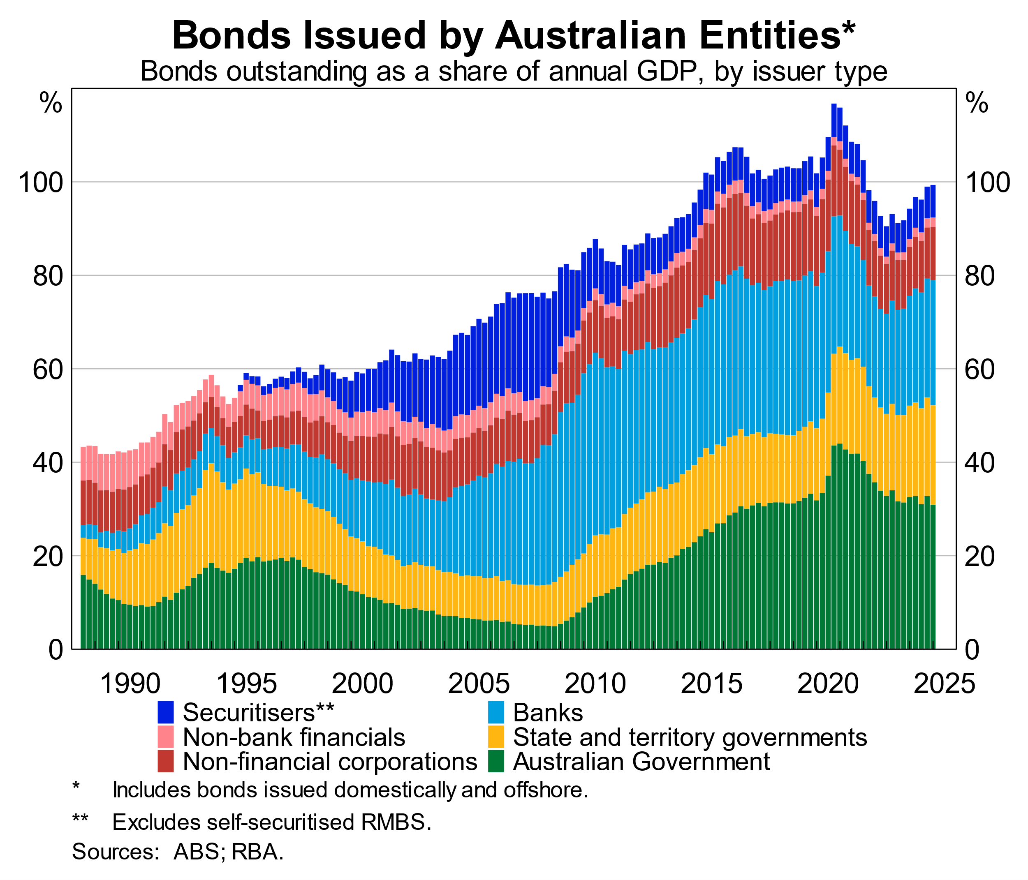

The growth of the market has been supported by a diverse range of investors: banks accumulating liquid assets in response to regulation; super funds managing Australia’s maturing compulsory savings system; and foreign investors attracted by Australia’s institutions, credit profile and history of relatively high yields.

For most of its history, Australia has benefited from being a net importer of capital, and the bond market has been a key vehicle for that. The growth of the bond market has continued despite an extraordinary decline in Australia’s net foreign liabilities in recent years (Graph 2). That is because Australians have accumulated foreign assets, especially equity, while foreign investors have continued to seek to hold Australian debt.[4]

Graph 2

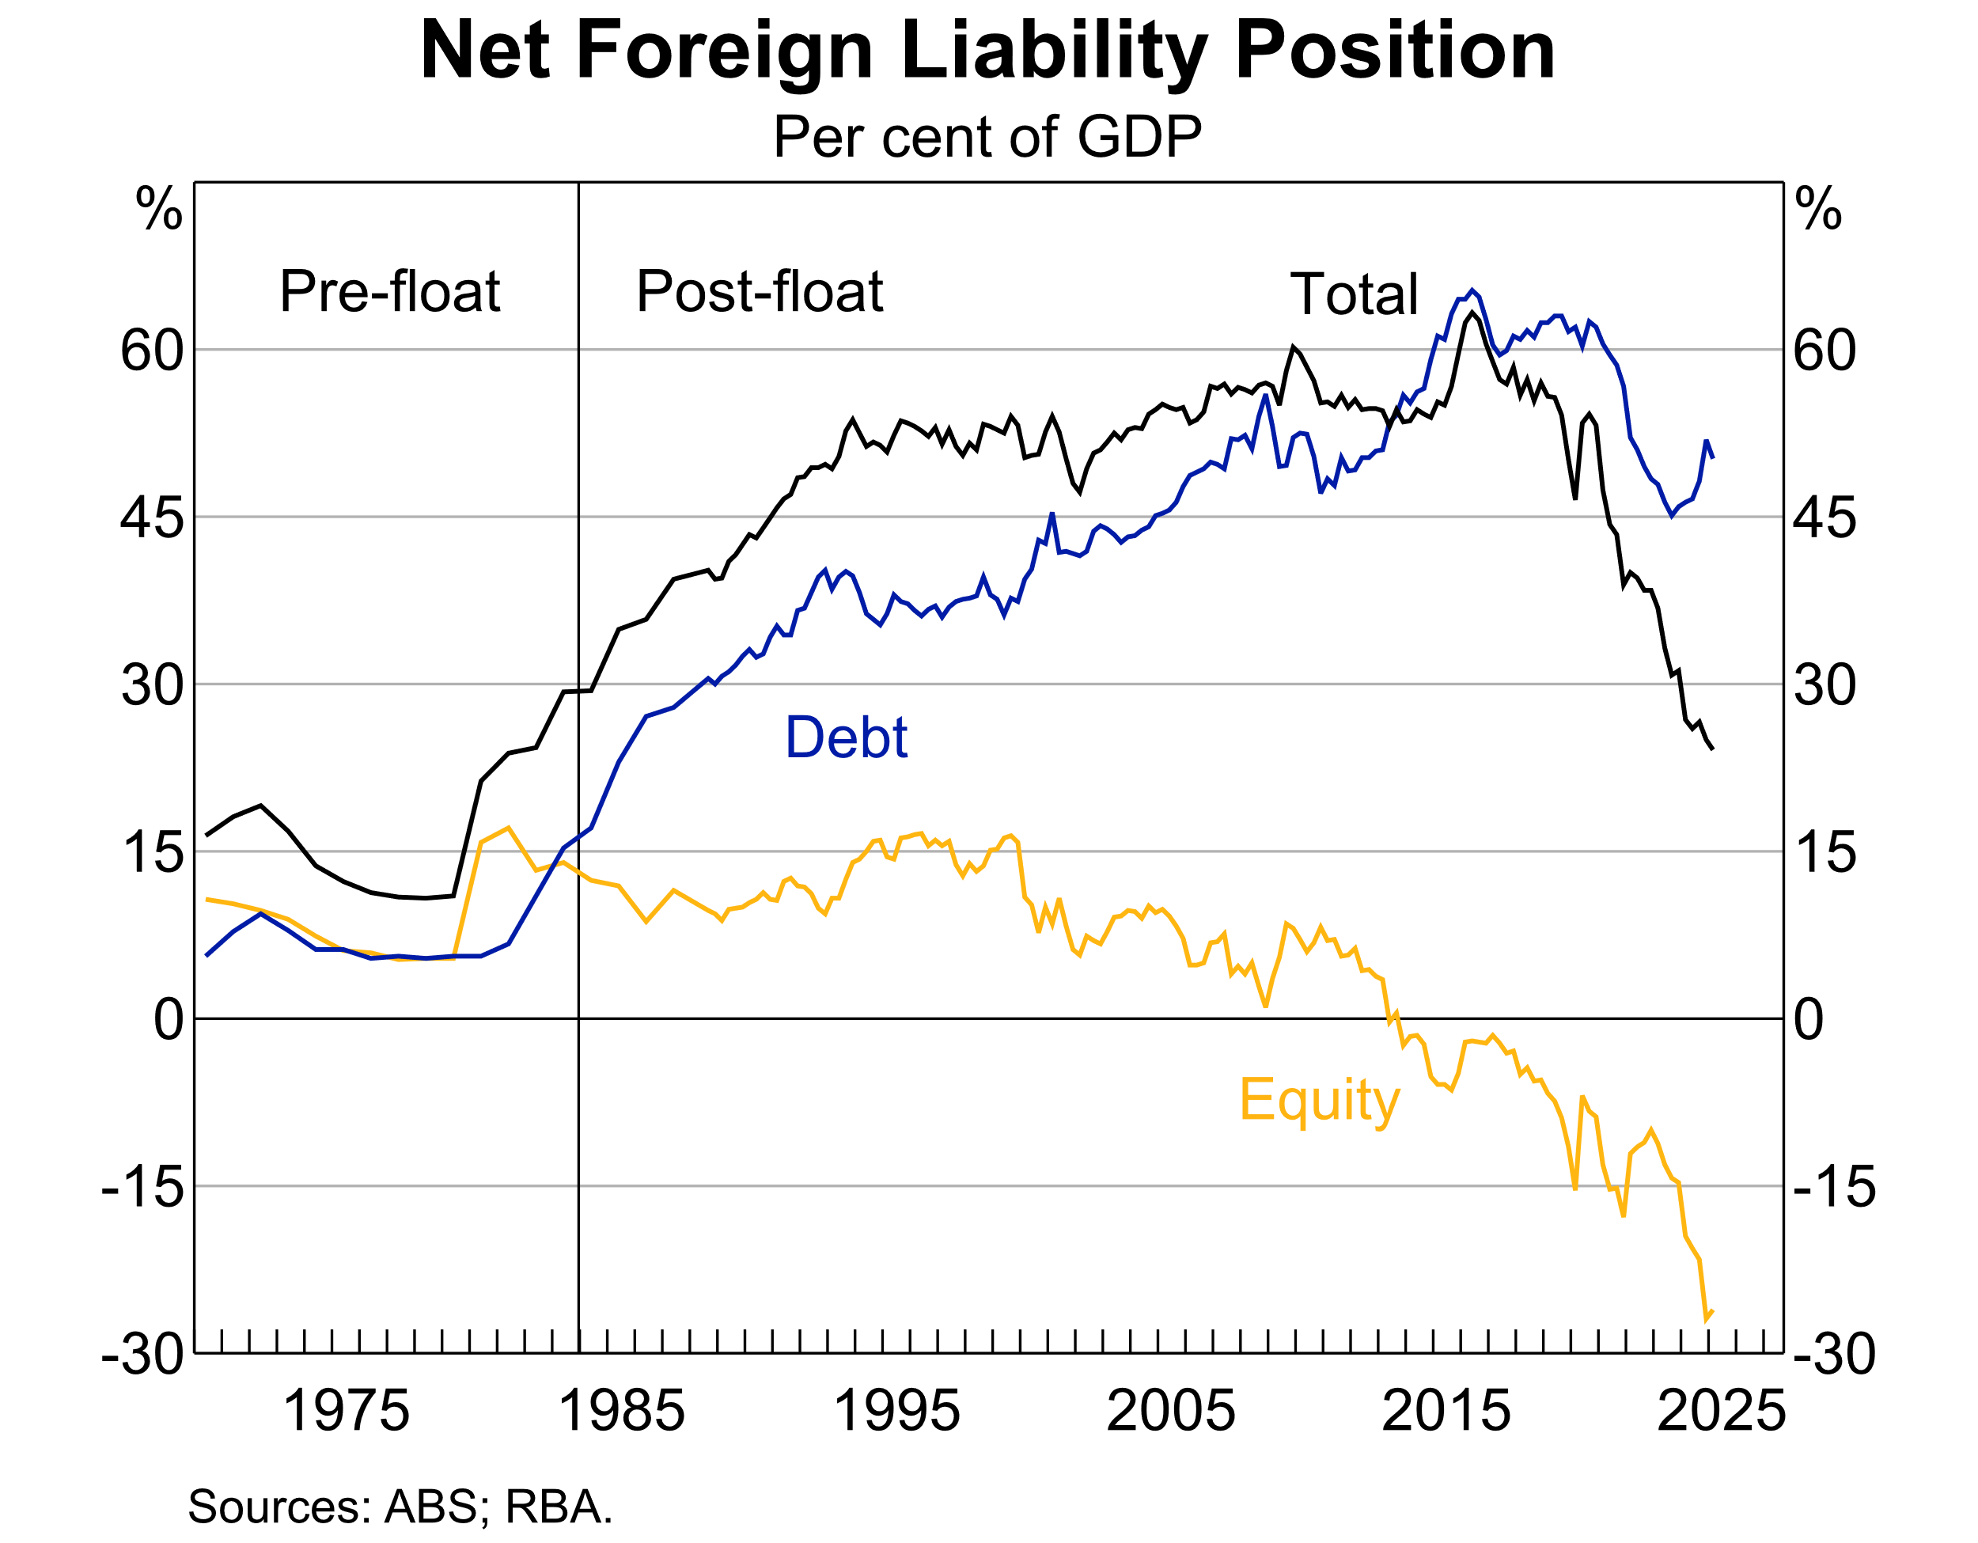

As the bond market has grown, we have seen a positive feedback loop. A bigger market has seen more diversity, liquidity and maturity of the underlying infrastructure. Several recent and emerging trends speak to this:

* *We have seen greater depth of the Australian dollar (i.e. onshore) market.* Since the 1980s, Australian banks and other corporations have mainly issued bonds offshore in foreign currency to access deeper markets.[5] So we tend to think of the Australian bond market in these broader terms. But in the past few years issuance has shifted onshore – banks now source around half of their bond funding onshore and corporates are issuing much more of their longer term debt onshore (Graph 3). At the same time, foreign investors have been more active in the onshore market.[6]

Graph 3

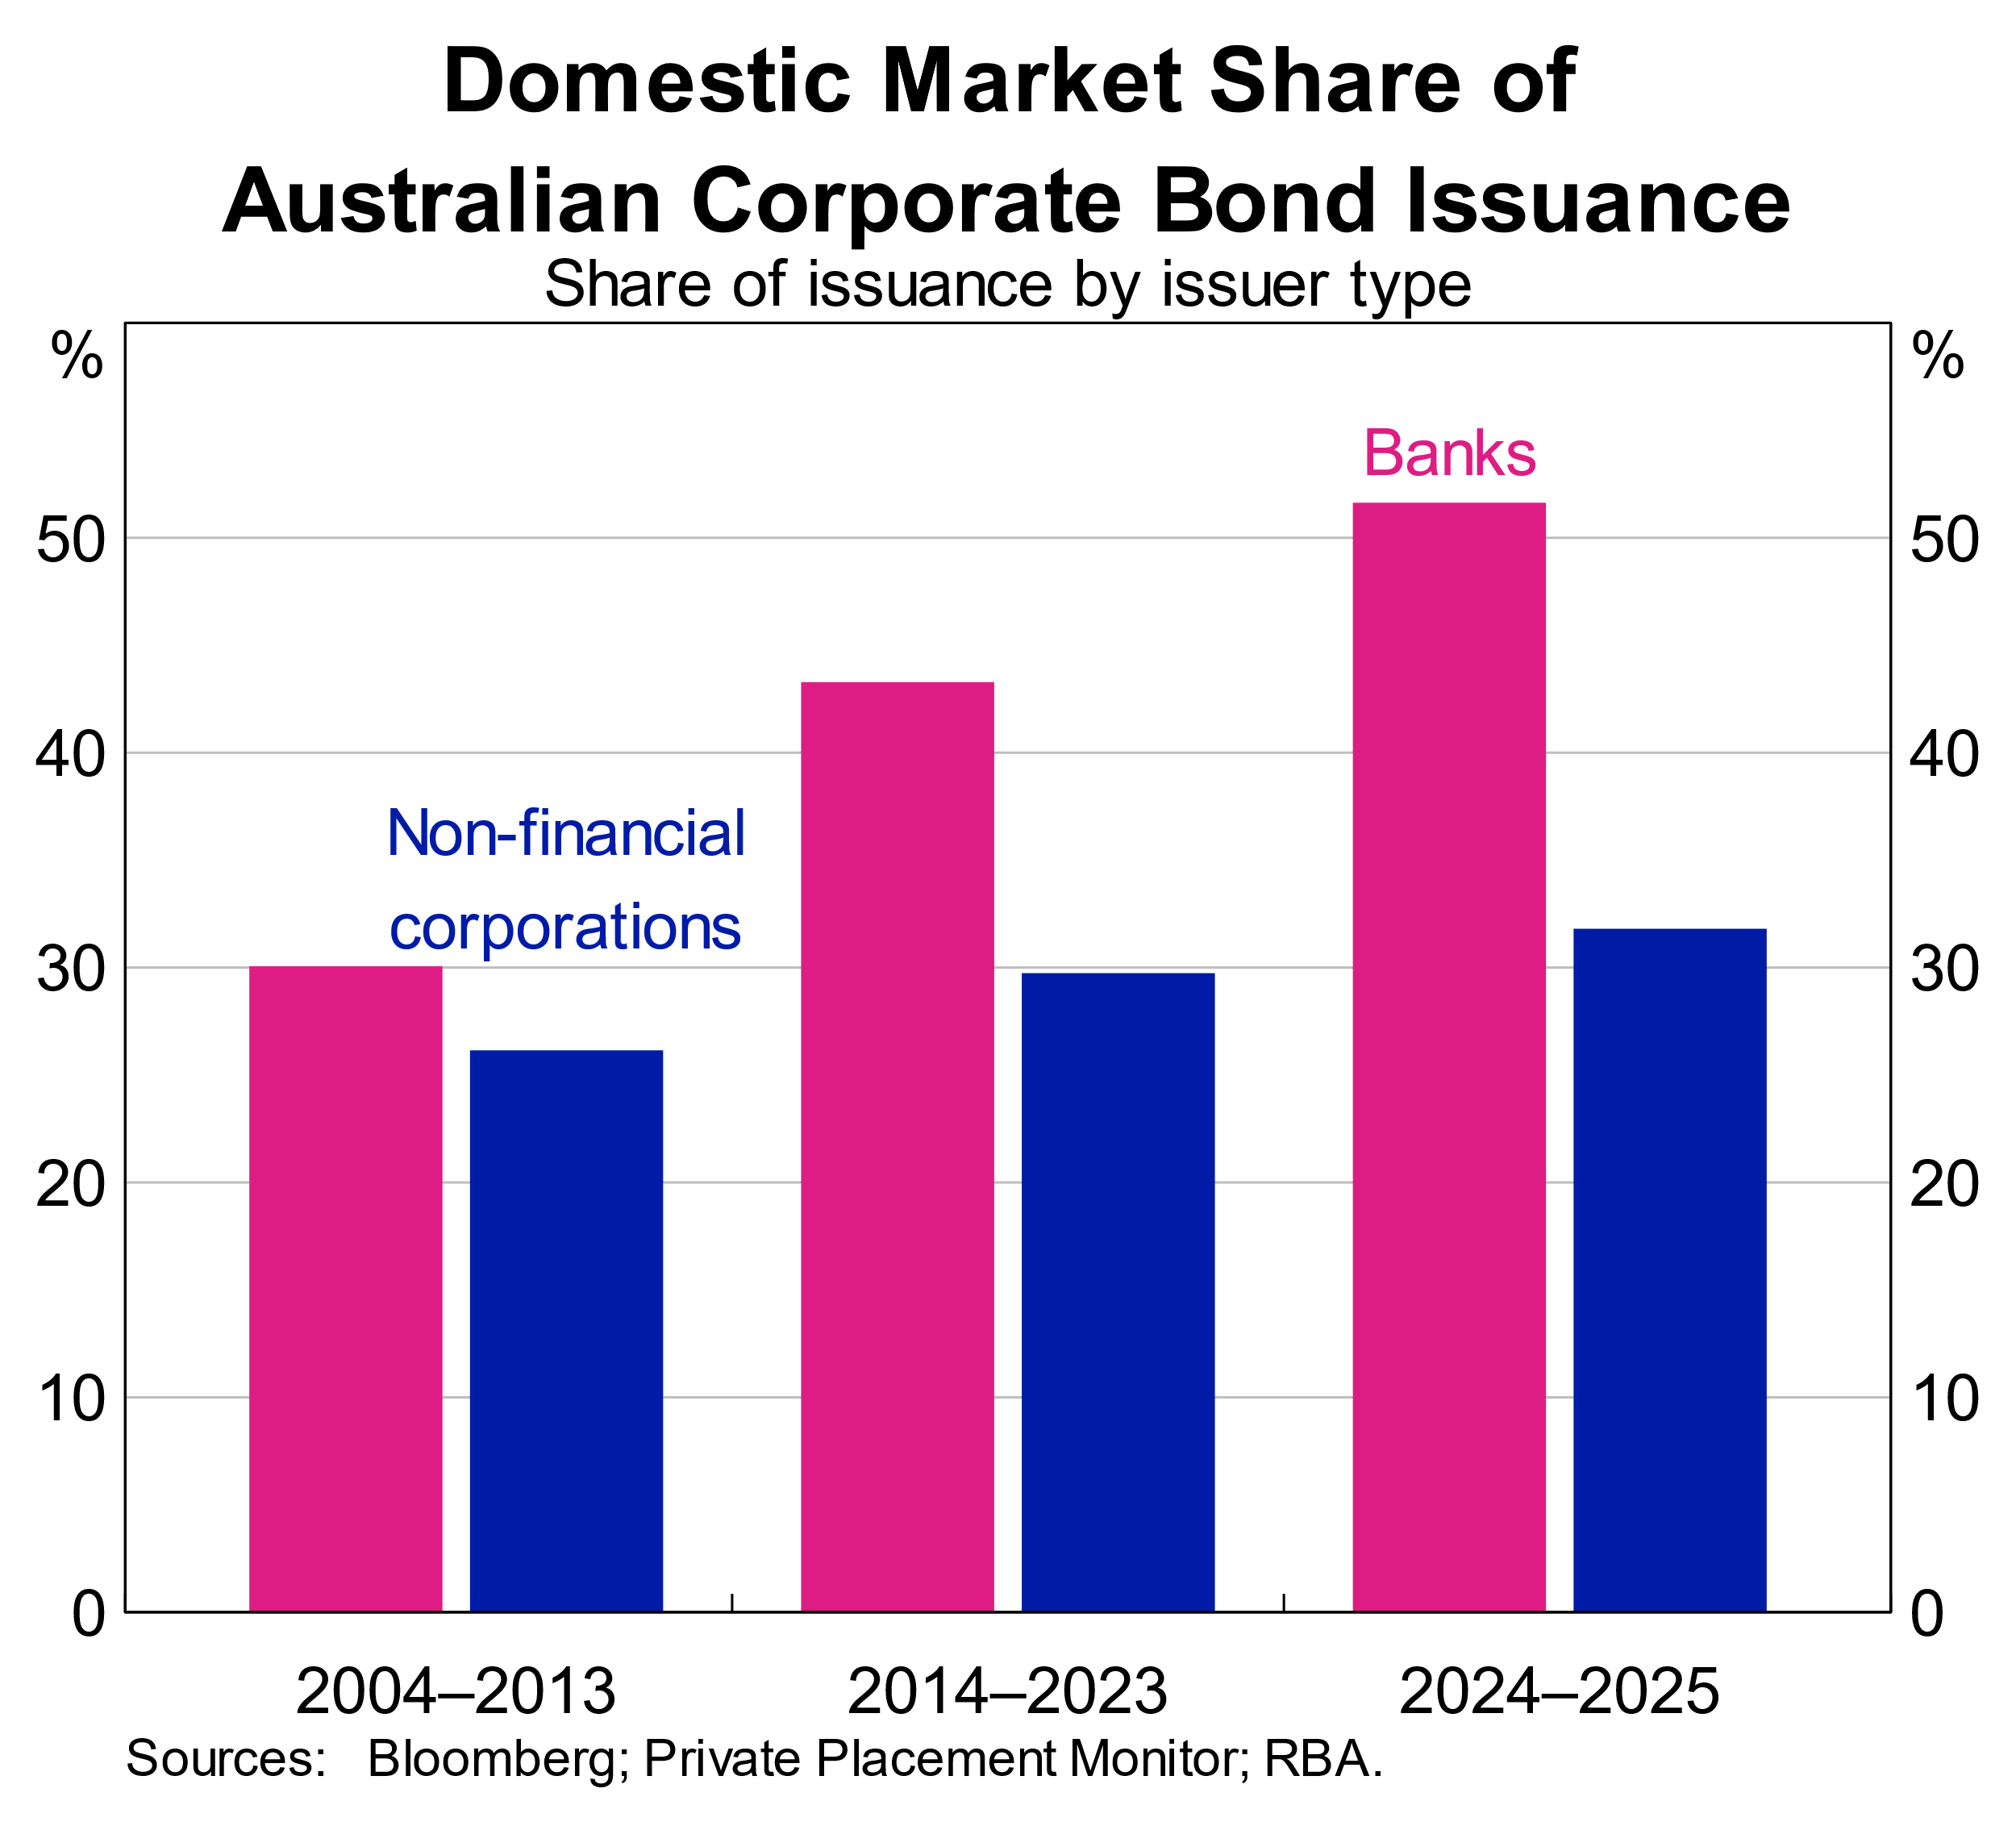

* *Liquidity has been supported by an expanded repo market*, where bonds can be used as collateral to raise cash. The repo market for AGS and semis has doubled in size relative to the physical bond market over the past decade (Graph 4). We also see a broader range of participants and more diverse collateral. The growth of repo partly reflects the larger physical bond market, and is despite money markets having been flush with reserves in recent years.[7]

Graph 4

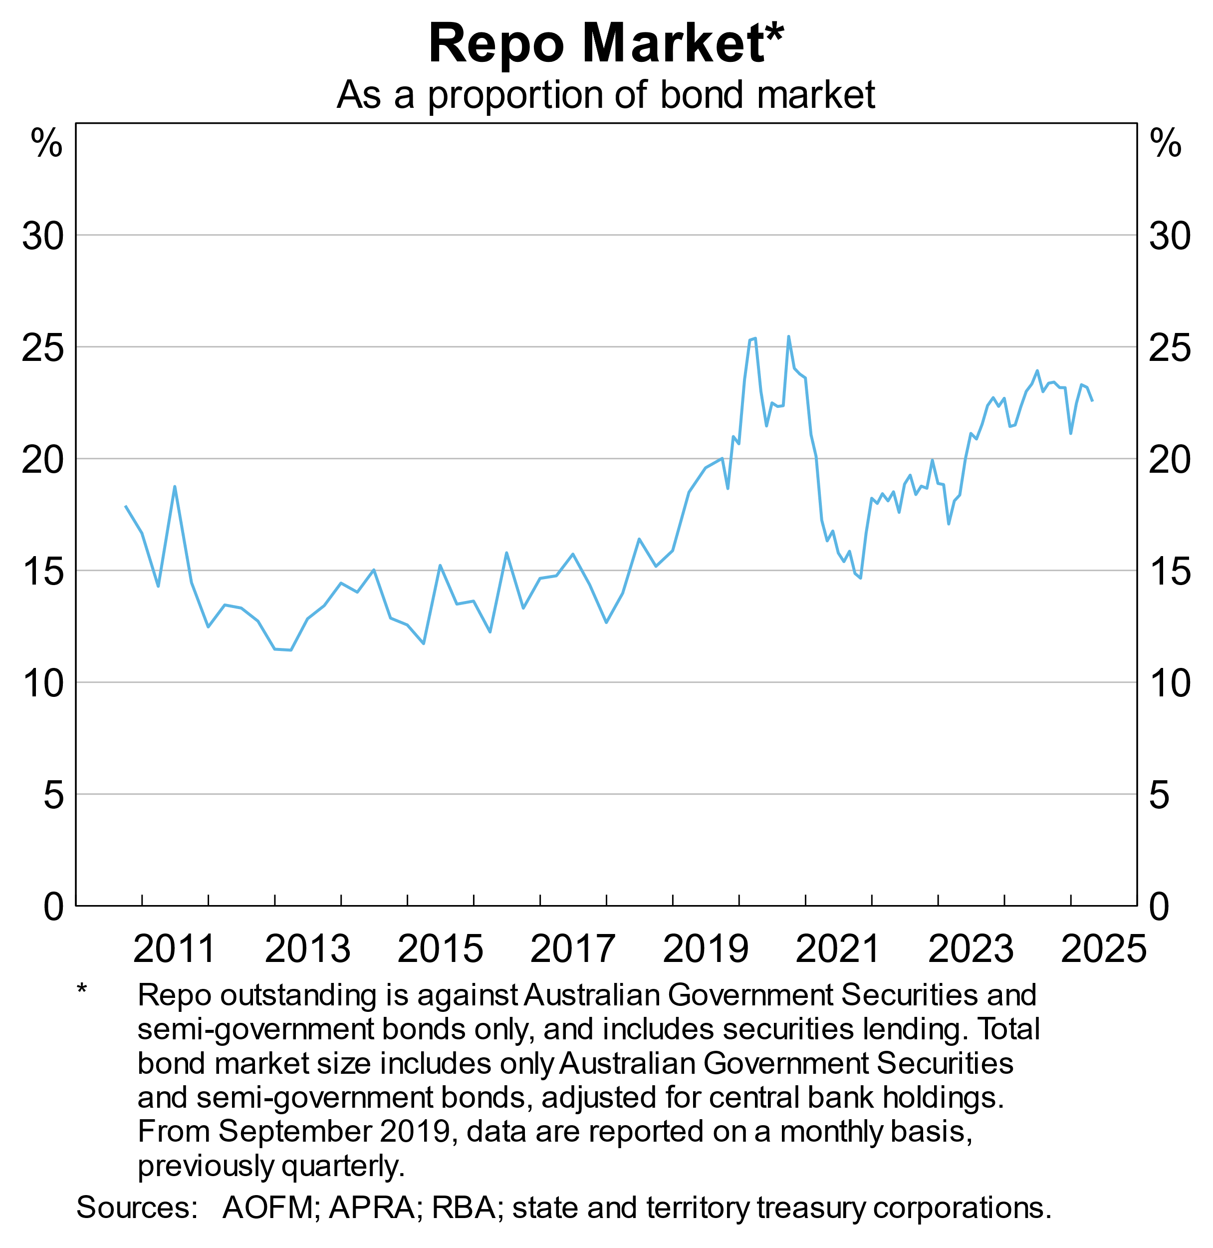

* *The market is moving toward enhanced infrastructure and transparency.* There is a growing industry consensus that centralised clearing could enhance the efficiency, stability and transparency of the Australian bond and repo markets.[8] And a welcome development in the repo market is that the ASX is developing an overnight repo pricing benchmark (SOFIA).

Some earlier expectations for the bond market have not come to fruition. Most notably, the corporate bond sector remains small by international standards, with lower rated issuers still tending to seek capital abroad. That said, this partly reflects the ongoing strength of the Australian banks, the emergence of a private credit market, and a long-term decline in corporate leverage since the global financial crisis.[9]

Overall, the Australian bond market has come a long way. Rather than the negative feedbackeffects that people worried about at the turn of the century, we have seen a positive feedback loop as the market has grown. The market has become more attractive over time to both issuers and investors.

# Challenges and opportunities in a volatile and uncertain world

What then might the future hold?

The international backdrop presents two key challenges: competition for global capital; and the potential for periodic market disruptions to spill over. I’ll now outline what each in turn might mean for the Australian bond market. From here, I am largely focusing on government bond markets.

## Competition for global capital

Recent years have seen increased supply of government bonds globally. That reflects both new issuance and a wind down of central banks’ holdings (Graph 5). Some observers have gone so far as to refer to this as an emerging global ‘bond glut’.[10]

Graph 5

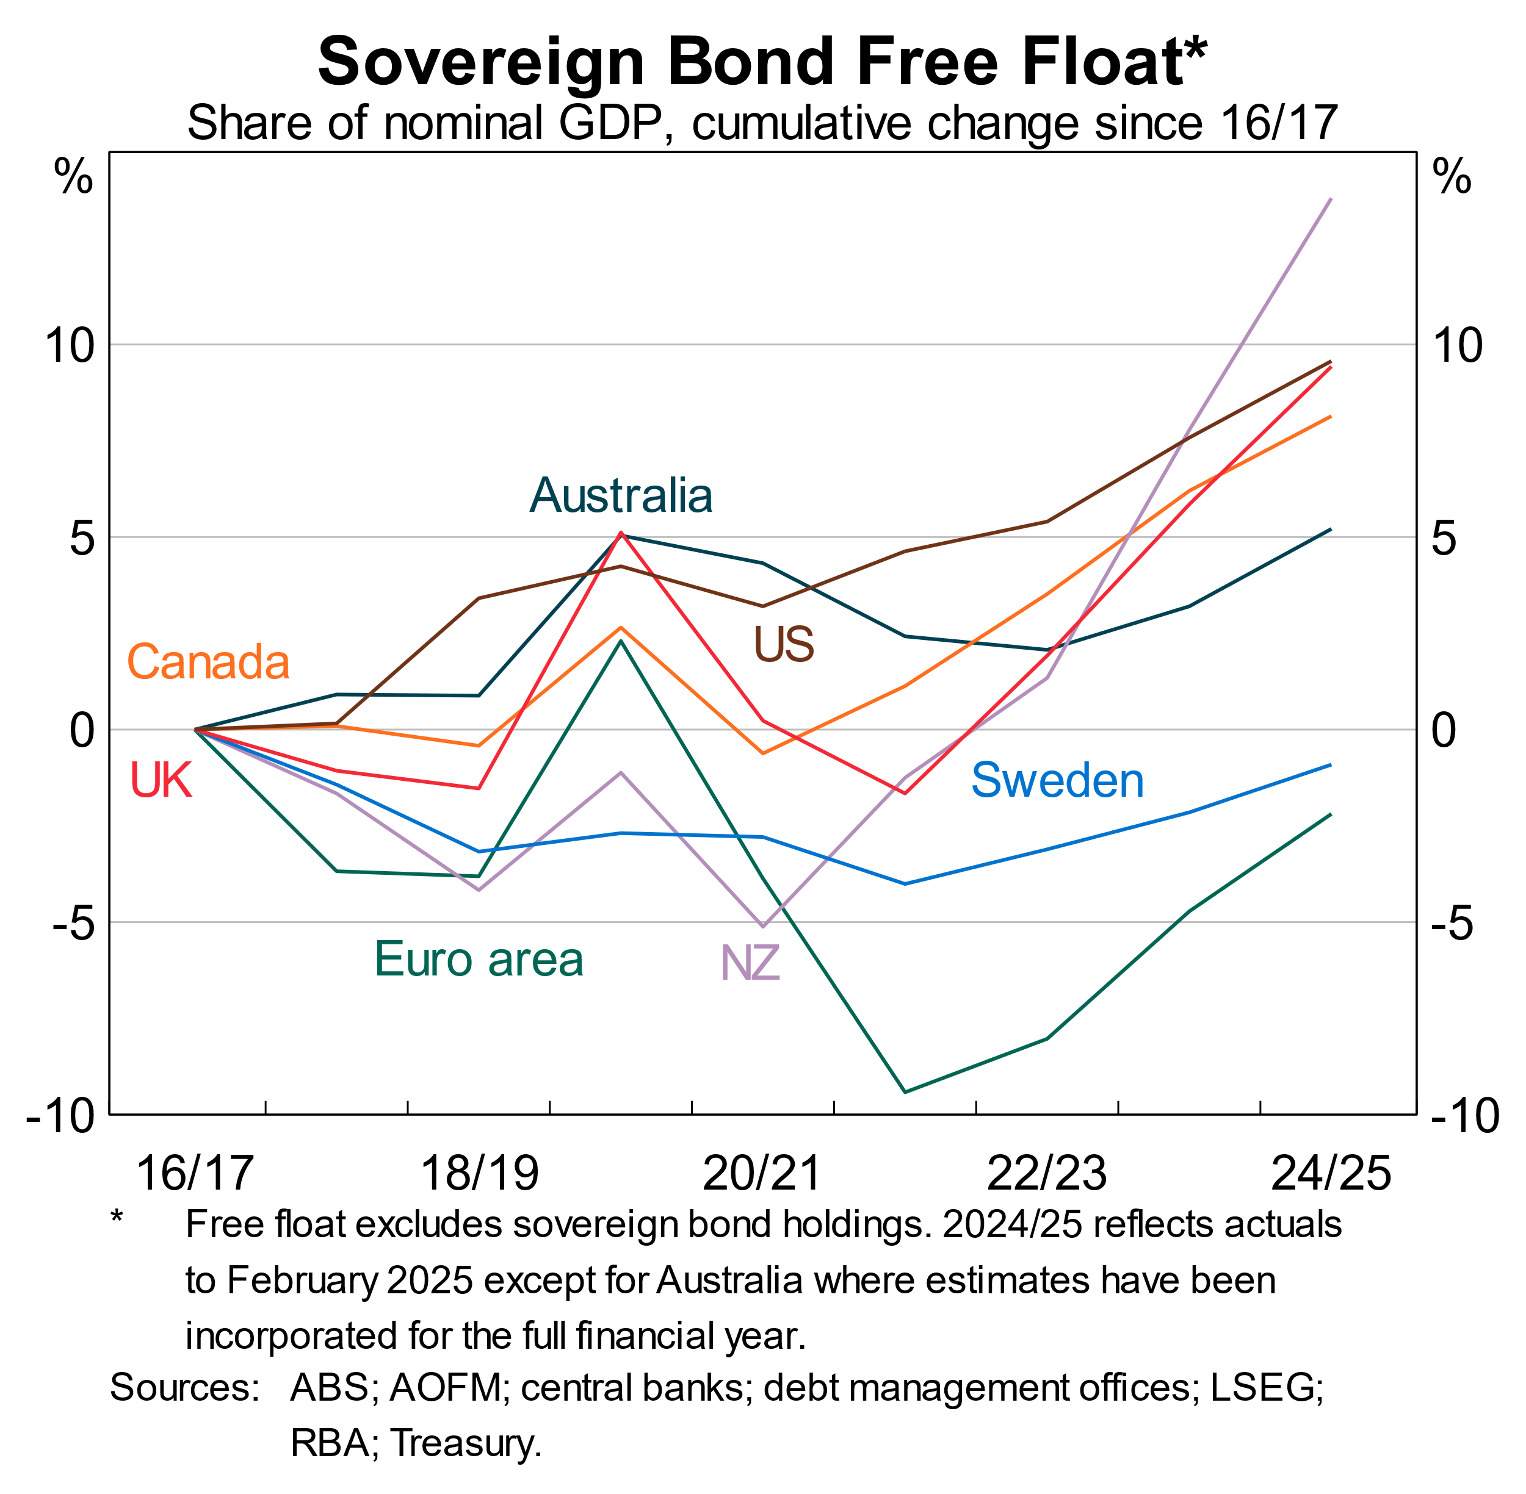

In turn, there has been a sustained rise in the yield that government bonds pay over expected future short rates – the *term premium* (Graph 6). And yields on bonds have also risen relative to those in derivatives markets – the *interest rate swap spread*.[11]

This shift should be kept in context – the term premium has returned closer to historical norms. Even so, it suggests a fundamental shift from the previous decade or so, when we saw strong demand for government bonds from price-insensitive buyers and historically low term premiums.

Graph 6

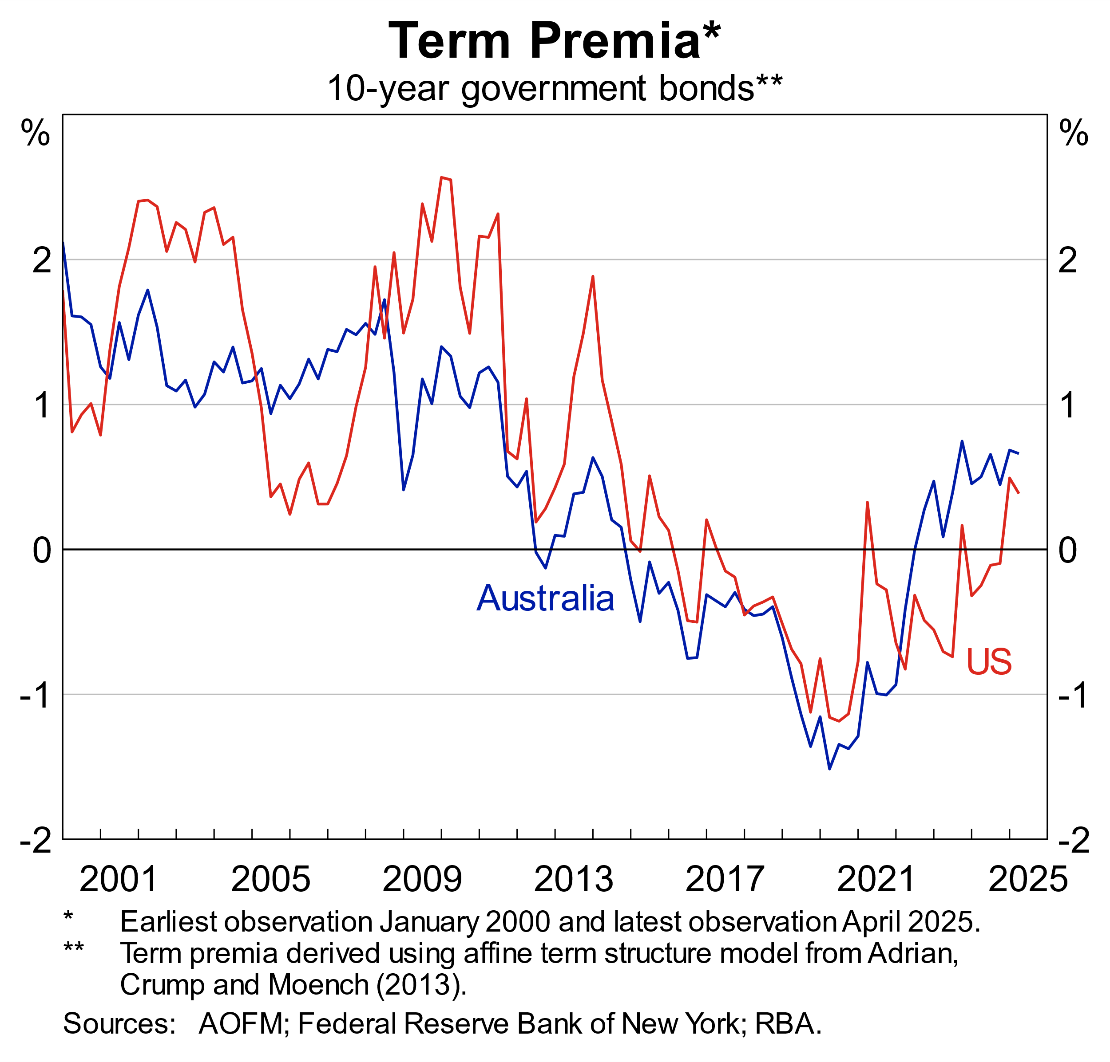

What does this mean for Australia?

The supply of government bonds in Australia is also projected to grow at a fast pace relative to history. That largely reflects funding tasks for both the Australian federal and state borrowing authorities. It also reflects the gradual unwinding of the RBA’s holdings of AGS and semis. The ‘free float’ of AGS available to private investors is projected to increase by around 4 percentage points of GDP a year in coming years – the highest since the pandemic.

At the same time, foreign investors continue to own a large share of Australian bonds (Graph 7). That is despite a rapidly growing pool of domestic savings, as I mentioned earlier. Foreign ownership comprises around two-thirds of the free float of AGS available to private investors, though a much lower share of semis.[12]

Graph 7

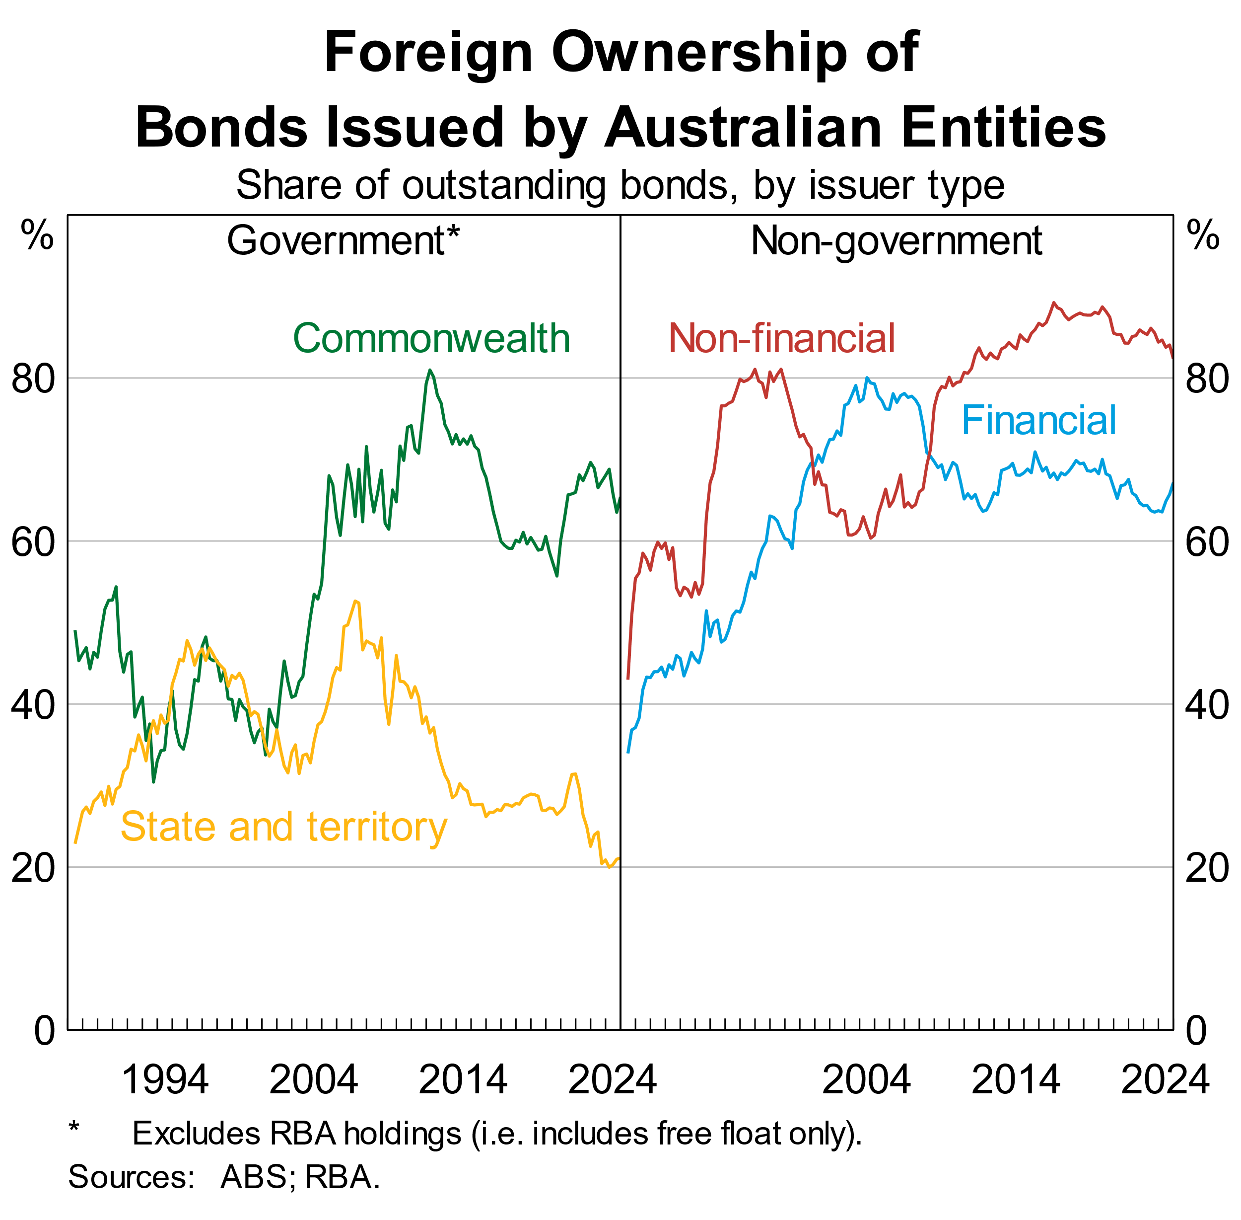

In this context, Australia’s institutions and credit profile have long provided an important comparative advantage. Our discussions in liaison confirm that foreign investors are attracted to Australia’s strong and stable institutional arrangements. Australia’s general government net debt is amongst the lowest in the developed world, at around 30 per cent of GDP (Graph 8). As a result, while Australia comprises only around 1 per cent of the outstanding sovereign bonds in advanced economies, it makes up more than 10 per cent of the AAA-rated sovereign bond universe. Looking beyond government bonds, Asian investors have developed a larger presence in bank and corporate bonds in recent years for these same reasons. And in the process, issuers have developed stronger relationships with new offshore investors.

Graph 8

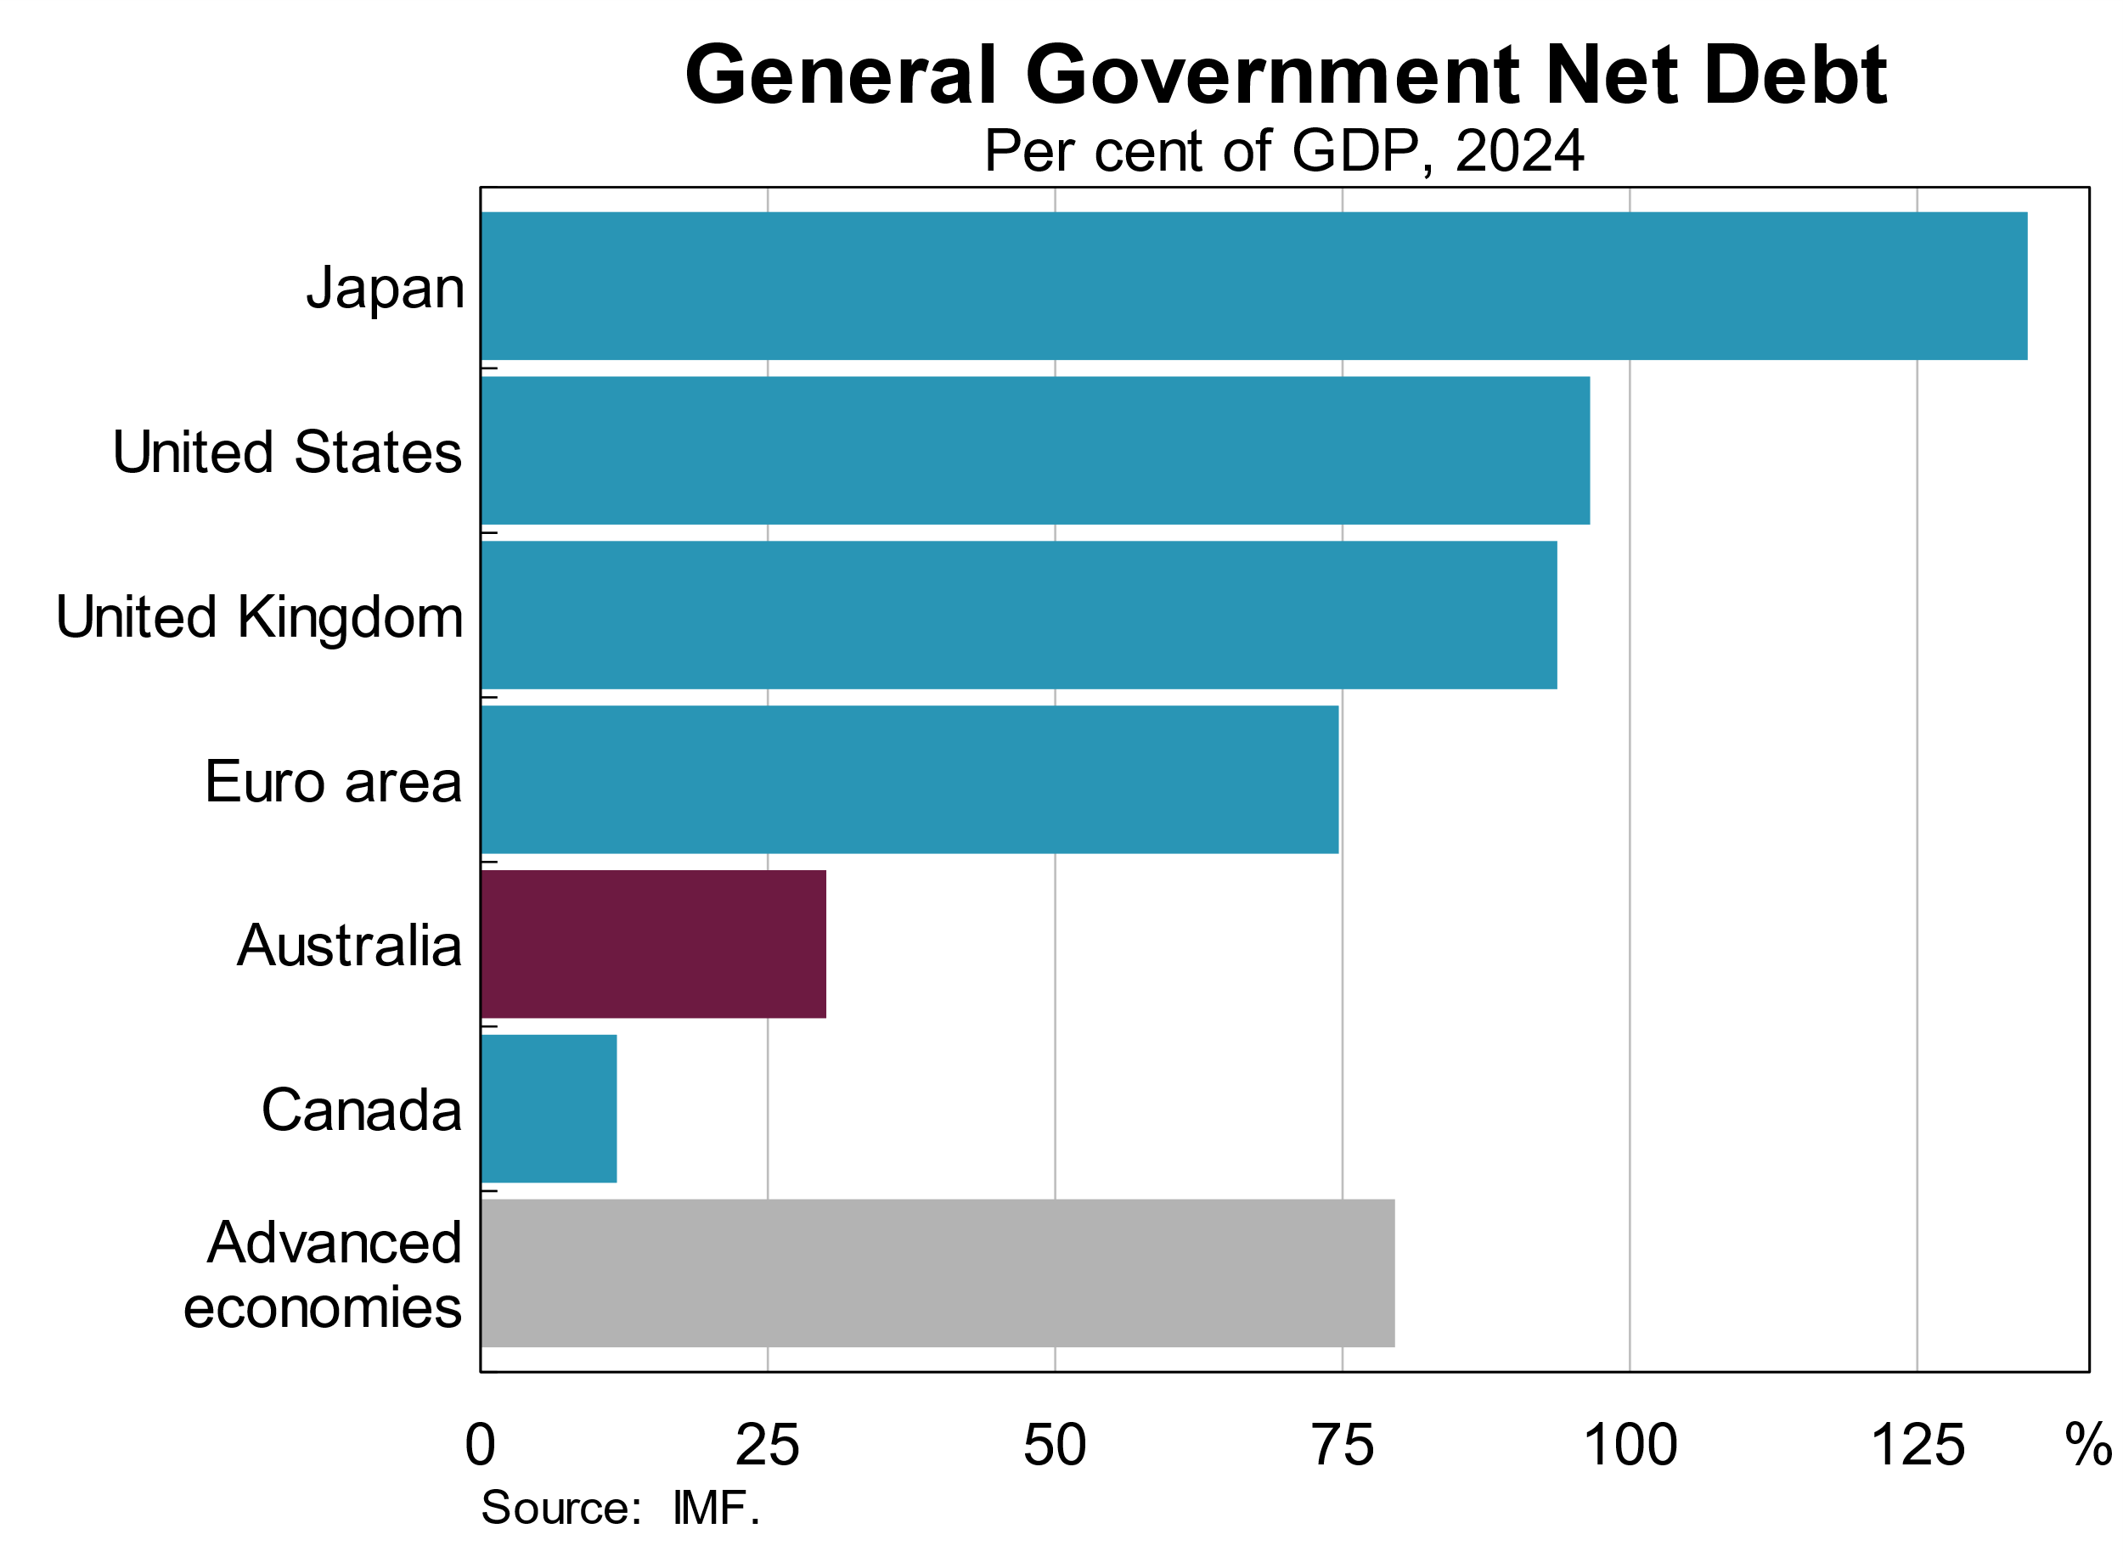

Much as international trade may be diverted in a new economic order – so too might international capital. There are a range of plausible scenarios for how this may play out. Investors may be concerned about Australia’s exposures as a small economy with a large trade relationship with China and a major stake in an open international trading and financial architecture. But working in the other direction are the enduring institutional factors I have mentioned, which will continue to be attractive to investors. In some scenarios where these institutional factors take precedence, Australia could even be a net recipient of broader portfolio allocations.

Ultimately, prices will clear markets. And Australia’s floating exchange rate has historically also provided important flexibility, helping to absorb any shifts in relative demand for Australian assets.

## Market disruptions and spillovers

A second issue is the potential for market disruptions to spill over to the Australian market. This is not new of course. But in an environment of elevated uncertainty, increasing supply and (as I’ll get to) leverage in global bond markets, we need to be prepared for periodic disruptions.[13]

Events in early April were somewhat dramatic, though brief, and illustrated how changes in the global economic system will play out quickest in capital markets. The US administration’s announcement of larger and broader tariffs than expected, and the response of other governments, saw markets rapidly reassess the outlook. Some large positions in international government bond markets, often associated with leverage, were unwound relatively quickly leading to a sharp rise in yields and thinner liquidity.[14]

There was a similar unwinding of positions in the Australian Government bond market and some participants reduced their trading amid the volatility. As a result, we saw some large moves in AGS yields and a decline in market liquidity (Graph 9). Bid-ask spreads widened to several times their normal level. Yields for other bonds rose relative to AGS, including because they have less liquidity than the AGS market.

Graph 9

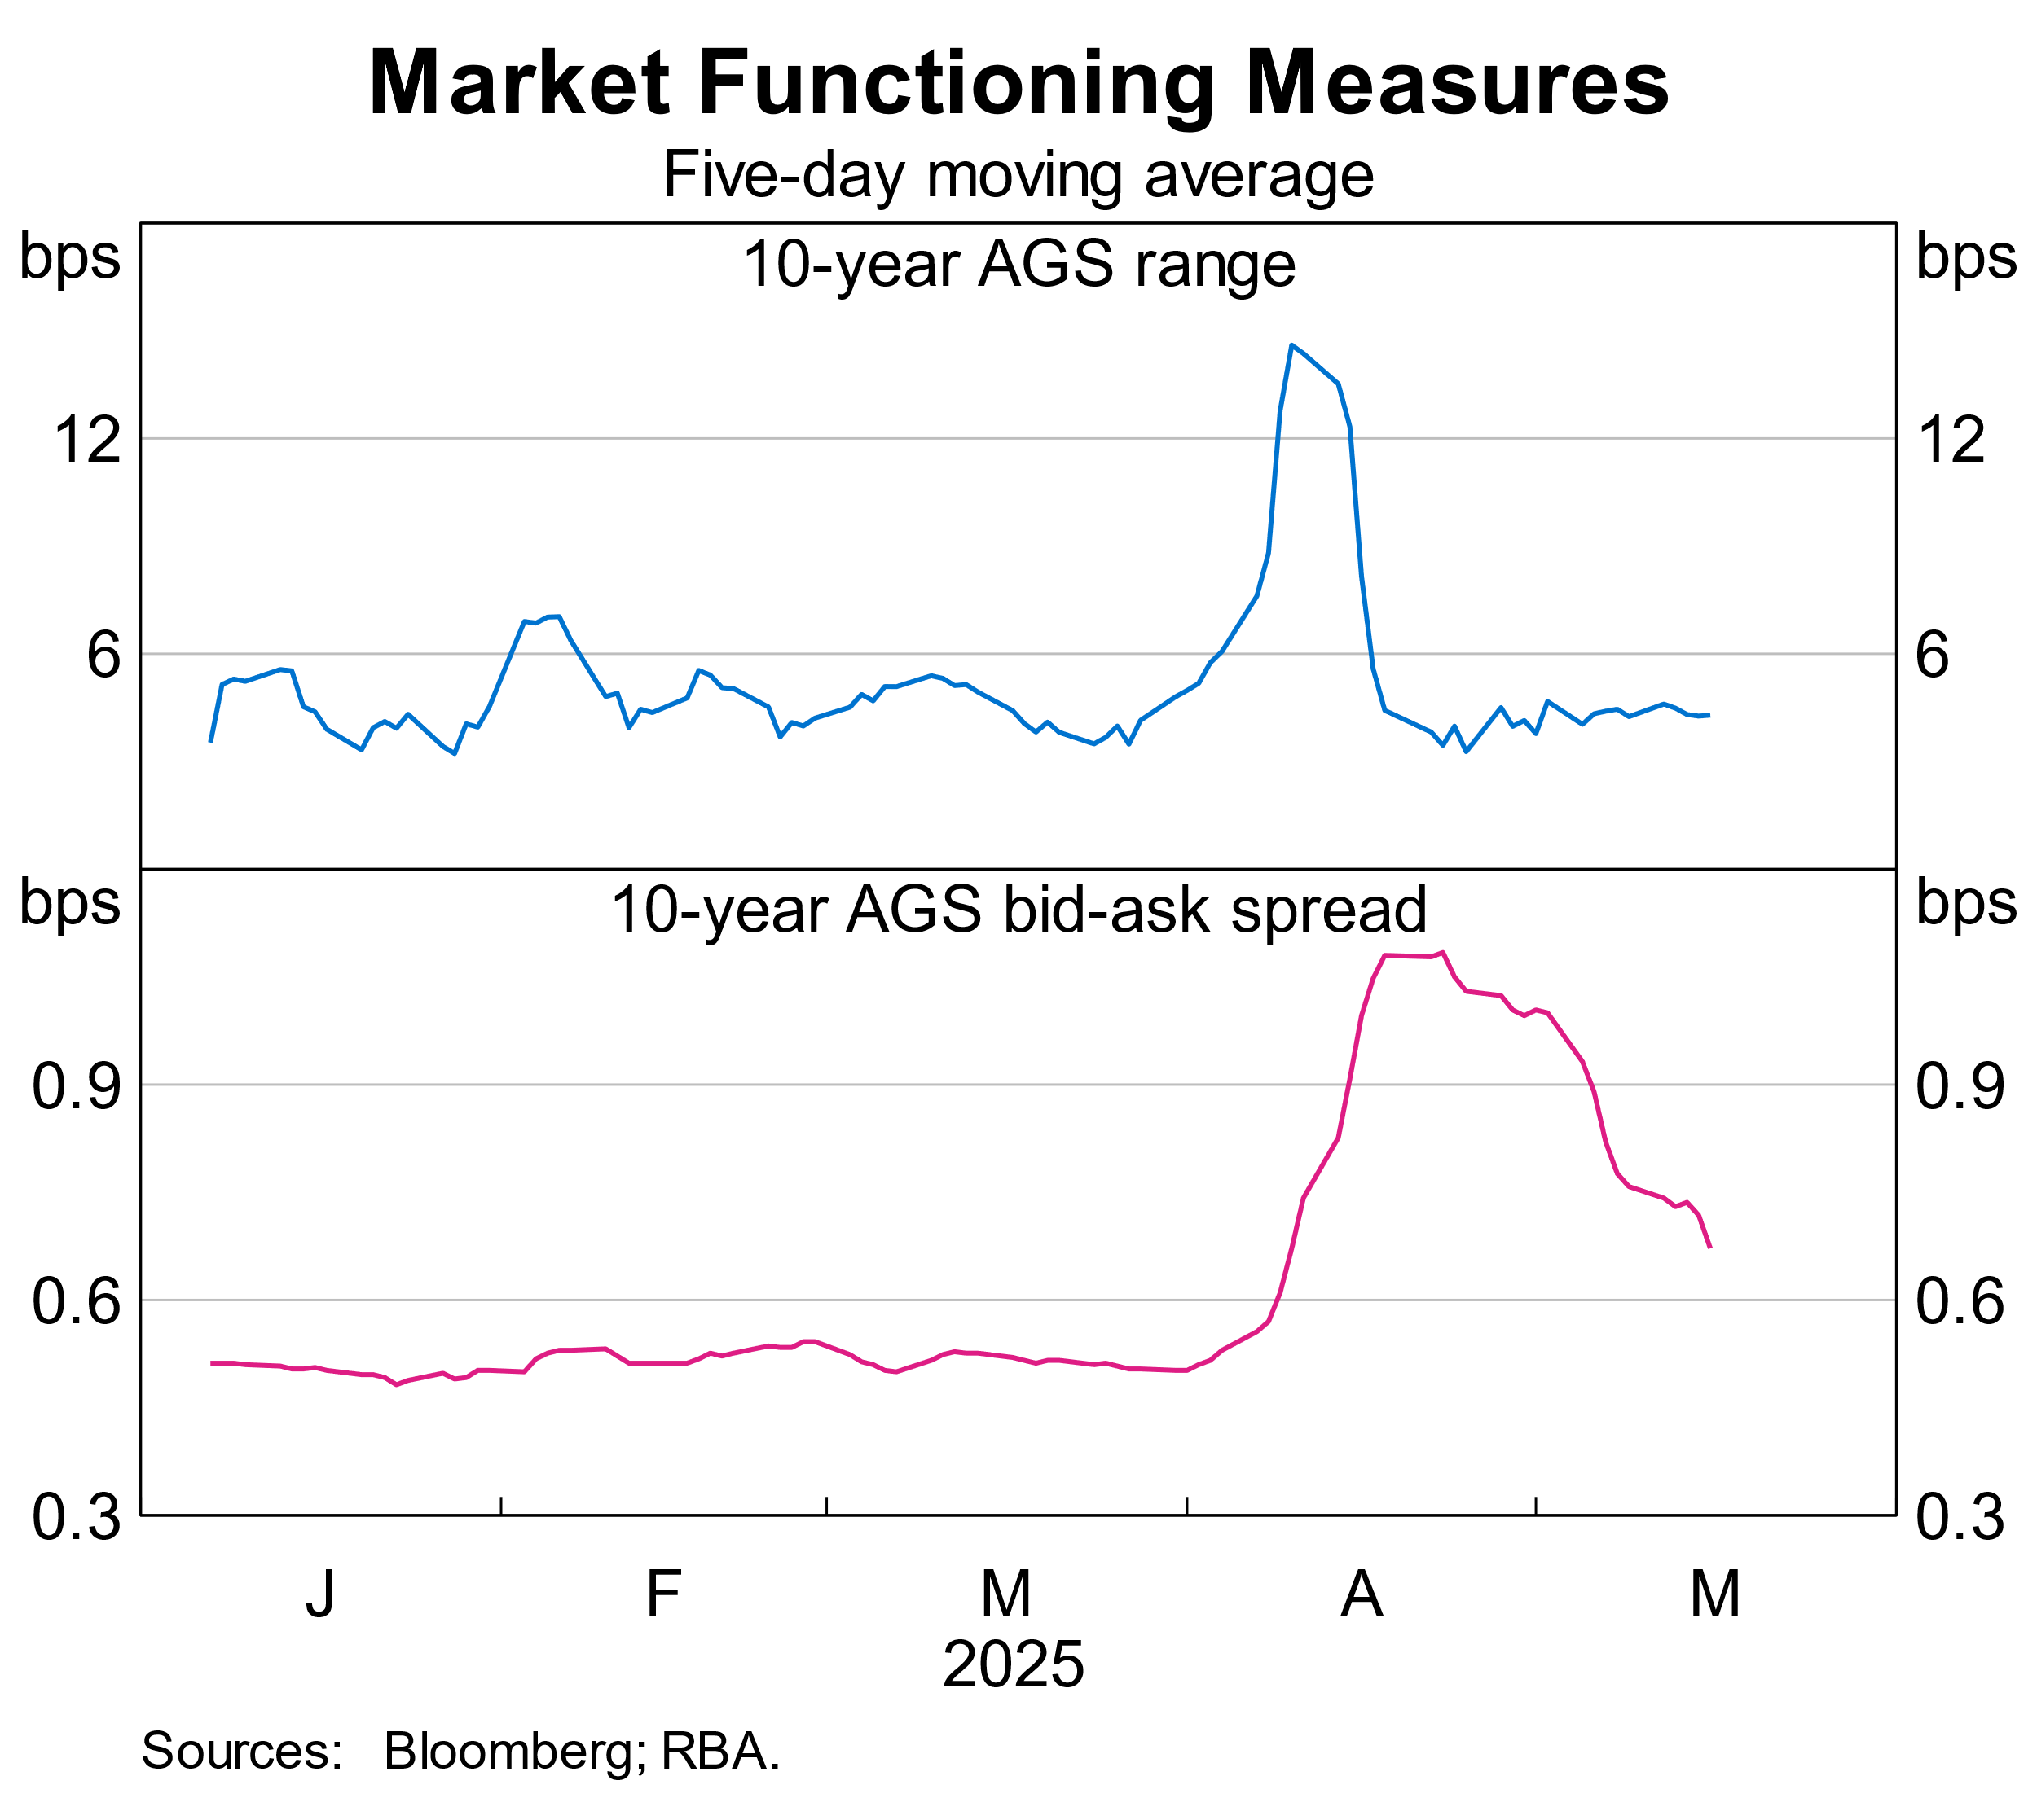

On this occasion, Australian markets were ultimately able to adjust – we saw a repricing, but not a broad-based shift to cash. Sellers were able to find willing buyers, and Australian governments continued issuing, though at a slower pace. Derivatives markets were resilient, including bond futures, which play a particularly important role in price discovery and risk management in the Australian market. This was in contrast with the early days of the pandemic, when markets became dysfunctional and threatened broader financial stability.

A key reason that markets stabilised quickly was the pause on the implementation of tariffs. That suggests little room for complacency.

So what other lessons can we take?

One is to remain attentive to market leverage. We did not see large-scale deleveraging in AGS or other Australian bonds.But leveraged investors such as hedge funds have had an increased role in many markets in recent years. They bring significant benefits as a source of liquidity in normal times, but also introduce risks as deleveraging can amplify shocks.

In Australia, we hear that hedge funds are a growing source of demand in some sectors such as semis. But unlike in other countries, where pension funds and insurers can employ significant leverage when holding bonds, Australia’s large superannuation sector is restricted from – and has less incentive to – directly take on leverage.[15]

And, ultimately, this was a reminder of the importance of resilience in core money markets. Australian repo markets continued to function, which avoided broader deleveraging and supported the ability to trade and issue in bonds. In turn, liquidity in money markets was supported by the RBA’s monetary policy implementation framework.

# Implications of the RBA’s new framework for implementing monetary policy

Which brings me to my final topic – the RBA’s new framework for implementing monetary policy and its role in markets.

Recent years have seen a significant decline in the RBA’s balance sheet as our pandemic-era policies have matured.[16] In light of that, we recently announced how we will implement monetary policy in the future to control the cash rate – which is the RBA’s operational target for monetary policy.[17]

For markets, this framework emphasises the important role of two aspects of liquidity:

* + - 1. *Central bank liquidity* – by which I mean the availability of reserves as the ultimate liquid asset.At its heart, the framework provides an ‘ample’ level of reserves, as participants can fully satisfy their demand at our ‘full allotment’ repo operations. That is a change from pre-pandemic times when we supplied a scarce quantity of reserves.
      2. *Market liquidity* – by which I mean the ability to obtain funding in active private money markets. While the framework provides more reserves than in the past, it still aims to also provide private money markets with the space to operate effectively. That is done by applying a modest cost on reserves and operating in the market only weekly.

The recent episode highlighted the importance of these two aspects of liquidity. Money markets redistributed liquidity where it was needed. And we saw a relatively modest increase in demand for reserves at our weekly operations, which helped keep the necessary overall liquidity in the system (Graph 10). Together, that helped to ensure the initial shock was not amplified through broader markets.

Graph 10

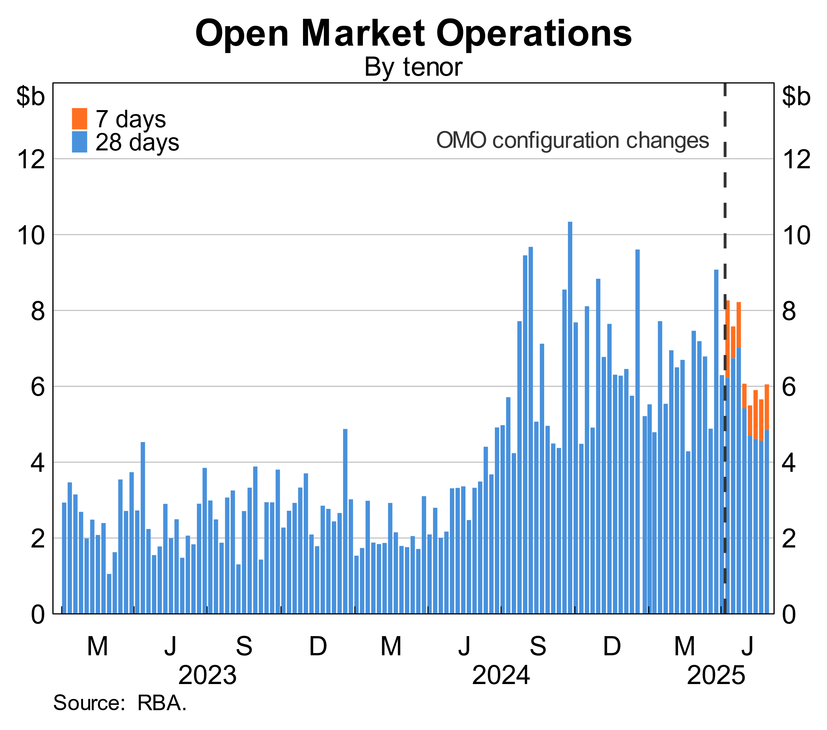

The framework’s set-up is forward looking. We expect our repo operations to expand from a low share of the market, to meet demand for reserves as our bond holdings gradually unwind (Graph 11). But we do not want that to significantly displace the normal operation of private money markets.

Graph 11

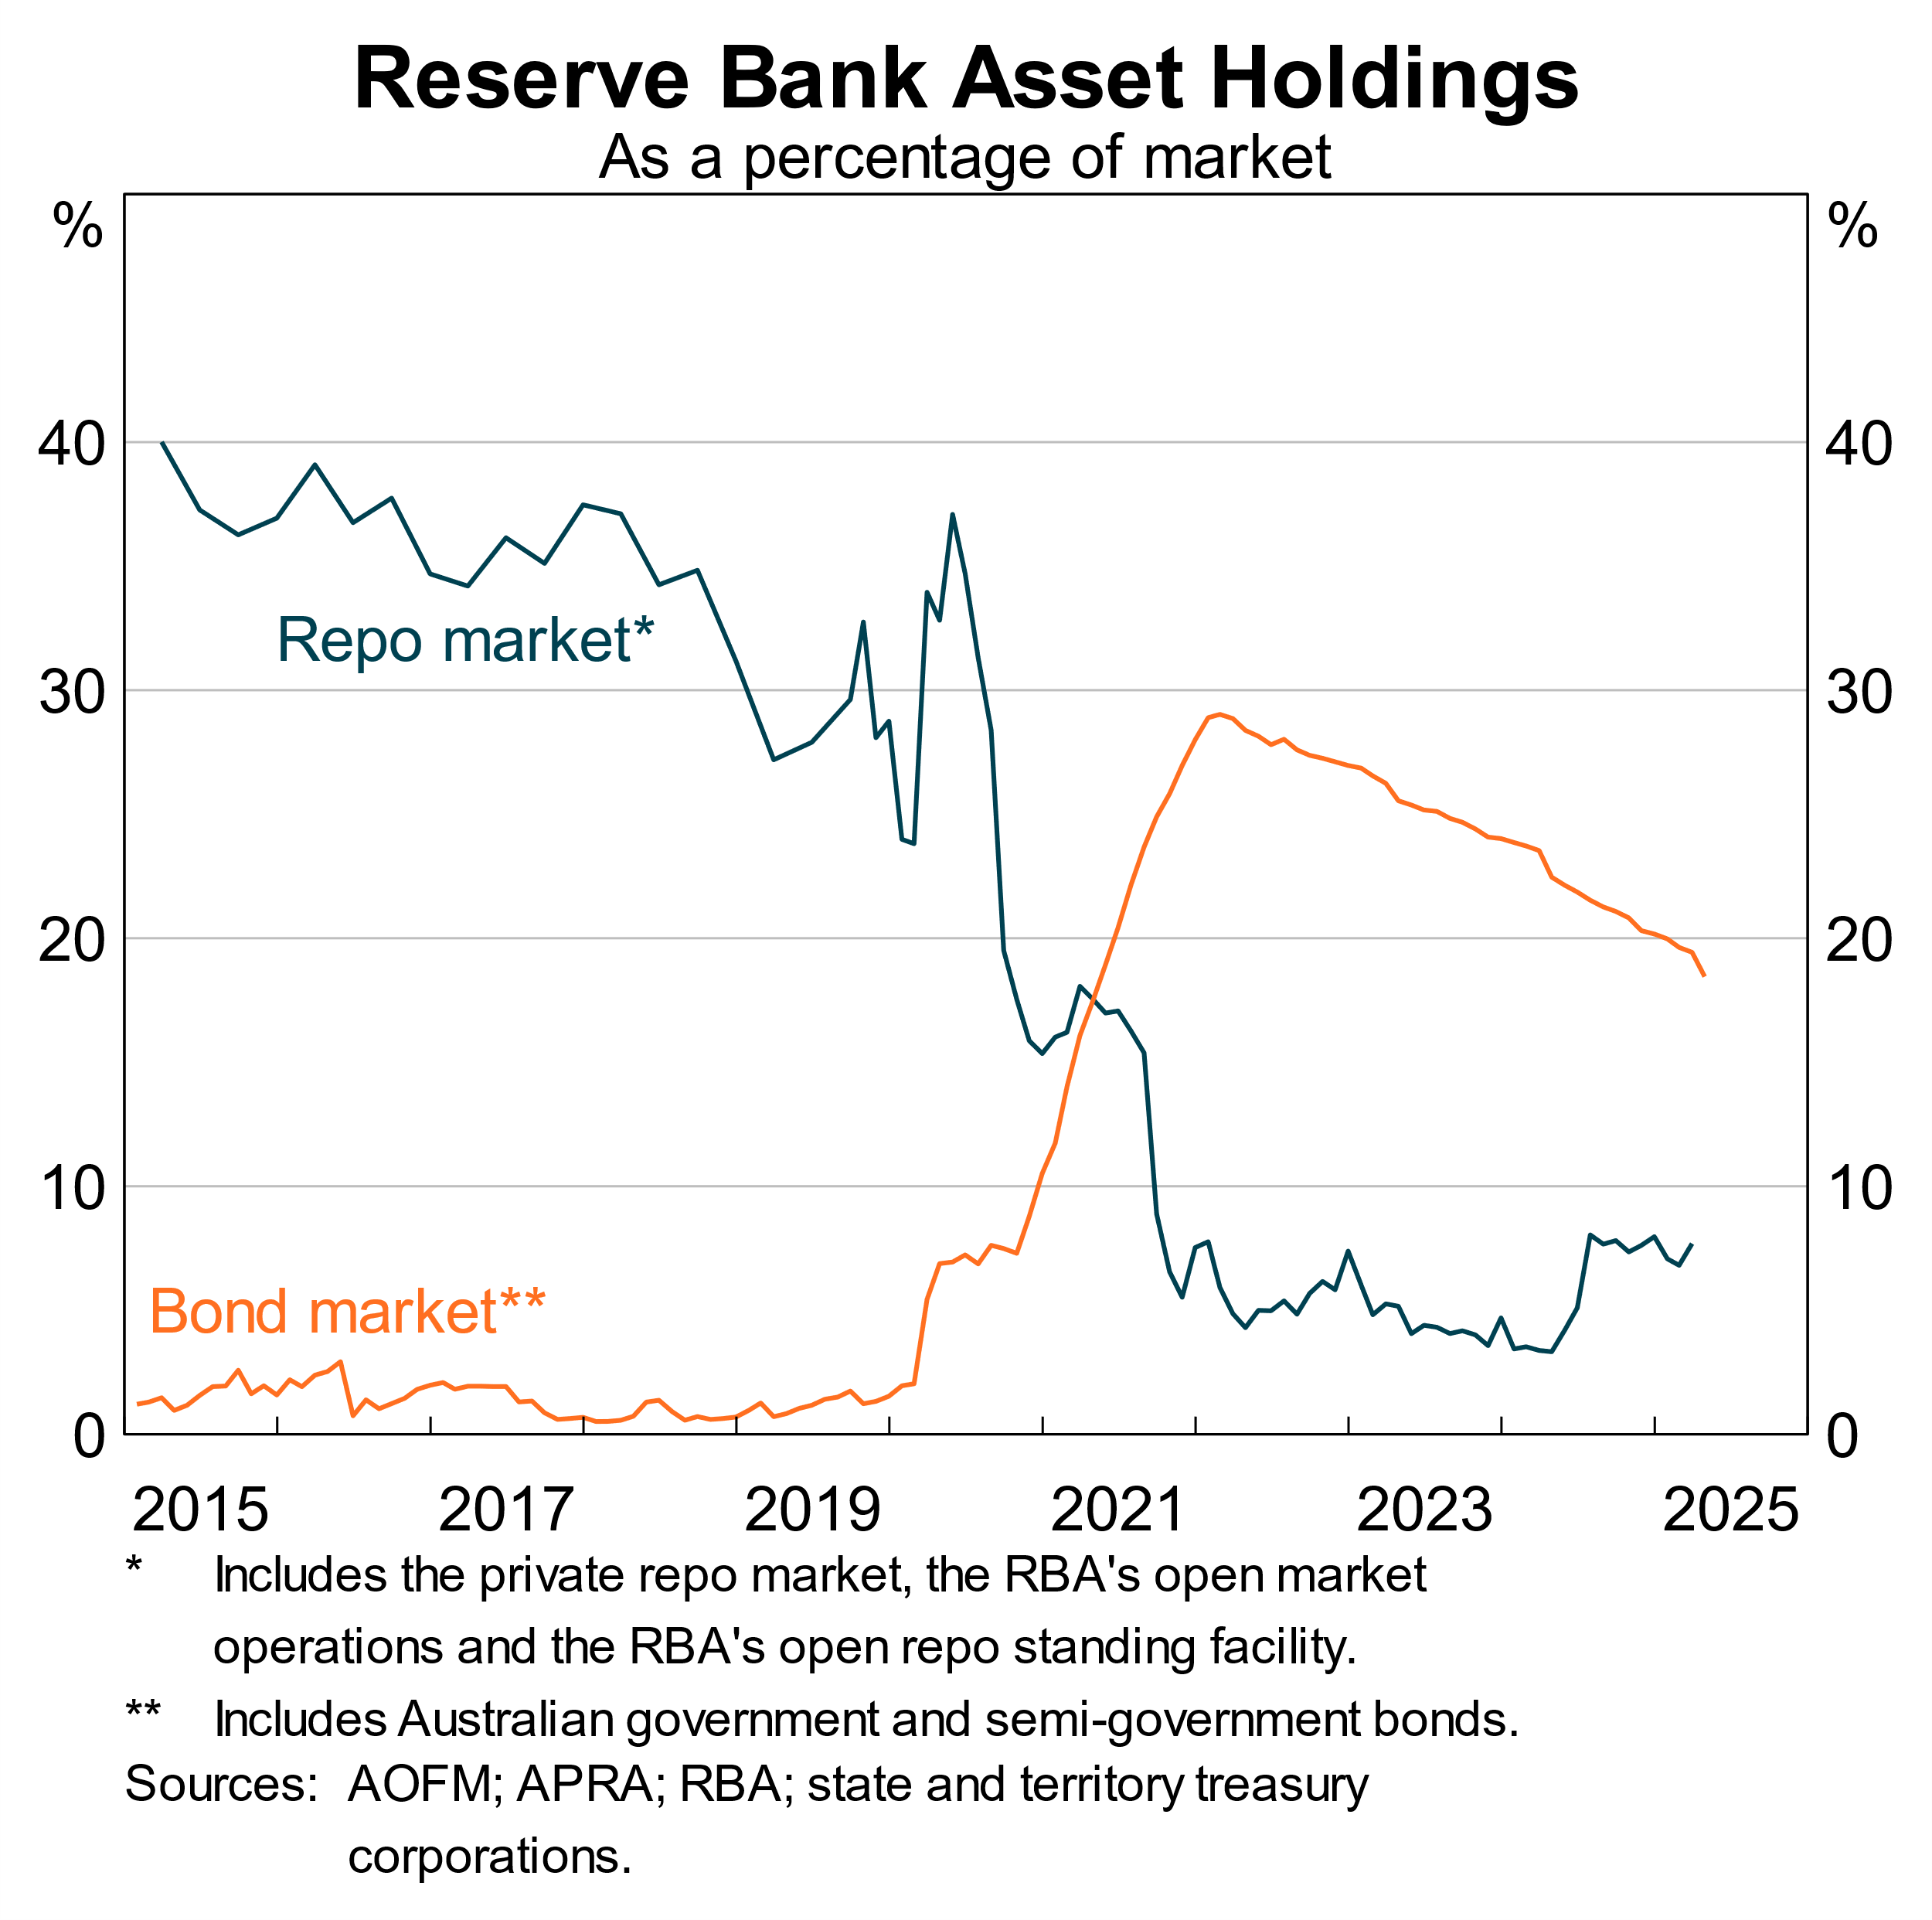

To help support the smooth operation of markets, we have also emphasised that use of our ‘overnight standing facility’ will be seen as *routine* liquidity management by both the RBA and APRA.[18]

In all, we have put through changes seen as appropriate for the future – including the price and tenor of operations and the rate we pay on reserves. While we will learn and recalibrate as needed, markets also benefit from predictability and so the intent is not to adjust these settings frequently.

# Conclusion

Let me conclude.

We are facing a volatile world. The global economic system is in flux and what will emerge is difficult to predict. Australia’s open economy has long benefited from open capital flows, and the Australian bond market provides a critical linkage with the rest of the world.

In that context, the Australian bond market has a number of key and enduring strengths. Its growth over time has been accompanied by greater depth, diversity and infrastructure. More broadly, Australia’s stable institutional foundations and favourable credit profile should help it to remain an attractive destination for international capital, alongside strong growth in domestic savings.

In an uncertain environment we should be prepared for periods of volatility and market disruption, as events in early April highlighted. Australian markets exhibited resilience and that episode did not become systemic. Importantly, it did not result in a broader shift to cash. On that front, the RBA’s new operational framework is designed to both foster liquid money markets and provide ample central bank reserves. That combination can help Australian markets to remain flexible and resilient in a volatile world.

Thank you for your time and I look forward to your questions.

1. * I would like to thank Katie Alexander, Amelia Gao, Sophia Psaros, Joey Reinhard, Avish Sharma for their assistance and Matthew Boge, Michele Bullock, Iris Chan, Jon Cheshire, Cameron Dark, Sean Dowling, Matt Gibson, Andrew Hauser, Sarah Hunter, Brad Jones, Chris Kent, Jeremy Lawson, Michelle Lewis, Nick Prokhovnik, Chris Schwartz, Claudia Seibold, Penny Smith, Michael Thornley and Peter Wallis for their helpful contributions and comments.
2. In light of these implications, the government at the time decided to maintain sufficient government bond issuance to support broader financial markets, notably the functioning of the futures market. See Treasury (2003), ‘Review of the Commonwealth Government Securities Market’; AOFM (2008), ‘Role of the CGS Market’, *AOFM Annual Report 2007–08*.
3. There is also a significant market in ‘Kangaroo bonds’ – Australian dollar-denominated bonds issued by non-resident entities in Australia.
4. See Smith P (2023), ‘[The Extraordinary Decline in Australia’s Net Foreign Liabilities](https://www.rba.gov.au/speeches/2023/sp-so-2023-10-18.html)’, Speech at the CFA Societies 2023 Australian Investment Conference, Sydney, 18 October.
5. See Black S, J Kirkwood, A Rai and T Williams (2012), ‘[A History of Australian Corporate Bonds](https://www.rba.gov.au/publications/rdp/2012/pdf/rdp2012-09.pdf)’, RBA Research Discussion Paper No 2012-09.
6. This is distinct from the current account position. Australian issuers can access foreign capital either by issuing domestically in Australian dollars or abroad in foreign currency (with many hedging exposures back into Australian dollars).
7. See Bristow L and M Tang (2024), ‘[The Australian Repo Market: A Short History and Recent Evolution](https://www.rba.gov.au/publications/bulletin/2024/jul/the-australian-repo-market-a-short-history-and-recent-evolution.html)’, RBA *Bulletin*, July. Liaison also indicates that liquidity in the physical bond market has been well supported by dealer balance sheets, which have not faced some of the same regulatory constraints seen abroad.
8. The potential benefits of central clearing have been bolstered by the increased size and diversity of the market, though industry will need to weigh up these benefits against the set-up and ongoing costs. See Council of Financial Regulators (2025), ‘[Reassessing the Case for Central Clearing of Bonds and Repos in Australia](https://www.cfr.gov.au/publications/consultations/2025/reassessing-the-case-for-central-clearing-of-bonds-and-repos-in-australia/pdf/response-to-consultation.pdf)’, March.
9. See Lowe P (2014), ‘[Opportunities and Challenges for Market-based Financing’, Speech to the ASIC Annual Forum 2014, Sydney, 25 March.](https://www.rba.gov.au/speeches/2014/sp-dg-250314.html) 
10. See Schnabel I (2025), ‘No Longer Convenient? Safe Asset Abundance and r*’, Speech at the Bank of England’s 2025 BEAR Conference, London, 25 February.
11. See Cohen BH, P Hördahl and D Xia (2018), ‘Term Premia: Models and Some Stylised Facts’, *BIS Quarterly Review*, September.
12. This partly reflects the popularity of semis as a high-quality liquid asset in the Australian banking system because they offer higher returns than AGS. See Batchelor S and M Roberts (2024), ‘[Recent Developments in the Semi-government Bond Market](https://www.rba.gov.au/publications/bulletin/2024/jan/recent-developments-in-the-semi-government-bond-market.html)’, RBA *Bulletin*, January.
13. More generally the world can be characterised as increasingly volatile, uncertain, complex and ambiguous (VUCA). See Hauser A (2025), ‘[Monetary Policy in a VUCA World](https://www.rba.gov.au/speeches/2025/sp-dg-2025-03-05.html)’, speech to the Australian Financial Review Business Summit, Sydney, 5 March.
14. Particularly popular were ‘relative value’ positions based on expected movements between bond yields and swap yields (swap spread), and between short- and long-term yields (curve steepness). See Perli R (2025), ‘Recent Developments in Treasury Market Liquidity and Funding Conditions’, Remarks at the 8th Short-Term Funding Markets Conference, Washington DC, 9 May.
15. This of course came to the fore in the LDI episode in the United Kingdom. Defined benefit funds such as those historically common in the United Kingdom have significant interest rate risk on their liabilities that they seek to match on their assets. By contrast, super funds carry little interest rate risk on liabilities as they are defined contribution, and APRA restricts super funds from directly taking on leverage. See CFR (2022), ‘[Report on Leverage and Risk in the Superannuation System](https://www.cfr.gov.au/publications/policy-statements-and-other-reports/2022/report-on-leverage-and-risk-in-the-superannuation-system/pdf/2022-cfr-report-to-government-on-leverage-and-risk-in-the-superannuation-system.pdf)’, September; RBA (2025), [*Financial Stability Review*](https://www.rba.gov.au/publications/fsr/2025/apr/pdf/financial-stability-review-2025-04.pdf), April.
16. In the past two years, the Term Funding Facility was repaid and banks have as a result shifted their liquid assets from reserves into government securities. See Jacobs D (2023), ‘[Australian Fixed Income Markets – Recent Developments and a Look Ahead](https://www.rba.gov.au/speeches/2023/sp-so-2023-05-24.html)’, Speech at the AOFM Fixed Income Forum, Tokyo, 24 May.
17. Assistant Governor Christopher Kent recently spoke about these changes in detail. See Kent C (2025), ‘[The RBA’s Monetary Policy Implementation System – Some Important Updates](https://www.rba.gov.au/speeches/2025/sp-ag-2025-04-02.html)’, Speech at KangaNews Debt Capital Markets Summit, Sydney, 2 April; Kent C (2024), ‘[The Future System for Monetary Policy Implementation](https://www.rba.gov.au/speeches/2024/sp-ag-2024-04-02.html)’, Bloomberg Australia Briefing, Sydney, 2 April.
18. See APRA and RBA (2025), ‘[Joint APRA-RBA Statement on Use of the RBA’s Overnight Standing Facility](https://www.rba.gov.au/media-releases/2025/mr-25-11.html)’, Media Release, 2 April.