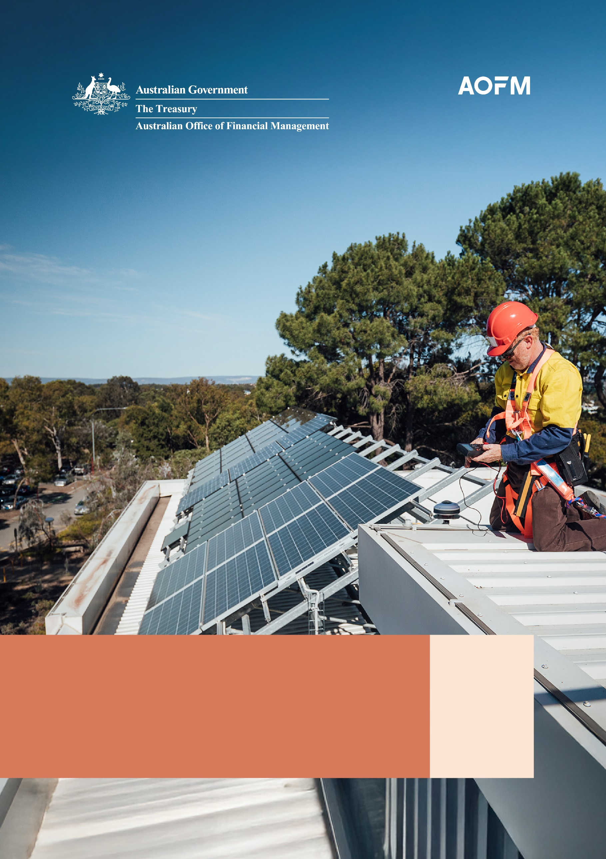
Australian Government Green Treasury Bond Allocation and Impact Report
March 2026

© Commonwealth of Australia 2026
ISBN: 978-1-923278-37-0
This publication is available for your use under a Creative Commons Attribution 4.0 International licence, with the exception of the Commonwealth Coat of Arms, the Commonwealth of Australia logo, photographs, images, third party materials, materials protected by a trademark, signatures and where otherwise stated. The full licence terms are available from creativecommons.org/licenses/by/4.0/legalcode.
Use of Commonwealth of Australia material under a Creative Commons Attribution 4.0 International licence requires you to attribute the work (but not in any way that suggests that Commonwealth of Australia endorses you or your use of the work).
Commonwealth of Australia material used ‘as supplied’
Provided you have not modified or transformed Commonwealth of Australia material in any way including, for example, by changing the [ORG] text; calculating percentage changes; graphing or charting data; or deriving new statistics from published Commonwealth of Australia statistics – then Commonwealth of Australia prefers the following attribution:
Source: The Commonwealth of Australia.
Derivative material
If you have modified or transformed Commonwealth of Australia material, or derived new material from those of the Commonwealth of Australia in any way, then [ORG] prefers the following attribution:
Based on Commonwealth of Australia data.
Use of the Coat of Arms
The terms under which the Coat of Arms can be used are set out on the Department of the Prime Minister and Cabinet website (see www.pmc.gov.au/government/commonwealth-coat-arms).
Other uses
Enquiries regarding this licence and any other use of this document are welcome at:
Manager
Media Unit
The Treasury
Langton Crescent
Parkes ACT 2600
Email: media@treasury.gov.au
Acknowledgement of Country
In the spirit of reconciliation, the Treasury acknowledges the Traditional Custodians of country throughout Australia and their connections to land, sea and community. We pay our respect to their Elders past and present and extend that respect to all Aboriginal and Torres Strait Islander peoples.
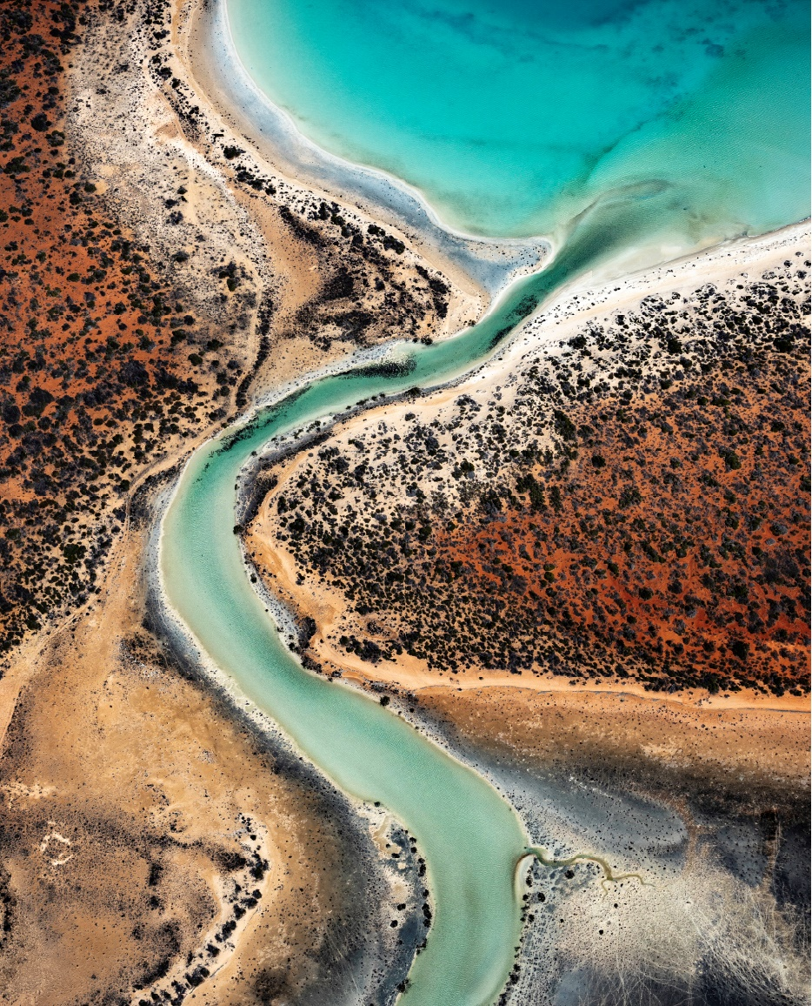 Gathaagudu/Shark Bay, Western Australia, on the Country of the Malgana people, the Traditional Owners of this land and waters.

Contents
Overview viii
Summary of Green Treasury Bonds allocation x
Summary of eligible Australian Green Treasury Bond projects xii
Chapter 1: Australian context 1
Sustainable finance in Australia 2
Climate change mitigation 3
Climate change adaptation 8
Environmental policies and programs 10
Chapter 2: Renewable energy 12
Renewable energy investments 13
Rewiring the Nation 16
Snowy Hydro 21
Regional Hydrogen Hubs 24
Community Batteries 28
Advancing Renewables Program 31
Chapter 3: Energy efficiency 34
Household Energy Upgrades Fund™ 35
Social Housing Energy Performance Initiative 38
Chapter 4: Clean transportation 41
Electric rail infrastructure in the Infrastructure Investment Program 42
Driving the Nation Fund 47
Electric bus charging infrastructure 51
Chapter 5: Climate change adaptation 54
International climate finance projects 55
Chapter 6: Environmentally sustainable management
of living natural resources and land use 63
Urban Rivers and Catchments Program 64
Chapter 7: Biodiversity conservation (terrestrial and aquatic) 67
Saving Koalas Fund 68
Reef 2050 71
Chapter 8: Sustainable water and wastewater management 74
Murray–Darling Basin Plan 75
Chapter 9: Circular economy 80
Recycling Modernisation Fund 81
Chapter 10: Eligibility process and reporting 85
Selection of Eligible Green Expenditures 85
Green Treasury Bonds eligibility window 86
Approach to impact and allocation reporting 86
Statement by the Co-Chairs of the Green Bond Committee 88
Assurance Reports 89
Third party verification 89
Disclaimer 92
Endnotes 94

List of figures
Figure 1: Expenditure of eligible projects by year x
Figure 2: Green Treasury Bond proceeds allocation by expenditure year xi
Figure 3: Allocation of Green Treasury Bond proceeds
by ICMA Green Bond Principles project category xi
Figure 4: Tracking against the 2030 target, 2035 target, 2005 to 2050 4
Figure 5: Australia’s net zero priorities 5
Figure 6: Map of Rewiring the Nation projects 17
Figure 7: Number of SHEPI 2a upgrades around Australia 40
Figure 8: Australian climate finance in the Indo-Pacific 55
Figure 9: Locations of projects managed by the Saving Koalas Fund 70
Figure 10: Eligibility window 86

List of tables
Table 1: Green Treasury Bond Expenditure and Allocation xiii
Table 2: Impacts of Eligible Green Expenditures xv
Table 3: Allocation Data for CEFC Renewable Energy Investments ($ million) 13
Table 4: Impact data for CEFC renewable energy investments 14
Table 5: Allocation Data for Rewiring the Nation ($ million) 18
Table 6: Impact data for Rewiring the Nation 19
Table 7: Social impact data for Rewiring the Nation 20
Table 8: Allocation Data for Snowy 2.0 ($ million) 21
Table 9: Impact data for Snowy 2.0 22
Table 10: Social co-benefits for Snowy 2.0 22
Table 11: Allocation data for Regional Hydrogen Hubs ($ million) 25
Table 12: Impact data for Regional Hydrogen Hubs 26
Table 13: Allocation data for Community Batteries ($ million) 28
Table 14: Impact data for Community Batteries 29
Table 15: Allocation data for the Advancing Renewables Program ($ million) 32
Table 16: Impact data for the Advancing Renewables Program 33
Table 17: Allocation Data for the Household Energy Upgrades Fund™ ($ million) 36
Table 18: Impact data for the Household Energy Upgrades Fund™ 37
Table 19: Allocation Data for the Social Housing Energy Performance Initiative (SHEPI) ($ million) 38
Table 20: Impact data for the Social Housing Energy Performance Initiative 39
Table 21: Allocation Data for Electric Rail Infrastructure Investments ($ million) 42
Table 22: Impact Data for Electric Rail Infrastructure Investments 44
Table 23: Social impact data for electric rail infrastructure investments 44
Table 24: Allocation data for the Driving the Nation Fund ($ million) 47
Table 25: Impact data for the Driving the Nation Fund 48
Table 26: Social impact data for the Driving the Nation Fund 49
Table 27: Allocation Data for Electric bus charging infrastructure ($ million) 51
Table 28: Impact data for Electric bus charging infrastructure 52
Table 29: Social impact data for Electric bus charging infrastructure 52
Table 30: Allocation data for international climate finance projects ($ million) 56
Table 31: Impact data for international climate finance projects 59
Table 32: Further information on international climate finance sub-projects 60
Table 33: Allocation Data for the Urban Rivers and Catchments Program ($ million) 64
Table 34: Impact Data for the Urban Rivers and Catchments Program 65
Table 35: Allocation Data for the Saving Koalas Fund ($ million) 68
Table 36: Impact Data for the Saving Koalas Fund 69
Table 37: Allocation Data for Reef 2050 ($ million) 71
Table 38: Impact data for Reef 2050 73
Table 39: Allocation Data for the Murray–Darling Basin Plan ($ million) 77
Table 40: Impact Data for the Murray–Darling Basin Plan 79
Table 41: Allocation Data for the Recycling Modernisation Fund ($ million) 81
Table 42: Impact Data for the Recycling Modernisation Fund 82
Table 43: Social impact data for the Recycling Modernisation Fund 82
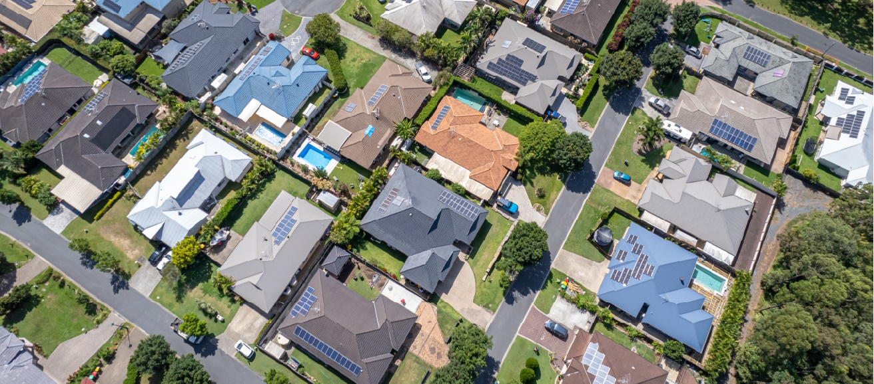

Overview
Green bonds help finance Australian Government and delivery partner actions aimed at reducing the impact of climate change and protecting the environment. Issuing sovereign green bonds is a key priority under Australia’s Sustainable Finance Roadmap. Green Treasury Bonds (GTBs) help to mobilise the significant private capital required to achieve net zero and maximise the economic opportunities associated with energy, climate and sustainability goals.
Australia’s sovereign Green Bond Program has performed well since its first issuance in June 2024 with the program attracting broad support from a diverse investor base, including new and existing investors.
The program has been nominated for multiple awards for excellence in delivery, including winning Environmental Finance’s 2025 Green Bond of the Year – sovereign award. The GTB was recognised by market participants with the Kanganews Awards 2024 Australian Dollar Rates Bond Deal of the Year and the Australian Sustainability Bond Deal of the Year.
Following the initial $7 billion issue of the June 2034 GTB, the Australian Office of Financial Management (AOFM) has gradually increased the size of the bond line through a series of tenders which further support liquidity in the bond line. As at 30 June 2025, there were $9 billion of GTBs on issue. GTBs on issue subsequently increased to $10 billion as at 31 December 2025.
The AOFM plans to introduce a new GTB line every 2 to 3 years, with the next new line expected to be issued in 2026. Between launches of new GTB lines, the AOFM will continue to conduct smaller tenders into existing GTB lines. All issuance, including new lines and tenders into existing GTB lines are collectively referred to as GTBs or GTB proceeds.
The Green Bond Framework outlines how bonds are issued, including the basis for identifying, selecting, managing, and reporting expenditures and allocating GTB proceeds. The Green Bond Framework defines supported projects and programs as Eligible Green Expenditures. These expenditures must strongly align with one or more of the Green Bond Program’s 3 green goals.
- Climate Change Mitigation: contributing to Australia’s net zero transformation and emissions reduction targets.
- Climate Change Adaptation: adapting to climate risks and building our national resilience to climate impacts.
- Improved Environmental Outcomes: achieving national biodiversity targets and Australia’s nature positive objective.
The Green Bond Framework was deemed ‘credible and impactful’ and aligned to International Capital Market Association’s (ICMA) Green Bond Principles by Sustainalytics in its December 2023 Second Party Opinion. Proposed new Eligible Green Expenditures undergo a pre-issuance review for alignment with the Green Bond Framework. This was most recently conducted by Sustainalytics in October 2025. Annual allocation and impact reports are verified externally, in accordance with the Framework. Key program documents and reporting are available on the AOFM’s website.
The Green Bond Program is delivered by the Australian Treasury in partnership with the AOFM and is overseen by the interdepartmental Green Bond Committee. The Green Bond Committee anticipates the next review of the Framework will consider the Australian Sustainable Finance Taxonomy released in June 2025. The taxonomy was developed with government support by the Australian Sustainable Finance Institute as part of Australia’s Sustainable Finance Roadmap.
This publication is the second annual report, following the inaugural Green Treasury Bonds Allocation and Impact Report published in February 2025. New programs and projects added to the Green Bond Program include:
- Snowy Hydro – Snowy 2.0
- Social Housing Energy Performance Initiative
- Electric bus charging infrastructure
- Recycling Modernisation Fund.
Programs expected to be included in future reporting include the Australian Government’s Cheaper Home Batteries Program which commenced on 1 July 2025.
This report has been endorsed by the Green Bond Committee. The Australian National Audit Office (ANAO) has conducted a limited assurance of allocation reporting and Sustainalytics reviewed the impact reporting and alignment to international best practice.
This report is divided into:
- The Overview provides a summary of the report’s allocation and impact reporting.
- Chapter 1 highlights the Australian context and efforts to implement policies pursuing climate change mitigation, climate change adaptation and improved environmental outcomes.
- Chapters 2 to 9 detail allocation and impact data by ICMA Green Bond Principles categories for each Eligible Green Expenditure, including case studies.
- Chapter 10 and the final sections include further information on the Green Bond Program and assurances undertaken for this report.

Summary of Green Treasury Bonds allocation
Over the Australian financial year 2024–25, $6.608 billion has been spent on projects considered Eligible Green Expenditures under the Green Bond Framework. As shown in Figure 1, this represents an increase in expenditure on 2022–23 and 2023–24 levels and brings the total expenditure to $12.017 billion.

Figure 1: Expenditure of eligible projects by year
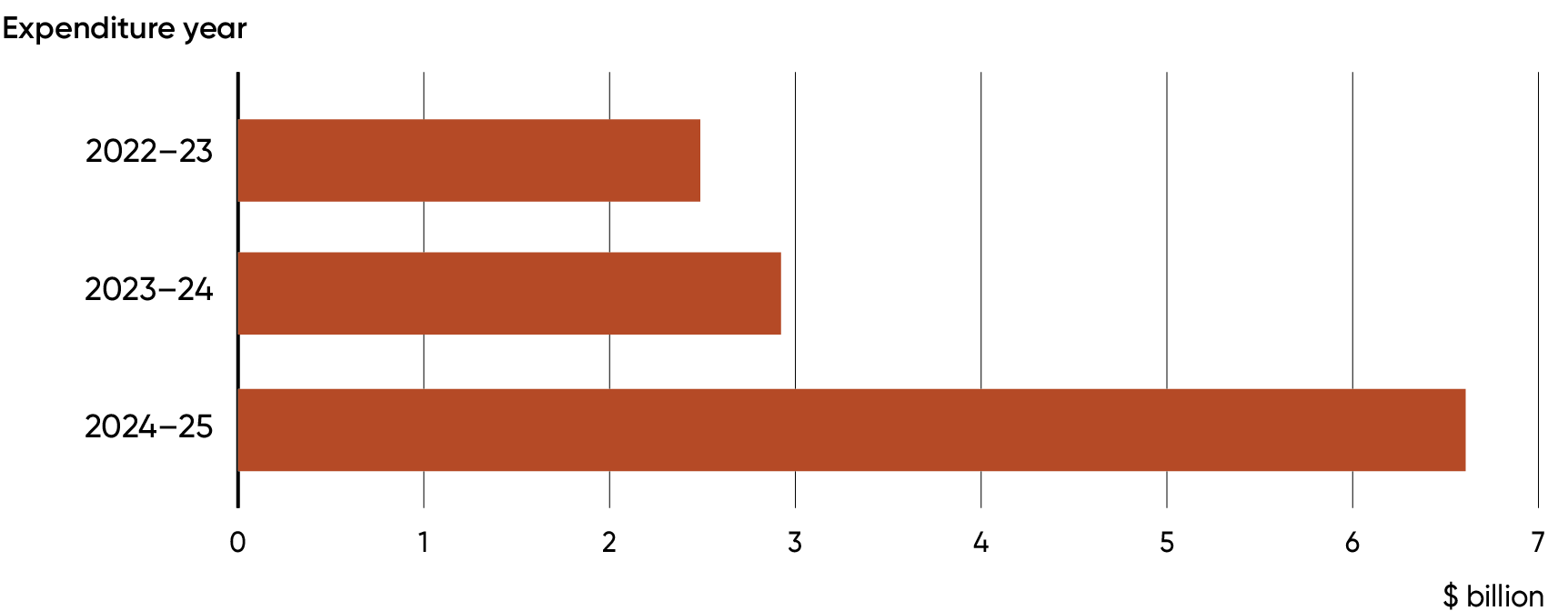
Through the Green Bond Program, the $6.608 billion of 2024–25 expenditure has been allocated $1.560 billion of 2023–24 GTB proceeds and $2.016 billion of 2024–25 GTB proceeds. The remaining $3.031 billion of 2024–25 expenditure is available to be allocated to in future allocation and impact reports.
Figure 2 outlines to which year of expenditure the $9 billion of GTB proceeds issued by AOFM to 30 June 2025 have been allocated. $5.409 billion of proceeds from the $7 billion 2023–24 issuance were allocated to 2022–23 and 2023–24 expenditure in the 2025 Report. Through this 2026 Report, the remaining GTB proceeds of $1.560 billion from 2023–24 issuance and $2.016 billion from 2024–25 have been allocated to 2024–25 expenditure.
The total allocation in this report is $3.576 billion. All GTB proceeds from issuance to 30 June 2025 have been fully allocated.

Figure 2: Green Treasury Bond proceeds allocation by expenditure year
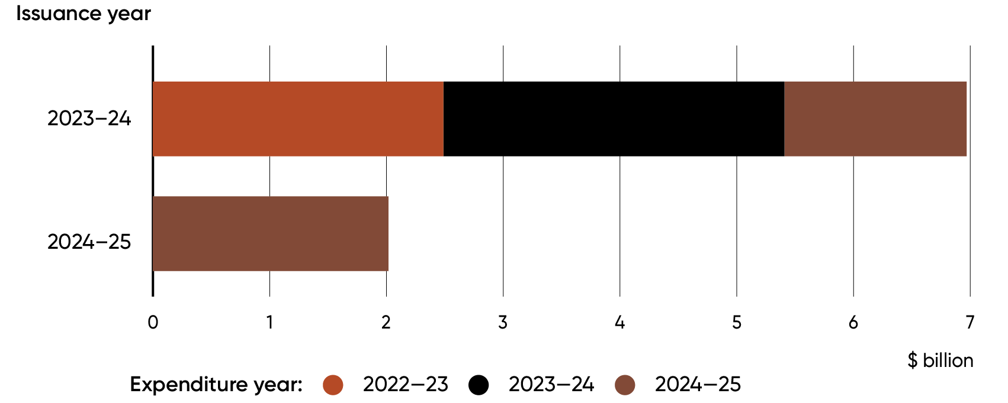
As the $3.576 billion in GTB proceeds to allocate is less than the $6.608 billion of expenditure in
2024–25, a pro-rata approach was used to allocate proceeds to each individual eligible project. The pro-rata rate used is 54.1 per cent. The $3.576 billion of GTB proceeds allocated to expenditure in this report is split among ICMA’s Green Bond Principles’ ‘Use of Proceeds’ categories as shown in Figure 3.

Figure 3: Allocation of Green Treasury Bond proceeds by ICMA Green Bond Principles project category
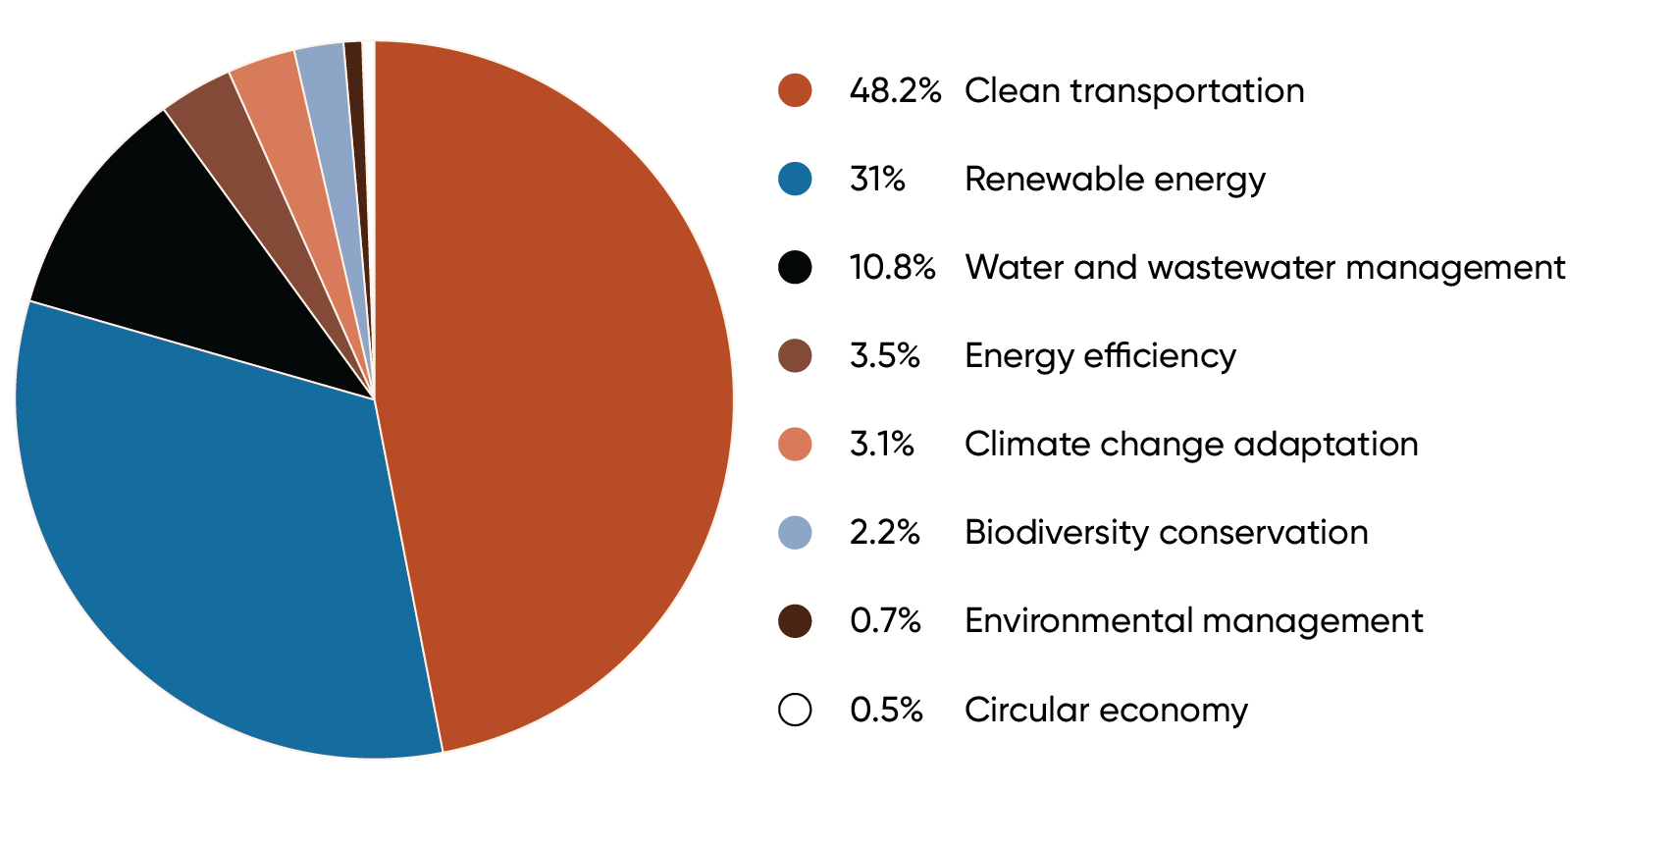

Summary of eligible Australian Green Treasury Bond projects
Table 1 reports the Australian Eligible Green Expenditure projects, their ICMA Green Bond Principles category, their alignment with Green Bond Program goals, their mapping to UN Sustainable Development Goals and a summary of expenditure and allocation data. Expenditure refers to the amount of money spent on a given Eligible Green Expenditure by the government. Allocation refers to the assigning of proceeds from bond issuance to the expenditure. Proceeds are the monies raised by the AOFM in the sale of GTBs.
There is $6.608 billion of expenditure in 2024–25 that can be allocated to, and $3.576 billion in GTB proceeds to allocate. When expenditure exceeds proceeds, industry practice is for the allocation and impact reporting to be considered on a pro-rata basis. The pro-rata rate for allocation of GTB proceeds to 2024–25 expenditure through this report is 54.1 per cent and is reflected in the difference between ‘Expenditure 2024–25’ and ‘Allocation 2026 report’ in Table 1.
The allocation data is presented as follows:
- ‘Previous expenditure’ is the total expended on an Eligible Green Expenditure in 2022–23 (the earliest year within the eligibility window of the inaugural GTB issuance) and 2023–24
- ‘Previous allocation’ is the total allocated to Eligible Green Expenditures from 2022–23 to
2023–24. ‘Previous allocation’ matches ‘Previous expenditure’ as all expenditure prior to 2024–25 has been fully allocated to
- ‘Expenditure 2024–25’ is the amount expended on an Eligible Green Expenditure in 2024–25. Total expenditure can be found by summing ‘Previous expenditure’ and ‘Expenditure 2024–25’
- ‘Allocation 2026 report’ is the allocation made to 2024–25 expenditure in this report
- ‘Total allocation’ is the sum of ‘Previous allocation’ and ‘Allocation 2026 report’.
Table 2 reports the associated impacts of the Eligible Green Expenditures. Impact data refers to the measurable outcomes associated with projects financed by GTBs. Impact data can be projected when impacts are expected to be in the future, for example, once a train line is built, or recorded when the impact has been measured or observed.
Only Eligible Green Expenditures with expenditure between July 2022 and June 2025 are included in these tables. See AOFM’s website for the full up-to-date list of indicative Eligible Green Expenditures.
See Chapter 10 for further information on the approach to impact and allocation reporting.
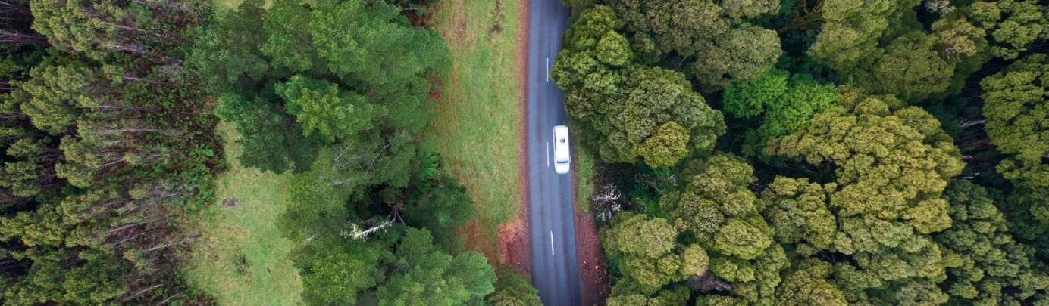

Table 1: Green Treasury Bond Expenditure and Allocation
ICMA Green Bonds Principles Category | Program Goal | Eligible Green  Expenditure | UN Sustainable  Development Goal | Previous expenditure ($m) | Previous allocation ($m) | Expenditure 2024–25  ($m) | Allocation 2026 report ($m) | Total allocation ($m)
Renewable energy | Climate change mitigation | CEFC Renewable Energy Investments | 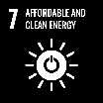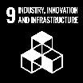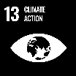 | 422.1 | 422.1 | 311.8 | 168.8 | 590.9
Renewable energy | Climate change mitigation | Rewiring the Nation |  | 5.0 | 5.0 | 1,515.0 | 820.0 | 825.0
Renewable energy | Climate change mitigation | Snowy Hydro Limited |  | - | - | 150.0 | 81.2 | 81.2
Renewable energy | Climate change mitigation | Regional Hydrogen Hubs |  | 35.5 | 35.5 | 25.1 | 13.6 | 49.1
Renewable energy | Climate change mitigation | Community Batteries |  | 13.7 | 13.7 | 14.3 | 7.7 | 21.4
Renewable energy | Climate change mitigation | Advancing Renewables Program |  | 305.6 | 305.6 | 133.7 | 72.4 | 378.0
Energy efficiency | Climate change mitigation | Household Energy Upgrades Fund™ | 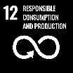 | 5.0 | 5.0 | 161.5 | 87.4 | 92.4
Energy efficiency | Climate change mitigation | Social Housing Energy Performance Initiative | 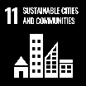 | - | - | 62.6 | 33.9 | 33.9

ICMA Green Bonds Principles Category | Program Goal | Eligible Green  Expenditure | UN Sustainable  Development Goal | Previous expenditure ($m) | Previous allocation ($m) | Expenditure 2024–25  ($m) | Allocation 2026 report ($m) | Total allocation ($m)
Clean transportation | Climate change mitigation | Electric rail infrastructure in the Infrastructure Investment Program |  | 3,365.9 | 3,365.9 | 3,041.6 | 1,646.2 | 5,012.1
Clean transportation | Climate change mitigation | Driving the Nation Fund |  | 37.3 | 37.3 | 37.5 | 20.3 | 57.6
Clean transportation | Climate change mitigation | Electric bus charging infrastructure |  | - | - | 35.0 | 18.9 | 18.9
Climate change adaptation | Climate change adaptation | International Climate Finance |  | 232.9 | 232.9 | 200.1 | 108.3 | 341.2
Environmentally sustainable management of living natural resources and land use | Improved Environmental Outcomes | Urban Rivers and Catchments Program | 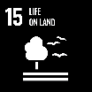 | 1.6 | 1.6 | 45.3 | 24.5 | 26.1
Biodiversity conservation (terrestrial and aquatic) | Improved Environmental Outcomes | Saving Koalas Fund |  | 24.8 | 24.8 | 14.1 | 7.6 | 32.4
Biodiversity conservation (terrestrial and aquatic) | Improved Environmental Outcomes | Reef 2050 | 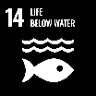 | 88.2 | 88.2 | 128.7 | 69.7 | 157.9
Sustainable water and wastewater management | Improved Environmental Outcomes | Murray–Darling Basin Plan | 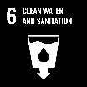 | 871.6 | 871.6 | 698.6 | 378.1 | 1,249.7
Circular Economy (waste management) | Improved Environmental Outcomes | Recycling Modernisation Fund |  | - | - | 32.8 | 17.8 | 17.8
Total (a) |  |  |  | 5,409.2 | 5,409.2 | 6,607.6 | 3,576.2 | 8,985.4
- Due to rounding, discrepancies may occur between sums of the component items and totals.

Table 2: Impacts of Eligible Green Expenditures
ICMA Green Bond Principles Category | Program goal | Eligible Green Expenditure | Impact metrics | Data | Projected / Recorded | Time Period
Renewable energy | Climate change mitigation | CEFC Renewable Energy Investments | Emissions avoided (kt CO2-e p.a.) | 400 | Projected | 25+ years from operation
Renewable energy | Climate change mitigation | CEFC Renewable Energy Investments | Renewable energy generation (GWh p.a.) | 4,100 | Projected | 25+ years from operation
Renewable energy | Climate change mitigation | CEFC Renewable Energy Investments | Energy storage capacity (MW/MWh) | 2,088 / 5,357 | Projected | 20 years
Renewable energy | Climate change mitigation | Rewiring the Nation | Increase in network capacity (MW) | 7,450 | Projected | From completion
Renewable energy | Climate change mitigation | Snowy Hydro Ltd | Energy storage capacity (MW/MWh) | 2,200 / 350,000 | Projected | From completion
Renewable energy | Climate change mitigation | Regional Hydrogen Hubs | Hydrogen produced (ktH₂/year) | 115.2 | Projected | Annually once all hubs complete
Renewable energy | Climate change mitigation | Community Batteries | Energy storage capacity (MW/MWh) | 5.1/12.0 | Recorded | 2024–25
Renewable energy | Climate change mitigation | Community Batteries | Number of Community Batteries deployed | 31 | Recorded | 2024–25
Renewable energy | Climate change mitigation | Advancing Renewables Program | Number of renewable energy projects funded | 88 | Recorded | 2024–25
Energy efficiency | Climate change mitigation | Household Energy Upgrades Fund™ | Number of concessional loans financed | 1,508 | Recorded | 2024–25
Energy efficiency | Climate change mitigation | Household Energy Upgrades Fund™ | Energy efficient technologies financed | 3,843 | Recorded | 2024–25
Energy efficiency | Climate change mitigation | Household Energy Upgrades Fund™ | Emissions avoided (kt CO2-e p.a.) | 50 | Projected | 10–20 years
Energy efficiency | Climate change mitigation | Social Housing Energy Performance Initiative | Number of dwellings with energy performance upgrades | Over 20,000 | Recorded | 2023–24 and 2024–25
 |  |  |  | Over 100,000^{(a)} | Projected | 2023–24 to 2028–29
Clean transportation | Climate change mitigation | Electric rail infrastructure in the Infrastructure Investment Program | Anticipated km of rail built or upgraded | 72.0 | Recorded | 2018–2025
 |  |  |  | 103.4^{(b)} | Projected | 2020–2028
Clean transportation | Climate change mitigation | Driving the Nation Fund | EV charging sites delivered | 17 | Recorded | 2024–25
Clean transportation | Climate change mitigation | Driving the Nation Fund | EV charging plugs approved for rebate | 244 | Recorded | January – April 2025
Clean transportation | Climate change mitigation | Electric bus charging infrastructure | Number of electric bus chargers installed | 16 | Recorded | 2024–25
Clean transportation | Climate change mitigation | Electric bus charging infrastructure | Emissions avoided (kt CO₂-e p.a.) | 0.440 | Recorded | 2024–25
Climate change adaptation | Climate change adaptation | International Climate Finance | Number of bilateral, regional and multilateral investments financed for environmental protection, biodiversity conservation and climate protection | 21 | Recorded | 2024–25
Environmentally sustainable management of living natural resources and land use | Improved Environmental Outcomes | Urban Rivers and Catchments Program | No. of EPBC-listed species benefited | 76 | Projected | 2025–June 2028
 | Improved Environmental Outcomes | Urban Rivers and Catchments Program | No. of EPBC-listed Threatened Ecological Communities benefited | 19 | Projected | 2025–June 2028
 | Improved Environmental Outcomes | Urban Rivers and Catchments Program | No. of Ramsar-listed wetlands benefited | 9 | Projected | 2025–June 2028
Biodiversity conservation (terrestrial and aquatic) | Improved Environmental Outcomes | Saving Koalas Fund | Number of grants made to community organisations | 59 | Recorded | 2022–2025
Biodiversity conservation (terrestrial and aquatic) | Improved Environmental Outcomes | Saving Koalas Fund | Additions and improvements to, and management of, land used as koala habitat (ha) | 5,564 | Recorded | 2022–2025
Biodiversity conservation (terrestrial and aquatic) | Improved Environmental Outcomes | Saving Koalas Fund | Number of koala population surveys conducted | 820 | Recorded | 2022–2025
Biodiversity conservation (terrestrial and aquatic) | Improved Environmental Outcomes | Reef 2050 | Reduction of anthropogenic dissolved inorganic nitrogen load leaving Great Barrier Reef catchments (per cent) | 28.4 | Recorded | As at June 2022
Biodiversity conservation (terrestrial and aquatic) | Improved Environmental Outcomes | Reef 2050 | Reduction of anthropogenic fine sediment load leaving Great Barrier Reef catchments (per cent) | 16.0 | Recorded | As at June 2022
Biodiversity conservation (terrestrial and aquatic) | Improved Environmental Outcomes | Reef 2050 | Reduction of anthropogenic particulate nitrogen load leaving Great Barrier Reef catchments (per cent) | 15.4 | Recorded | As at June 2022
Biodiversity conservation (terrestrial and aquatic) | Improved Environmental Outcomes | Reef 2050 | Reduction of anthropogenic particulate phosphorus load leaving Great Barrier Reef catchments (per cent) | 18.5 | Recorded | As at June 2022
Biodiversity conservation (terrestrial and aquatic) | Improved Environmental Outcomes | Reef 2050 | Pesticide risk condition – aquatic species unlikely to experience harmful effects from pesticides (per cent) | 95.0 | Recorded | 2022
Biodiversity conservation (terrestrial and aquatic) | Improved Environmental Outcomes | Reef 2050 | Proportion of grazing lands with greater than 70 per cent ground cover in the late dry season (per cent) | 92.0 | Recorded | 2022
Sustainable water and wastewater management | Improved Environmental Outcomes | Murray–Darling Basin Plan | Surface water registered to Commonwealth (GL/y) | 11.3 | Recorded | FY2024–25
Sustainable water and wastewater management | Improved Environmental Outcomes | Murray–Darling Basin Plan | Surface Water registered for environmental use (GL/y) | 26.9 | Recorded | FY2024–25
Sustainable water and wastewater management | Improved Environmental Outcomes | Murray–Darling Basin Plan | Proportion of surface water allocation (in Commonwealth accounts) forfeited (per cent) | <5 | Recorded | FY2024–25
Circular Economy (waste management) | Improved Environmental Outcomes | Recycling Modernisation Fund | Number of waste management projects completed | 22 | Recorded | FY2024–25
Circular Economy (waste management) | Improved Environmental Outcomes | Recycling Modernisation Fund | Additional waste processing capacity (tonnes p.a.) | 105,200 | Projected | Once fully operational
- The projected number of dwellings with energy performance upgrades includes the over 20,000 recorded number of dwellings with energy performance upgrades.
- The projected anticipated km of rail built or upgraded includes the 72.0 km of recorded rail built or upgraded.

Chapter 1: Australian context
Australia’s environment is a vital part of its national identity and underpins our economy and wellbeing. It is the habitat for nearly 600,000 native species and home to one of the oldest living cultures on earth. First Nations people have cared for Country for over 60,000 years.
The Australian Government acknowledges the need to protect the environment from the impacts of climate change. It is committed to the Paris Agreement goal of holding global average temperature increases to well below 2°C above pre-industrial levels and pursuing efforts to limit the increase to 1.5°C. It has committed to a 43 per cent reduction below 2005 levels by 2030, and net zero by 2050. In September 2025 Australia announced a 2035 emission reduction target of 62 to 70 per cent below 2005 levels. This target was informed by independent advice from the Climate Change Authority and Treasury modelling.
Climate change impacts are already imposing social and economic costs on Australians and the environment. Over the past year, the evidence base of existing and projected impacts has been improved with publishing of the first National Climate Risk Assessment. Publication of the first National Adaptation Plan will also help guide the government’s policy responses.
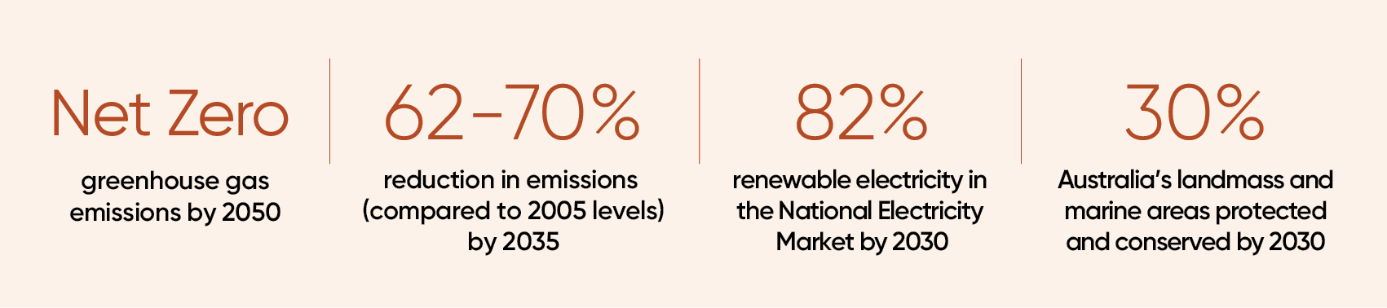
Australia remains committed to limiting global warming and reducing climate impacts by leading negotiations for COP31, meeting its committed 2030 and 2035 emissions reductions targets and adapting to protect Australians’ way of life. Australia is committed to investing in targeted climate change mitigation and adaptation solutions, including the Net Zero Plan, 6 sectoral plans, and continuing to invest in the Future Made in Australia.
Achieving Australia’s climate and environmental objectives will require a significant amount of private and public investment. Over 130 ASX200 companies have net zero commitments. Demand is growing from investors to drive decarbonisation, leverage the opportunities of a net zero economy, improve climate change adaptation measures and protect the environment.

Sustainable finance in Australia
A strong sustainable finance framework helps remove barriers to private capital flowing where it’s needed to achieve the net zero transformation. Sustainable finance reforms help investors and companies invest efficiently and take advantage of opportunities in the transition to net zero.
The sustainable finance market in Australia continues to develop, with the voluntary Australian Sustainable Finance Taxonomy released in June 2025. Sustainable finance issuance in the Australian market was $48.3 billion in 2024 and $37.4 billion in 2025. Consistent levels of issuance show continued strong interest from both issuers and investors in accessing the Australian market through labelled products.
The Government is also delivering sustainable finance reforms outlined under the Sustainable Finance Roadmap (the Roadmap). Issuance of GTBs is priority 9 of the Roadmap. Other Roadmap initiatives include mandatory climate-related financial disclosures for large businesses and financial institutions, which phased in from 1 January 2025. This requires large Australian businesses and financial institutions to prepare a ‘sustainability report’ which must follow reporting requirements in the Australian Sustainability Reporting Standards (AASB S2). The AASB S2 largely aligns with International Sustainability Standards Board’s IFRS S2 climate-related disclosures.
The Roadmap also includes the Australian Sustainable Finance Taxonomy a voluntary framework classifying economic activities that contribute to sustainability objectives, launched in June 2025. It defines ‘green’ and ‘transition’ activities to help guide private sector capital toward investments supporting the transition to net zero.
Voluntary best-practice guidance is under development for organisations considering climate-related transition plans and the government has undertaken consultation on a labelling regime for investment products marketed as ‘sustainable’ or similar.

Climate change mitigation
The world is undergoing its biggest and fastest economic transformation since the Industrial Revolution. The Australian Government recognises the need to invest in climate change mitigation to reduce greenhouse gas emissions and move towards net zero. Action to reduce emissions will help prevent the worst impacts and costs of climate change. Taking strong climate change action to reach net zero emissions will help deliver a safer future and more prosperous economy.
International cooperation is essential for managing the collective challenge of climate change. The world is still moving towards net zero. More than 84 per cent of global GDP is covered by net zero commitments.
For a comprehensive overview of Australia’s decarbonisation progress and reporting on the Government’s initiatives, programs and plans to support Australia’s path to net zero emissions, please see the Annual Climate Change Statement 2025.
Climate change commitments
Australia is committed to:
- a single year target to reduce greenhouse gas emissions to 43 per cent below 2005 levels by 2030, and a multi-year emissions budget of 4,353 Mt carbon dioxide-equivalent (CO2-e) between 2021 and 2030
- a reduction of 62–70 per cent below 2005 levels by 2035 and a multi-year budget consistent with this target (indicative values of 1,248 to 1,395 Mt CO2-e over the period 2031–35)
- net zero by 2050.

Progress towards climate change commitments
Australia’s Emissions Projections 2025 show that emissions in 2025 were 437 Mt CO₂-e, 29 per cent below 2005 levels. Australia’s emissions in 2024 were 446 Mt CO₂-e.
The baseline projections, which include policies that have been implemented, project Australia’s emissions will be 42 per cent below 2005 levels in 2030 – just shy of the national point-in-time target of 43 per cent. This represents a slight decrease compared to 2024’s Emissions Projections which projected a 42.6 per cent decline on 2005 levels in 2030. Australia’s emissions outlook will continue to improve as more significant climate change mitigation policies are implemented.

Figure 4: Tracking against the 2030 target, 2035 target, 2005 to 2050
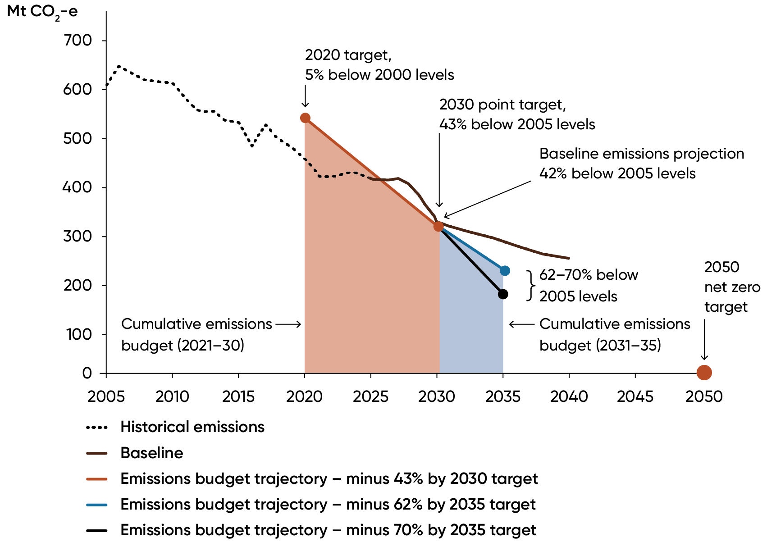
Source: DCCEEW (2025), Australia’s Emissions Projections 2025
The projections show that under the baseline scenario, Australia is on track to meet its 2030 target on an emissions budget basis (equivalent to total emissions over a period of time). To meet its ambitious but achievable 2035 target on a budget basis, Australia will need to further reduce its emissions over 2031–2035 by 283-429 Mt CO₂-e.

The Net Zero Plan
In September 2025, the Australian Government released the Net Zero Plan (the Plan) along with 6 sectoral plans, to pursue the opportunities in and guide Australia’s transition to net zero. All sectors must reduce emissions from current levels for Australia to reach net zero.
The Plan identifies 5 decarbonisation priorities for Australia to achieve net zero:
- clean electricity across the economy
- lowering emissions by electrification and efficiency
- expanding clean fuel use
- accelerating new technologies
- net carbon removals scaled up.

Figure 5: Australia’s net zero priorities
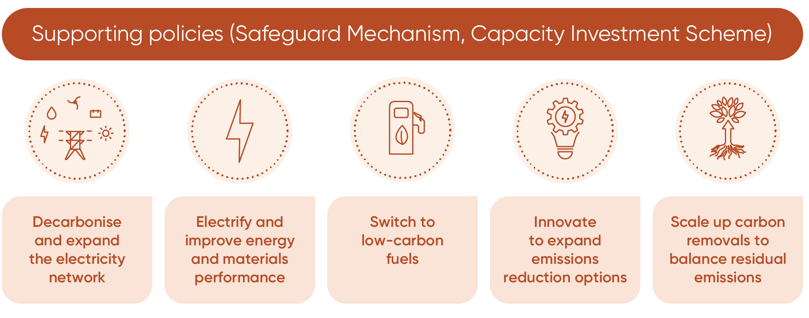
The 2035 target and the Government’s Net Zero Plan are underpinned by 6 sectoral decarbonisation plans. The pathway for each sector differs. Some sectors will use tried and tested solutions that require coordinated action, other sectors need innovation and investment.
The heavy lifting for emissions reduction is occurring in the decarbonisation of the energy sector, which will assist other sectors to decarbonise as they electrify or shift to clean fuel or new technologies.
The 6 sector emissions reduction plans supporting the Net Zero Plan are:
- electricity and energy
- agriculture and land
- the built environment
- industry
- resources
- transport.

Safeguard Mechanism
The Safeguard Mechanism is the Australian Government’s policy for reducing emissions at Australia’s largest industrial facilities. The Safeguard Mechanism applies to industrial facilities emitting more than 100,000 tonnes of CO₂-e per year.
It sets legislated limits – known as baselines – on the greenhouse gas emissions of these facilities. The emissions limits decline predictably and gradually. These limits will help achieve Australia’s emission reduction targets and net zero by 2050.
Over the 2024–25 compliance period, 207 facilities were covered by the Safeguard Mechanism. Covered emissions reduced by 2.4 per cent from 135.9 million tonnes of carbon dioxide equivalent (MtCO2-e) in 2023–24 to 132.7 MtCO2-e in 2024–25.
The Safeguard Mechanism is administered by the Clean Energy Regulator which has reported the scheme is operating as intended to encourage safeguard facilities to progressively reduce their industrial emissions at source. The Safeguard Mechanism is due for review in 2026–27.

Future industries
In addition to domestic decarbonisation policies, Australia has an important role in the global transition to net zero and is in a strong position to benefit from the opportunities it presents. Most of Australia’s exports go to economies with net zero commitments, and competition to attract investment in net zero industries is increasing.
World-class renewable energy and mineral resources, a highly skilled population and a track record as a reliable trading partner, position Australia well to be a major beneficiary of these global shifts and become a renewable energy superpower.
The Future Made in Australia agenda takes steps to encourage the significant private sector investment needed to harness global net zero transformation opportunities and ensure Australia’s future prosperity (see Box 1: A Future Made in Australia).
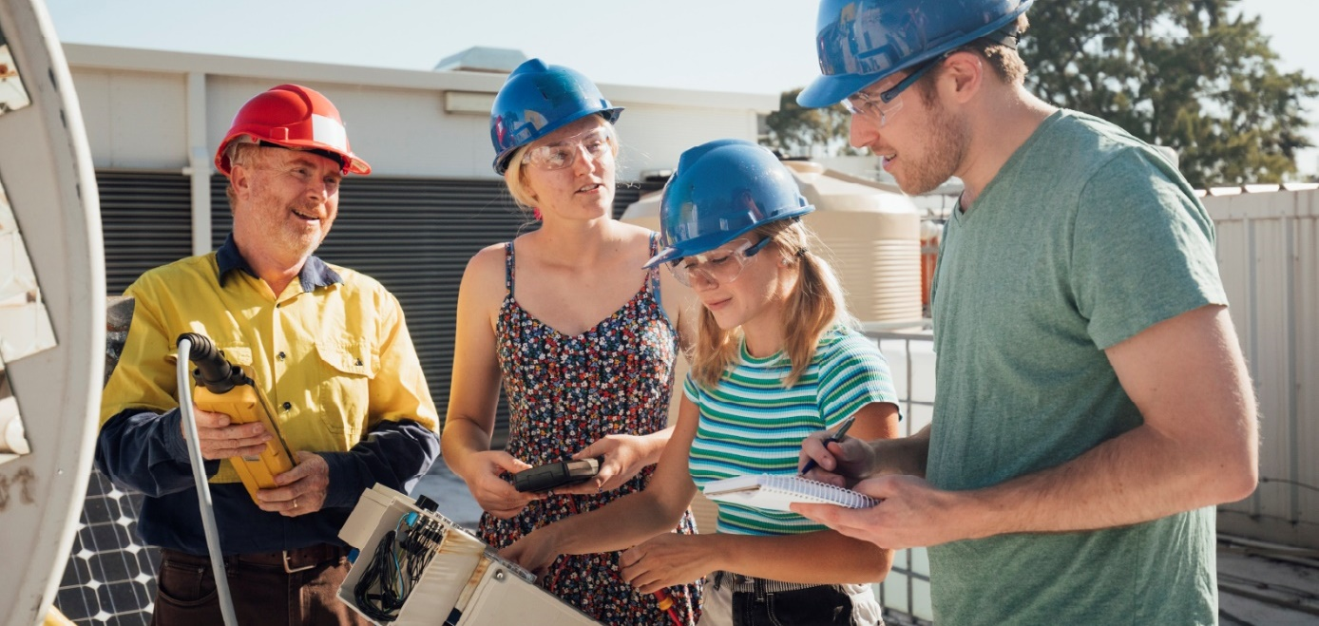

Box 1: A Future Made in Australia
In the 2024–25 Budget, the Government announced $22.7 billion for a Future Made in Australia agenda. The focus is on attracting private sector investment to maximise the economic and industrial benefits of the move to net zero and secure Australia’s place in a changing global economic and strategic landscape.
The Future Made in Australia Act 2024 (the Act) commenced on 10 December 2024. The Act establishes a National Interest Framework to support the Australian Government’s consideration and decision-making in relation to significant public investment that unlocks private investment in the national interest.
The National Interest Framework’s ‘net zero transformation’ stream relates to industries that:
- are expected to have a sustained comparative advantage in a net zero global economy
- where public investment is likely to be needed for the sector to make a significant contribution to emissions reduction at an efficient cost.
Four industries have been identified as being aligned with the net zero transformation stream:
- Renewable hydrogen
- Green metals
- Low carbon liquid fuels
- Clean energy manufacturing (including battery and solar panel supply chains).
The Australian Government has also established a new front door for investors with major transformational investment proposals related to Future Made in Australia. This will make it simpler to invest in Australia and will help attract more global and domestic capital.
The Sustainable Finance Roadmap also supports private capital flows aligned with a strong net zero future.

Climate change adaptation
Even with strong global action to reduce emissions, the impacts of climate change are already being felt and will continue to increase over the coming decades due to past greenhouse gas emissions.
To help manage increasing risks arising from climate change, Australia needs to consider adaptation actions, enable more private sector investment and support people and communities in disproportionately vulnerable situations.
Successful climate change adaptation should be place-based, community-led and values-driven. Governments, households, businesses, and community organisations all have a role, and decisions should be underpinned by science and analysis.
Domestic climate change adaptation action takes many forms that can include:
- protecting species and managing resources so the natural environment can endure and overcome climate change impacts
- upgrading infrastructure, including buildings and transport systems, to better withstand heatwaves and extreme weather events
- supporting the wellbeing of Australians most impacted by climate change, especially those who face increasing disasters, extreme temperatures and severe weather events.
The Australian Government released its first National Climate Risk Assessment and National Adaptation Plan in September 2025. These provide a framework to guide decisions about adapting to increasing climate risks.
The Australian, state and territory, and local governments are taking steps to advance adaptation actions. All Australian states and territories have progressed adaptation plans, either as standalone strategies or part of a broader climate plan. State and territory governments are primarily responsible for delivering adaptation responses in service delivery and infrastructure, including emergency services, health systems, the natural environment, planning and transport.
The Australian Government is funding action to respond to future climate risks, with $3.6 billion committed to adaptation and resilience measures since 2022 and around $9 billion out to 2030. Key adaptation programs already underway include:
- the Disaster Ready Fund is the government’s program for disaster resilience and risk reduction, providing up to $1 billion over five years from July 2023 to 2028. The program aims to support projects that address the physical and social impacts of disasters on Australian communities. In 2023–24 and 2024–25, up to $400 million was invested in projects around Australia, with another $200 million to be invested in 2025–26.
- continuing the Regional Investment Corporation (RIC) with an additional $1 billion in loan funding and broadening the RIC’s loan scope to include assistance for improving climate resilience, boosting sector productivity, and supporting agriculture in the net zero transition.
- investing $250 million in the Saving Australia’s Bushland Program over the next 5 years to boost conservation, contributing to the 30 by 30 target.
The Australian Government is also providing international finance to support adaptation. This funding is laid out through the climate change adaptation category of the 2024–25 GTB Allocation and Impact Report has been directed to supporting our near-neighbours to address their climate challenges.

Box 2: National Climate Risk Assessment and National Adaptation Plan
The National Climate Risk Assessment (the Assessment) details the ongoing and intensifying impact climate change will have on Australian communities and ecosystems. It provides an objective evidence base for decision making to help government, industry and communities conduct their own climate risk assessments and take adaptation actions.
The Assessment found:
- droughts are expected to increase in frequency and severity
- fire seasons will continue to increase in duration and severity, particularly in south-east Australia
- sea-levels around Australia will continue to rise, worsening coastal flooding and erosion.
The National Adaptation Plan establishes a framework for adapting to these risks. It provides guidance on how Australia can adapt to climate risks and build national resilience to climate impacts. The Plan creates the framework to drive change by responding to climate risks in key areas by:
- ‘mainstreaming’ adaptation action
- driving private sector investment
- supporting people and communities in disproportionately vulnerable situations.
The Plan also helps further embed management of climate risks as part of business-as-usual work in government, organisations and communities and by individuals across Australia.

Environmental policies and programs
Australia is committed to protecting and conserving its unique biodiversity and ecosystems through key reforms and programs. Australia’s natural environment and iconic places are under increasing threat. The pressures on the environment are significant – including land-use change, habitat loss and degradation, feral animals and invasive plant species. The impact of climate change on the environment will exacerbate pressures and contribute to further decline.
Healthy ecosystems help to regulate climate and supply the food, fibres and medicines essential for our health, wellbeing and livelihoods. The Australian Government is committing funding across a broad range of programs that build a strong foundation for ecosystem resilience and restoration. These programs include the Threatened Species Action Plan 2022–2032, Saving Native Species, the Nature Repair Market, the Murray-Darling Basin Plan and the Reef 2050 Long-term Sustainability.
Australia’s main national environmental legislation, the Environment Protection and Biodiversity Conservation Act 1999 (EPBC Act), provides the legal framework to help protect and manage matters of national environmental significance.
The Australian Government’s reforms to the EPBC Act will deliver:
- stronger environmental protection and restoration
- more efficient and robust project assessments
- greater accountability and transparency in decision making.
This will better protect Australia’s natural environment while supporting national priorities such as improving productivity and delivering homes, jobs, clean energy and economic prosperity.
These reforms will also create a National Environmental Protection Agency (National EPA). This will bring together regulatory functions of Australia’s national environmental laws, including aspects of the updated EPBC Act, into one independent organisation.
Environment Information Australia (EIA) was established as a division in DCCEEW in 2023 to improve the availability and quality of information, data and reporting. EIA works with experts and partners across Australia, including government, industry, researchers and First Nations people.
Under the reforms, the Head of EIA will have legislated responsibilities and be responsible for:
- providing and facilitating access to environmental data from a range of sources for use by the National EPA, the minister and the public
- independently reporting on Australia’s state of the environment every 2 years
- establishing and maintaining environmental economic accounts.
Box 3: Strategy for Nature
Australia’s Strategy for Nature 2024–2030 provides a roadmap for understanding, caring for and sustainably managing nature. Aligned with the Kunming-Montreal Global Biodiversity Framework, the Strategy seeks to halt and reverse biodiversity loss by 2030, putting nature on a path to recovery by 2050. It identifies 9 priority areas for Australia including:
6 national targets to address biodiversity decline
- protect and conserve 30 per cent of Australia’s landmass and 30 per cent of Australia’s marine areas by 2030
- degraded areas which are seen as a priority are under effective restoration by 2030
- minimise the impact of climate change on biodiversity
- no new extinctions
- increase Australia’s circularity rate and reduce pollution and its impact on biodiversity by 2030
- eradicate or control invasive species in priority landscapes and further minimise their introduction by 2030.
- 3 enablers of change to drive transformational action
- ensure environmental data and information are widely accessible and support decision-making
- mainstream nature into government and business decision-making, including in financing, policies, regulations and planning processes
- ensure equitable representation and participation in decisions relating to nature particularly for First Nations peoples.

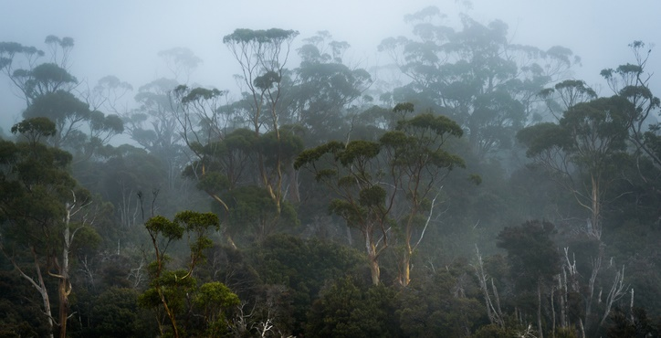

Chapter 2: Renewable energy
Australia’s energy systems remain in transition. Many ageing coal plants are expected to be retired in the next decade or so. Electricity demand is expected to grow as other sectors seek to reduce their emissions by electrifying. Renewable energy is increasing its share of energy production and storage in the grid. Renewable hydrogen will play an essential complementary role to electrification in decarbonising the global economy, particularly in hard-to-abate sectors.
Electricity generation accounts for 34 per cent of current emissions. Electricity sector emissions continue to decline, now 29.2 per cent from the peak in year to June 2009. This reflects continuing renewable deployment and the displacement of fossil fuel power.
The Australian Government has set emissions reduction targets to help the transition to net zero. This includes the 82 per cent renewable electricity generation and 43 per cent emissions reduction targets by 2030, and the 62 to 70 per cent emissions reduction target by 2035.
The Electricity and Energy Sector Plan builds on these commitments, by setting out a pathway to 2050 with 3 distinct phases:
- To 2030 – increase renewable electricity generation to 82 per cent
- To 2035 – continue to electrify homes, businesses, low-heat industrial use and light vehicles
- To 2050 – renewable gases and low carbon liquid fuels support decarbonisation in difficult to abate uses.
Renewable generation in Australia continued to grow further in calendar year 2024, to 36 per cent of total generation (102 terawatt hours), the highest on record. In 2024, solar generation constituted 18 per cent of total generation, and wind 12 per cent.
The Australian Energy Market Operator’s 2024 Integrated System Plan (AEMO’s ISP) has found that storage needs to increase significantly from 3,000 megawatts to 49,000 megawatts, grid scale wind and solar need to increase 6-fold and distributed solar PV to increase 4-fold by 2050. This is to meet the expected doubling in electricity consumption as electrification increases.
Households are expected to continue to play a role in this transition, particularly with the 1 July 2025 commencement of the government’s Cheaper Home Batteries program. The program is helping reduce barriers to installing batteries which can help households make the most of their rooftop solar power by storing it for when it is needed. This program is expected to be included in future allocation and impact reporting.
GTBs finance large scale renewable and storage projects through the CEFC Renewable Energy Investments, Rewiring the Nation, Snowy Hydro, Regional Hydrogen Hubs, Community Batteries, and Advancing Renewables Program.

Renewable energy investments
The Clean Energy Finance Corporation’s (CEFC) capital is playing a leading role in helping develop large-scale renewables across Australia. Large-scale solar and wind generation is critical to delivering the clean energy that will power the low emissions economy of the future. Renewable energy will also underpin the electrification of a vast range of existing commercial, industrial and residential activities, such as enabling the electric vehicle transition and laying the foundations for Australia’s emerging green hydrogen industry.
GTBs are contributing to a variety of large-scale renewable energy and energy storage projects. All projects are aligned with relevant Climate Bonds Initiative or European Union Taxonomy technical thresholds as outlined in the Second Party Opinion.

Green Treasury Bond Allocation
GTBs allocated $168.8 million in 2024–25 towards CEFC renewable energy investments (Table 3).
The total Australian Government contribution refers to total committed financing towards the eligible CEFC renewable energy investments. The total cost of projects refers to the total combined value of the eligible projects, including financing from the Australian Government through the CEFC as well as other government and non-government sources.
To maintain commercial confidentiality, allocation reporting reflects all CEFC investment into eligible renewable energy projects over the reporting period on an aggregated basis.

Table 3: Allocation Data for CEFC Renewable Energy Investments ($ million)
Eligible Green Expenditure | 2024–25 Expenditure | Allocation 2026 Report | Total Australian Government Contribution | Total Cost of Project
Renewable Energy Investments | 311.8 | 168.8 | 923.8 | 9,706.6

Co-financing arrangements
Projects are co-financed with private proponents and investment funds. GTB proceeds are only allocated to finance CEFC contributions. The CEFC aims to catalyse and leverage an increased flow of private finance for renewable energy projects in Australia as part of the net zero transition.

Material risks
In its most recent Annual Report, the CEFC observed that market conditions for new generation investment remained challenging. Rising capital costs, particularly for wind, continued to undermine project economics making it difficult for projects to reach financial close. Operational renewables, especially solar, also faced challenges with high levels of economic curtailment driven by the increasing frequency of negative pricing events. Some regions also experienced grid outages and/or thermal congestion as they waited for significant transmission buildout. Combined with declining large-scale generation renewable energy certificate prices, this has impacted investor sentiment for new renewable generation investment.
CEFC renewable energy investment commitments are subject to inherent risks and uncertainties, which can include external factors such as the regulatory environment and market conditions, meaningful local community and First Nations engagement, obtaining grid connection approvals, environmental approvals or resolving legal challenges. All these factors can delay projects significantly and impact the timing of deployment.

Project impacts
GTBs will contribute to projects that are expected to enable approximately 4,100 gigawatt hours of new renewable energy generation per annum on average (Table 4). This is estimated to avoid over 400 kilotons of CO₂-e equivalent each year. CEFC storage projects financed through GTBs are expected to contribute to around 2,088 megawatts / 5,357 megawatt hours of new storage capacity.
The estimated projected emissions avoided per annum are lifetime greenhouse emissions divided by the estimated number of operational years. Emissions Intensity Factors, which estimate the CO₂ avoided per gigawatt-hour of renewable generation, are based on DCCEEW projections published in 2024 (scope 2). Emissions Intensity Factors are available to 2040 only. The CEFC has estimated Emissions Intensity Factors from 2041 onward by applying the average percentage decline in Emissions Intensity Factors up to 2040.
Project Impacts are reported for eligible projects from 2024–25, which may include projects also eligible in previous periods and covered in previous reports.

Table 4: Impact data for CEFC renewable energy investments
Metric | Value | Recorded / Projected | Time Period
Emissions avoided (kt CO₂-e p.a.) | 400 | Projected | 25+ years from operation
Renewable energy generation (GWh p.a.) | 4,100 | Projected | 25+ years from operation
Energy storage capacity (MW / MWh) | 2,088 / 5,357 | Projected | 20 years

Social co-benefits
CEFC investments in the renewable energy sector deliver benefits to local and regional communities, in addition to the employment and economic activity associated with the planning, development and operational phases.
The energy transition requires a large skilled workforce across every discipline, with particular opportunities in rural and regional areas. The CEFC does not make employment decisions at a project level (this is a matter for project proponents) but as a specialist investor on behalf of the Australian Government it seeks to use its capital to influence positive community and employment outcomes. This is done through the application of Australian Industry Participation Plans, the Buy Australian Plan and First Nations Investment Screening processes.
Eligible renewable energy projects in 2024–25 are estimated to create 80 full-time equivalent jobs, and more than 850 jobs during construction periods
Case study 1: Golden Plains Wind Farm
Golden Plains Wind Farm, near Geelong in Victoria, is a key asset in the race to decarbonise the electricity grid and is expected to replace energy supply that will be lost when the Yallourn coal-fired power station retires in 2028.
The CEFC has committed up to $350 million in finance toward the construction of the Golden Plains Wind Farm across 2 stages. When completed, the total capacity of the Golden Plains Wind Farm will be 1,333 megawatts. GTBs have contributed to Stage One of this project in the reporting period.
The CEFC committed $222.5 million in debt finance to the 756 megawatts Stage One of the wind farm, known as Golden Plains Wind Farm East, alongside Westpac, Bank of China, Mizuho, German state-owned investment bank KfW, Commonwealth Bank, and Danish Credit Export Agency EKF.
Stage One of the project marked its first generation to the grid in October 2024 and in July 2025, the Australian Energy Market Operator allowed Golden Plains to increase its generating capacity to 560 MW, making it the highest generating wind farm in Australia at the time.
The financing attracted global recognition. It was named Asia Pacific Renewables Deal of the Year in the 2022 Project Finance International Awards, which recognise excellence and innovation in project finance transactions and was named among the Global Trade Review Best Deals 2023.
During construction, the project is forecast to generate 700 new jobs for the local economy and 70 ongoing jobs. Community engagement measures at Stage One include a TagEnergy community fund that provides free green electricity to residents living within 3 kms of a turbine, and engagement with First Nations peoples to develop Indigenous training scholarships. This program will be extended as part of Stage Two, delivering additional money into the local community.
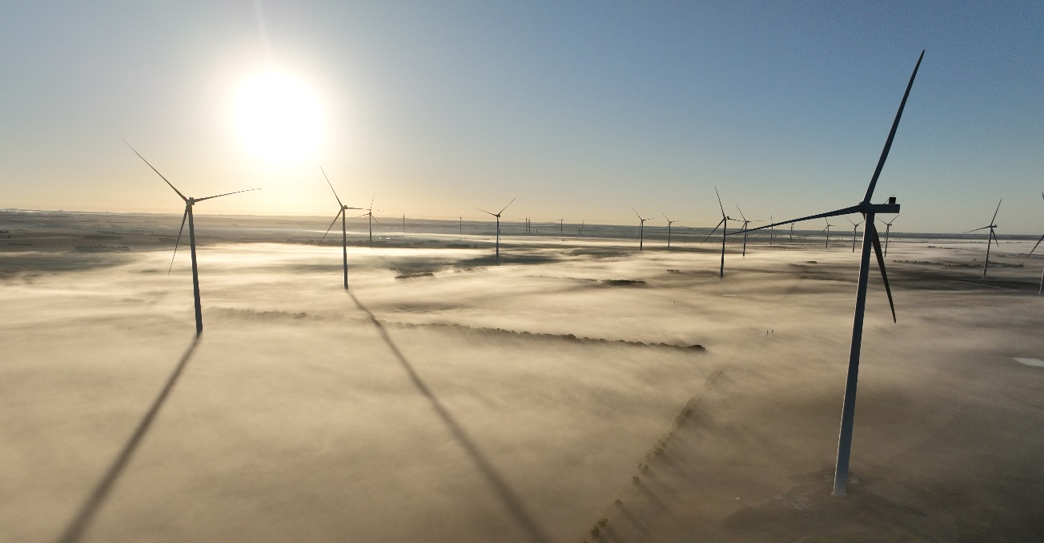
Golden Plains Wind Farm near Rokewood, Victoria. Photo courtesy of Thomas Darker.

Rewiring the Nation
Through the Rewiring the Nation Fund, the CEFC is investing $19 billion on behalf of the Australian Government in projects essential to achieve its net zero emissions ambitions. These investments are expected to lower Australia’s emissions by contributing to the transition of the National Electricity Market to 82 per cent renewables by 2030.
The Australian Energy Market Operator’s (AEMO) Draft Integrated System Plan (ISP) for 2026 expects that the National Electricity Market will need 6,000 km of new transmission by 2050. These transmission projects would deliver $22.3 billion in avoided costs for consumers and deliver emissions reductions valued at $1.9 billion.
This major investment in the renewable energy sector will help Australia deliver more affordable and reliable renewable energy. Rewiring the Nation is critical to Australia’s 82 per cent renewables target, 43 per cent emissions reduction target by 2030, 62 to 70 per cent emissions reduction target, and net zero by 2050.
The Rewiring the Nation Fund focuses on investments that facilitate timely delivery of grid and transmission projects and make clean energy more accessible and affordable for Australian consumers. It aims to accelerate investment in essential projects, including transmission infrastructure, long-duration storage, electricity distribution network infrastructure and distributed energy resources.
The CEFC has announced the following investment commitments as of 15 December 2025:
- $490 million to Central-West Orana Renewable Energy Zone (Phase 1) (NSW)
- $120 million to VNI West (Victoria) (early works)
- $100 million to support the NSW Electricity Infrastructure Roadmap
- $1.935 billion to HumeLink (NSW)
- $750 million to Central-West Orana Renewable Energy Zone (NSW)
- $140 million to VNI West (NSW) (early works)
- $3.8 billion to Marinus Link (Victoria and Tasmania)
Further details on these investment commitments can be found in the CEFC’s Annual Reports.
As projects progress, including reaching final investment decisions, the rollout of Rewiring the Nation capital is expected to continue in future years. New eligible investments financed from the Rewiring the Nation Fund will be reported in future Green Bond Allocation and Impact Reports.
Transmission and distribution infrastructure projects are only included as Eligible Green Expenditures if more than 67 per cent of newly enabled generation capacity in the system is below 100 gCO₂-e/kWh over a rolling 5-year period.

Figure 6: Map of Rewiring the Nation projects
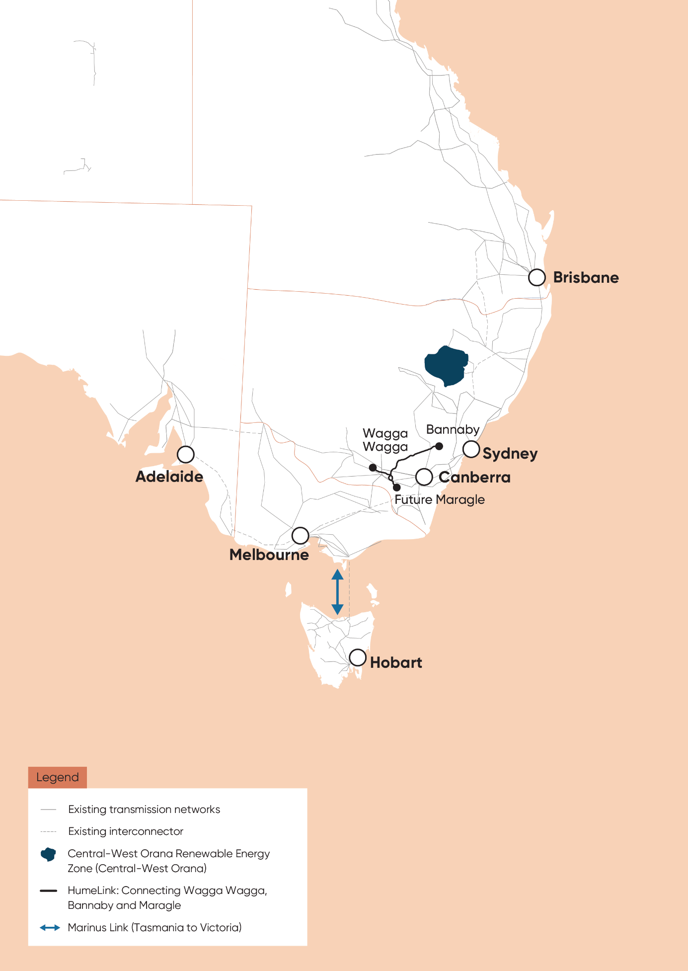

Green Treasury Bond allocation
GTBs contributed $820.0 million in 2024–25 towards Rewiring the Nation (Table 5).
The total Government contribution represents the total Rewiring the Nation Fund investment capital at 30 June 2025. During the reporting year the Australian Government announced an additional $650 million to the CEFC’s Rewiring the Nation Fund. Once finalised, the total Australian Government contribution will be $19.65 billion.
Allocation reporting reflects all CEFC Rewiring the Nation Fund projects over the reporting period on an aggregated basis to maintain commercial confidentiality.

Table 5: Allocation Data for Rewiring the Nation ($ million)
Eligible Green Expenditure | 2024–25 Expenditure | Allocation 2026 Report | Total Australian Government Contribution^{(a)}
Rewiring the Nation | 1,515 | 820 | 19,000
- Based on the Clean Energy Finance Corporation Investment Mandate Direction 2023.

Co-financing arrangements
The Australian Government is working with state and territory governments to deliver significant transmission projects. Projects may be co-financed with state and territory governments and the private sector.

Material risks
Rewiring the Nation projects are subject to inherent risks and uncertainties including external inputs such as the regulatory environment and market conditions. These may impact timing of future deployment.
Completing large infrastructure projects such as those targeted by the CEFC’s Rewiring the Nation Fund depends on external inputs such as social license and securing of critical energy assets and workforce. Delays in the acquisition of these external inputs has the potential to delay project completion, and corresponding investment deployment.

Project impacts
The Central-West Orana Renewable Energy Zone, HumeLink and Marinus Link projects are expected to contribute to an additional 7,450 megawatts of network transmission capacity for renewable energy once all currently committed funds are deployed and projects are operational (Table 6).
Project Impacts are reported for eligible projects from 2024–25, which may include projects also eligible in previous periods and covered in previous reports.

Table 6: Impact data for Rewiring the Nation
Metric | Project | Value | Recorded/ Projected | Time Period
Increase in network capacity (MW) | Central-West Orana Renewable Energy Zone | 4,500 | Projected | From completion
Increase in network capacity (MW) | HumeLink | 2,200 | Projected | From completion
Increase in network capacity (MW) | Marinus Link (Stage 1) | 750 | Projected | From completion

Social co-benefits
Rewiring the Nation projects will seek to positively impact the regions where projects are proposed. For example, EnergyCo NSW expects that the Central-West Orana Renewable Energy Zone could attract up to $25 billion in private investment and will create approximately 1,850 direct jobs in the local area during construction and about 930 ongoing operational jobs from 2034 (Table 7). The REZ will also create additional demand for workers in local manufacturing, retail, transport and the supply of goods and services.
In investing through the Rewiring the Nation Fund, the Investment Mandate requires the CEFC to consider, where practical, the essential role of social licence matters in the successful deployment of clean energy technologies as part of the transaction process.
CEFC investment proposals are screened for impacts on Aboriginal and Torres Strait Islanders through the CEFC First Nations Screening Approach. These considerations also form part of CEFC’s Rewiring the Nation-related investment decisions.

Table 7: Social impact data for Rewiring the Nation
Metric | Project | Value | Recorded/ Projected | Time Period
Jobs Created | Central-West Orana Renewable Energy Zone | 1,850 | Projected | Peak construction
Jobs Created | HumeLink | 1,600 | Projected | Peak construction
Jobs Created | Marinus Link | 1,400 (Tas) 1,000 (Vic) | Projected | Peak construction

Case study 2: Humelink to provide essential infrastructure for net zero transition
The CEFC committed up to $1.935 billion to enable the construction of HumeLink, part of a clean energy ‘superhighway’ connecting millions of consumers to low emissions, low-cost renewable energy.
The CEFC worked with Transgrid to develop a tailored financing package, combining concessional senior debt with subordinated notes. The investment commitment was subsequently reduced to $1.35 billion due to changes in financial market conditions and increased private sector investment participation.
HumeLink will link the Greater Sydney electricity load centre with the Snowy Mountains Hydroelectric Scheme (Snowy 2.0), EnergyConnect in southwest NSW and the NSW element of VNI West (NSW). The infrastructure will deliver up to 2,200 MW of pumped storage to major population centres and unlock additional renewable capacity.
HumeLink will deliver more than $1 billion in net benefits to Australian households and businesses by providing access to more sustainable, affordable and reliable energy. It will also provide an economic boost to regional communities, creating up to 1,600 construction jobs and delivering $6.3 billion in direct and indirect investment in local economies.
Transgrid is prioritising local employment, training and skills development to provide lasting community benefits, including investing more than $11 million directly into the community to provide enduring social legacy outcomes.

Snowy Hydro
Snowy 2.0 is an important project for the future security and reliability of Australia’s energy system and will provide firming capacity to support the transition to a decarbonised grid. It will provide an additional 2,200 megawatts of dispatchable, on-demand generating capacity and approximately 350,000 megawatt hours of large-scale storage to the National Electricity Market.
Snowy 2.0 is an expansion of the existing Snowy Mountains Hydro-electric Scheme. The project involves linking 2 existing dams via 27 km of tunnels and the construction of a new underground power station. It will primarily operate as a pumped hydro generator.
Snowy 2.0 will operate like a giant battery, using periods of surplus renewable electricity generation from wind and solar to pump water to the upper dam (Tantangara) and releasing the water back to the lower dam (Talbingo) generating electricity when the National Electricity Market needs additional supply.
Snowy Hydro is an incorporated Australian company that is governed by an independent Board of Directors and operates on a commercial basis. It is a Government Business Enterprise that operates under the Australian Government’s Statement of Expectations. The Australian Government is the sole shareholder of Snowy Hydro.

Green Treasury Bond allocation
GTBs financed $81.2 million of Government investment in Snowy 2.0 in 2024–25 (Table 8).
The Total Australian Government Contribution represents the expected proportion of funding of the project which may be financed through GTBs. GTBs will not be used to finance the Australian Government’s equity contribution to the project.
Snowy Hydro is currently undertaking a reassessment of the completion costs of the project. The total cost of the project may change following this process.

Table 8: Allocation Data for Snowy 2.0 ($ million)
Eligible Green Expenditure | 2024–25 Expenditure |  | Allocation 2026 Report | Total Australian Government Contribution | Total Cost of Project
Snowy Hydro | 150.0 | 81.2 |  | 4,500.0 | Total cost under reassessment

Co-financing arrangements
Snowy 2.0 is financed by Snowy Hydro using a mixture of shareholder equity, a Commonwealth loan facility and private market debt.

Material risks
Project risks for Snowy 2.0 include potential construction delays and cost pressures. The Government continues to monitor these risks through engagement and oversight of Snowy Hydro as a prescribed Government Business Enterprise. The total cost of Snowy 2.0 has not been reported in Table 9 due to the Snowy 2.0 cost reassessment announced on 3 October 2025.

Project impacts
Snowy 2.0 will provide on-demand energy and large-scale storage for the National Electricity Market. Once complete, the project is expected to provide an additional 2,200 megawatts of generating capacity and approximately 350,000 MWh of energy storage to the National Electricity Market.

Table 9: Impact data for Snowy 2.0
Metric | Project | Data value | Record/ Projected | Time Period
Energy storage capacity (MW/MWh) | Snowy 2.0 | 2,200 / 350,000 | Projected | From completion

Social co-benefits
Snowy 2.0 is expected to generate around 5,200 jobs over its lifetime, of which 4,000 will be direct jobs in the Snowy Mountains region.

Table 10: Social co-benefits for Snowy 2.0
Metric | Project | Value | Recorded/ Projected | Time Period
Jobs Created | Snowy 2.0 | 5,200 approx. | Recorded | As at December 2025
Local expenditure | Snowy 2.0 | $292.5m approx. | Recorded | As at December 2025

[Insert Snowy 2.0 project photo here]
Case study 3: Snowy 2.0 – TBM Monica
Snowy 2.0 will provide an additional 2,200 megawatts of dispatchable, on-demand generating capacity and approximately 350,000 megawatt hours of large-scale storage to the National Electricity Market. This is enough energy storage to power 3 million homes for a week.
The project links 2 existing dams – Tantangara and Talbingo – through 27km of tunnels and building a new underground power station. The tunnels are being excavated by complex and specialised tunnel-boring machines (TBMs) which by global tradition are given female names. The project started with 3 TBMs – Florence, Kirsten and Lady Eileen. A fourth TBM was acquired in 2024 and was commissioned to begin tunnelling in early 2026.
Snowy Hydro, as the owner of the project, engaged with the local First Nations community to name the fourth TBM. An Indigenous art and storytelling competition was organised in partnership with Tumut High School and the Stars Foundation, a not-for-profit organisation for First Nations girls and young women.
The TBM was named ‘Monica’, after aspiring engineer and local high school student Monica Brimmer, 15.
Monica won the competition with a piece that reflected the spirit and purpose of Australia’s largest renewable energy project. Monica’s creation was inspired by flowing water, connected dams, mountains, energy, an underground power station and a connection to Country.
Monica said her artwork represented the creation of renewable energy and symbolised a ‘greener future in which the land and our animals are better cared for.’
‘Knowing there’s something really important to the project out there with my name, in the mountains, is really cool,’ Monica said. ‘I’ve been interested in engineering for quite a while – and it’s pretty cool to put art and engineering together as part of something I could put my mind to.’
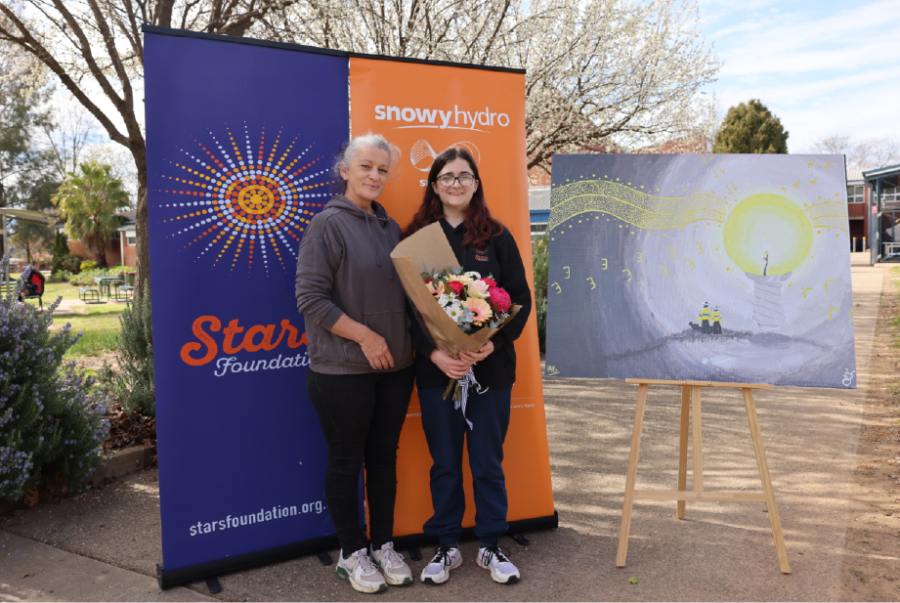
Monica and her mum Julie with her winning artwork. Photo courtesy of Snowy Hydro Ltd.

Regional Hydrogen Hubs
Hydrogen hubs are locations where hydrogen producers, users and potential exporters can co-locate and collaborate to drive innovation, share infrastructure, create demand and scale up the industry.
The Australian Government has invested around $500 million to support the development of hydrogen hubs in regional Australia as well as design and development studies. The hubs are part of the 2024 National Hydrogen Strategy to support clean hydrogen industry growth and development at scale. The strategy supports the net zero transition and will help position Australia as a global green hydrogen leader.
The hubs will give Australia’s green hydrogen industry an early-stage springboard to scale, which will help support other industrial sectors in the regions. These industrial clusters will lower the cost of production, encourage innovation, and enhance skills and training.
All Regional Hydrogen Hubs projects financed through GTBs will produce green hydrogen only. Hydrogen projects are limited to production processes by electrolysis powered by renewables or grid electricity.
The Australian Government has multiple initiatives to assist the development of renewable hydrogen. The Regional Hydrogen Hubs program works alongside the Hydrogen Headstart Program. Hydrogen Headstart will provide revenue support for large-scale renewable hydrogen projects through a competitive application process administered by the Australian Renewable Energy Agency (ARENA). Hydrogen Headstart is also part of the GTB program. However, allocations are not expected until hydrogen production has commenced.

Green Treasury Bond allocation
GTBs contributed to 2 of 5 sub-projects across Australia, totalling $13.6 million in 2024–25 (Table 11).
The George Town Green Hydrogen Project received a $2 million allocation in the 2025 Allocation and Impact Report. As the project was subsequently discontinued, the George Town Green Hydrogen Project is not included and is not allocated to in this report.
The total cost of the project refers to the proponent’s estimates of lifetime project cost. The totals do not include projects for which data is unavailable or cannot be reported (N/A).

Table 11: Allocation data for Regional Hydrogen Hubs ($ million)
Eligible Green Expenditure | Projects supported | 2024–25 Expenditure | 2024–25 Allocation | Total Australian Government Contribution | Total Cost of Project
Regional Hydrogen Hubs | Euroa Hydrogen Project Gladstone | - | - | 3.0 | 6.0
Regional Hydrogen Hubs | CQH2 Gladstone | 5.1 | 2.8 | N/A | N/A
Regional Hydrogen Hubs | H2 Kwinana Clean Energy Hub | 20.0 | 10.8 | 70.0 | 403.1
Regional Hydrogen Hubs | Tasmanian Green Hydrogen Hub | - | - | 70.0 | 300.0
Regional Hydrogen Hubs | Hunter H2 Hub | - | - | 70.0 | 207.6
Regional Hydrogen Hubs | Total | 25.1 | 13.6 | 213.0 | 916.7

Co-financing arrangements
Projects are co-financed by private proponents and/or state and territory governments.
GTB proceeds are allocated to green hydrogen activities. Some proceeds have been allocated to entities that also operate in the fossil fuel industry, although allocated proceeds are not permitted to be used for those activities. Further information on eligible activities and ongoing monitoring of grant funding is available in the Grant Opportunity Guidelines for the Activating a Regional Hydrogen Industry – Clean Hydrogen Industrial Hubs program.

Material risks
Projects supported under the program are subject to technical and commercial risk. All Regional Hydrogen Hub implementation projects are working towards a final investment decision.
On 3 October 2024, Origin Energy announced that it would exit the Hunter Hydrogen Hub. Origin cited commercial factors for its decision, including uncertainty surrounding the pace and timing of the development of the hydrogen market and the risk associated with capital intensive projects. Orica Australia, which was to be the hub’s primary customer, has taken over the project. It is part of Orica’s decarbonisation plans for its ammonia and ammonium nitrate facility. The project was awarded additional support by ARENA in 2025 under the Hydrogen Headstart Program.
On 3 February 2025, the Queensland Government announced it would end its support for the Central Queensland Hydrogen Project (CQ-H2) led by Stanwell Corporation alongside domestic and international partners. As a result, the CQ-H2 project has been terminated. The government has been working with impacted stakeholders to identify severable and viable project components, and will continue to support the Yarwun Calcination Trial, which was a sub-project of the CQ-H2.
The government remains committed to its 2024 National Hydrogen Strategy and positioning Australia as a global hydrogen leader by 2030. Other government policy initiatives support early hydrogen projects including the Hydrogen Headstart Program and Hydrogen Production Tax Incentive.

Project impacts
Renewable projects financed through GTBs are projected to contribute to 115.2 kilotons of hydrogen production per annum once all projects are operational.

Table 12: Impact data for Regional Hydrogen Hubs
Metric | Project | Value | Record/ Projected | Time Period
Hydrogen produced (ktH₂/year)^{(a)} | Euroa Hydrogen Project Gladstone | 56.0 | Projected | Annually from early 2030
Hydrogen produced (ktH₂/year)^{(a)} | H2 Kwinana Clean Energy Hub | 9.5 | Projected | Annually from completion
Hydrogen produced (ktH₂/year)^{(a)} | Tasmanian Green Hydrogen Hub | 45.0 | Projected | Annually from mid-2031
Hydrogen produced (ktH₂/year)^{(a)} | Hunter Hydrogen Hub | 4.7 | Projected | Annually from completion
Hydrogen produced (ktH₂/year)^{(a)} | Total | 115.2
- Since the CQH2 project was cancelled, there are no impacts available.
The Australian Government contributes to Regional Hydrogen Hubs projects through grants to state and territory governments and/or industry proponents. Projected hydrogen production has been identified by project proponents of individual projects as part of feasibility studies. Projections have not been produced by the Australian Government. Methodology may differ between projects.
Once each project is operational, emissions avoided data will be available by comparing the energy sources displaced by green hydrogen. Projected emissions avoided data are unavailable at this stage.

Social co-benefits
Hydrogen Hubs will support employment opportunities for regional communities. Data for regional job creation will be available when individual projects are complete.
Case study 4: The Hunter Valley Hydrogen Hub
The Hunter Valley Hydrogen Hub is a renewables-based hydrogen hub development near Newcastle. Orica Australia leads the project and intends to produce renewable hydrogen using a 50-MW electrolyser powered by renewable electricity to replace methane gas in Orica’s ammonia production process.
Orica is the recipient of a grant of up to $70 million under the Regional Hydrogen Hubs program. The NSW Government has also awarded Orica a Hydrogen Hub Initiative grant of up to $45 million for the project.
In July 2025, the Australian Government announced that Orica had been awarded up to $432 million through the Hydrogen Headstart Program, which will be provided in the form of a production credit administered by ARENA and paid per unit of eligible hydrogen produced.
The project represents a major step in decarbonising Orica’s existing Kooragang Island ammonia manufacturing facility and producing low-carbon ammonia and ammonium nitrate for domestic use across mining, agriculture and industrial sectors.
These projects are key to decarbonising hard-to-electrify industrial processes. Funding is an essential for bridging the commercial gap for early mover renewable hydrogen projects in Australia. The estimated annualised emissions benefit at phase one of full production is equivalent to taking approximately 26,500 cars off the road each year.
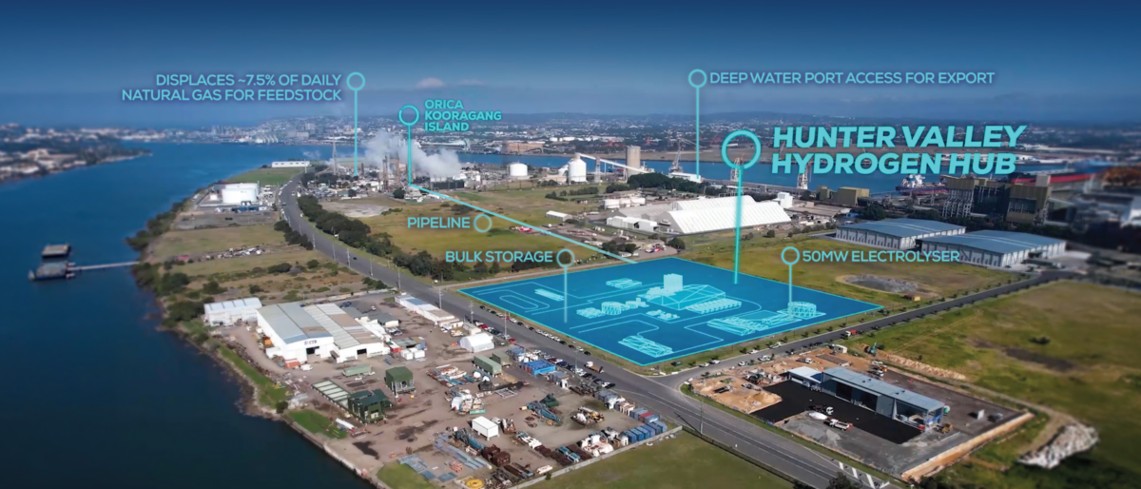
The Hunter Valley Hydrogen Hub at Kooragang Island, New South Wales. Photo courtesy of Orica.

Community Batteries
The Community Batteries for Household Solar program is installing more than 400 Community Batteries across Australia. The batteries will store excess solar energy for consumers to use during peak times, put downward pressure on household electricity costs, contribute to lowering emissions, provide network benefits and support further solar installations.
The $200 million program, led by DCCEEW, delivers grants through the Department of Industry, Science and Resources’ Business Grants Hub and ARENA Community Batteries funding. The Business Grants Hub is administering up to $29 million in grants to install batteries in up to 57 locations. The remaining $171 million has been allocated to ARENA to deliver at least 342 batteries.

Green Treasury Bond allocation
GTBs contributed $7.7 million to Community Batteries over 2024–25 (Table 13).
Funding in future financial years is expected to be financed through GTBs.

Table 13: Allocation data for Community Batteries ($ million)
Eligible Green Expenditure | 2024–25 Expenditure | Allocation 2026 Report | Total Australian Government Contribution | Total Cost of Project
Community Batteries (DCCEEW) | 6.2 | 3.4 | 27.9^{(a)} | 37.1
Community Batteries (ARENA) | 8.1 | 4.4^{(b)} | 100.2 | 256.7
Total | 14.3 | 7.7^{(c)} | 128.1 | 293.8
- Expenditure for this component is not finalised and does not yet align with the reported value of $29 million.
- Only includes Round 1 project costs.
- Note some of the 2024–25 total allocation does not add up to 7.8 due to rounding.

Co-financing arrangements
Community Batteries sub-projects can be co-financed with project proponents. Where total project costs are above the grant amount, the grantees are responsible for the difference. This amount can be funded from the grantee or from project partners.

Material risks
No material risks have been identified in delivering Community Batteries. A small number of projects have identified siting issues and grantees are working through options for alternative siting.

Project impacts
Once online, the batteries will have an impact on local network constraints and expand rooftop solar capacity, reduce emissions and reduce electricity costs for consumers. The batteries will reduce pressure on the electricity grid and absorb excess energy that could cause voltage spikes. GTBs financed 31 Community Batteries in 2024–25.

Table 14: Impact data for Community Batteries
Metric | Value | Record/ Projected | Time Period
Energy storage capacity (MW/MWh) | 5.1 / 12.0 | Recorded | 2024–25
Number of Community Batteries deployed | 31 | Recorded | 2024-25

Social co-benefits
Energy consumers that could benefit from batteries include households, hospitals, schools and tertiary education institutions, council facilities, housing developments, social and community housing, sports facilities, libraries, aquatic centres, shopping centres, and regional and remote communities.

Case study 5: Ausgrid – co-located Community Batteries program
Ausgrid aims to deploy 46 front-of-the-meter Community Batteries – ground and pole-mounted – across its network. It is installing batteries in Sydney, Georges River, the Central Coast, and Lake Macquarie. The project supports grid stability and reduces network constraints. It also enables communities to share battery storage, alleviate solar export curtailment, and lower household electricity costs.
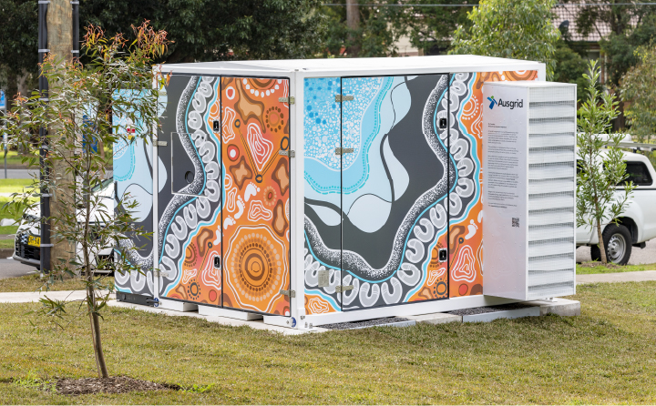
A community battery in Bexley North, New South Wales. Photo courtesy of Ausgrid.

Case study 6: Ausgrid – Energy Storage as a Service (ESaaS)
Energy Storage as a Service (ESaaS) is an Ausgrid initiative that provides eligible households with shared access to Community Batteries. This makes stored renewable energy available to renters and homeowners regardless of whether they have rooftop solar.
Customers in eligible catchment areas near Community Batteries can join ESaaS through participating retailers. The battery energy ESaaS customers use is stored locally, reducing use of the transmission network. Ausgrid determines the battery catchment area and number of eligible customers based on battery size, proximity and network connectivity. Customers can save up to $200 per annum depending on usage. Ausgrid has 6 battery projects installed and providing ESaaS.

Advancing Renewables Program
ARENA runs the Advancing Renewables Program (ARP) and supports development, demonstration, and pre-commercial deployment projects. This includes opportunities to:
- optimise the transition to renewable electricity
- commercialise clean hydrogen
- support the transition to low emissions metals.
ARP funds only low emissions projects that involve renewable energy technology or improve existing mechanisms to facilitate renewable energy technologies.
Examples of projects ARP has contributed to in 2024–25 include:
- ARENA is contributing $45 million to Fortescue’s Solar Innovation Hub in the Pilbara, Western Australia, a 500 megawatts test bed for cutting-edge solar tech within a 1,500 megawatts PV pipeline. By trialling multiple breakthrough projects – like robotics and rapid-deployment solar – the Hub aims to cut solar costs, speed up innovation, and deliver real-world insights to accelerate Australia’s clean energy future.
- ARENA is supporting Aussie solar innovator 5B with $15.5 million to accelerate automation of its modular, factory-built Maverick solar arrays. By developing automated manufacturing and robotic deployment systems at its Sydney HQ, 5B aims to cut solar farm costs by up to 70 per cent by 2030. The Maverick’s rapid deployment and new high-capacity design are set to help Australia meet its solar deployment targets.
- RayGen is receiving $27 million from ARENA to further develop its solar and thermal storage technology. The project includes the design of a subsequent 200 MW solar and 115 megawatts / 1,200 megawatt hours storage facility at Yadnarie, South Australia. This project aims to deliver dispatchable, long-duration renewable energy, helping to meet Australia’s growing need for reliable clean electricity and supporting progress towards net zero emissions.

Green Treasury Bond allocation
GTBs have contributed $72.4 million to the ARP in 2024–25 (Table 15).
The total government contribution to projects represent contracted funding for individual projects (past and expected). Most projects were established prior to issuance of GTBs.
The total cost of project includes co-financing with project partners.

Table 15: Allocation data for the Advancing Renewables Program ($ million)
Eligible Green Expenditure | Projects supported | 2024–25 Expenditure | Allocation 2026 Report | Total Australian Government Contribution | Total Cost of Project
Advancing Renewables Program | Renewable hydrogen | 5.5 | 3.0 | 78.7 | 272.5
Advancing Renewables Program | Decarbonise land transport | 6.7 | 3.6 | 40.4 | 138.8
Advancing Renewables Program | Optimising the transition to renewable electricity | 101.2 | 54.8 | 455.8 | 3,331.8
Advancing Renewables Program | Other | 20.3 | 11.0 | 104.9 | 1,387.5
Advancing Renewables Program | Total(a) | 133.7 | 72.4 | 679.9 | 5,130.6
- Due to rounding, discrepancies may occur between sums of the component items and totals.

Co-financing arrangements
ARP funding is deployed by ARENA through grants. The program is co-financed with project partners, but grant recipients are usually expected to match funding provided by ARENA. ARENA will provide the minimum funding needed for the project to proceed, at times subject to all other parties to the project receiving a commercial return.
GTB proceeds can only be used for renewable energy activities, in line with the Framework. They cannot be used for any other activities. Some GTB proceeds have been allocated to entities in high-emitting industries, strictly for the purposes of developing renewable energy projects. ARENA provides clear direction on eligible activities and monitors grant funding per the Advancing Renewables Program Guidelines.

Material risks
No material risks have been identified to deliver the ARP.

Project impacts
GTBs have contributed to 31 development, demonstration, and pre-commercial deployment projects under the ARP (Table 16). It is difficult to aggregate the climate and environmental impact of the ARP given the varied nature of the program.
Projects under the ARP have varied timeframes given they are at a pre-commercial stage.

Table 16: Impact data for the Advancing Renewables Program
Metric | Project priority area | Value | Projected/Recorded | Time Period
Number of renewable energy projects funded | Commercialising renewable hydrogen | 10 | Recorded | 2024–25
Number of renewable energy projects funded | Decarbonising land transport | 6 | Recorded | 2024–25
Number of renewable energy projects funded | Optimising the transition to renewable electricity | 56 | Recorded | 2024–25
Number of renewable energy projects funded | Other | 16 | Recorded | 2024–25
Number of renewable energy projects funded | Total | 88

Social co-benefits
The ARP will aid in the development of industry capacity and capability, including new renewable energy jobs and companies. It will generate a positive economic impact in regional areas, through the creation of new jobs and by increasing economic activity.
The program is expected to reduce electricity costs for consumers and reduce air pollution as part of the transition to renewable energy. It will also engage First Nations stakeholders throughout the delivery, ensuring it is aligned with best practice principles for First Nations engagement.

Chapter 3: Energy efficiency
Increasing energy efficiency reduces energy bills, lowers emissions and improves energy reliability and security for households, businesses and industry.
Australia’s National Energy Performance Strategy outlines the Australian Government’s coordinated action to improve energy performance across the country to make businesses more competitive, and homes more comfortable and cheaper to run. The Strategy demonstrates how energy performance can be integrated into net zero planning across sectors and accelerate the transition to net zero.
Lowering emissions by electrification and efficiency is priority 2 of Australia’s Net Zero Plan. The plan highlights energy efficiency improvements as key to supporting the energy transition, with improvements in buildings, appliances and equipment helping balance increased electricity demand from accelerated electrification of vehicles and industry.
The Government is progressing several measures aimed at improving energy performance, including:
- Expanding the Australian Government’s contribution to $800 million for the $1.1 billion Social Housing Energy Performance Initiative.
- $1 billion to the CEFC for the Household Energy Upgrades Fund™, which provides low-cost finance for best practice energy performance initiatives. The CEFC works with co-financiers to create tailored and discounted green finance products which are easy for households to access.
- Expanding energy performance programs like the National Australian Built Environment Rating System (NABERS), the Greenhouse and Energy Minimum Standards (GEMS) scheme and Commercial Buildings Disclosure program, to allow consumers to make more informed choices on energy efficiency.
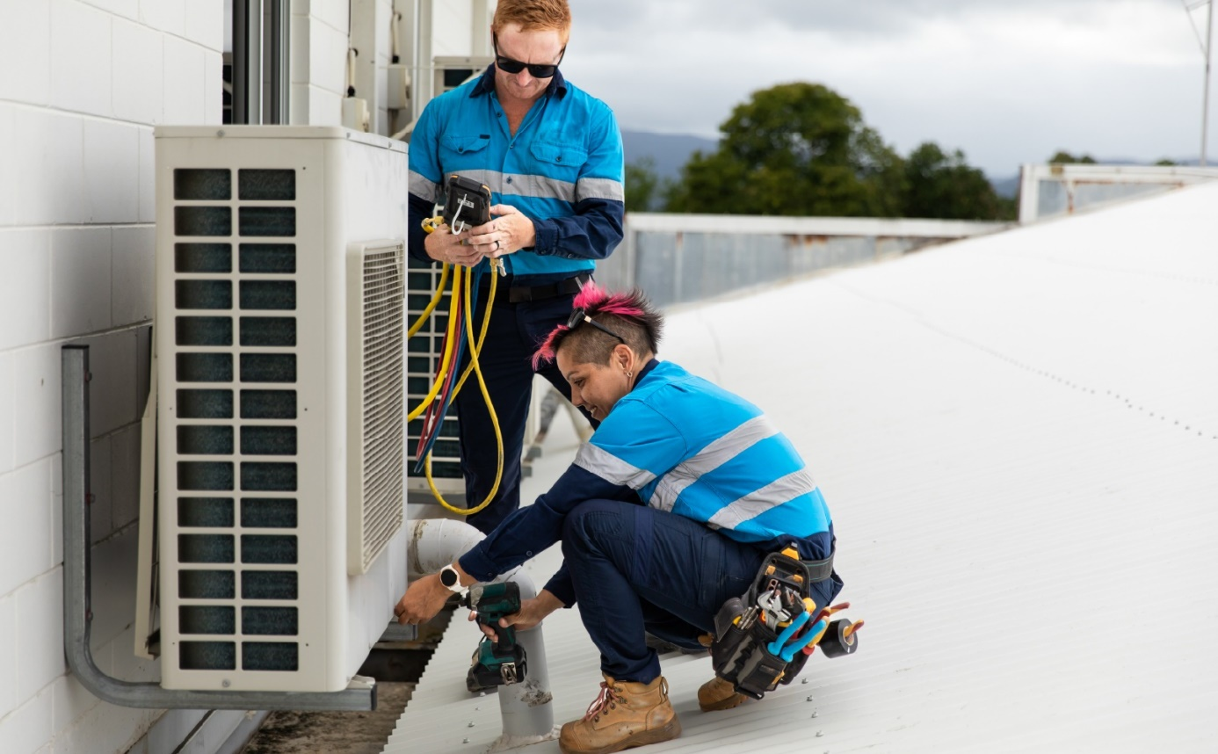

Household Energy Upgrades Fund™
The $1 billion CEFC Household Energy Upgrades Fund™ (HEUF™) is designed to fast-track the retrofit of greener and more sustainable homes Australia wide. By ‘crowding in’ additional private capital, alongside HEUF™ capital, the CEFC aims to deliver a catalytic outcome, providing low-cost financing together with private financial institutions for home upgrades that improve energy performance.
The HEUF™ is structured so that the CEFC can leverage the consumer reach and lending capability of Australian financiers to offer discounted consumer loans direct to their customers. Accordingly, the CEFC is not offering discounted consumer loans directly to consumers.
HEUF™ related investment activity is likely to be limited to debt financing, investing on market terms and returns, with any discounts to be passed on to the end customer and towards unlocking barriers to the uptake of clean energy technologies. Other forms of finance may be considered where there is potential to unlock concessional loan finance for consumers.
Making Australia’s homes more sustainable is a big part of how the country will get to net zero emissions by 2050. With the majority of existing Australian homes built before sustainability measures were included in construction standards, many will benefit from measures to reduce their heating, cooling and other energy needs, protecting households from extreme temperatures and fluctuating energy prices.
The CEFC has prioritised technologies with the potential to deliver the largest household energy or emissions reduction benefits.
A sample of eligible technologies that can be financed through the HEUF™ include:
- Energy generation and storage: solar PV systems and batteries, solar hot water systems
- Heating and cooling: double-glazed windows, insulation, air conditioners, ceiling fans and hot water heat pumps
- Miscellaneous: EV chargers, energy monitoring systems, pool pumps and induction cooktops.
On 15 December 2025, the CEFC has announced the following investment commitments:
- $60 million to support solar PV, home batteries and other energy efficiency upgrades with fintech lender Plenti
- $160 million to support the installation of energy efficient clean technologies with Westpac
- up to $75 million to help finance the $150 million ING Green Upgrade Loan program
- $50 million to Bank Australia to support energy performance upgrades of existing homes
- $20 million to the CommBank Home Energy Upgrades service
- $20 million to Starling Energy Group, which operates via its retail brand Plico (together with a further $15 million from the CEFC’s General Portfolio) to support end-to-end solar, battery and VPP services
- Up to $40 million to Brighte to support a wide range of energy upgrades – including solar and battery systems, energy-efficient heating and cooling, insulation, and EV chargers.

Green Treasury Bond allocation
The GTB contributed $87.4 million in 2024–25 to the HEUF™ (Table 17).
The total Australian Government contribution refers to the total HEUF™ investment capital from the Australian Government. To maintain commercial confidentiality allocation reporting reflects all CEFC HEUF™ projects over the reporting period on an aggregated basis.

Table 17: Allocation Data for the Household Energy Upgrades Fund™ ($ million)
Eligible Green Expenditure | 2024–25 Expenditure | 2024–25 Allocation | Total Australian Government Contribution | Total Cost of Project
Household Energy Upgrades Fund™ | 161.5 | 87.4 | 1,000.0 | N/A

Co-financing arrangements
Through the HEUF™, the CEFC is working with co-financiers to develop a range of flexible finance options that aim to support consumers and help them make informed choices with long term benefits. These may include:
- Green home loans: To back renovation and retrofits using clean energy technologies to significantly improve energy performance levels determined through credible home energy assessments
- Green personal loans: Used for home energy improvements and clean energy technologies
- Innovative concessional financial offerings: Products with a focus on unlocking energy savings for borrowers including rental and strata property customers through access to energy efficiency and clean energy technologies.
As part of the Government’s Investment Mandate issued to the CEFC, the CEFC must aim to leverage at least an amount equal to the HEUF™ Amount (that is $1 billion) from the private sector across the portfolio of investments made under this fund.

Material risks
Projects are subject to inherent risks and uncertainties, which can include external inputs such as those related to the regulatory environment and market conditions, including the level of market interest rates, consumer finance regulation, inflationary pressures on both equipment costs and consumer budgets, and the rate of adoption of new technologies. Each of these may impact the timing of deployment.

Project impacts
Across the eligible period, the HEUF™ financed 1,508 loans for household energy upgrades and 3,843 energy efficient technologies. The number of loans and technologies financed is expected to grow as the program continues.

Table 18: Impact data for the Household Energy Upgrades Fund™
Metric | Value | Recorded/ Projected | Time Period
Number of concessional loans financed | 1,508 | Recorded | 2024–25
Energy efficient technologies financed | 3,843 | Recorded | 2024–25
Emissions avoided (kt CO₂-e p.a.) | 50 | Projected | 10–20 years

Social co-benefits
Over the life of the program, the HEUF™ is expected to help more than 110,000 households lower their energy bills, ensuring homes are warmer in winter and cooler in summer.
The Energy Efficiency Council found increasing household ratings of energy efficiency from 1 to 3 stars can reduce energy bills by around 30 per cent and increasing from 3 to 5 stars can reduce bills by around 18 per cent.

Social Housing Energy Performance Initiative
The expanded Social Housing Energy Performance Initiative (SHEPI) is providing $1.1 billion (including $800 million from the Commonwealth) to support energy performance upgrades to social housing.
The SHEPI aims to reduce energy costs and consumption and improve thermal comfort for social housing tenants. It is expected to reach more than 100,000 social housing properties. Upgrades under the SHEPI will benefit tenants through sustained savings on their energy bills, and improvements to their comfort and health.
The SHEPI is partly co-funded and designed in partnership with states and territories. It is flexible, supporting bespoke arrangements with state and territory governments to provide energy performance upgrades that respond to the needs of social housing stock in each jurisdiction.
The SHEPI is delivering a range of upgrades including solar systems, batteries, energy efficient electric appliances and insulation. Housing and energy portfolios in each jurisdiction are leading the delivery of upgrades.

Green Treasury Bond allocation
GTBs contributed $33.9 million in 2024–25 towards SHEPI (Table 19).
The total Australian Government contribution represents the total projected funding of SHEPI at 30 June 2025. Funding in future financial years is anticipated to be financed through GTBs.
SHEPI (Project 2a) is the original initiative. SHEPI (Project 2b) is the expansion announced in November 2024.

Table 19: Allocation Data for the Social Housing Energy Performance Initiative (SHEPI) ($ million)
Eligible Green Expenditure | 2024–25 Expenditure | 2024–25 Allocation | Total Australian Government Contribution^{(a)} | Total Cost of Project
SHEPI: Project 2a | 62.6 | 33.9 | 290.7 | N/A
SHEPI: Project 2b | - | - | 489.4 | N/A
Total | 62.6 | 33.9 | 780.1 | N/A
- Excludes funding for program administration.

Co-financing arrangements
The SHEPI is supported by over $290 million in co-funding from state and territory governments.

Material risks
Capital works in residential settings are subject to inherent risks, including work health and safety issues, supply chain pressures, and potential delays in project delivery. Active risk management is a key design principle of the program, with an emphasis on careful planning and incorporating safety in implementation. The model leverages established state and territory arrangements including risk management processes. Funding agreements require the development of risk management plans and regular risk reporting, alongside ongoing engagement with state and territory delivery partners to support effective risk monitoring.

Project impacts

Table 20: Impact data for the Social Housing Energy Performance Initiative
Metric | Value | Recorded/ Projected | Time Period
Number of dwellings with energy performance upgrades | Over 20,000 | Recorded | FY2023–24 and FY2024–25
Number of dwellings with energy performance upgrades | Over 100,000^{(a)} | Projected | FY2023–24 to FY2028–29
- The projected number of dwellings with energy performance upgrades includes the over 20,000 recorded number of dwellings with energy performance upgrades.

Social co-benefits
SHEPI is expected to fund upgrades to more than 100,000 social housing properties. State and territory governments have identified the upgrade types that suit the needs of residents living in different climates across Australia. The energy upgrades will help improve residents’ comfort and health by keeping homes warmer in winter and cooler in summer.

Figure 7: Number of SHEPI 2a upgrades around Australia
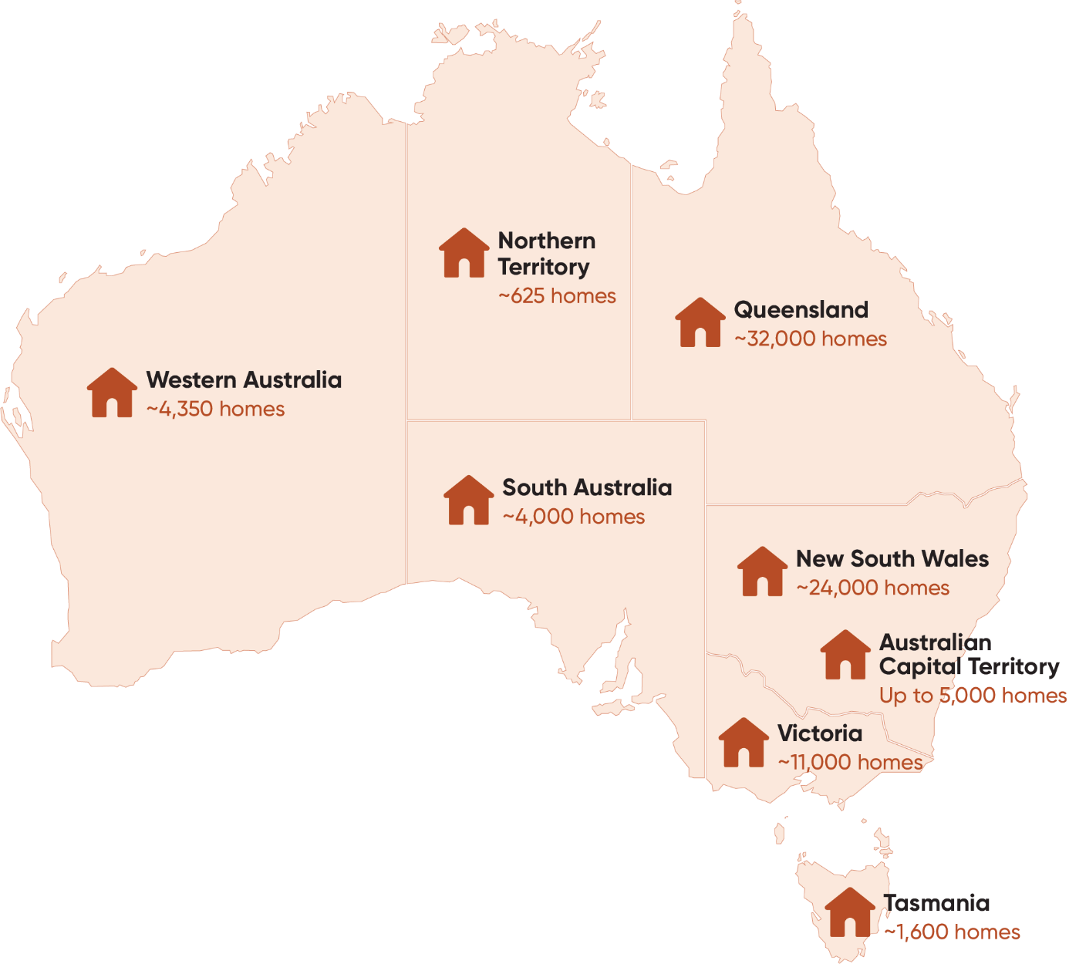

Chapter 4: Clean transportation
The transport sector was responsible for 23 per cent of Australia’s annual CO₂-equivalent gas emissions in 2025. Without further action, transport will be the second highest emitting sector by 2030. The Australian Government is working to reduce transport and infrastructure emissions through initiatives such as the National Electric Vehicle Strategy, Australian New Vehicle Efficiency Standard, Active Transport Fund, and various sectoral action plans.
As part of the Net Zero Plan, the Government released the Transport and Infrastructure Net Zero Roadmap and Action Plan in consultation with industry to support reducing transport emissions. The Action Plan has identified 5 priority actions to decarbonise transport systems:
- invest in enabling low and zero emissions transport infrastructure
- electrify and increase transport’s energy performance
- switch to low carbon alternatives (LCLFs) to power transport where electrification is not feasible
- innovate to expand cost competitive transport technology options
- scale up efforts to reduce embodied emissions in transport infrastructure.
The Australian Government released the National Electric Vehicle Strategy in April 2023 as part of the Powering Australia plan to improve affordability, create jobs, and reduce emissions. It provides a nationally consistent framework to get the road transport sector on a path to net zero emissions.
A net zero transport system will require networks and infrastructure that encourage greater use of active and public transport. Public transport generates lower emissions per passenger and per km compared to private car use.
Weekday rail commuting helps alleviate urban transport network congestion. Rail carries 68 per cent of the mass transport passenger kms across Australia’s capital cities. The Australian Government is investing in electrifying the public transport network through the Infrastructure Investment Program.
The Australian Government is expanding the national rollout of EV charging and hydrogen refuelling infrastructure through the Driving the Nation Fund. The Fund will support initiatives to enable the transition to electric vehicles.
In 2024–25, GTBs financed clean transportation programs such as electric rail infrastructure through the Infrastructure Investment Program, the shift to electric vehicles in Driving the Nation Fund, and the rollout of Electric bus charging infrastructure in Perth.

Electric rail infrastructure in the Infrastructure Investment Program
GTBs are used to finance the following electric intracity rail projects:
- Sydney Metro – Western Sydney Airport: A new 23 km railway that links the Western Parkland City area and the new Western Sydney International (Nancy-Bird Walton) Airport with central business hubs and the broader Sydney public transport system.
- METRONET: The METRONET package of works encompasses 72 kms of new passenger lines and 23 new stations expanding Perth’s existing metropolitan rail network. Financing from GTBs is directed towards 5 METRONET projects: Byford Extension, Victoria Park Canning Level Crossing Removal, Morley Ellenbrook Line, Thornlie Cockburn Link, and the Yanchep Rail Extension.
- Gold Coast Light Rail (Stage 3): A 6.7 km extension south of the existing tram network to link Broadbeach South and Burleigh Heads.
- Canberra Light Rail (Stage 2A): A 1.7 km extension of the existing light rail, to Commonwealth Park. The Canberra Light Rail will be powered by 100 per cent renewable energy.
These rail projects are aligned with Climate Bond Standards Low Carbon Transport Criteria.

Green Treasury Bond allocation
GTBs have contributed $1.6 billion in 2024–25 to 4 electric rail projects across Australia (Table 21).
The total Australian Government contribution and total cost of project refers to the commitment by the Australian Government as at the 2025–26 Pre-election Economic and Fiscal Outlook. Figures may change with cost pressures for large scale infrastructure projects.

Table 21: Allocation Data for Electric Rail Infrastructure Investments ($ million)
Eligible Green Expenditure | Projects supported | 2024–25 Expenditure | Allocation 2026 Report | Total Australian Government Contribution | Total Cost of Project
Electric Rail Infrastructure Investments | Sydney Metro – Western Sydney Airport | 931.5 | 504.2 | 5,190.0 | 10,380.0
Electric Rail Infrastructure Investments | METRONET^{(a)} | 2,065.5 | 1,117.9 | 4,216.9 | 8,424.6
Electric Rail Infrastructure Investments | Gold Coast Light Rail – Stage 3 | 34.6 | 18.7 | 395.6 | 1,549.0
Electric Rail Infrastructure Investments | Canberra Light Rail – Stage 2A | 10.0 | 5.4 | 343.9 | 687.8
Electric Rail Infrastructure Investments | Total | 3,041.6 | 1646.2 | 10,146.4 | 21,041.4
- Only includes Byford Extension; Victoria Park Canning Level Crossing Removal; Morley Ellenbrook Line; Thornlie Cockburn Link; and the Yanchep Rail Extension.

Co-financing arrangements
Electric rail projects in the Infrastructure Investment Program have been co-financed with state and territory governments and/or local governments. GTB proceeds are only allocated to Australian Government contributions. The proceeds are allocated when Australian Government contributions have been released to a state or territory. This timing may differ from the allocation of funds through State green bond programs.
- Sydney Metro – Western Sydney Airport is co-funded with the New South Wales Government, with the Australian Government committing $5.2 billion.
- The METRONET package of works is co-funded with the Western Australian Government. The Australian Government has committed $4.2 billion to the 5 selected initiatives, with the Western Australia Government committing $4.2 billion.
  - Western Australian Government contributions to METRONET may be financed through Western Australia Treasury Corporation Green Bonds. Further information on Western Australia Treasury Corporation Green Bonds’ contribution to this project can be found in the Sustainability Bond Framework Annual Report.
- Gold Coast Light Rail Stage 3 is co-funded with the Queensland Government and City of Gold Coast local government. The Australian Government has committed $395.6 million, the Queensland Government $1.0 billion, and the City of Gold Coast has committed $110.1 million – totalling $1.5 billion.
  - Queensland Government contributions to this project are financed through Queensland Treasury Corporation green bonds. Further information on Queensland Treasury Corporation Green Bonds’ contribution to this project can be found in the Queensland Treasury Corporation Green Bond Annual Report 2025.
- The Canberra Light Rail Stage 2A is being co-funded with the Australian Capital Territory Government. The funding will be split equally across the Australian Government and the ACT Government, with each committing $343.9 million to the project.

Material risks
No material risks have been identified for the electric rail infrastructure projects financed through GTBs.
All electric rail projects have commenced construction. As with all large-scale infrastructure projects, funding for these projects may change in the future to align with construction market conditions and project delivery timeframes. Should cost pressures be realised, committing additional funding would be a matter for the Australian Government to consider.

Project impacts
Electric rail projects financed through GTBs are expected to build or upgrade 103.4 km of rail (Table 22).
Emissions avoided projections are not available for electric rail projects. State and territory operators may publish emission data and passenger numbers for those projects. Future Allocation and Impact Reports may report operational emissions and passenger data (where available) for rail projects financed through GTBs.

Table 22: Impact Data for Electric Rail Infrastructure Investments
Metric | Projects | Impact Data | Recorded/ Projected | Time Period
Anticipated km of rail built or upgraded | Sydney Metro – Western Sydney Airport | 23.0 | Projected | 2020–26
Anticipated km of rail built or upgraded | METRONET | 72.0 | Recorded | 2018–25
Anticipated km of rail built or upgraded | Gold Coast Light Rail | 6.7 | Projected | 2022–27
Anticipated km of rail built or upgraded | Canberra Light Rail | 1.7 | Projected | 2023–28
Anticipated km of rail built or upgraded | Total | 103.4
The METRONET data covers only the 5 METRONET projects funded using GTBs proceeds. Data for the Gold Coast Light Rail is only for Stage 3 of the project. Data for the Canberra Light Rail is only for Stage 2A of the project.

Social co-benefits
Electric rail projects will facilitate increased use of public transportation, enabling population growth in surrounding suburbs. They will directly and indirectly contribute to around 29,685 jobs at the local, state, and national level across the projects. (Table 23).
Job creation data for Sydney Metro – Western Sydney Airport is projected for the construction phase only. Job creation data for METRONET is projected for Thornlie-Cockburn Link and Yanchep Rail Extension only. Job creation for METRONET and Gold Coast Light Rail is projected over the project lifetime.

Table 23: Social impact data for electric rail infrastructure investments
Metric | Projects | Impact Data | Recorded / Projected | Time Period
Projected number of jobs created | Sydney Metro – Western Sydney Airport | 14,000 | Projected | 2020–26
Projected number of jobs created | METRONET^{(a)} | 13,925 | Projected | Project lifetime
Projected number of jobs created | Gold Coast Light Rail | 760 | Projected | Project lifetime
Projected number of jobs created | Canberra Light Rail | 1,000 | Projected | Project lifetime
Projected number of jobs created | Total | 29,685
- Only recorded for Thornlie-Cockburn Link and Yanchep Rail Extension projects.

Case study 7: METRONET
METRONET is the single largest public transport investment Perth has seen. It is a vision for a well-connected city with more transport, housing and employment choices. With approximately 72 kms of new passenger rail and 23 new stations, METRONET is a catalyst to turn more than 8,000 hectares of land around new stations into desirable places to live, work and play.
METRONET aims for sustainability through planning, design, procurement, and construction of transport infrastructure, stations and precincts. METRONET’s Sustainability Strategy is aligned to independent certification schemes including the Green Building Council of Australia Green Star ratings, and Infrastructure Sustainability Council Ratings.
The Australian Government has committed $4.2 billion in funding to 5 METRONET projects through GTBs. These projects include:
- Byford Rail Extension
- Victoria Park-Canning Level Crossing Removal
- Morley-Ellenbrook Line
- Thornlie-Cockburn Link
- Yanchep Rail Extension
The Byford Rail Extension project aims to connect residents in Byford and the wider Serpentine-Jarrahdale area to the Perth CBD. The project is now officially opened and has replaced existing stations and crossings with elevated stations and elevated rail to improve traffic flow and ease road congestion. The project improved pedestrian access in city centres with an 8km shared bike and pedestrian path, and 2 pedestrian bridges.
The Victoria Park-Canning Level Crossing Removal removed 6 level crossings along the Armadale Line by raising the rail over the road and building elevated stations. The project created over 600 parking bays, storage space for nearly 300 bicycles, 24 bus stands, and is expected to result in 4,375 new jobs. The project became operational in June 2025. A joint opening celebration was held on 12 October 2025 with the Byford Rail Extension.
The Morley-Ellenbrook Line is a 21 km development that increased public transport in Perth’s northeastern suburbs. With construction completed in November 2024, public transport travel time is expected to be cut by 50 per cent, with 3,000 jobs created over the project lifetime.

The Thornlie-Cockburn Link is Perth’s first east-west cross line connection, making travel more flexible and easier for residents in the city’s south-eastern suburbs. Two new stations are expected to cater to 4,335 daily boardings by 2031, and the project will create 1,680 new jobs through the construction process.
The Yanchep Rail Extension project delivered a 14.5 km section of the Joondalup Line from Butler to Yanchep, to support regional population growth and reduce congestion. The project was completed in July 2024 and supported over 1,300 jobs during its construction.
Further information about the various METRONET projects can be found at the METRONET website.
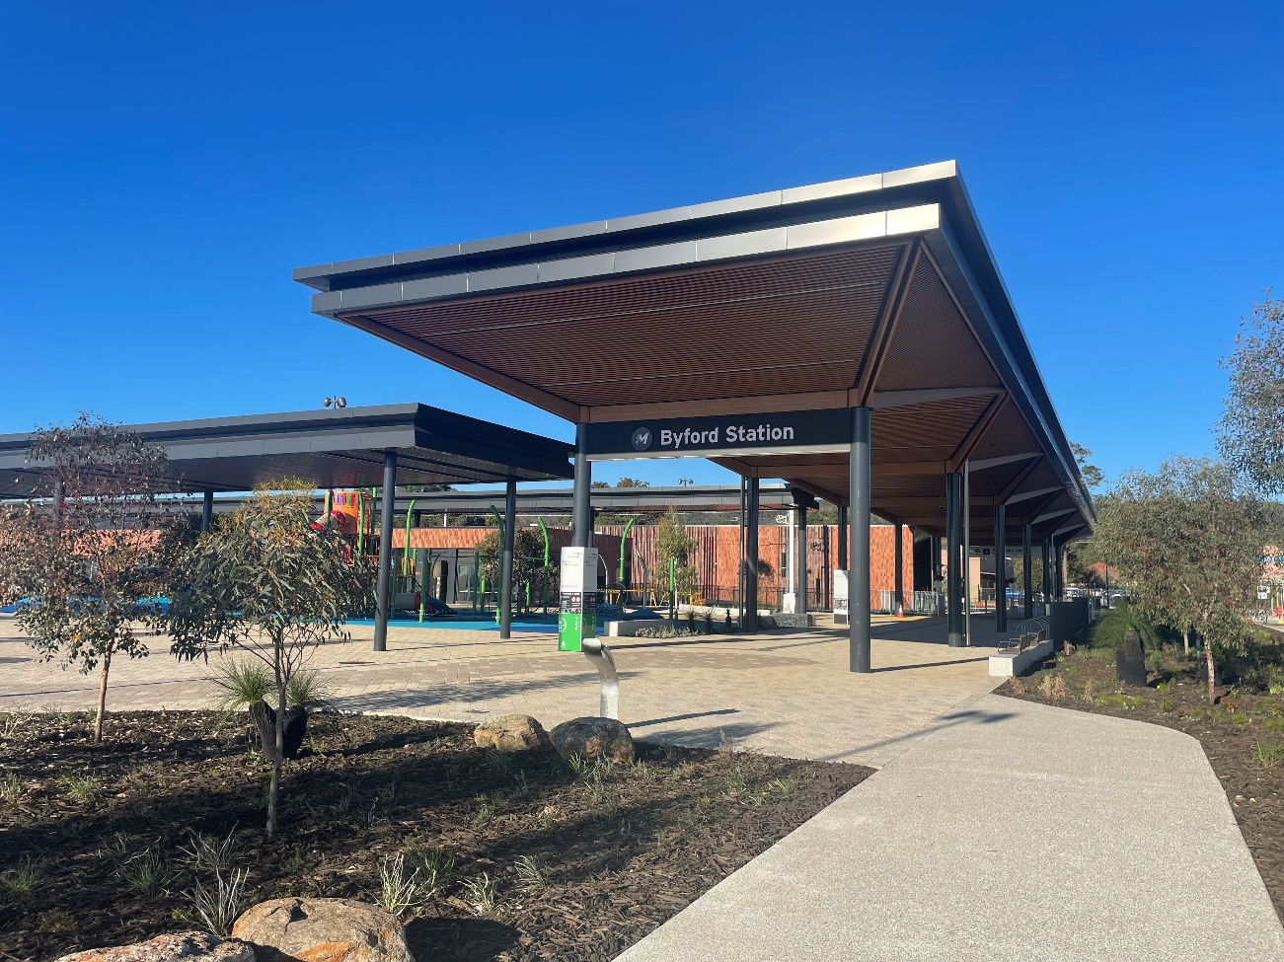
Byford Railway Station in Perth, Western Australia. Photo courtesy of Public Transport Authority of Western Australia.

Driving the Nation Fund
The Driving the Nation Fund aims to enable the shift to electric vehicles (EVs). It supports transformational infrastructure by expanding the national rollout of EV charging and hydrogen refuelling infrastructure, the electrification of heavy vehicle fleets, and innovation in electric vehicle charging solutions across Australia.
Three elements of the Driving the Nation Fund were financed through GTBs in the reporting period.
- Driving the Nation Program – to co-fund initiatives to reduce road transport emissions (ARENA).
- National EV charging network – to help deliver up to 117 EV chargers on key highway routes across Australia (DCCEEW).
- Dealership and Repairer Initiative for Vehicle Electrification Nationally (DRIVEN) Program – to support the installation of EV charging infrastructure at automotive dealerships and EV repairers across the country (DCCEEW).

Green Treasury Bond allocation
GTBs have contributed $20.3 million over 2024–25 (Table 24).
The total Government contribution to projects represent contracted funding for individual projects (past and expected). Most ARENA projects were established prior to issuance of GTBs. The total cost of projects is not reported for the DRIVEN Charger Rebate Stream.
The total cost of all other Driving the Nation Fund projects includes co-financing with project partners.

Table 24: Allocation data for the Driving the Nation Fund ($ million)
Eligible Green Expenditure | Projects supported | 2024–25 Expenditure | 2024–25 Allocation | Total Australian Government Contribution | Total Cost of Project
Driving the Nation Fund | Driving the Nation Program (ARENA) | 36.4 | 19.7 | 158.2 | 495.0
Driving the Nation Fund | National EV charging network (DCCEEW) | 0.5 | 0.3 | 39.3 | 78.6
Driving the Nation Fund | DRIVEN Program (DCCEEW) | 0.6 | 0.3 | 60.0 | N/A
Driving the Nation Fund | Total | 37.5 | 20.3 | 257.5 | 573.6

Co-financing arrangements
ARENA delivers funding for the Driving the Nation Program through grants. ARENA will provide the minimum funding needed for the project to proceed, at times subject to all other parties to the project receiving a commercial return.
The Australian Government has partnered with the NRMA to fund the $78.6 million National EV charging network project. The Australian Government and the NRMA will each contribute 50 per cent ($39.3 million).
The DRIVEN Charger Rebate Stream is delivered as a rebate so no co-financing arrangements are applicable. DCCEEW notes that rebate recipients may have spent more than the rebate cap on installation of chargers onsite, however DRIVEN does not require visibility over full project expenditure.

Material risks
No material risks have been identified to deliver the Driving the Nation Fund.
EV charging infrastructure projects are subject to inherent risks and uncertainties, which can impact the time of deployment and cost of EV charging sites. Progress reporting and payments based on actual delivery contribute to mitigating delivery risks for the National EV charging network project.

Project impacts
Financing through GTBs will contribute to the 117 EV charging sites that will be delivered under the National EV charging network. In 2024–25, 17 of these 117 were delivered (Table 25).
Funding for the National EV Charging Network was announced on 26 April 2023, including a list of confirmed and potential locations for charging infrastructure roll-out, with all chargers expected to be rolled out within 3 years of the roll out beginning.

Table 25: Impact data for the Driving the Nation Fund
Project | Metric | Value | Recorded / Projected | Time Period
National EV Charging Network | EV charging sites delivered | 17 | Recorded | FY2024–25
DRIVEN Charger Rebate Stream Round 1 | EV charging plugs approved for rebate | 244 | Recorded | January – April 2025

Social co-benefits
The National EV charging network project will raise current and future EV driver confidence by establishing a nationwide network of chargers. The fast chargers will be compatible with all EVs and accessible by all motorists.
New sites will complement existing and planned EV charging infrastructure. Site selection for new EV chargers will target known blackspots, prioritising regional and remote communities.
The DRIVEN Charger Rebate Stream supports dealerships and EV repairers nationwide by providing funding for the purchase and installation of smart EV chargers at eligible sites.

Table 26: Social impact data for the Driving the Nation Fund
Metric | Project | Value | Recorded / Projected | Time Period
Regional locations supported | National EV Charging Network | 17 | Recorded | FY2024–25
Businesses supported | DRIVEN Charger Rebate Stream Round 1 | 110 | Recorded | January – April 2025

Case study 8: Driving the nation case studies
Case study 8.1: Accelerating the local government transition to Battery Electric Vehicles in WA
The Western Australia Local Government Association (WALGA) is addressing the current barriers to Battery Electric Vehicles (BEVs) adoption for local governments (LG) through an aggregated approach, which includes a procurement model providing an ongoing pathway for LG fleet electrification through streamlined and cost-efficient procurement processes. WALGA has successfully rolled out the target 105 chargers and 129 BEVs across 22 LG fleets.
Case study 8.2: Accelerate electric vehicle fleet project through Origin Energy and Custom Fleet
Origin Energy (Origin) is partnering with Custom Fleet (Custom) to help business customers transition their fleets to BEVs by providing end-to-end fully managed BEV fleet management solutions. Origin and Custom will lease or purchase from manufacturers up to 1,140 light vehicle BEVs for business customers and install a mix of 22kW (3 phase) and 7kW (single phase) chargers. Origin has progressed almost half of this rollout to over 100 separate customers.
Case study 8.3: Rigid and prime mover truck electrification project
Centurion Transport has completed construction of 15 DC fast chargers (ranging between 50-150 kW) and the installation of a fully off-grid energy system consisting of a 10.32 MWh battery and a 4.35 MW rooftop solar PV array at its largest depot in Hazelmere, Western Australia to support the energy needs of 30 fully operational battery electric trucks.

Case study 8.4: Depot of the future Vehicle Electrification Project
The Depot of the Future Vehicle Electrification Project, led by Team Global Express, will procure and deploy 60 heavy BEVs, the associated depot charging infrastructure, and a battery energy storage system. It will demonstrate the impact of large-scale BEV integration in fleet operations, creating between 50 and 70 jobs in the construction stage.
Case study 8.5: Automating EV Charging in line with Wholesale Pricing
Amber Electric Pty Ltd is leading the project which will develop a software solution to facilitate BEV smart charging and vehicle-to-grid (V2G) bi-directional charging in line with wholesale energy prices. The project also includes a subsidy arrangement for the purchase and installation of 100 smart chargers and 50 V2G bi-directional chargers for the project trial participants. This technology, at scale, aims to support grid stability by adapting charging sessions in response to the levels of variable renewable energy in the grid and discharging energy during periods of high demand across distribution networks.
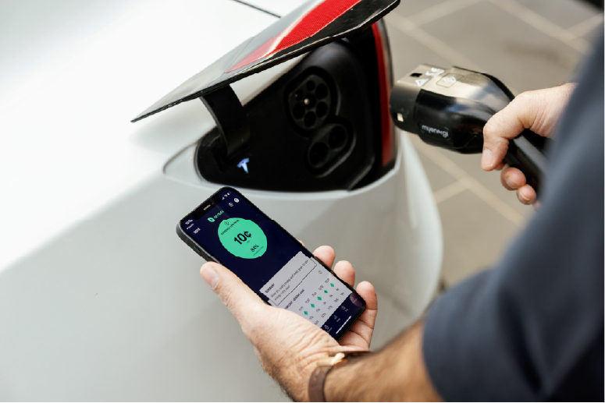
Charging an electric vehicle. Photo courtesy of Amber Electric.

Electric bus charging infrastructure
The Australian Government has committed $125 million to support the delivery of Electric bus charging infrastructure in Perth, matched by the Western Australian (WA) Government’s acquisition of 130 locally manufactured electric buses.
The Electric bus charging infrastructure project will support the WA Government’s delivery of a new electric bus network for Perth through upgrades to bus depots and the installation of solar panels, batteries and bus charging infrastructure.

Green Treasury Bond allocation
The Australian Government has allocated $18.9 million of GTB proceeds to the project in 2024–25 (Table 27).

Table 27: Allocation Data for Electric bus charging infrastructure ($ million)
Eligible Green Expenditure | 2024–25  Expenditure | Allocation 2026 Report | Total Australian Government Contribution | Total Cost of Project
Electric bus charging infrastructure | 35.0 | 18.9 | 125.0 | 125.0

Co-financing arrangements
There is no co-financing for the Electric bus charging infrastructure project as it is fully funded by the Australian Government. The Western Australian Government funded the acquisition of 130 locally manufactured electric buses.

Material risks
No material risks have been identified for the project. Electric bus charging infrastructure has commenced construction. As with all large-scale infrastructure projects, funding for this project may change in the future to align with construction market conditions and project delivery timeframes.
Should cost pressures be realised, it will be a decision of the Australian Government to consider and commit additional funding.

Project impacts
New electric bus infrastructure to Perth’s public transport network will support the Western Australian Government’s commitment of net zero emissions by 2050 for public transport in Western Australia.
The project will support the full phase out of diesel buses from the Perth public transport network. Each electric bus has the capability to travel up to 300 km on a single charge.

Table 28: Impact data for Electric bus charging infrastructure
Metric | Value | Recorded / Projected | Time Period
Number of electric bus chargers installed | 16 | Recorded | 2024–25
Emissions avoided (kt CO2-e p.a.) | 0.440 | Recorded | 2024–25

Social co-benefits
Investment for new Electric bus charging infrastructure in Western Australia is directly supporting more than 100 local jobs, including 9 apprenticeships.

Table 29: Social impact data for Electric bus charging infrastructure
Metric | Project | Value | Recorded / Projected | Time Period
Local jobs supported | Electric bus charging infrastructure | 100 | Recorded | June 2024

Case Study 9: Electric bus charging infrastructure in Perth, Western Australia
The expansion of Western Australia’s electric bus fleet will see charging infrastructure installed at key depots.
This investment from the Australian and State Government is enabling WA urban network buses to transition to a cleaner, quieter, and more sustainable public transport network, aligned with Western Australia’s Climate Policy and the Public Transport Authority’s Net Zero Emissions by 2050 target.
The project focuses upgrades to existing bus depots in metropolitan Perth. Upgrades include the installation of solar panels, battery storage, and smart charging systems to support overnight charging of electric buses during off-peak electricity periods. These upgrades reduce reliance on diesel, lower operational costs, and stimulate local energy generation and storage industries.
The project has achieved key milestones including the completion of the Malaga Bus Depot upgrade. Malaga is now operational with capacity for up to 110 electric buses and 16 charging units. The commencement of construction works at the Karrinyup Bus Depot, which will be the first suburban depot outside the CBD to operate electric buses. These achievements mark the first deployment of electric buses into Perth’s suburban routes.
The project is supporting local employment through construction contracts, depot upgrades, and the local manufacturing of electric buses, contributing to job creation across Western Australia’s transport and energy sectors.
Further information can be found on the Western Australian Government website or Infrastructure Investment website.
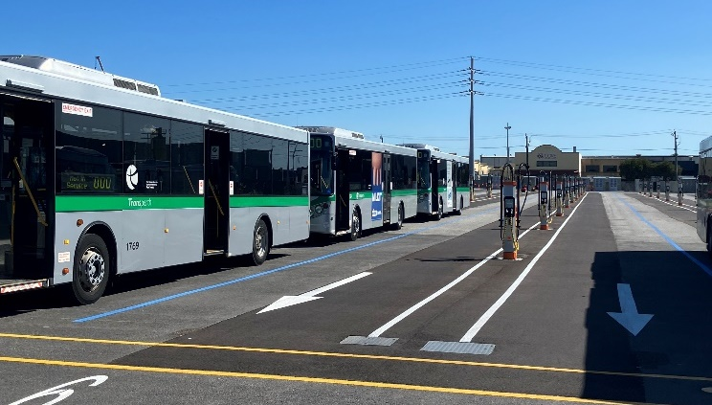
Malaga Bus Depot, Perth, WA, courtesy of the Public Transport Authority of Western Australia

Chapter 5: Climate change adaptation
Climate change has become a real and present threat. The effects of climate change will continue to impact lives and livelihoods unless adaptation measures are taken.
The Australian Government is preparing for higher average temperatures by planning and implementing adaptation measures domestically and internationally. Australia is well placed to adapt to climate challenges given our natural resources, world-class institutions, stable economy and strong sense of community.
The Australian Government’s role in assisting Australians to build resilience to the impacts of climate change includes:
- providing national leadership on climate change adaptation
- ensuring the availability of nationally authoritative climate science and information
- managing climate risks to government assets and services.
The Australian Government’s National Adaptation Plan (NAP) was released in 2025 and responds to the findings of the National Climate Risk Assessment (NCRA). The NAP is a significant step towards climate change preparedness. It outlines the Australian Government’s national leadership role, complementing plans prepared by other jurisdictions and sectors.
Action to address priorities identified in the NCRA and NAP are currently funded through the Australian Government’s Disaster Ready Program. Activities delivered under the Disaster Ready Fund are not able to be financed through proceeds from Green Treasury Bonds as they are financed through Australia’s Future Fund.
The Government recognises that climate change is a shared challenge for all countries and is supporting the Indo-Pacific region to increase its adaptive capacity in line with Australia’s international climate change commitments, including the Paris Agreement. GTBs are financing climate change adaptation projects in the Pacific and Southeast Asia, along with Australia’s contributions to multilateral climate funds.

International climate finance projects
Australia’s international climate finance supports countries in the Indo-Pacific region to adapt to the increasing impacts of climate change and to reduce their emissions by investing in renewable energy and clean technologies to meet their net zero transition goals.
Australia’s climate finance is focused on the Pacific and Southeast Asia (Figure 8). It includes bilateral and regional programs, along with contributions to multilateral development banks’ climate programming, and multilateral climate funds. Australia also mobilises private finance into new climate investments in developing countries.
Projects selected for the GTB project pool are a subset of Australia’s climate finance investments. Australia reports climate finance to the UNFCCC in its Biennial Transparency Report, in line with its obligations. The selected investments have been counted in accordance with the Green Bond Framework – the amount of adaptation and mitigation finance reported to the UNFCCC may differ due to methodological differences for accounting.

Figure 8: Australian climate finance in the Indo-Pacific
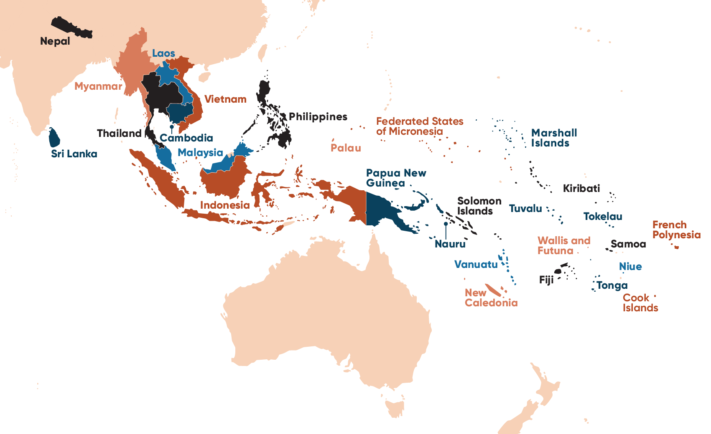

Green Treasury Bond allocation
GTBs contributed $108.3 million to 21 sub-projects under International Climate Finance over 2024–25 (Table 30).
Government contributions for individual sub-projects are not fixed and are subject to change. Please refer to the AusDevPortal for the total estimated Government funding for each project based on current available data.
Due to the nature of international climate financing, it is not possible to determine the total cost of projects including co-contributions from other parties, such as foreign governments and international organisations. The co-financing arrangements section below details where the Australian Government is co-financing or co-delivering a project.

Table 30: Allocation data for international climate finance projects ($ million)
Eligible Green Expenditure | Projects supported | 2024–25 Expenditure | 2024–25 Allocation | Total Australian Government Contribution | Total Cost of Project
International climate finance projects | Climate Resilient Communities (CRC) | 26.5 | 14.3 | N/A | N/A
International climate finance projects | SHIELD Against Disasters & Climate Change Program (Philippines) | 3.6 | 1.9 | N/A | N/A
International climate finance projects | Inclusive Water Governance and Strengthening Climate Resilience in the Mekong Region | 0.5 | 0.3 | N/A | N/A
International climate finance projects | Building capabilities for green, climate resilient and inclusive dev. in lower Koshi River basin | 1.0 | 0.5 | N/A | N/A
International climate finance projects | Climate and Oceans Support Program in the Pacific Phase 3 (COSPPac3) | 7.9 | 4.3 | N/A | N/A
International climate finance projects | Partnership for Climate, Renewable Energy and Infrastructure (KINETIK) | 39.4 | 21.3 | N/A | N/A
International climate finance projects | Commonwealth Climate Finance Access Hub (Pacific) | 0.9 | 0.5 | N/A | N/A
International climate finance projects | Pacific Climate Finance Access and Effectiveness | 10.0 | 5.4 | N/A | N/A
International climate finance projects | Support for the Secretariat of the Pacific Regional Environment Programme | 8.1 | 4.4 | N/A | N/A
International climate finance projects | PNG Climate FIRST (Finance Initiative for Resilience and a Sustainable Transition) | 5.1 | 2.7 | N/A | N/A
International climate finance projects | Global Environment Facility 6, 7, 8 | 18.4 | 10.0 | N/A | N/A
International climate finance projects | Montreal Protocol Multilateral Fund | 7.8 | 4.2 | N/A | N/A
International climate finance projects | Green Climate Fund (GCF) | 15.0 | 8.1 | N/A | N/A
International climate finance projects | Water for Women Climate Resilient Inclusive Water, Sanitation and Hygiene Fund (2018–2025) | 9.5 | 5.1 | N/A | N/A
International climate finance projects | Pacific Climate Infrastructure Financing Partnership (PCIFP) - Off-Grid Programs | 15.0 | 8.1 | N/A | N/A
International climate finance projects | Australian Water Partnership for the Indo-Pacific Phase 3 | 8.3 | 4.5 | N/A | N/A
International climate finance projects | Tuvalu Coastal Adaptation Project | 3.8 | 2.0 | N/A | N/A
International climate finance projects | Kiribati-Australia Climate Partnership | 0.9 | 0.5 | N/A | N/A
International climate finance projects | Fund for Responding to Loss and Damage (FRLD) | 10.0 | 5.4 | N/A | N/A
International climate finance projects | Support for Weather Ready Pacific | 7.5 | 4.0 | N/A | N/A
International climate finance projects | Solomon Islands Humanitarian and Disaster Relief and Resilience Program | 1.1 | 0.6 | N/A | N/A
International climate finance projects | Total (a) | 200.1 | 108.3 | N/A | N/A
- Due to rounding, discrepancies may occur between sums of the component items and totals.

Co-financing arrangements and delivery partners
Australia’s international climate finance programs are generally delivered jointly funded with other countries or global organisations, such as the United Nations, as delivery partners and through co-financing.
- Climate Resilient Communities is financed and delivered by the Australian Government.
- The Strengthening Institutions and Empowering Localities against Disasters and Climate Change (SHIELD) initiative is implemented in coordination with the Philippines government.
- Inclusive Water Governance and Strengthening Climate Resilience in the Mekong Region is delivered by Oxfam and one component is co-financed with the Swiss government.
- The program to build community resilience to disasters in the Lower Koshi River Basin is delivered in partnership with the International Centre for Integrated Mountain Development, a regional inter-governmental organisation.
- Phase 3 of the Climate and Oceans Support Program in the Pacific is co-financed with the New Zealand government and delivered in partnership with 14 Pacific Island countries.
- The Partnership for Climate, Renewable Energy and Infrastructure is delivered in partnership with the Government of Indonesia.
- The Commonwealth Climate Finance Access Hub is co financed and co delivered with 14 partners, consisting of sovereign governments, non-governmental organisations and multinational organisations.
- Australia’s funding towards Pacific Climate Finance Access and Effectiveness finances the UN Development Programme’s Governance for Resilient Development in the Pacific project, delivered with 6 Pacific Island countries, and the Climate Finance Access Network delivered by the Global Green Growth Facility with 8 Pacific Island countries.
- Australia provides core support for the Secretariat of the Pacific Regional Environment Programme (SPREP) which supports its Pacific Island country and territory members.
- The PNG Climate Finance Initiative for Resilience and Sustainable Transition (Climate FIRST) is financed by Australia and delivered by the Global Green Growth Institute (GGGI) in partnership with the PNG Climate Change and Development Authority (CCDA).
- The Global Environment Facility is financed by 40 donor countries, with projects delivered in partnership with government and non-government organisations in recipient countries.
- The Montreal Protocol Multilateral Fund (MPMF) is co-financed by countries globally and delivered by the MLF Secretariat in partnership with agencies from recipient countries.
- The Green Climate Fund is the world largest climate fund and works to accelerate transformative climate action in developing countries through a country-owned partnership approach and the use of flexible financing solutions and climate investment expertise.
- The Water for Women Climate Resilient Inclusive Water, Sanitation and Hygiene Fund (2018–2025) supports improved sustainable access to climate resilient and inclusive water, sanitation and hygiene services in 16 Asia-Pacific countries.
- Pacific Climate Infrastructure Financing Partnership (PCIFP) – Off-Grid Programs will boost the development of off-grid small scale renewable energy infrastructure in remote and rural communities.
- Australia Water Partnership for the Indo-Pacific Phase 3 will enhance climate-resilient water resource management in the Indo-Pacific.
- The Tuvalu Coastal Adaptation Project supports land reclamation and reduction of vulnerability on the islands of Funafuti, Nanumea and Nanumaga.
- The Kiribati Australia Climate Partnership supports the people of Kiribati to be resilient to the impacts of climate change and disasters.
- The Fund for responding to Loss and Damage works to address the urgent and growing needs of vulnerable communities in developing countries facing the irreversible impacts of climate change.
- Weather Ready Pacific aims for all Pacific nations to have access to localised, accurate and timely forecasts and warning products to help plan and respond to weather conditions.
- The Solomon Islands Humanitarian and Disaster Relief and Resilience Program will support the Solomon Islands government to improve responses to disasters.

Material risks
No material risks have been identified to finance International Climate Finance projects through GTBs. The Department of Foreign Affairs and Trade (DFAT) considers any risks that may hinder its ability to achieve its development program objectives and implements measures to increase the likelihood of success. DFAT manages development risk throughout the lifespan of any investment.

Project impacts
GTBs have contributed to 6 bilateral initiatives, 11 regional initiatives and 4 multilateral initiatives (Table 31).

Table 31: Impact data for international climate finance projects
Metric | Value | Record/ Projected | Time Period
No. of bilateral investments | 6 | Recorded | 2024–25
No. of regional investments | 11 | Recorded | 2024–25
No. of multilateral investments | 4 | Recorded | 2024–25
Total | 21
International climate finance projects report impacts on a case-by-case basis. These cannot be aggregated as impact metrics differ between sub-projects and methodologies may differ between project owners. Table 31 outlines the qualitative and quantitative impacts from each international climate finance projects, including social co-benefits.
DFAT’s AusDevPortal provides additional details on contributions to UN Sustainable Development Goals and performance ratings for some sub-projects. Links to specific projects are provided in Table 32. The AusDevPortal is updated periodically with new data.

Social co-benefits
Australia supports various community-led ecosystem restoration and conservation programs in the Indo-Pacific. This improves biodiversity and helps make communities resilient against climate change and natural disasters. These projects also generate opportunities for employment and upskilling, helping build institutional knowledge and expertise to continue to support communities. Table 32 outlines social co-benefits and other outcomes for individual projects, where available.

Table 32: Further information on international climate finance sub-projects
Project | Outcomes
Climate resilient communities | Enhanced the integration of climate change across Australia’s development program to help deliver on the climate commitments in the International Development Policy. 19 ODA investments were supported in 2024–25. Also see Case Study 10.
SHIELD against disasters and climate change (Philippines) | Established structured multi-stakeholder platforms across the Philippines that led to their provincial climate risk profiles and typhoon tracking and alerts and integration of resilience and risk strategies into provincial annual planning.  The program has also enabled collaboration between the Australia’s and the Philippines scientific agencies. This is leading to the development of products that enhance the existing GeoRiskPH platform which provides stakeholders with accessible data and analytics to better prepare for and reduce risks from natural hazards.
Inclusive water governance and strengthening climate resilience in the Mekong region | Ensured water resources governance processes at the national and regional levels in the Mekong subregion were more inclusive of civil society, women and marginalised social groups, and that local communities implement inclusive disaster risk reduction and climate change adaptation strategies.
Building capabilities for green, climate resilient and inclusive development in the Lower Koshi River Basin | Supported local governments to integrate Gender Responsive Budgeting and GEDSI assessments into 10 Local Disaster and Climate Resilient Plans in Nepal.  Conducted assessments with 905 community members to identify inclusivity gaps, such as disability-accessible shelters and flood warning systems.  Strengthened resilience of 619 individuals through collaborative learning on watershed management, flood preparedness, and community engagement.
Climate and Oceans Support Program in the Pacific Phase 3 | Support national climate services in Pacific countries to use sea-level monitoring, tide predictions and real-time data to produce tailored agrometeorological and fisheries bulletins for use in agriculture and fisheries sectors.
Partnership for Climate, Renewable Energy and Infrastructure (Indonesia) | Supports Indonesia-led policy and regulatory reform to increase investment in the energy transition, including for small and medium-sized enterprises.  Promotes a just transition in which the marginalised participate in and benefit from the-shift to net zero.
Commonwealth Climate Finance-Access Hub | Deployed advisers to 27 Commonwealth countries, including the Pacific, to assist government departments to support with climate finance grant applications, capacity building and policy support.  Supported 108 projects and 160 capacity-building initiatives to train officials in climate finance.
Pacific Climate Finance Access-and Effectiveness | Mobilised USD53.1 million in Climate Finance into the Pacific as of August 2025 and supported a pipeline of USD96.8 million in Climate Finance for the region as of August 2025.  Trained 247 women and 191 men in the Pacific on various topics related to climate finance.  Projects have accounted for an accumulated estimate of 11,424 mtCO₂ emissions avoided or reduced.
Support for the Secretariat of-the Pacific Regional Environment Programme | Support all Pacific Island countries preparations for international climate change meetings, in their climate and resilience assessments, along with strengthening climate, hydrological and meteorological services.
Papua New Guinea Climate FIRST | Develop investment proposals and partnerships to enhance PNG’s access to large-scale climate finance, with the aim to mobilise up to USD 400 million from international and domestic sources.  Supporting the establishment of a Climate Finance Steering Committee for PNG government agencies.

Project | Outcomes
Global Environment Facility (GEF) 7 & 8 | Approved 29 climate change mitigation projects and programs totalling USD251.7 million in support of climate change mitigation through the GEF Trust Fund, as reported in its 2025 submission to the UNFCCC.  Projects and programs under GEF-8 are on track to generate transformative results: protecting over 218.4 million hectares of critical ecosystems, restoring 8.6 million hectares of degraded land, avoiding 1,905.4 million tons of greenhouse gas emissions, supporting transboundary cooperation in 40 shared water ecosystems, and eliminating 261.8 thousand tons of hazardous chemicals and waste.  Co-financing continues to exceed GEF-8 targets, with over $30.2 billion mobilised – equivalent to $8.70 for every GEF dollar invested.
Montreal Protocol Multilateral Fund | Since commencement (1995–2021), 51.1 Gt CO2-e in avoided greenhouse gas emissions.  10,198 projects funded across 144 developing countries as of 2025.
Green Climate Fund (GCF) | In 2024, the GCF committed USD 2.5 billion to 44 new climate projects and expanded its private-sector engagement by approving USD 1.2 billion for 12 private-sector projects. Adaptation comprised 43 per cent of GCF’s new funding commitments.  As at October 2025, the GCF has had the following impacts: 95.9 mtCO₂-e emissions reduced; 249.3m beneficiaries reached; USD443.2m value to resilient and low emission assets; 33.2m hectares of resilient and low emission ecosystem coverage; 7,275MW low emission energy capacity installed and 9.7MWh of energy intensity/improved efficiency.
Water for Women Climate Resilient Inclusive Water, Sanitation and Hygiene Fund (2018-2025) | Support sustainable access to climate resilient water, sanitation and hygiene services in 16 Asia Pacific countries.  The fund has supported more than 3.7 million people to date, including those in the most marginalised communities.
Pacific Climate Infrastructure Financing Partnership (PCIFP) – Off-Grid Programs | Supporting small, off-grid renewable energy infrastructure to boost development in remote and rural communities as a component of the Renew Pacific program.
Australia Water Partnership for the Indo-Pacific Phase 3 | Enhance climate resilient water resource management in the Indo-Pacific, including co-create policies, practices and tools.
Tuvalu Coastal Adaptation Project | Support the reclamation of land and the reduction of vulnerability in the islands of Funafuti, Nanumea, and Nanumaga through strengthening institutions, human resources and building awareness.
Kiribati-Australia Climate Partnership | The partnership aims to increase supply and access to renewable energy and implement sustainable coastal protection solutions.
Fund for Responding to Loss and Damage (FRLD) | The Fund launched a call for proposals under the Barbados Implementation Modalities (BIM) at COP30 in Belem. The BIM is a USD250 million program that will support a range of interventions to address climate change losses and damages.
Support for Weather Ready Pacific | Support all Pacific nations access to localised, accurate and timely forecast and warning products to help communities plan for and respond to weather conditions.
Solomon Islands Humanitarian and Disaster Relief and Resilience Program | Support the Solomon Islands government to improve responses to disaster, including via-capacity development for national personnel and infrastructure improvement.

Case study 10: Climate Resilient Communities
Australia's International Development Policy acknowledges climate change as the greatest shared threat to all countries. DFAT’s flagship climate program, Climate Resilient Communities (CRC), supports the implementation of Australia’s climate change commitments under the International Development Policy, helping to meet Australia’s climate finance targets. Relevant programs are being financed by the Australian Government through GTBs.
CRC bolsters support for DFAT to increase investment in climate change with a particular focus on water, agriculture, food, nature-based solutions and energy sectors.
CRC is designed to help integrate climate and disaster resilience across all sectors in the Development Program, including the following co-funded climate resilient initiatives.
- The Atoll Food Futures (AFF) program – running in Tuvalu, Kiribati and Fiji – addresses food insecurity by increasing household-level fruit and vegetable production and consumption. As growing food in atolls can be challenging due to poor soil and saltwater intrusion, the program introduced climate-adapted garden beds and ran demonstrations on composting, natural pest protection, seed saving and food preservation. AFF reached 4,500 people. Nearly all (94 per cent) reported they grew more fresh food. Half participating households also earned income by selling surplus produce.
- In the Marshall Islands, Australia is co-funding climate-resilient WASH systems in schools, improving access for children, particularly adolescent girls and girls with disabilities. The program targets 45 public schools – around 40 per cent of schools nationwide. The program is upgrading water infrastructure and raising awareness of sustainable WASH practices, including menstrual health and hygiene.
- Through the new Cambodia Climate Resilience Program (CCRP), Australia is partnering with Cambodia to strengthen water systems to withstand climate impacts. The program will support Cambodia’s climate change adaptation targets by strengthening water governance and policies, with a sub-national focus on 3 key river basins. The program also promotes inclusive water strategies (involving women, people with disabilities and Indigenous peoples) and provides grants to NGOs and civil society to pilot climate-smart approaches, with successful models shared and scaled across the country.
- Through the new Tonga Australia Resilient Communities Program (TARCP), Australia is supporting community-driven solutions for climate action. The program will support climate-resilient infrastructure and disaster risk reduction (DRR) activities in 122 rural communities in Tonga, including resilient cyclone shelters, water supply systems and roads. This community-driven approach prioritises the voices and needs of local people.
Through the CRC, development programs across DFAT can access resources, specialist skills and capability to help deliver the climate targets in Australia’s International Development Policy.

Chapter 6: Environmentally sustainable management of living natural resources and land use
Australia’s unique ecosystems are under pressure from use of natural resources, habitat loss, invasive species, pollution and climate change. A holistic approach that brings together land, water and living resources management practices including adaptive management is crucial to keeping Australia’s complex and dynamic ecosystems functioning and maintaining healthy biodiversity.
Australia’s economy and future growth potential are linked to our natural resources, many of which are finite or may be irreparably damaged if managed unsustainably. Land use and the sustainable management of living natural resources must be responsibly handled to secure the safety of Australia’s complex ecosystems.
Objective 5 of the Australian Government’s Strategy for Nature is to improve conservation management of Australia’s landscapes, waterways, wetlands and seascapes. This includes targets of protecting and conserving 30 per cent of Australia’s landmass and marine areas by 2030 and ensuring priority degraded ecosystem areas are under effective restoration by 2030. The Strategy targets use and development of natural resources in an ecologically sustainable way.
GTBs are supporting Australia’s urban waterways through the Urban Rivers and Catchments Program.
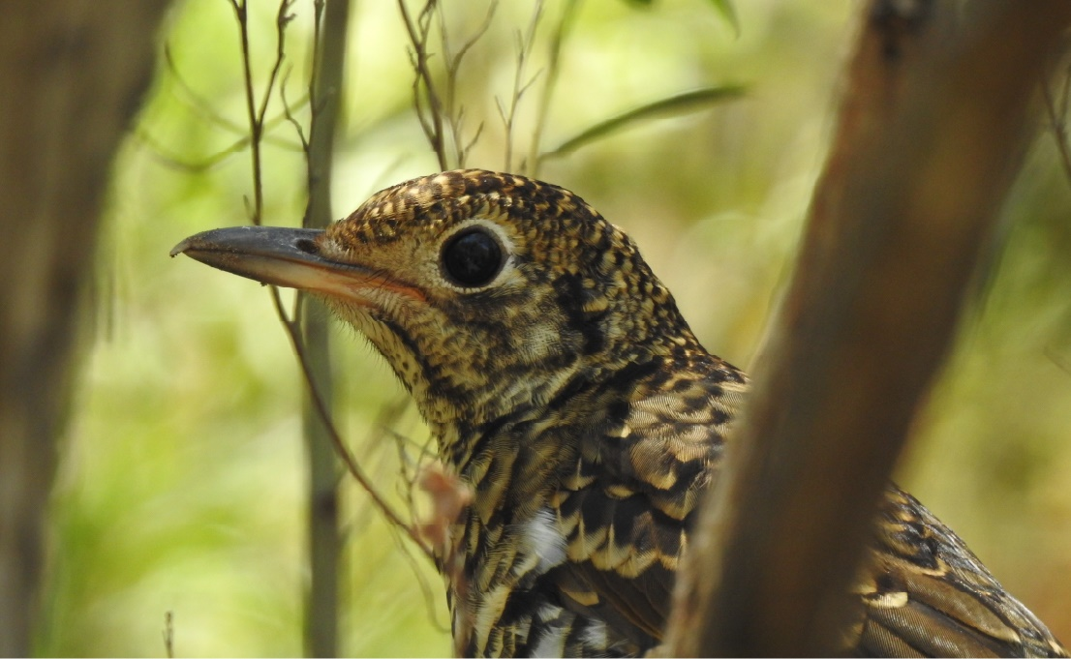
Bassian Thrush at Blackwater Dam. Photo courtesy of Peter Watton.

Urban Rivers and Catchments Program
The Urban Rivers and Catchments Program (URCP) is restoring the health of Australia’s urban waterways for native plants, animals, and local communities.
Nearly half of all nationally listed threatened animals and a quarter of threatened plants occur in urban areas. They share these areas with 96 per cent of Australia’s population.
The program is funding over 100 projects around Australia to help conserve native plants and animals including platypus, birds and native fish. Additionally, many projects are also improving access to waterways that provide benefits for health and social wellbeing.
The Australian Government first supported the program through the 2022–23 October Budget, committing $91 million of funding to deliver Round 1 of URCP. In the 2023–24 Budget, an additional $109 million of funding was committed under URCP to deliver Round 2.

Green Treasury Bond Allocation
GTBs contributed $24.5 million under URCP in 2024–25 (Table 33).
The total Government contribution represents expected funding over the life of the program as at the 2025–26 MYEFO. Funding in future financial years is anticipated to be financed through GTBs.
The total cost of projects is not reported in this grant program.

Table 33: Allocation Data for the Urban Rivers and Catchments Program ($ million)
Eligible Green Expenditure | 2024–25 Expenditure | Allocation 2026 Report | Total Australian Government Contribution | Total Cost of Project
Urban Rivers and Catchments Program | 45.3 | 24.5 | 200.0 | N/A

Co-financing arrangements
Round 1 of the program is delivered through Specific Purpose Payments to States and Territories by state and territory governments and nominated delivery agents. Co-investment was not a requirement for Round 1 projects.
Round 2 is delivered through competitive grants. For Round 2, recipients delivering Stream 2 (large) projects (with grant funding between $2 million and $10 million) were required to provide matching co-investment. Some recipients delivering Stream 1 (small to medium) projects (with grant funding between $0.15 million and $2 million) also contribute co-investment; however, the amounts vary by project, as a cash contribution was not mandatory for these grants.
As at 31 December 2025, Round 2 is leveraging an additional $72.66 million in cash co investment, plus $18.20 million in in-kind contributions, from all grantees across both Streams. Grantees include community groups, NGOs, regional organisations, councils, state/territory governments (for Stream 2 projects only) and First Nations land and water management groups. Co-contributions are detailed in each project’s grant agreement.

Material risks
No material risks have been identified to deliver the Urban Rivers and Catchments Program.
Risk management frameworks are in place at program and project levels, with risk settings actively monitored through established governance processes.
For Round 1, risks are managed through the Federation Funding Agreement – Environment Schedule, project-specific conditions, and payments based on the demonstrated delivery of milestones.
For Round 2, risks are managed through the Grant Opportunity Guidelines, grant agreements, project conditions, 6-monthly reporting to DCCEEW, and payments based on the demonstrated delivery milestones.
Most projects across both rounds include funding conditions to ensure risks are managed at an acceptable level. Higher risk projects also include ‘hold point’ milestones where progress is paused until specified deliverables or conditions are met and approved by the Australian Government.

Project impacts
As of the 2024–25 Financial Year, the Urban Rivers and Catchments Program has delivered biodiversity and ecohydrological outcomes across more than 100 projects. These efforts have contributed to the restoration and re-naturalisation of aquatic and riparian environments (Table 34).
The Program will produce environmental outcome reporting through the DCCEEW Monitoring, Evaluation, Reporting and Improvement Tool (MERIT) – a publicly available reporting product delivered through CSIRO’s Atlas of Living Australia (MERIT website).

Table 34: Impact Data for the Urban Rivers and Catchments Program
Metric | Value | Record/ Projected | Time Period
No. of EPBC-listed species benefited | 76 | Projected | 2025–June 2028
No. of EPBC-listed Threatened Ecological Communities benefited | 19 | Projected | 2025–June 2028
No. of Ramsar-listed wetlands benefited | 9 | Projected | 2025–June 2028

Social co-benefits
Social co-benefits of URCP include the improvement of urban ‘green’ and ‘blue’ space, including improved community access to nature, improved water quality to benefit public health, and increased shading to help reduce urban heat-related impacts due to climate change.
Most projects include First Nations organisations in project delivery including engagement and/or employment opportunities. Many projects are also actively involving local community volunteers and organisations, providing opportunities to improve mental and physical health, social connections, skills and abilities.
Case study 11: Bringing Cox Creek back to life – restoring a biodiversity hotspot in the Adelaide Hills
Winding through the heart of the Adelaide Hills, Cox Creek is a vibrant waterway teeming with life. As the home of iconic native species like the Australasian bittern, southern brown bandicoot, rakali, and Western Bassian thrush, this small creek plays a big role in local biodiversity.
But years of historic land use and the spread of invasive woody weeds had taken a toll. Unstable creek banks, increased sedimentation and a sharp decline in native vegetation threatened the health of this treasured ecosystem and its benefit to the local community.
That is now changing.
In 2025, Adelaide Hills Council was awarded a $1.98 million grant through Round 2 of the Australian Government’s Urban Rivers and Catchments Program, leveraging an additional $610,000 in council and stakeholder contributions to launch the Cox Creek Bridgewater Restoration Project.
This ambitious project is tackling the creek's challenges head-on through:
- removal of dense, habitat-altering woody weeds
- stabilisation of eroding stream banks
- riparian restoration using native species.
One of the most striking early wins came in mid–2025. Despite the ecological concern of an unprecedented dry summer – the first time Cox Creek ran dry in recorded history – the project team seized an opportunity. With access to the dry creek bed, they moved swiftly, clearing over 6 hectares of willow and ash infestations well ahead of schedule.
These early actions have:
- accelerated the project timeline
- reduced future maintenance costs
- opened up new opportunities for native revegetation.
With momentum building and the community behind it, Cox Creek is on track for an ecological comeback,securing the future of its native species and reaffirming its place as a natural jewel in the Adelaide Hills landscape.
Before  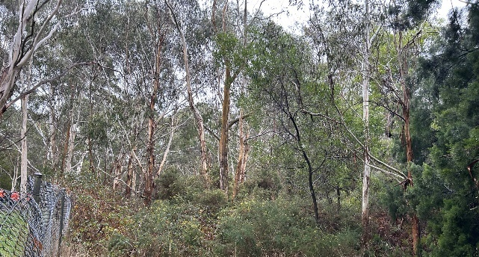 | After  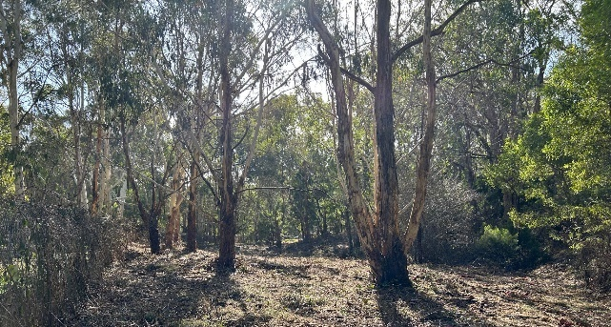
Before and after: Restoration case study photos showing before and after images at Mt George Conservation Park, South Australia. Photo courtesy of Peter Watton.
During restoration works contractors recorded a Bassian thrush (Zoothera lunulata halmaturina) at Mt George Conservation Park. This endangered species, whose status heightened after the Kangaroo Island bushfires, is an insectivorous ground-feeder reliant on dense, moist understorey (habitat this project is restoring to the landscape).

Chapter 7: Biodiversity conservation (terrestrial and aquatic)
The Australian continent and surrounding seas support 600,000–700,000 native species. A high proportion of which are found nowhere else in the world. About 85 per cent of Australia’s plant species are endemic to the continent which is home to half of the world’s marsupial species.
However, Australia’s biodiversity has suffered the largest documented decline in biodiversity of any continent over the last 200 years. Threats that affect the largest number of listed species include invasive species, ecosystem modifications and other human activities.
Australia’s Strategy for Nature 2024–2030 recognises that nature underpins our economy, climate, First Nations peoples’ connection to culture and identity, and our health and wellbeing. The Strategy lays out a vision to halt and reverse biodiversity loss by 2030, so that by 2050 we will be living in harmony with nature.
GTBs are financing biodiversity conservation in Australia through the Saving the Koalas Fund and Reef 2050.


Saving Koalas Fund
The Saving Koalas Fund supports the recovery and long-term conservation of the koala and its habitats. GTBs contribute to 3 aspects of Saving Koalas Fund:
- Community grants
- Large habitat restoration projects
- The National Koala Monitoring Program.
The Saving Koalas Fund is delivered in partnership with First Nations people, the community, conservation organisations, governments, scientists and land managers. The fund is helping to deliver actions in the National Recovery Plan for the Koala.
Community Grants and large habitat restoration projects are expected to conclude in the 2025–26 financial year.

Green Treasury Bond Allocation
GTBs contributed $7.6 million to the Saving Koalas Fund over 2024–25 (Table 35).
The total Government contribution represents the expected funding of each sub-program over its lifetime as of the 2025–26 MYEFO. Funding in future financial years is anticipated to be financed through GTBs.

Table 35: Allocation Data for the Saving Koalas Fund ($ million)
Eligible Green Project | Projects supported | 2024–25 Expenditure | Allocation 2026 Report | Total Australian Government Contribution | Total Cost of Project
Saving Koalas Fund | Community grants | 2.0 | 1.1 | 9.7 | 9.7
Saving Koalas Fund | Koala habitat restoration and protection projects | 9.6 | 5.2 | 25.5 | 25.5
Saving Koalas Fund | National Koala Monitoring Program | 2.5 | 1.4 | 10.0 | 10.0
Saving Koalas Fund | Total^{(a)} | 14.1 | 7.6 | 45.2 | 45.2
- Due to rounding, discrepancies may occur between sums of the component items and totals.

Co-financing Arrangements
The Saving Koalas Fund is delivered through grants and procurements through DCCEEW. Grant recipients, including government agencies, educational institutions, and community organisations, may also contribute financially to sub-projects.

Material Risks
No material risks have been identified to deliver the Saving Koalas Fund. Grant agreements were made in line with program guidelines and to best knowledge this is all consistent with the requirements of the GTB Program.

Project Impacts
GTBs will contribute to the preservation of 5,564 hectares of koala habitat (Table 36).
Community grants support various organisations in their efforts to restore koala habitats, reduce environmental degradation, help manage koala populations and increase biodiversity throughout the Australian landscape.
The investment in research and monitoring is also expected to have long-term benefits for koala populations.

Table 36: Impact Data for the Saving Koalas Fund
Project | Metric | Value | Recorded / Projected | Time Period
Community grants | Number of grants made to community organisations | 59 | Recorded | 2022–2025
Koala habitat restoration and protection projects | Additions and improvements to, and management of, land used as koala habitat (ha) | 5,564 | Recorded | 2022–2025
National Koala Monitoring Program | Number of koala population surveys conducted | 820 | Recorded | 2022–2025

Figure 9: Locations of projects managed by the Saving Koalas Fund
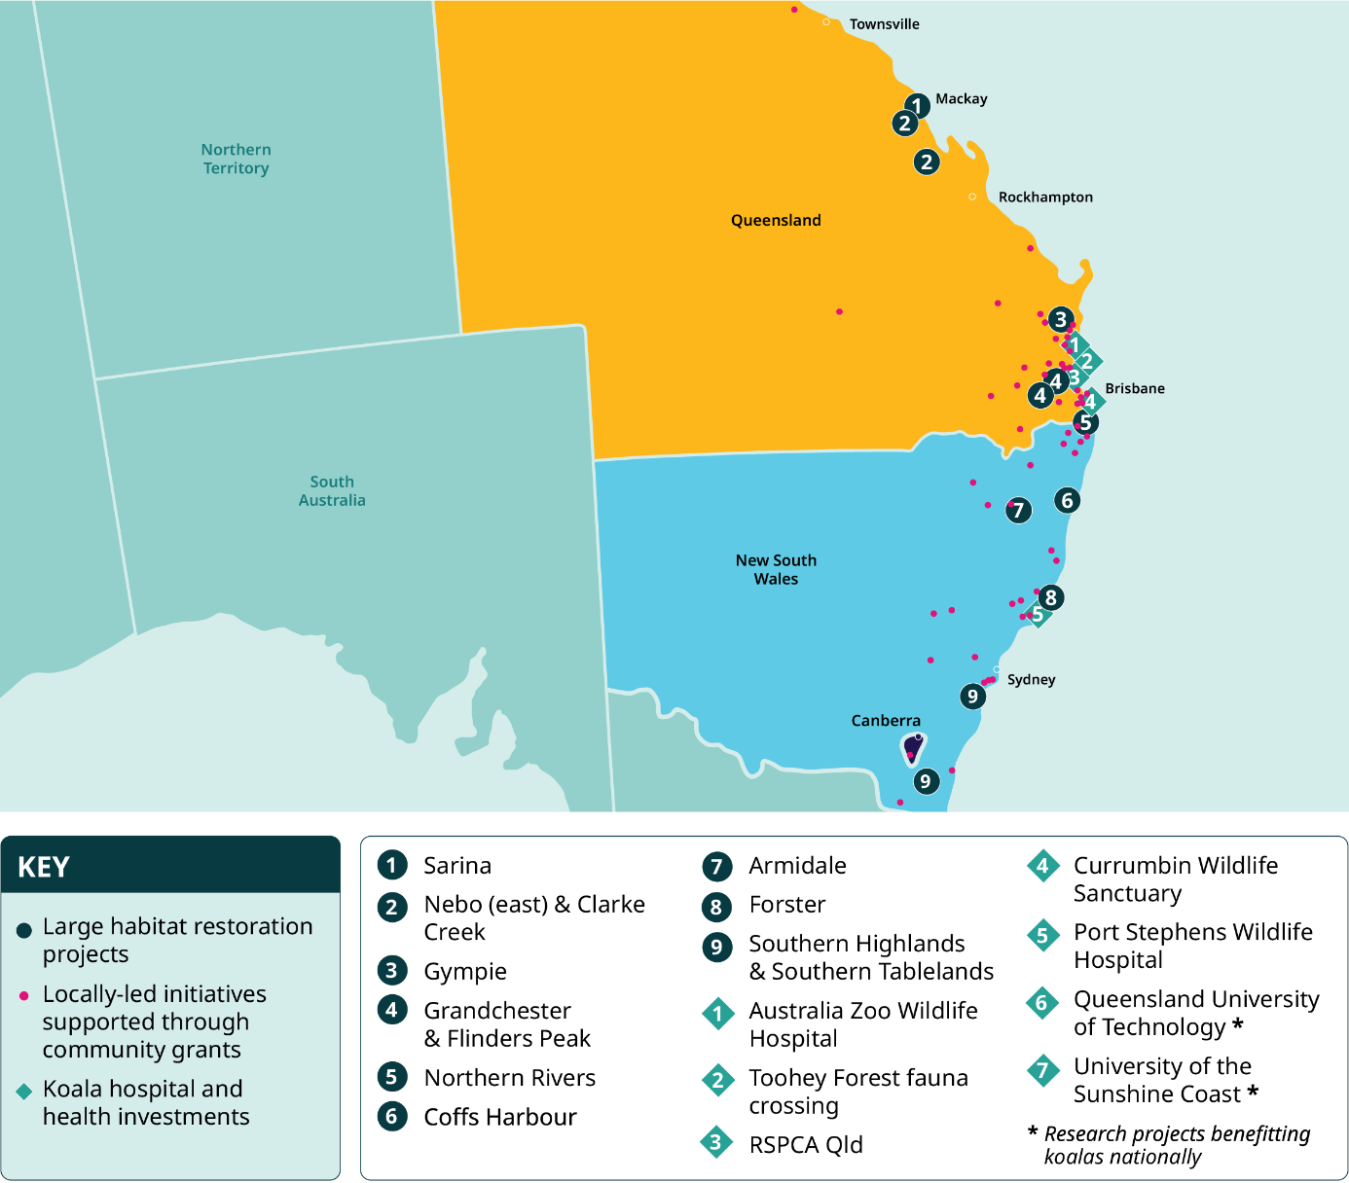
DCCEEW (2024), Saving Koalas Fund

Social Co-benefits
The Saving Koalas Fund collaborates with First Nations communities in delivering projects. Several large habitat restoration projects engage First Nations peoples to understand land management and share knowledge on land and wildlife conservation practices. First Nations organisations have also been involved in habitat restoration and cultural burning activities.
Community grant programs also partner with First Nations organisations and communities to provide guidance regarding land management and conservation and educate communities about First Nations cultural heritage, including 3 First Nations led projects.

Reef 2050
The Great Barrier Reef is one of the world’s natural wonders, the largest coral reef on Earth, and an Australian icon. While the Reef faces significant threats, including from climate change, the Government is investing in its resilience and restoration to protect the Reef now and into the future.
The Australian and Queensland governments released the Reef 2050 Long Term Sustainability Plan in response to the World Heritage Committee’s recommendation that Australia develop a long-term plan for sustainable development to protect the Outstanding Universal Value of the Great Barrier Reef.
The Reef 2050 Plan is Australia’s overarching strategy to improve the Reef’s health and resilience by delivering coordinated local, national and global action in key areas. The most recent Reef 2050 Plan was released in December 2021 with the vision that ‘The Great Barrier Reef is sustained as a living natural and cultural wonder of the world.’
The Reef 2050 Plan has 5 priority areas for action:
- limit the impacts of climate change by contributing to global efforts to reduce emissions and supporting the Reef and communities to adapt
- improve water quality by working with landholders, industries and communities to accelerate action to reduce the impacts from land-based activities
- reduce impacts from water-based activities by strengthening partnerships with Reef industries and delivering strong marine park management
- influence the reduction of international sources of impact to reduce marine debris entering the Reef from outside Australia and protect migratory species
- protect, rehabilitate, and restore Reef habitat, species and heritage sites by minimising impacts from disturbances and assisting with their recovery.

Green Treasury Bond Allocation
GTBs contributed $69.7 million over 2024–25 to the Reef 2050 Plan (Table 37).
Projects are funded through a range of mechanisms, including grants, procurements, partnerships and other financial arrangements. Detailed allocation by sub-projects is not available at this stage.
The total Government contribution and the total cost of the project reflects Australian Government funding for on ground Reef protection and restoration programs in scope of the Green Bond Program from 2022–23 to 2029–30 under the Reef 2050 Plan 2021–25.

Table 37: Allocation Data for Reef 2050 ($ million)
Eligible Green Project | 2024–25 Expenditure | 2024–25 Allocation | Total Australian Government Contribution | Total Cost of Project
Reef 2050 | 128.7 | 69.7 | 807.5 | 807.5

Co-financing Arrangements
The combined Australian and Queensland government investment in the Reef is more than $5 billion from 2014 to 2030. The $807.5 million covered in this reporting is part of the total $3.7 billion Australian Government investment. For this report, there has been a revised approach to total Australian Government Contribution and Total Project Cost compared to reporting in the 2025 Allocation and Impact Report.

Material Risks
No material risks have been identified to deliver the Reef 2050.

Project impacts
The Reef 2050 Activities Report 2024–2025 provides a summary of investments and contains case studies which highlight the results achieved through the Australian Government’s significant long- term investment in the health of the Great Barrier Reef.
Water Quality activities relate to Work Area 2 of the Reef 2050 Plan 2021–25 which contribute to improving water quality in the Great Barrier Reef. The Reef 2050 Water Quality Improvement Plan sets out 2025 water quality targets and land management and catchment targets.
The Australian Government 2025 targets to improve water quality in the Reef are:
- 60 per cent reduction of anthropogenic dissolved inorganic nitrogen load leaving Great Barrier Reef catchments
- 25 per cent reduction of anthropogenic fine sediment load leaving Great Barrier Reef catchments
- 20 per cent reduction of anthropogenic particulate nitrogen load leaving Great Barrier Reef catchments
- 20 per cent reduction of anthropogenic particulate phosphorus load leaving Great Barrier Reef catchments
- At least 99 per cent of aquatic species protected
- 90 per cent of grazing lands will have greater than 70 per cent ground cover.
Reporting against these targets is included in Table 38. Detailed progress towards targets and regional project impacts can be found in the Australian and Queensland governments’ Reef Water Quality Report Card.
The most recent Reef water quality data were released in May 2024 and includes 2021 and 2022. Significant work goes into data collection, validation, analysis, review and reporting to ensure the integrity and quality of the Reef Water Quality Report Card results. Each modelling process as part of the assessment takes several months to run on high-performance computers. The next set of Reef water quality data is expected to be released by December 2026.

Table 38: Impact data for Reef 2050
Project | Metric | Value | Projected/  Recorded | Time Period
Projects in Work Area 2 of Reef 2050 | Reduction of anthropogenic dissolved inorganic nitrogen load leaving Great Barrier Reef catchments (per cent) | 28.4 | Recorded | As at June 2022
Projects in Work Area 2 of Reef 2050 | Reduction of anthropogenic fine sediment load leaving Great Barrier Reef catchments (per cent) | 16.0 | Recorded | As at June 2022
Projects in Work Area 2 of Reef 2050 | Reduction of anthropogenic particulate nitrogen load leaving Great Barrier Reef catchments (per cent) | 15.4 | Recorded | As at June 2022
Projects in Work Area 2 of Reef 2050 | Reduction of anthropogenic particulate phosphorus load leaving Great Barrier Reef catchments (per cent) | 18.5 | Recorded | As at June 2022
Projects in Work Area 2 of Reef 2050 | Pesticide risk condition – aquatic species unlikely to experience harmful effects from pesticides (per cent) | 95.0 | Recorded | 2022
Projects in Work Area 2 of Reef 2050 | Proportion of grazing lands with greater than 70 per cent ground cover in the late dry season (per cent) | 92.0 | Recorded | 2022

Social co-benefits
The Reef is an intrinsic part of the lives of its Traditional Owners, who continue to care for their Sea Country as a significant cultural landscape. More than 70 Traditional Owner groups have long, continuing cultural obligations to the Reef and its catchment stretching back over 60,000 years. For Traditional Owners, its value is immeasurable as it is intertwined with identity, self, and culture. Strong social and economic connections with the Reef are also evident among the broader community. People rely on or use the Reef for their livelihoods, recreation and wellbeing.
The Reef supports a range of reef-dependent commercial (including tourism and fishing) and non-commercial (recreation and research) uses that collectively form an important part of the social and economic fabric of communities in the catchments. Other industries, while not directly dependent on Reef health for their economic sustainability, operate within the Reef (such as ports, shipping) or adjacent to it (such as agriculture) and have an important relationship with the Reef.
The Reef 2050 Plan objectives include specific indigenous heritage and social elements to achieve a ‘Healthy Reef, and Healthy People’, including:
- Traditional Knowledge about the Great Barrier Reef is owned and managed by Traditional Owners and is protected and retained for future generations
- Traditional Owners’ rights are genuinely recognised and prioritised, and inform and drive how benefits are shared
- uses of the Reef are ecologically sustainable as the system changes, in turn sustaining economic and social benefits.

Chapter 8: Sustainable water and wastewater management
Australia is the land of droughts and flooding rains. This presents unique challenges and requires careful and sustainable water and wastewater management.
Australian water resources are managed by agencies at different levels of government. State and territory governments are primarily responsible for managing water in their jurisdictions. The Australian Government provides national coordination and leadership to drive policy and law reforms to manage the country’s water resources sustainably and productively for future generations of Australians.
Australia’s water policies aim to improve the sustainable management of national water resources, and increase water security for communities, agriculture, and the environment to ensure reliable future supply. This includes promoting all sources of water, including recycled water, treated wastewater, stormwater and groundwater.
DCCEEW is committed to renewing the National Water Initiative in consultation with state and territory governments. The new National Water Agreement will build on the NWI to address current and future challenges. The new National Water Agreement seeks to ensure sustainable water planning in a changing climate, improve water quality and the health of water-dependent ecosystems and strengthen the influence of Aboriginal and Torres Strait Islander Peoples in water management.
GTBs finance programs support the Murray–Darling Basin which covers 75 per cent of New South Wales, more than 50 per cent of Victoria, 15 per cent of Queensland, 8 per cent of South Australia and all of the Australian Capital Territory.
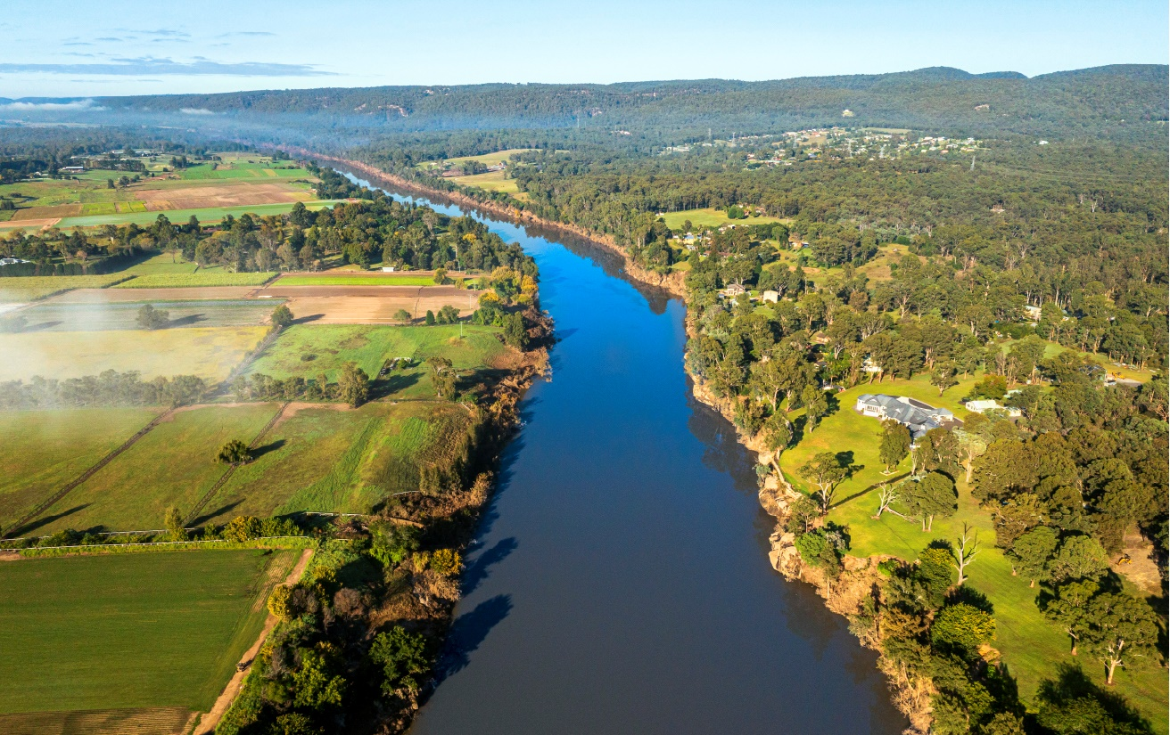

Murray–Darling Basin Plan
The Murray–Darling Basin (the Basin) is Australia’s largest river system. It comprises interconnected rivers and lakes and is home to 16 wetlands of international significance under the Ramsar Convention. It is home to 367 bird species (of which 35 are endangered), 65 mammal species (16 are endangered), 31 native frog species and over 50 species of native fish. It covers over 1 million square km – the size of France and Germany combined.
Over the years, the combination of droughts and increasing human use of the waterways for agriculture, manufacturing, and communities has led to a decline in the environmental health of the Basin. The Basin Plan 2012 (Cth) (Basin Plan) provides an integrated and strategic framework for reform consistent with the requirements of the Water Act 2007 (Cth) (Water Act). The Basin Plan sets the amount of water that can be taken from rivers in the Basin each year, leaving enough to maintain a healthy environment.
The Basin Plan is an integrated and strategic framework for water reform in the Basin, consistent with the requirements of the Water Act. It includes 2 water recovery targets. Key elements of the Basin Plan include:
- limiting the amount of water taken from the Basin each year (sustainable diversion limits) and water management through local watering plans
- returning water to the environment to improve the health of the Basin’s rivers and wetlands
- managing infrastructure development, operation and maintenance to ensure environmental water flows where it is needed and programs to modernise how Australia saves and manages its water efficiently.
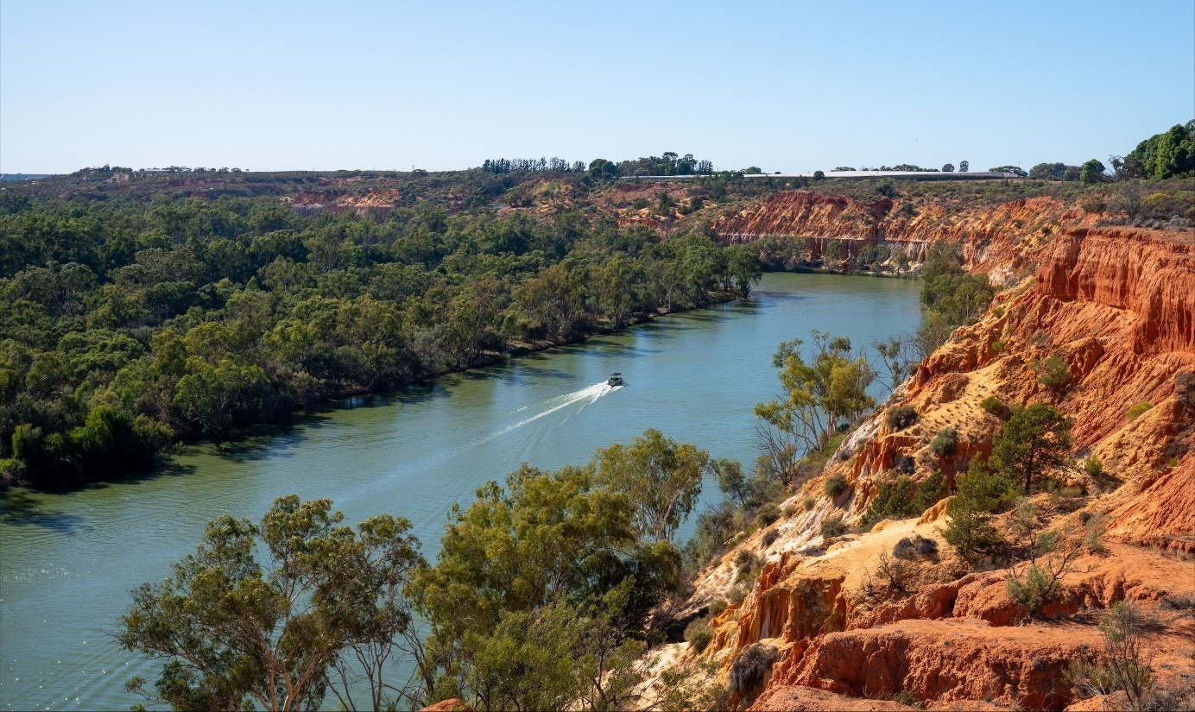
The Murray River at Heading Cliffs, South Australia.
As of 30 June 2025, the Commonwealth environmental water holdings are comprised of 2,941.5 GL of surface water entitlements and 46.8 GL of groundwater entitlements. The Commonwealth Environmental Water Holder (CEWH) manages these water entitlements to protect or restore rivers, wetlands and floodplains in the Murray–Darling Basin, to give effect to international agreements.
Since 2008–09, a total of 18,497 GL of Commonwealth environmental surface water has been delivered and 295 GL of Commonwealth groundwater has been retained in aquifers across the Murray–Darling Basin.
The Basin Plan also includes groundwater management, managing water quality, water markets and trade, mechanisms to enforce compliance with water rules, monitoring and evaluation, and adaptive management.
GTBs are used to finance 3 program streams for activities across the Basin.
- Water for the Environment Special Account (WESA): funding the recovery of environmental water in the Basin to increase the volume of water resources available for environmental use by 450 gigalitres per year (GL/y) and to help ease or remove constraints to deliver the water.
- Environmental Water Holdings Special Account (EWHSA): funding to pay for the costs of managing the Commonwealth’s portfolio of water entitlements and the use of those holdings to protect or restore rivers, wetlands and floodplains in the Basin and to give effect to international agreements.
- Sustainable Rural Water Use and Infrastructure Program (SRWUIP): a national program that invests in rural water use, management and efficiency, including improved water knowledge and market reform, and water purchase for the environment. SRWUIP is the key mechanism to ‘bridge the gap’ to the sustainable diversion limits under the Basin Plan.

Green Treasury Bond allocation
GTBs have financed $378.1 million over 2024–25 of activities across the Basin including the Basin Plan (Table 39) .
The Sustainable Water Use and Infrastructure Program expenditure includes $117.02 million in accrued expenditure. See ‘Approach to impact and allocation reporting’ for further information on the treatment of accruals and timing of expenditure.
The program of works across the Basin commenced in 2007 and is funded until 2027–28. The total Government contribution represents the expected funding of each sub-program as of the 2025–26 MYEFO. Funding in future financial years will be financed through GTBs.

Table 39: Allocation Data for the Murray–Darling Basin Plan ($ million)
Eligible Green Expenditure | 2024–25 Expenditure | Allocation 2026 Report | Total Australian Government Contribution | Total Cost of Project
Water for the Environment Special Account | 295.7 | 160.0 | 1,674.0 | N/A^{(b)}
Sustainable Water Use and Infrastructure Program | 360.2 | 195.0 | 7,038.0 | N/A^{(b)}
Environmental Water Holdings Special Account | 42.7 | 23.1 | 477.1 | N/A^{(b)}
Total | 698.6 | 378.1 | 9,189.1^{(a)} | N/A^{(b)}
- The Total Government Contribution amount does not include funding allocated to measures that have been noted as ‘not for publication’ by the Australian Government. For the Water for the Environment Special Account and the Sustainable Rural Water Use and Infrastructure Program it covers the full measure value including departmental funds and programs with and without water recovery components.
- It is not possible to provide the Total Cost of Project at this stage as different sub-projects may include contributions by other parties, including state and territory governments.

Co-financing arrangements
The Murray–Darling Basin Agreement, which forms Schedule 1 of the Water Act, is a long-standing arrangement signed by Basin state governments and the Australian Government. State governments may contribute to projects financed through the Basin Plan.

Material risks
Water recovery programs take time to deliver and for water recovered to be counted towards Basin Plan targets. Early commencement and steady progression of water recovery programs is necessary to meet the December 2027 statutory timeframes, and any delays to programs may risk delivery.
The costs of program delivery by state governments may be impacted by resourcing costs and delays in project implementation.
Climatic and market conditions can influence the price of water entitlements, making it more expensive to recover water for Basin Plan targets. The Australian Climate Service’s latest National Climate Risk Assessment 2025 found that time spent in drought and associated water scarcity is likely to increase across most of Australia. There are also differences between water market conditions in the northern and southern basins that may influence prices over time.
The expenditure of funds from the EWHSA is largely driven by the quantum of statutory fees and charges and other delivery costs incurred through holding and using the Commonwealth’s environmental water holdings. The volume of water entitlements recovered to meet the Basin Plan recovery targets and the volume of environmental water delivered each year will therefore impact annual expenditure from the EWHSA.
Climatic conditions drive the quantum of water allocated each year by state water authorities, as well as the demand for environmental water on a seasonal basis. These drivers also impact decisions by the CEWH to sell or purchase water each year.
The volume of water entitlements recovered to meet the Basin Plan recovery targets and the volume of environmental water delivered each year will therefore impact annual expenditure from the EWHSA.

Project impacts
The Basin Plan, funded under WESA and SRWUIP, seeks to recover water towards 2 targets:
- bridging the Gap to sustainable diversion limits (2,075 GL/y)
- recover an additional 450 GL/y for enhanced environmental outcomes.
During 2024–25, GTBs contributed to the recovery of 11.3 GL/y towards the Bridging the Gap target and 26.9 GL/y towards the 450 GL/y target of enhanced environmental water. This investment plus historic water recovery efforts leaves 6.9 GL/y to be recovered against the Bridging the Gap target and 292.4 GL/y to be recovered against the 450 GL/y target, as at 30 June 2025.
The EWHSA targets a metric that less than 5 per cent of surface water allocations (in Commonwealth accounts) are forfeited on 30 June at the end of each water year.

Table 40: Impact Data for the Murray–Darling Basin Plan
Project | Metric | Value | Projected/ Recorded | Time Period
Sustainable Rural Water Use and Infrastructure Program | Surface water registered to Commonwealth (GL/y)(c) | 11.3 | Recorded | FY2024–25
Water for the Environment Special Account | Surface Water registered for environmental use (GL/y)(a),(b) | 26.9 | Recorded | FY2024–25
Environmental Water Holdings Special Account | Proportion of surface water allocation (in Commonwealth accounts) forfeited (per cent)(c) | <5 | Recorded | FY2024–25
- Contribution to 450 GL/y target, in the financial year the entitlement was registered with the Commonwealth.
- The value stated here only reflects new registered acquisitions to the 450 GL/y target during the reporting period. It does not include entitlements that were reclassified from the Bridging the Gap (2,075 GL/y) target to the 450 GL/y target.
- Contribution to 2,075 GL/y target, in the financial year the entitlement was registered with the Commonwealth.
Water recovery data are validated between DCCEEW and the Murray–Darling Basin Authority. Relevant details and data sources are regularly updated by DCCEEW in progress updates on the Murray–Darling Basin water recovery.
Information on the management of Commonwealth environment water is recorded by DCCEEW as part of regular updates on water holdings.

Social co-benefits
Current programs are designed to minimise adverse impacts, and the Australian Government is also working with the Basin governments to deliver the Sustainable Communities Program. This program provides funding to communities affected by water recovery to help diversify their economies, build resilience and capacity, prepare for a future with less water, and respond to local challenges and priorities.
As part of the Basin Plan, the Government is fulfilling its commitment to increase First Nations Peoples’ ownership and access to water through the Murray–Darling Basin Aboriginal Water Entitlements Program (AWEP). In the Murray–Darling Basin water is a vital part of the connection to Country. However, the impacts of colonisation have deeply affected these communities’ access to water.

Chapter 9: Circular economy
A circular economy keeps products and materials in use for as long as possible by prioritising reuse, repair and recycling. This minimises waste and improves resource efficiency. Australia is aiming to double its circularity by 2035, signalling a shift in use, recovery and regeneration of resources across the economy. This transition creates a growing pipeline of projects that can be financed through GTBs, particularly those that reduce waste, extend product lifecycles or enable the recovery of materials.
Australia’s Circular Economy Framework identifies priority areas for increasing circularity across industry, built environment, food and agriculture, and resources sectors. These areas align closely with GTB Eligible Green Expenditures, including sustainable materials management, waste reduction infrastructure and technologies that support reuse and recycling. Achieving the national target of doubling circularity would:
- add up to $26 billion in Gross Domestic Product each year by 2035
- reduce greenhouse gas emissions by up to 14 per cent by 2035
- divert up to 26 million tonnes of materials from landfill each year.
A more circular economy will contribute to Australia’s climate strategy by reducing emissions across the full lifecycle of materials and products. Circular practices lower the demand for energy intensive extraction and manufacturing by designing out waste, extending product lifespans and increasing the recovery and reuse of materials. This reduces upstream emissions, avoids landfill-related emissions and supports broader emissions reduction targets. These benefits strengthen the case for GTB projects financing that enables material efficiency, recycling infrastructure and low-carbon production systems.
The Australian Government is supporting several circular economy initiatives.
- The ReMade in Australia scheme enables consumers, businesses and governments to identify genuine, certified products and projects that use recycled content made or constructed in Australia.
- The Government’s Environmentally Sustainable Procurement policy encourages public sector purchasing of low waste, recycled and responsibly sourced materials, helping to stimulate demand for circular products and services.
- DCCEEW has also developed the National Framework for Recycled Content Traceability, improving transparency across supply chains and enabling better verification of recycled content, material recovery and end of life outcomes.
Together, these initiatives create a more supportive environment for GTB eligible projects that advance circularity, resource efficiency and low carbon material systems.
GTBs are financing the circular economy through the Recycling Modernisation Fund, a national initiative expanding Australia’s capacity to sort, process and remanufacture glass, plastic, tyres, paper and cardboard.

Recycling Modernisation Fund
The Recycling Modernisation Fund (RMF) is a national initiative that is expanding Australia’s capacity to sort, process and remanufacture waste materials that are subject to export regulations under the Recycling and Waste Reduction Act 2020.
The Australian Government is contributing over $200 million towards new and upgraded recycling infrastructure projects through the RMF. The RMF will see $1 billion of investment in recycling infrastructure, with contributions from the states and territories and industry.
The objective of the RMF is to improve recycling outcomes by addressing critical infrastructure gaps in Australia’s waste management and resource recovery system. This is achieved by increasing the supply of quality recycled materials available for use and increasing the capacity for domestic sorting, processing and manufacturing of waste glass, plastic, tyres, paper and cardboard.
The Australian Government’s investment in recycling infrastructure through the RMF is supporting the transition to a safe, circular economy, through addressing critical gaps in our domestic recycling capacity. The additional recycling capacity funded by the RMF supports Australia’s transition to a circular economy by allowing more products to be reused, recycled or remanufactured when they are no longer useful or required for their initial purpose.
DCCEEW administers the RMF in partnership with the States and Territories through the Federal Financial Relations framework.

Green Treasury Bond allocation
GTBs contributed $17.8 million over 2024–25 to the Recycling Modernisation Fund (RMF) (Table 41).

Table 41: Allocation Data for the Recycling Modernisation Fund ($ million)
Eligible Green  Expenditure | 2024–25 Expenditure | Allocation 2026 Report | Total Australian Government Contribution | Total Cost of Project
Recycling Modernisation Fund | 32.8 | 17.8 | 229.2 | 1,003.5

Cofinancing arrangements
Australian Government funding is provided to the states and territories through the Federal Financial Relations Framework, with bilateral schedules in place between the Australian Government and all states and territories.
Most RMF projects are co-financed by state and territory governments and third-party project proponents. States and territories generally match federal government funding, with some exceptions.

Material risks
The RMF is administered through the Federal Financial Relations Framework, with bilateral schedules in place between the Australian Government and all states and territories.
All RMF funding rounds are underpinned by funding guidelines. Where states administer the assessment process through Federal Funding Agreements, the Australian Government ensures the assessment criteria align with the eligibility criteria for the program.
The RMF governance arrangements include a risk plan, a national delivery partners forum, bilateral meetings, and regular provision of data by states and territories which is reported publicly through the RMF Viewer on the DCCEEW website.
Some projects have been delayed because of COVID-19, natural disasters and supply chain disruptions. To ensure the funded projects can be delivered, the RMF has been extended to 30 June 2027.
Some projects have been withdrawn and are not included in the impact data. Reasons for withdrawal included supply chain disruptions due to COVID-19, non-completion of funding pre-requisites and feedstock supply uncertainty.

Project impacts
As of 30 June 2025, there were 130 RMF projects, with more to be announced. On completion, the projects are expected to sort, process, recycle and remanufacture 1.4 million additional tonnes of waste glass, plastic, tyres, paper and cardboard per year.
The Government has delivered 63 projects since the start of the program, including: 30 plastics recycling facilities, 12 glass recycling facilities, 9 materials recovery facilities, 4 multi-material facilities, 2 paper and cardboard recycling facilities, 3 transfer stations and 3 tyre recycling facilities.
Of these, 22 projects were funded through the RMF in the 2024–25 financial year.

Table 42: Impact Data for the Recycling Modernisation Fund
Metric | Value | Recorded / Projected | Time Period
Number of waste management projects completed | 22 | Recorded | FY2024–25
Additional waste processing capacity (tonnes p.a.) | 105,200 | Projected | Once fully operational

Social co-benefits
Project proponents provide data on the estimated number of jobs created for each facility funded through the program, with 192 new jobs created.

Table 43: Social impact data for the Recycling Modernisation Fund
Metric | Value | Recorded / Projected | Time Period
Estimated number of ongoing jobs created | 90 | Recorded | FY2024–25
Estimated number of construction jobs created | 102 | Recorded | FY2024–25
Total | 192 | Recorded | FY2024–25
Case Study 12: RMF in action – Australia’s first drum pulper
In 2022–23, Victoria generated 1.2 million tonnes of paper and cardboard waste. Although paper and cardboard are easily recyclable materials, 560,000 tonnes of this waste was sent to landfills in the same year. This represents a significant amount of resources that could otherwise be recovered and reused. Decomposing paper and cardboard in landfill also releases methane. This is a potent greenhouse gas that contributes to climate change.
With the support of the Australian and Victorian governments through the Recycling Modernisation Fund (RMF), VISY is innovating to help boost the amount of paper and cardboard waste recycled in Australia. VISY commissioned Australia's first drum-pulper at its Coolaroo facility in Victoria. The drum pulper is unlike traditional upright pulpers that cut the paper. It uses a gentler, rotating action, that helps preserve more paper fibres for higher quality recycling.
The pulper came online in August 2023. It processed 180,000 tonnes of paper and cardboard in its first year. Visy’s co-located paper mill turns this 100 per cent recycled paper back into a variety of paper products including food and beverage packaging.
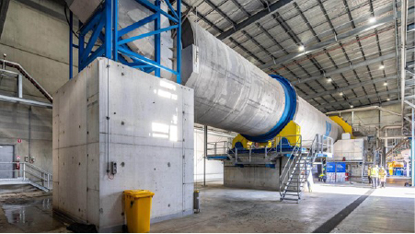
Australia’s first drum pulper in Coolaroo, Victoria. Photo courtesy of VISY Industries.
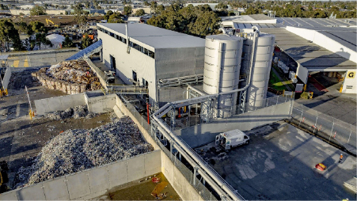
A recycling facility in Coolaroo, Victoria. Photo courtesy of VISY Industries
Case Study 13: RMF in action - More recycling capacity for the NT
In 2022–23, the Northern Territory generated 421,000 tonnes of core waste. 28 per cent of this waste was recycled.
Collecting household waste is the first step in recycling materials so they can be used again. But many regional and remote communities don’t have kerbside waste collection or nearby recycling centres. This makes it harder for people to recycle, and valuable materials often end up in landfill instead. The Central Desert Regional Council (CDRC) solved these challenges with the support of the Australian and Northern Territory governments through the Recycling Modernisation Fund (RMF). The CDRC spans over 282,000 square kilometres. It covers remote communities to the north and east of Alice Springs in the Northern Territory. These are some of Australia’s most remote communities.
The council built multi-material recycling bays in Yuelamu, Nyirripi, Willowra, Atitjere, Lajamanu, Laramba and Engawala. The bays give residents a space to drop off and sort their waste for recycling. The sorted waste enables CDRC staff to easily manage materials for recycling or recovery, with up to 802 tonnes of waste diverted from landfill per year.
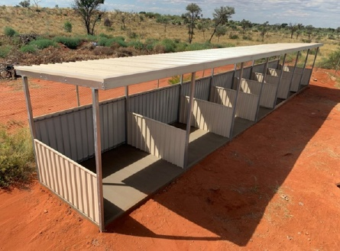
Remote sorting bay in the Northern Territory supported by RMF funding from the Australian and Northern Territory governments. Photo courtesy of the Central Desert Regional Council.

Chapter 10: Eligibility process and reporting

Selection of Eligible Green Expenditures
Projects in some sectors are excluded from consideration as an Eligible Green Expenditure in the Australian Green Bond Framework. Projects that relate to the development, refining and transportation of fossil fuels, as well as programs that predominately assist Australia’s highest greenhouse gas emitting facilities are excluded. This is why some major emissions reductions policies, such as the Safeguard Mechanism, are ineligible for the Green Bond Program.
Treasury reviews Australian Government spending decisions made through the Budget process and identifies projects that are likely to align with the Green Bond Framework (the Framework) and the Second-Party Opinion on the Framework. The interdepartmental Green Bond Committee endorses the Eligible Green Bond Expenditures to be allocated GTB proceeds.
Treasury, informed by the interdepartmental Green Bond Committee, has an ongoing responsibility to update the list of Eligible Green Expenditures and review existing Eligible Green Expenditures. This list of Eligible Green Expenditures is available on the AOFM website.
International best practice is considered when selecting projects to be allocated GTB proceeds. For the Australian Green Bond Framework, taxonomy screening thresholds of the Climate Bond Initiative and the European Union were applied at the time of writing in 2023.
The sustainable finance market has advanced considerably since then. To keep the Framework current, Treasury will update the current framework periodically to align with best practice. This includes considering opportunities for alignment with the Australian Sustainable Finance Taxonomy.


Green Treasury Bonds eligibility window
Eligible Green Expenditures can have expenditure that occurs in the financial year prior to issuance, the financial year of issuance, or in the following 2 financial years (Figure 10). However, at least 50 per cent of proceeds must be allocated to expenditure in the financial year of issuance and future years. This ensures there is sufficient known expenditure to sustain the Green Bond Program and forward-looking expenditures that support new initiatives.

Figure 10: Eligibility window
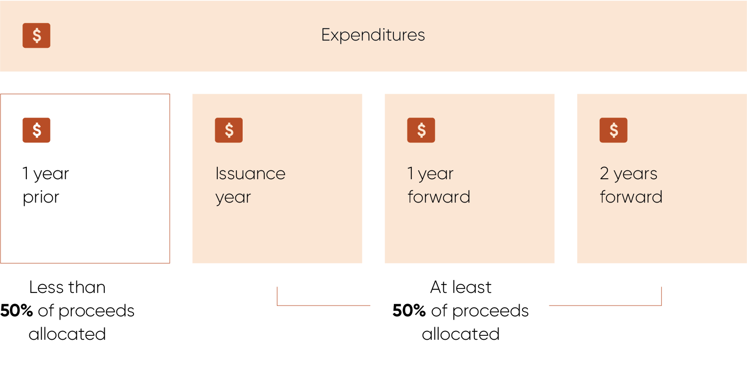
Note: Years relate to financial years.

Approach to impact and allocation reporting
Australian Government agencies that manage and deliver Eligible Green Expenditures have sourced and provided relevant data for impact and allocation reporting. Each Eligible Green Expenditure has its own impact and allocation data indicator(s). Subject to data availability, the impact indicators align with the ICMA Handbook-Harmonised Framework for Impact Reporting.
Many projects allocated GTB proceeds are in the construction stage and are yet to have realised impacts. Where possible, expected project impacts have been reported. Social co-benefits of projects allocated GTB proceeds have been included in this report to capture benefits beyond the primary green objectives.
The ICMA ‘Green Bond Principles’ outline that GTB proceeds should be allocated to projects that have clear environmental benefits. The proceeds of GTB issuance are allocated to expenditures on eligible projects, which include operating, capital and balance sheet expenditures. This aligns with other sovereign green bond issuers, including New Zealand and the United Kingdom. State government and bank issuers usually take a slightly different approach – allocating proceeds to a pool of assets.
The allocation of GTB proceeds can occur from the point when the Australian Government accounts for spending on a program or project classified as an Eligible Green Expenditure. For example, when money has been provided or expenses accrued to project proponents which may include state or territory governments, private companies, and community organisations. This occurs after funding is committed by Government so it can take a longer time to deploy funding.
Due to timing differences in financing by the Australian Government and co-financiers, it is not possible to accurately represent in this report the impacts solely attributable to GTBs. Impacts can be pro-rated based on GTB contributions or Australian Government contributions as a proportion of total lifetime cost of the project.
Under the Green Bond Framework, it is intended that GTB proceeds be fully allocated within two financial years following the financial year of issuance. Ongoing reporting will be undertaken on an aggregate portfolio basis, that is aggregate GTB proceeds, rather than against an individual green bond line.

Reporting change from the Green Bond Framework
This report does not provide the value of proceeds yet to be expended for each Eligible Green Expenditure, as referenced in the Green Bond Framework. Future expenditures are subject to government decisions and contracting arrangements. Projecting future allocation of GTB proceeds to Eligible Green Expenditures is not feasible, as allocations are made at the time of expenditure. Where possible, total Government contribution and total cost of project is reported.

Assurance and verification processes
Projects allocated GTB proceeds under the Australian Green Bond Program must be aligned with the Australian Green Bond Framework and be found to align by an independent third party, in the Second Party Opinion or through pre- and post-issuance reviews. These projects are classified as Eligible Green Expenditures.
The impact and allocation data in this report have been sourced from Australian Government agencies that manage and deliver Eligible Green Expenditures. The impact data is signed off by relevant departments and agencies and reviewed by an independent third party, this year by Sustainalytics. The Chief Financial Officers of these agencies have signed off on the relevant financial information, and the Australian National Audit Office has performed a limited assurance of the allocation reporting.
Eligible Green Expenditures may not align with measures in the Australian Government Budget or other public sources due to funding exclusions that do not meet the Green Bond Criteria or commercial sensitivities. Total costs of projects may be estimates from project proponents and not the Australian Government. Where available, sources used for project costs have been provided.
Where Eligible Green Expenditures are co-financed with state and territory governments, private companies or community organisations, only the Australian Government’s portion of the expenditures are allocated.

Statement by the Co-Chairs of the Green Bond Committee
In our opinion, the Australian Government GTB Allocation and Impact Report, for GTBs issued in the year ended 30 June 2025, is prepared in accordance with section 6.1 of the Australian Government Green Bond Framework.

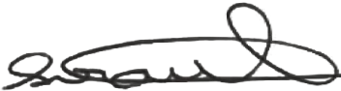 | 
Penny Sirault  Green Bond Committee Co-Chair  Assistant Secretary  The Treasury  6 March 2026 | Miranda Lello  Green Bond Committee Co-Chair  Assistant Secretary  Department of Climate Change, Energy, the Environment and Water  6 March 2026

Assurance Reports

Third party verification
The Australian Government is committed to complying with its Green Bond Framework and ensuring the use of proceeds are appropriately allocated. The allocation reporting has been reviewed by the Australian National Audit Office and the impact reporting has been reviewed by Sustainalytics. The Australian National Audit Office’s report is available below and the Sustainalytics report is available on the AOFM website.
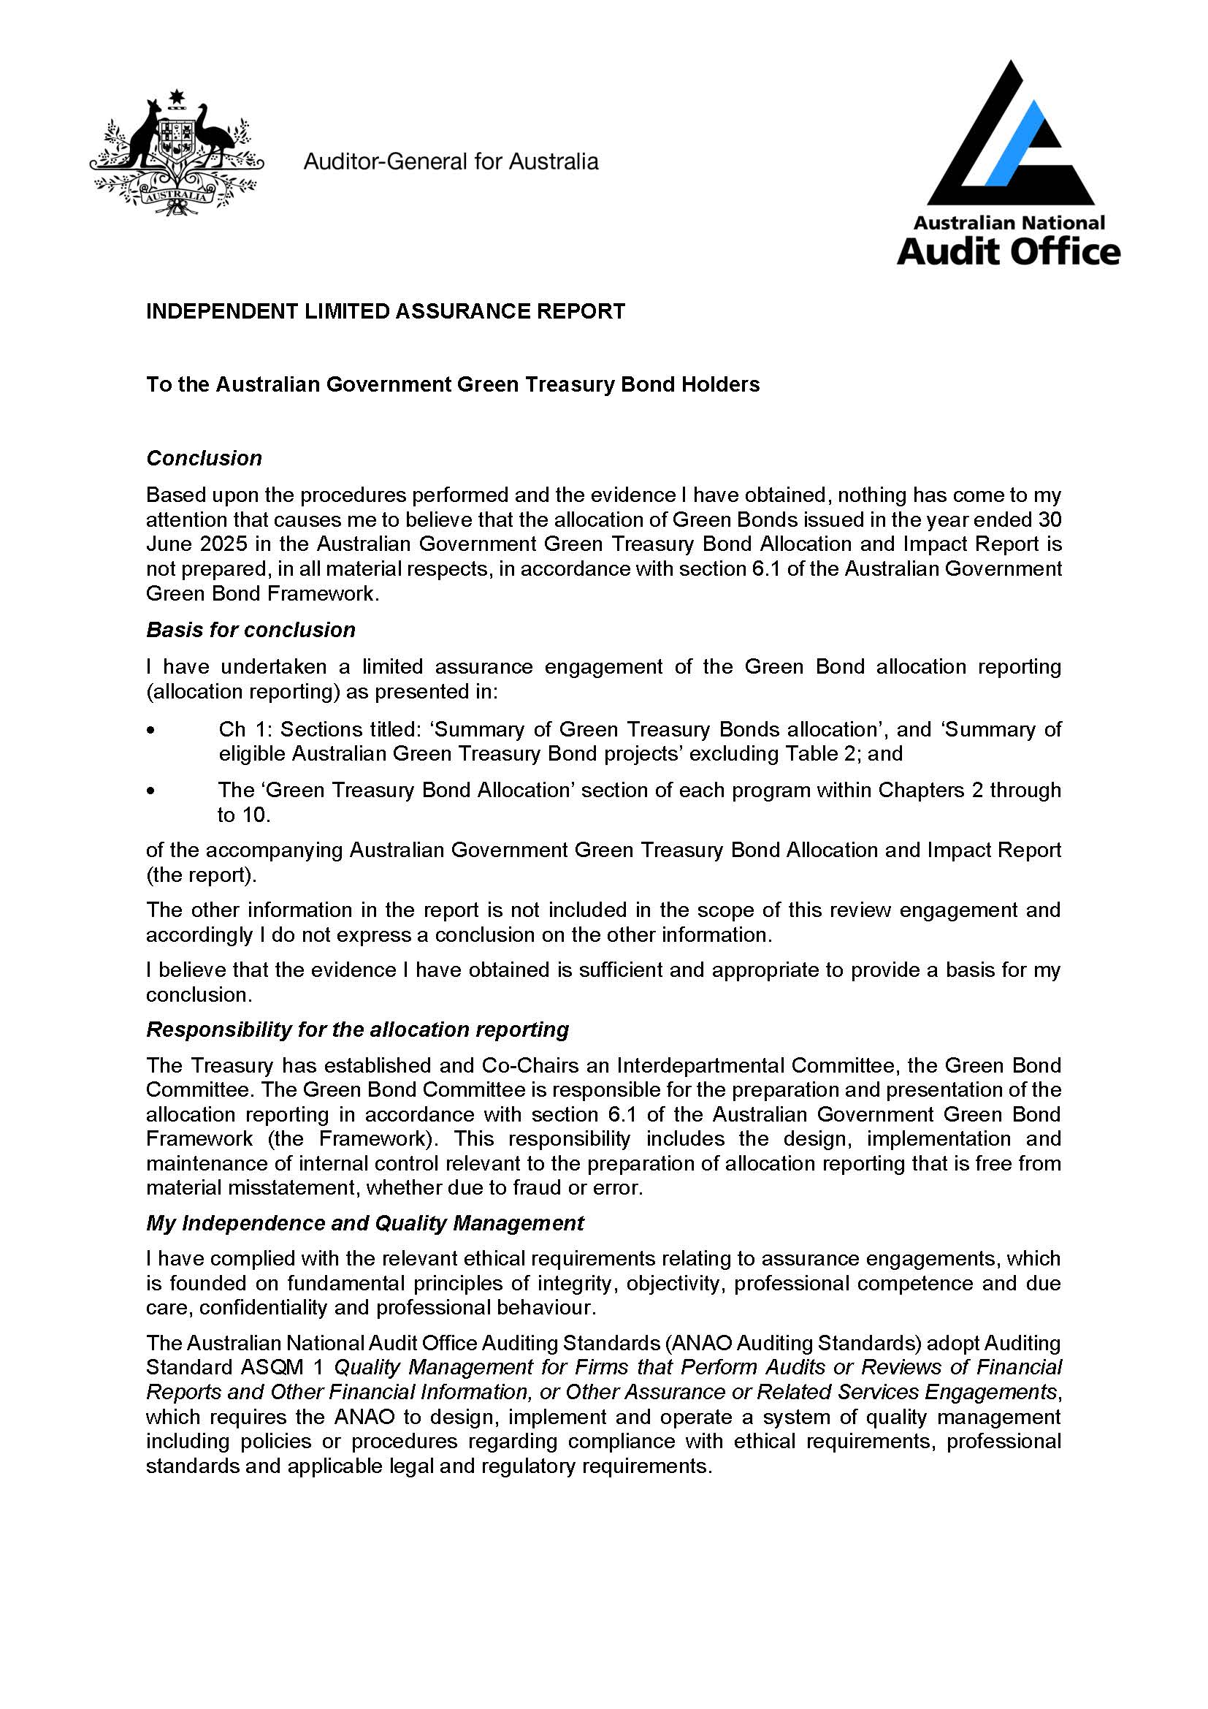
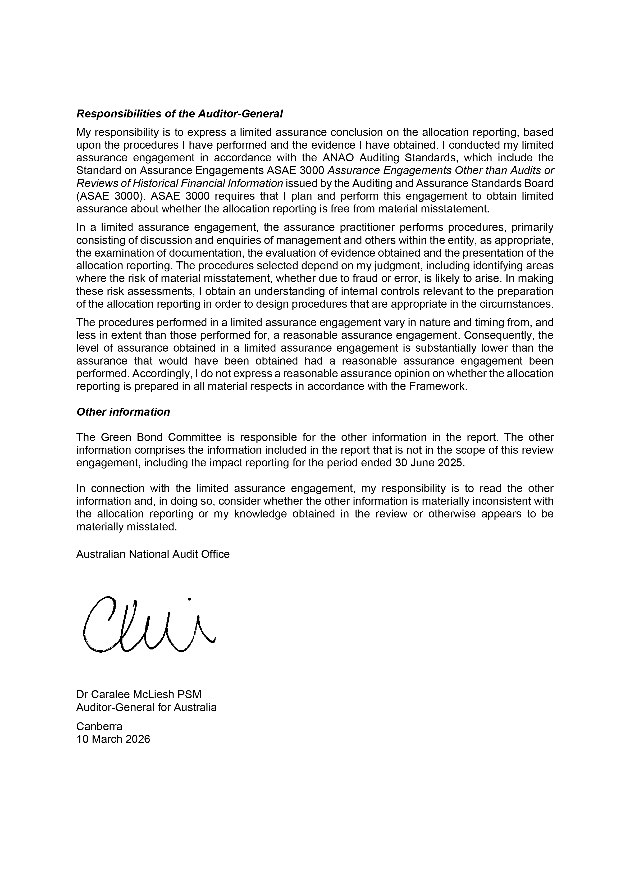

Disclaimer
Legal considerations
This 2026 Australian Government Green Treasury Bond Allocation and Impact Report (Report) has been prepared by the Treasury on behalf of the Australian Government. The allocation reporting has been reviewed by the Australian National Audit Office and the impact reporting has been reviewed by Morningstar Sustainalytics. This Report is a requirement under the Australian Government Green Bond Framework (the Framework) and should be read in conjunction with the Framework, including the Disclaimer.
The Treasury and Australian Office of Financial Management (AOFM) are not licensed in Australia to provide financial product advice in relation to green bonds. This Report is not a product disclosure statement, disclosure document or other offer document under Australian law or any other law. The Report is not suitable for financial, environmental, and social due diligence and the obligation to conduct any due diligence.
This Report does not form part of the contractual terms of any green bonds. An investor in the green bonds will not have cooling off rights.
There is no legal obligation to allocate the proceeds of Green Treasury Bonds in the manner described in this Report or to comply with this Report or the ICMA Green Bond Principles on an ongoing basis. Bonds may cease to be labelled as green, in which case investors may consider that the bonds or loans no longer align with their intentions or requirements and may (as applicable) have increased difficulty finding interested buyers or obtaining an acceptable price. If Green Treasury Bonds cease to be labelled as ‘green’, the Treasury intends to notify investors by publication on the AOFM’s website and via an Australian Securities Exchange notice system. Any failure to give any such notice will not constitute an event of default or any other breach under the terms of any relevant bonds.
No representation or warranty is given, and Treasury, the AOFM and the Australian Government do not provide any guarantee or assurance as to the actual impact on climate change mitigation, climate change adaptation, improved environmental outcomes, or otherwise, of any green bonds issued in the manner described in this Report or the proceeds allocated to Eligible Green Expenditures.
Neither the information contained in this Report, nor any other information supplied in connection with any Green Treasury Bonds should be considered or relied on as a recommendation or a statement of opinion (or a report of either of those things) by Treasury, the AOFM or the Australian Government that any recipient of this Report or any other information supplied in connection with any Green Treasury Bonds should acquire, subscribe for, purchase or otherwise deal in any bonds described in the Report.
Each investor contemplating acquiring, subscribing for, purchasing, or otherwise dealing in any such Green Treasury Bonds should rely upon their own independent investigation of the Australian Government and an investment in Green Treasury Bonds (including any associated risks) and must base their investment decision solely upon their independent assessment and such investigations as they consider necessary.
The distribution and use of this Report, any supplement or other related material, and the offer or sale of Green Treasury Bonds may be restricted by law or directive in certain jurisdictions and intending purchasers and other investors should inform themselves about them and observe any such restrictions. A person may not (directly or indirectly) offer for subscription or purchase or issue an invitation to subscribe for or buy green bonds, nor distribute or publish this Report or any other offering material or advertisement relating to any Green Treasury Bonds except if the offer or invitation, or distribution or publication, complies with all applicable laws and directives.

Endnotes

The Australian Government the Treasury (June 2024), Sustainable Finance Roadmap, https://treasury.gov.au/publication/p2024-536290, accessed 13 October 2025.
Australian Office of Financial Management (December 2023), Green Bond Program, https://www.aofm.gov.au/securities/green-bond-program, accessed 13 October 2025.
International Capital Market Association (June 2025), Green Bond Principles (GBP), https://www.icmagroup.org/sustainable-finance/the-principles-guidelines-and-handbooks/green-bond-principles-gbp/, accessed 13 October 2025.
The Australian Government Department of Climate Change, Energy, the Environment and Water (November 2025),Net Zero , https://www.dcceew.gov.au/climate-change/emissions-reduction/net-zero, accessed 3 December 2025.
Australian Council of Superannuation Investors (2024). Promises, Pathways & Performance Climate Change Disclosures in the ASX200, https://acsi.org.au/research-reports/promises-pathways-and-performance-climate-change-disclosure-in-the-asx200/, accessed 18 November 2025.
Westpac IQ (November 2025), Sustainable Finance Market Update Q3 2025, https://www.westpaciq.com.au/thought-leadership/2025/11/sustainable-finance-market-update-q3-fy25, accessed 8 December 2025.
The Australian Government Department of Climate Change, Energy, the Environment and Water (November 2025), Net Zero, https://www.dcceew.gov.au/climate-change/emissions-reduction/net-zero, accessed 3 December 2025.
The Australian Government Department of Climate Change, Energy, the Environment and Water (November 2025), Annual Climate Change Statement, https://www.dcceew.gov.au/climate-change/strategies/annual-climate-change-statement-2025, accessed 3 December 2025.
The Australian Government Department of Climate Change, Energy, the Environment and Water (November 2025), Australia’s emissions projections 2025, https://www.dcceew.gov.au/climate-change/publications/australias-emissions-projections-2025, accessed 3 December 2025.
The Australian Government Department of Climate Change, Energy, the Environment and Water (May 2025), Australia’s greenhouse gas emissions: December 2024 quarterly update, https://www.dcceew.gov.au/about/news/national-greenhouse-gas-inventory-quarterly-update-december-2024, accessed 3 December 2025.
The Australian Government Department of Climate Change, Energy, the Environment and Water (2024), Australia’s emissions projections 2024, https://www.dcceew.gov.au/climate-change/publications/australias-emissions-projections-2024, accessed 8 December 2025.
The Australian Government Department of Climate Change, Energy, the Environment and Water (November 2025), Net Zero Plan, https://www.dcceew.gov.au/climate-change/publications/net-zero-plan, accessed 3 December 2025.
Australian Government Clean Energy Regulator (November 2025),Safeguard data, https://cer.gov.au/markets/reports-and-data/safeguard-data#preliminary-data, accessed 27 November 2025.
Australian Government Clean Energy Regulator (28 February 2025), Latest report shows Australian Government schemes working to reduce emissions, https://cer.gov.au/news-and-media/media/2025/february/latest-report-shows-australian-government-schemes-working-to-reduce-emissions, accessed 8 December 2025.
The Australian Government Department of Climate Change, Energy, the Environment and Water (September 2025), National Adaptation Plan (p3), https://www.dcceew.gov.au/sites/default/files/documents/national-adaptation-plan.pdfhttps://www.dcceew.gov.au/sites/default/files/documents/national-adaptation-plan.pdf, accessed 17 February 2026.
The Australian Government Department of Climate Change, Energy, the Environment and Water (September 2025), Australia’s National Climate Risk Assessment 2025 (p35), https://www.acs.gov.au/pages/national-climate-risk-assessment, accessed 19 September 2025.
The Australian Government Department of Climate Change, Energy, the Environment and Water (August 2025), National Greenhouse Gas Inventory Quarterly Update: March 2025 (p14), https://www.dcceew.gov.au/climate-change/publications/national-greenhouse-gas-inventory-quarterly-update-march-2025, accessed 8 December 2025.
The Australian Government Department of Climate Change, Energy, the Environment and Water (August 2025), Australian Energy Update 2025 (p3), https://www.energy.gov.au/publications/australian-energy-update-2025, accessed 10 December 2025.
Australian Energy Market Operator (June 2024), 2024 Integrated System Plan (ISP), https://www.aemo.com.au/energy-systems/major-publications/integrated-system-plan-isp/2024-integrated-system-plan-isp, accessed 7 January 2026.
Clean Energy Finance Corporation (December 2024), Renewable Energy, https://www.cefc.com.au/where-we-invest/investment-focus-areas/renewable-energy/, accessed 7 January 2026.
Australian Energy Market Operator (December 2025), 2026 Integrated System Plan (ISP), https://www.aemo.com.au/energy-systems/major-publications/integrated-system-plan-isp/2026-integrated-system-plan-isp, accessed 13 January 2026.
The Australian Government Department of Climate Change, Energy, the Environment and Water (October 2025), Rewiring the Nation, https://www.dcceew.gov.au/energy/renewable/rewiring-the-nation, accessed 7 January 2026.
Clean Energy Finance Corporation (23 May 2024), Media Release: CEFC confirms single largest investment with $490 million backing for NSW energy grid, https://www.cefc.com.au/media/media-release/cefc-confirms-single-largest-investment-with-490-million-backing-for-nsw-energy-grid/, accessed 23 January 2026.
Clean Energy Finance Corporation (18 September 2024), Media Release: CEFC advancing Australia’s energy transformation with VNI West commitment, https://www.cefc.com.au/media/media-release/cefc-advancing-australia-s-energy-transformation-with-vni-west-commitment/, accessed 23 January 2026.
Clean Energy Finance Corporation (17 November 2023), Media Release: CEFC makes first RTN investment as NSW steps up clean energy transformation, https://www.cefc.com.au/media/media-release/cefc-makes-first-rtn-investment-as-nsw-steps-up-clean-energy-transformation/, accessed 23 January 2026.
Clean Energy Finance Corporation (6 October 2025), Media Release: Major construction underway on nation-critical HumeLink project, https://www.cefc.com.au/media/media-release/major-construction-underway-on-nation-critical-humelink-project/, accessed 23 January 2026.
Clean Energy Finance Corporation (4 April 2025), Media Release: CEFC statement regarding Central-West Orana REZ, https://www.cefc.com.au/media/statement/cefc-statement-regarding-central-west-orana-rez/, accessed 23 January 2026.
Clean Energy Finance Corporation (28 August 2024), Media Release: VNI West gets greenlight for early works with $700m equity commitment, securing 1000 jobs in regional NSW, https://www.cefc.com.au/media/media-release/vni-west-gets-greenlight-for-early-works-with-700m-equity-commitment/, accessed 23 January 2026.
Clean Energy Finance Corporation (3 September 2025), Media Release: CEFC to invest in visionary Marinus Link project in largest-ever transaction, https://www.cefc.com.au/media/media-release/cefc-to-invest-in-visionary-marinus-link-project-in-largest-ever-transaction/, accessed 23 January 2026.
EnergyCo (December 2025), Central-West Orana Renewable Energy Zone, https://www.energyco.nsw.gov.au/cwo-rez, accessed 7 January 2026.
Transgrid (27 November 2025), Nation-critical HumeLink project marks major milestone as first towers rise, https://www.transgrid.com.au/media-publications/news-articles/nation-critical-humelink-project-marks-major-milestone-as-first-towers-rise/, accessed 18 December 2025.
Marinus Link (December 2025), Overview, https://www.marinuslink.com.au/overview/, accessed 7 January 2026.
EnergyCo (December 2025), Central-West Orana Renewable Energy Zone, https://www.energyco.nsw.gov.au/cwo-rez, accessed 7 January 2026.
EnergyCo (December 2025), Central-West Orana Renewable Energy Zone, https://www.energyco.nsw.gov.au/cwo-rez, accessed 7 January 2026.
Transgrid (2025), Humelink, https://www.transgrid.com.au/projects-innovation/humelink/, accessed 7 January 2026.
Marinus Link (October 2023), The economic contribution of Project Marinus, https://www.marinuslink.com.au/economic-contribution-2023/, accessed 18 December 2025.
Snowy Hydro (October 2025), Cost reassessment underway for on-schedule Snowy 2.0, https://www.snowyhydro.com.au/news/cost-reassessment-underway-for-on-schedule-snowy-2-0/, accessed 6 January 2026.
The Australian Government Department of Climate Change, Energy, the Environment and Water (November 2023), New Hydrogen Hub for Kwinana, https://www.dcceew.gov.au/about/news/new-hydrogen-hub-for-kwinana, accessed 30 November 2025.
The Australian Government Department of Climate Change, Energy, the Environment and Water (January 2024), Hydrogen hub for Bell Bay, Tasmania, https://www.dcceew.gov.au/about/news/hydrogen-hub-for-bell-bay-tasmania, accessed 29 November 2025.
NSW government (May 2024), Ministerial media release: $207.6 million hydrogen hub given green light in Hunter, https://www.nsw.gov.au/media-releases/2076-million-hydrogen-hub, accessed 30 November 2025.
Business.gov.au (2022), Funding to establish hydrogen hubs in regional Australia, https://business.gov.au/grants-and-programs/hydrogen-hubs-implementation-grants-round-1, accessed 29 November 2025.
The Australian Renewable Energy Agency (September 2025), Community Batteries Funding Round 2, https://arena.gov.au/funding/community-batteries-funding-round-2/, accessed 9 December 2025.
The Australian Government Department of Climate Change, Energy, the Environment and Water (June 2024), Household Energy Upgrades Fund, https://www.dcceew.gov.au/energy/programs/household-energy-upgrades-fund, accessed 14 December 2024.
The Australian Government Department of Climate Change, Energy, the Environment and Water (November 2025), Australia’s emissions projections 2025 (p 51), https://www.dcceew.gov.au/climate-change/publications/australias-emissions-projections-2025, accessed 17 December 2025.
The Australian Government Department of Climate Change, Energy, the Environment and Water (November 2025), Australia’s emissions projections 2025 (p 17), https://www.dcceew.gov.au/climate-change/publications/australias-emissions-projections-2025, accessed 17 December 2025.
The Australian Government Department of Infrastructure, Transport, Regional Development, Communications, Sport and the Arts (September 2025), Transport and Infrastructure Net Zero Roadmap and Action Plan (p3), https://www.infrastructure.gov.au/department/media/publications/transport-and-infrastructure-net-zero-roadmap-and-action-plan, accessed 8 December 2025.
The Australian Government Department of Climate Change, Energy, the Environment and Water (August 2024), The National Electric Vehicle Strategy, https://www.dcceew.gov.au/energy/transport/national-electric-vehicle-strategy, accessed 14 December 2024.
The Australian Government Department of Infrastructure, Transport, Regional Development, Communications, Sport and the Arts (September 2025), Transport and Infrastructure Net Zero Roadmap and Action Plan (p43), https://www.infrastructure.gov.au/department/media/publications/transport-and-infrastructure-net-zero-roadmap-and-action-plan, accessed 8 December 2025.
The Australian Government Department of Climate Change, Energy, the Environment and Water (August 2024), Transport and Infrastructure Net Zero Consultation Roadmap, https://consult.dcceew.gov.au/transport-and-infrastructure-net-zero-consultation-roadmap, accessed 14 December 2025.
Engineers Australia (March 2022), Future of rail transport, https://www.engineersaustralia.org.au/publications/future-rail-transport, accessed 14 December 2025.
The Australian Government Department of Infrastructure, Transport, Regional Development, Communications, Sport and the Arts (2024), Sydney Metro-Western Sydney Airport, https://investment.infrastructure.gov.au/key-projects/sydney-metro-western-sydney-airport, accessed 5 December 2025.
Queensland Government Department of Transport and Main Roads (December 2024), Gold Coast Light Rail, https://www.tmr.qld.gov.au/projects/gold-coast-light-rail, accessed 5 December 2025.
The Australian Government Department of Infrastructure, Transport, Regional Development, Communications, Sport and the Arts (August 2025), Canberra Light Rail – Stage 2A, https://investment.infrastructure.gov.au/projects/113788-20act-np, accessed 6 December 2025.
NSW Government Sydney Metro (2025), Project Overview: About Sydney Metro – Western Sydney Airport, https://www.sydneymetro.info/westernsydneyairportline, accessed 5 December 2025.
Queensland Government Department of Transport and Main Roads (December 2025), Gold Coast Light Rail, https://www.tmr.qld.gov.au/projects/gold-coast-light-rail, accessed 5 December 2025.
ACT Government Light Rail to Woden (2025), Light Rail Stage 2A: City to Commonwealth Park, https://www.act.gov.au/lightrailtowoden/stage-2a, accessed 12 December 2025.
NSW Government Sydney Metro (2024), Project Overview: About Sydney Metro – Western Sydney Airport, https://www.sydneymetro.info/westernsydneyairportline, accessed 5 December 2025.
Gold Coast Light Rail Stage 3 (2024), Gold Coast Light Rail Stage 3, https://www.gclr3.com.au/goldlinq/gclr3, accessed 2 December 2025.
Metronet (2025), About: Metronet, https://www.metronet.wa.gov.au/about, accessed 12 December 2025.
Metronet (2025), Byford Extension, https://www.metronet.wa.gov.au/projects/byford-extension, accessed 12 December 2025.
Metronet (2025), Victoria Park-Canning Level Crossing Removal, https://www.metronet.wa.gov.au/projects/level-crossing-removal, accessed 13 December 2025.
Metronet (2025), Morley-Ellenbrook Line, https://www.metronet.wa.gov.au/projects/morley-ellenbrook-line, accessed 12 December 2025.
Metronet (2025), Thornlie-Cockburn Link, https://www.metronet.wa.gov.au/projects/thornlie-cockburn-link, accessed 12 December 2025.
Metronet (2025), Yanchep Rail Extension, https://www.metronet.wa.gov.au/projects/yanchep-rail-extension, accessed 12 December 2025.
The Australian Government Department of Climate Change, Energy, the Environment and Water (September 2025), Assessing and adapting to Australia’s climate risks, https://www.dcceew.gov.au/climate-change/policy/adaptation/ncra, accessed 10 December 2025.
The Australian Government Department of Climate Change, Energy, the Environment and Water (February 2026), Urban Rivers and Catchments Program, https://www.dcceew.gov.au/environment/biodiversity/conservation/urban-rivers-catchments-program, accessed 24 February 2026.
The Australian Government Department of Climate Change, Energy, the Environment and Water (September 2025), Urban Rivers and Catchments Program, https://www.dcceew.gov.au/environment/biodiversity/conservation/urban-rivers-catchments-program, accessed 17 December 2025.
The Australian Government Department of Climate Change, Energy, the Environment and Water (October 2025), National Koala Monitoring Program, https://www.dcceew.gov.au/environment/biodiversity/threatened/species/koalas/national-koala-monitoring-program, accessed 17 December 2025.
The Australian Government Department of Climate Change, Energy, the Environment and Water (February 2025), Reef 2050 Plan Activities Report 2023-24, https://www.dcceew.gov.au/parks-heritage/great-barrier-reef/publications/reef-2050-activities-report-2023-24, accessed 19 September 2025.
The Australian Government Department of Climate Change, Energy, the Environment and Water (December 2025), National water policy, https://www.dcceew.gov.au/water/policy/policy, accessed 17 December 2025.
The Australian Government Department of Climate Change, Energy, the Environment and Water (March 2025), National waste and resource recovery reporting, https://www.dcceew.gov.au/environment/protection/waste/publications/national-waste-resource-recovery-reporting
Australian Office of Financial Management (November 2025), Green Treasury Bonds, https://www.aofm.gov.au/securities/green-bond-program, accessed 7 January 2026.

