Green Treasury Bonds 2026 Allocation and Impact Report Snapshot
The Australian Government issued $9.0 billion of Green Treasury Bonds as at 30 June 2025. This report allocated $3.6 billion in proceeds – comprising $1.6 billion of 2023–24 issuance and $2.0 billion of 2024–25 issuance.

Figure 1: Green Treasury Bond proceeds allocation by expenditure year
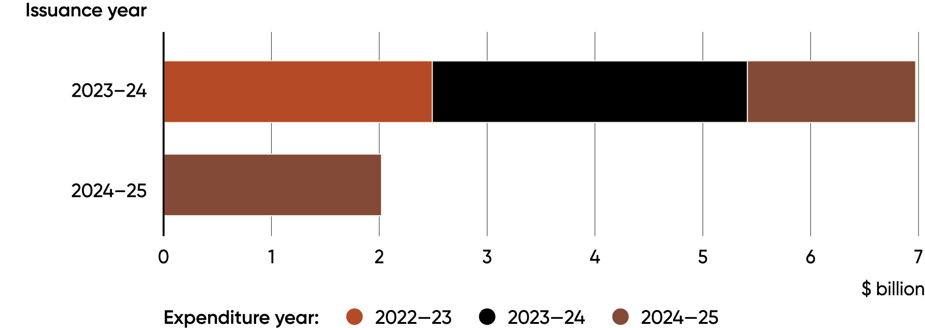
$6.6 billion was spent on eligible green projects in 2024–25. The $3.6 billion allocation to 2024‍–‍25 expenditure makes $3.0 billion available for future reporting.

Figure 2: Eligible expenditure by year
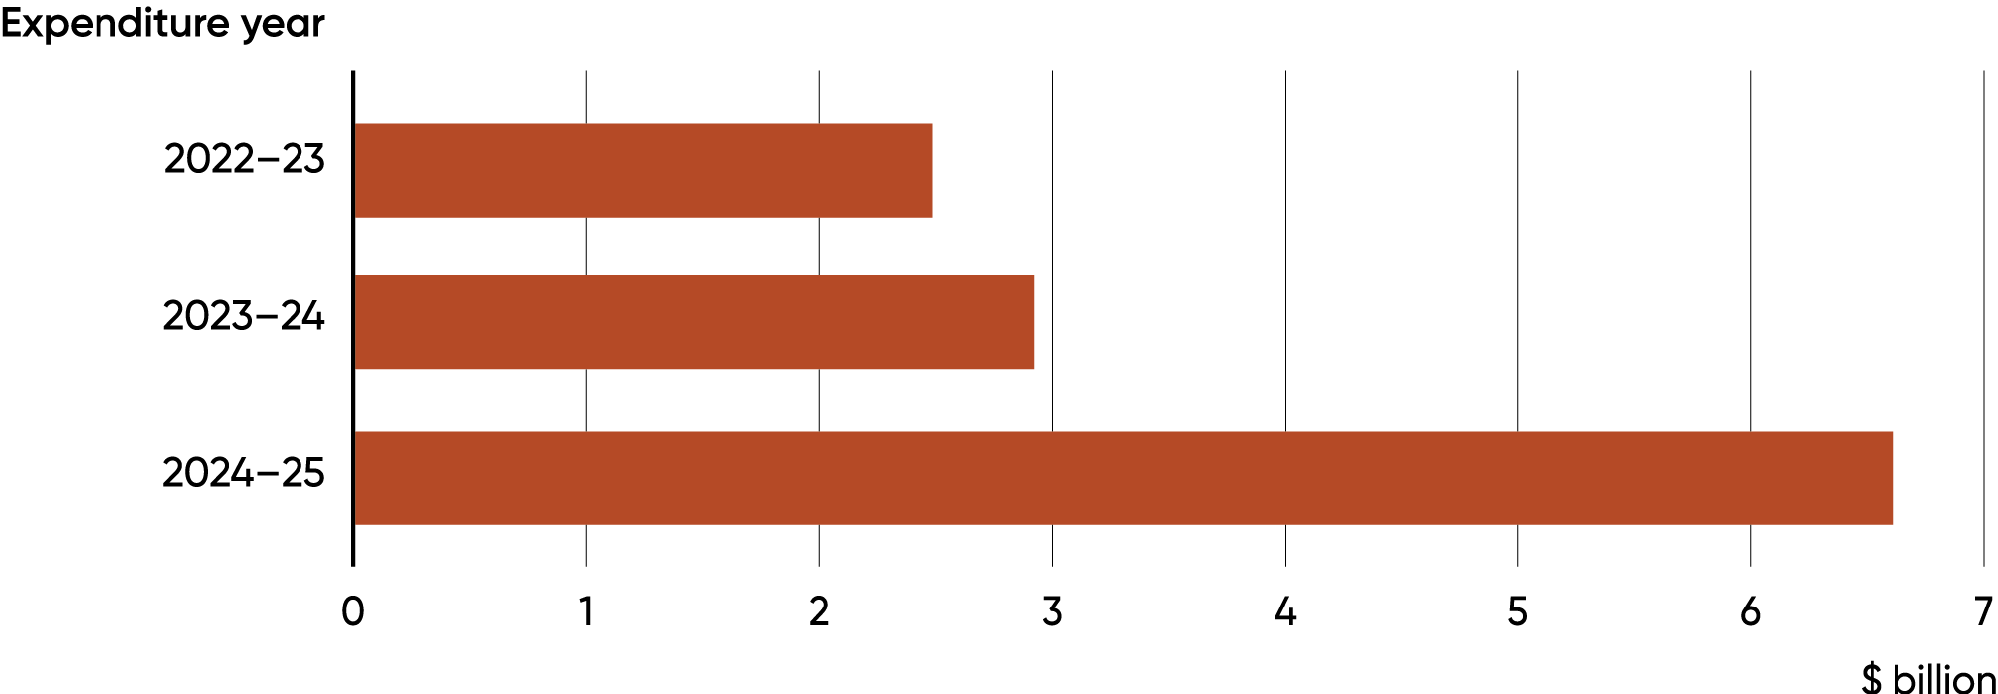

$3.6 billion was allocated across eight different International Capital Market Association (ICMA) Green Categories.

Figure 3: 2026 Report Allocation of Green Treasury Bond proceeds by ICMA Green Bond Principles project category
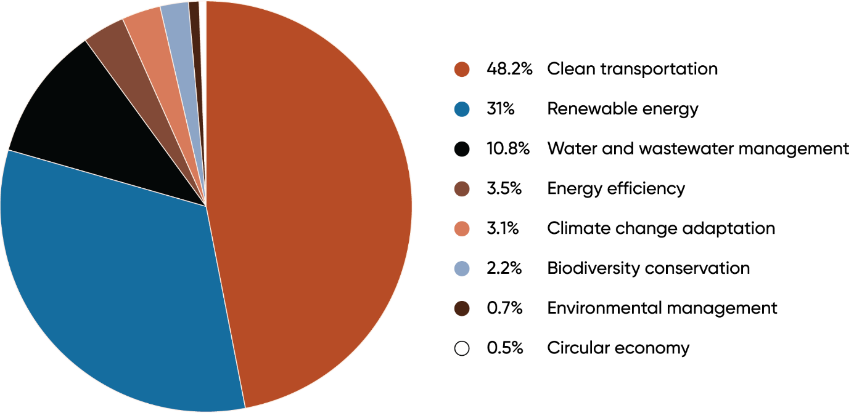
The Australian Government supported a range of projects in 2024–25, with expected impacts including:
- 1,333MW of new electricity generation capacity from the Golden Plains Wind Farm
- Helping restore the health of Australia’s urban waterways across more than 100 projects
- Improved access to water, sanitation and hygiene services for 3.7 million people in Asia‍–‍Pacific countries

2024–25 expenditure has been allocated to pro rata at 54.1 per cent. Highlighted impacts display the range of impacts achieved.
ICMA Green Category | Eligible green expenditure | Description | Previous allocation  ($m) | Expenditure  for 2024–25  ($m) | Allocation 2026 Report  ($m) | Selected impact indicator
Renewable energy | CEFC Renewable Energy Investments | Financing investments that add value and develop capability in renewables and low emission technologies | 422.1 | 311.8 | 168.8 | 400 kt CO₂-e emissions avoided annually once operational  4,100 GWh projected renewable energy generation p.a.
Renewable energy | Rewiring the Nation | Low-cost financing to upgrade Australia’s electricity grid and enable the renewable energy transition | 5.0 | 1,515.0 | 820.0 | 7,450 MW projected additional network capacity
Renewable energy | Snowy Hydro Limited | Generating renewable electricity for the national grid through Snowy 2.0 | - | 150.0 | 81.2 | 2,200 MW / 350,000 MWh generation and storage capacity expected upon completion
Renewable energy | Regional Hydrogen Hubs | Supporting green hydrogen industrial hubs | 35.5 | 25.1 | 13.6 | 115.2 kt H₂/year projected annual production
Renewable energy | Community Batteries | Deploying community batteries across Australia | 13.7 | 14.3 | 7.7 | 5.1 MW / 12.0 MWh energy storage capacity
Renewable energy | Advancing Renewables Program | Financing R&D projects for renewable energy technology | 305.6 | 133.7 | 72.4 | 88 projects funded
Energy efficiency | Household Energy Upgrades Fund™ | Low interest loans for energy saving home upgrades | 5.0 | 161.5 | 87.4 | An estimated 50 kt CO₂-e emissions avoided annually once operational
Energy efficiency | Social Housing Energy Performance Initiative (SHEPI) | Supporting energy performance upgrades to social housing | - | 62.6 | 33.9 | Energy performance upgrades made to over 20,000 homes
Clean transportation | Electric rail infrastructure in the Infrastructure Investment Program | Financing the construction of core electric rail transport infrastructure | 3,365.9 | 3,041.6 | 1,646.2 | 103.4 km of rail to be built or upgraded
Clean transportation | Driving the Nation Fund | Supporting electric vehicle charging infrastructure | 37.3 | 37.5 | 20.3 | 17 EV charging sites delivered  244 EV charging plugs approved for rebate
Clean transportation | Electric bus charging infrastructure | Supporting the delivery of the new electric bus network in Perth | - | 35.0 | 18.9 | 16 electric bus chargers installed
Climate change adaptation | International Climate Finance | Supporting global climate mitigation and adaptation initiatives | 232.9 | 200.1 | 108.3 | 21 initiatives supported
Environmentally sustainable management of living natural resources and land use | Urban Rivers and Catchments Program | Addressing natural resource management problems in urban waterways | 1.6 | 45.3 | 24.5 | 76 EPBC-listed species benefitting from the restoration and re-naturalisation of aquatic and riparian environments
Biodiversity conservation (terrestrial and aquatic) | Saving Koalas Fund | Supporting the recovery of Australia’s unique plants, animals and ecological communities | 24.8 | 14.1 | 7.6 | 5,564 ha of koala habitat land projected to be protected
Biodiversity conservation (terrestrial and aquatic) | Reef 2050 | Investing to protect the health and resilience of the Great Barrier Reef | 88.2 | 128.7 | 69.7 | 95 per cent of aquatic species unlikely to experience harmful effects from pesticides
Sustainable water and wastewater management | Murray-Darling Basin Plan | Recovering environmental water for the Murray–Darling Basin | 871.6 | 698.6 | 378.1 | 38.2 GL/year surface water registered for Commonwealth and environmental use
Circular Economy (waste management) | Recycling Modernisation Fund | Expanding waste-processing capacity by upgrading recycling infrastructure | - | 32.8 | 17.8 | 105.2 kt projected additional waste processing capacity
Total |  |  | 5,409.2 | 6,607.6 | 3,576.2
Projects support progress towards these UN Sustainable Development Goals
