Australian Office of Financial Management
  - Annual Report 2025‍–‍26

About this report
This report outlines the operations and performance of the Australian Office of Financial Management (AOFM) for the financial year ending 30 June 2026. It has been prepared in accordance with the provisions of section 46 of the Public Governance, Performance and Accountability Act 2013, the Public Governance, Performance and Accountability Rule 2014 and the Department of Finance Resource Management Guide No.135.
The AOFM is an administrative entity within the Commonwealth of Australia.
This annual report can be found on the AOFM’s website www.aofm.gov.au.
© Commonwealth of Australia 2026

ISSN 2204-0838 (print) | ISSN 2204-0846 (online)
Use of AOFM material under a Creative Commons BY Attribution 3.0 Australia licence requires you to attribute the work (but not in any way that suggests that the AOFM endorses you or your use of the work).
Australian Office of Financial Management material used ‘as supplied’.
If you are using AOFM material and provided you have not modified or transformed material in any way including, for example, by changing the AOFM text; calculating percentage changes; graphing or charting data; or deriving new statistics from published AOFM statistics, we prefer the following attribution:
Source: The Australian Office of Financial Management
Derivative material
If you have modified or transformed AOFM material, or derived new materials in any way, based on those provided by the AOFM, we prefer this attribution:
Based on Australian Office of Financial Management data
Use of the Coat of Arms
The terms under which the Coat of Arms can be used are set out on the Department of the Prime Minister and Cabinet’s website www.pmc.gov.au/government/commonwealth-coat-arms.
Other uses
Enquiries regarding this licence and any other use of this document are welcome at:
Australian Office of Financial Management
Treasury Building, Newlands Street, Parkes ACT 2600
Email: enquiries@aofm.gov.au

Letter of transmittal
3 September 2026
The Hon Dr Jim Chalmers MP
Treasurer
Parliament House
CANBERRA, ACT 2600

Dear Treasurer
I am pleased to present the annual report of the Australian Office of Financial Management (AOFM) for the year ended 30 June 2026.
The report has been prepared in accordance with all applicable obligations of the Public Governance, Performance and Accountability Act 2013 (PGPA Act) including section 46, which requires that you, as the relevant Minister, table the report in Parliament.
The annual performance statement in Part 2 of this report is prepared in accordance with section 39 of the PGPA Act and accurately reflects the AOFM’s performance for 2025–26.
The report includes the AOFM’s audited financial statements, prepared in accordance with the Public Governance, Performance and Accountability (Financial Reporting) Rule 2015.
I confirm the AOFM has in place appropriate fraud prevention, detection, investigation and reporting mechanisms, including fraud risk assessments and a fraud control plan. The AOFM has taken all reasonable measures to appropriately deal with fraud.
Yours sincerely
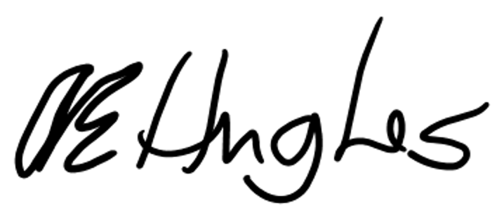
Anna Hughes
Chief Executive Officer

Contents
2025–26 activities iv
Our portfolio v
Part 1: Overview 1
Part 2: Performance statements 13
Performance assessment: Purpose 1 23
Performance assessment: Purpose 2 41
Performance assessment: Purpose 3 47
Performance assessment: Purpose 4 55
Part 3: Management and accountability 61
Part 4: Annual financial statements 111
Part 5: Aids to access 183

2025–26 activities
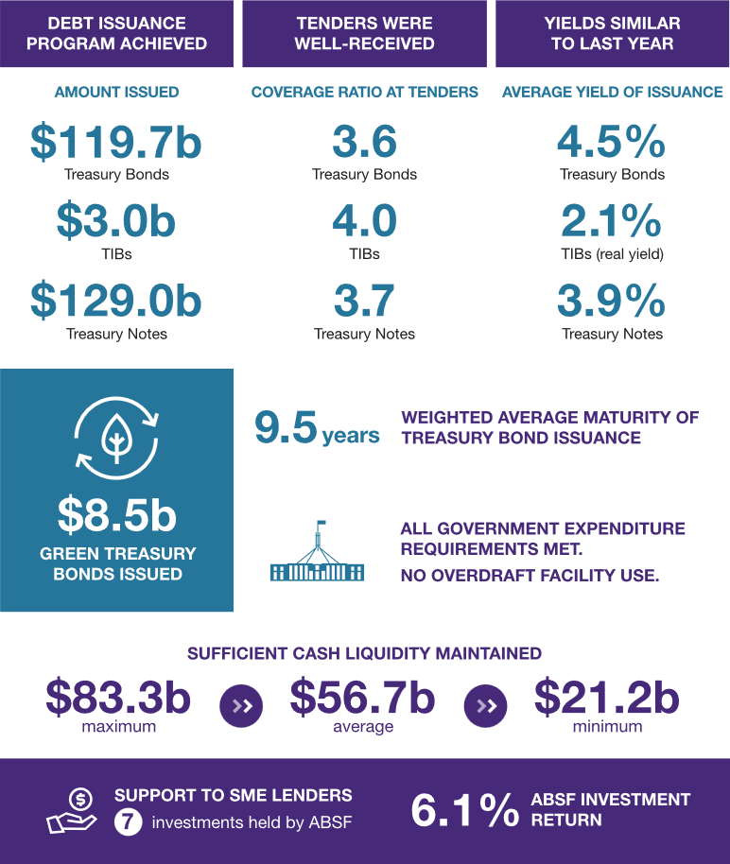

Our portfolio
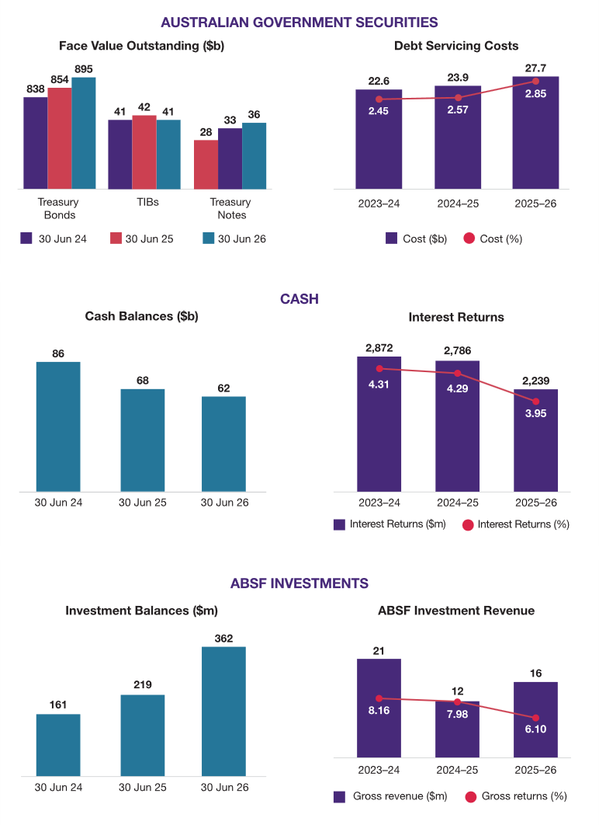

Part 1: Overview
A. Chief Executive Officer’s review 3
B. Role and activities 7
C. Organisational structure 11

- Chief Executive Officer’s review

The AOFM has continued to deliver on its purposes despite a challenging operating environment. Global uncertainty remains high, with the second half of the financial year dominated by the Middle East conflict and its impact on global inflation expectations. Amid these challenging conditions, the AOFM’s debt management program has proven resilient and ensured that we met the Commonwealth’s financing needs.
Our Funding, Strategy and Research team continued to demonstrate their strong capability and sound judgement in navigating ever-changing market conditions while earning praise for their deep expertise from Australian sovereign debt market participants.
For 2025–26, we started the year expecting to issue around $150 billion of Treasury Bonds (including Green Treasury Bonds). Due to better-than-expected budget outcomes, this was revised down to around $125 billion at the Mid-Year Economic and Fiscal Outlook and subsequently to around $120 billion in the 2026–27 Budget. Gross issuance for 2025–26 was $120 billion in Treasury Bonds, $3 billion in Treasury Indexed Bonds and $129 billion in Treasury Notes.
Demand for our bonds has remained strong, as demonstrated by the three syndications we conducted throughout the financial year:
- In July 2025, we conducted a $16 billion syndication of a 4.25 per cent Treasury Bond maturing in October 2036 with an order book of $62 billion.
- In January 2026, we completed a $15 billion syndication of a 4.75 per cent Treasury Bond maturing in October 2037 with an order book of $67 billion, the second largest on record.
- In May 2026, we completed a $7.5 billion syndication of a 5.00 per cent Green Treasury Bond maturing in June 2036, with an order book of $24 billion, the largest green syndication on record, exceeding that of the inaugural Green Treasury Bond.
As of 30 June 2026, the level of Australian Government Securities (AGS) on issue is $971 billion. This consisted of approximately $895 billion in Treasury Bonds, $41 billion in Treasury Indexed Bonds (TIBs) and $36 billion in Treasury Notes.
Following the Australian Bureau of Statistics beginning publication of a full monthly Consumer Price Index (CPI) series in late 2025, the AOFM began designing a new TIB product which will reference the new series. The pricing formulae for the new TIBs based on monthly CPI will be aligned with offshore peers. Issuance of the new product is likely to occur during the second half of 2026–27.
Despite our offshore investor outreach being curtailed due to the Middle East conflict, the team met its investor relations targets through a mixture of online meetings and additional domestic engagement. Notably, the AOFM team, along with the Treasury, published the Green Treasury Bond program’s second Allocation and Impact Report. Market participants responded positively, particularly to the granularity of the information provided.
Our Impact Investment team had a busy year focusing on enhancing the development of the securitisation market’s capacity to support both private and public transactions backed by loans to Australian small and medium enterprise (SMEs). For the 2025‍–‍26 financial year, the Australian Business Securitisation Fund (ABSF) made new commitments to invest in facilities sponsored by Banjo Loans ($90 million) and Laddr ($75 million). The AOFM also provided partial underwrites across public term transactions.
While the ABSF was scaled out of the public term transactions, its participation was noted as a key factor in managing execution risk, both prior to launching and in upsizing. Underwriting public term SME securitisations ensures that these transactions become public, further developing the performance track record for SME securitisations backed by receivables from less well-developed segments of the SME lending market.
In September 2025, the agency began an extensive consultation process to explore how we align our functions, capacity, and capabilities to deliver our purposes more efficiently. The decision to undertake structural reform was internally driven and followed strategic reflection and executive assessment of the agency’s future capability needs. The 2025 Census also informed the restructure, indicating that although we had the appropriate skills, capabilities and knowledge to perform our current functions, workloads were not evenly distributed. Almost 15 per cent of people reported that they were operating below capacity, while nearly 40 per cent had too much work. The primary objective of the restructure was to identify opportunities to align our functions and ensure that we have the right people in the right roles.
The new structure simplifies our hierarchy, reduces duplication, and strengthens accountability. It is designed to ensure our organisation is fit for purpose and better aligned to deliver into the future.
Following the finalisation of the structure, I requested that the Secretary to the Treasury commission an independent review of the AOFM to consider our operations, capability and organisational effectiveness.
The Review was released on the Treasury website on 24 April 2026 and found that the AOFM is effectively meeting the Commonwealth’s financing needs and delivering a highly respected debt management program. The Review confirmed AOFM’s strong capability to deliver and expressed confidence in its ability to meet its mandate. The Review also recognised the AOFM’s focus on strengthening its capability to execute the debt program, including through cross-skilling across the agency so staff can support tender operations and syndications. In addition, the Review acknowledged that this approach broadens the appeal of roles across the agency, supporting staff retention.
The Review recognised that the introduction of the Deputy Chief Executive Officer and the Chief Operating Officer roles is grounded in sound logic. It also found that the capabilities and structure of the AOFM’s operational functions are appropriate. We note that this structure is relatively new and expect that further benefits will emerge over time.
We acknowledge the recommendation from the Review to strengthen organisational capability during periods of heightened financial stress and to ensure appropriate challenge. In response, we are considering all options as part of our Strategic Workforce Plan. This Plan will focus on managing key person risk and bolstering organisational capability, workforce sustainability and succession planning while also addressing the organisation’s need for technical skills and contextual knowledge.
The Treasury and the AOFM agreed to the recommendations and the Treasury released its response to the review on 9 July 2026. As an agency that prides itself on continuous improvement, we will use the identified opportunities to improve our operations and will work with the Treasury to implement them.
In December 2025, ANZ was ordered by the Federal Court to pay $135 million in combined penalties for institutional and markets misconduct relating to the management of a $14 billion government bond deal and inaccurate reporting of secondary bond market turnover data to the Australian Government. This included a record $80 million penalty for unconscionable conduct. Given the nature of the findings, the AOFM will need to see a demonstrable change in the risk culture of ANZ before it can be considered for future syndications. The AOFM has undertaken some initial steps towards re-engagement with ANZ during the 2026‍–‍27 financial year.

The AOFM has finalised its Integrity Framework and delivered staff awareness activities to support understanding of what integrity looks like in practice. An internal audit review was also undertaken to assess the design of the framework and further strengthen governance and assurance processes. The internal audit review concluded that the framework is well-founded and fit for purpose, given the agency’s size, complexity and risk profile. It also identified strong operational discipline across the areas reviewed, with no integrity failures or material non-compliance with AOFM policy requirements.
We also strengthened the AOFM’s data and digital capabilities, recognising the increasing importance of timely, reliable information in supporting effective decision-making. During the year, we strengthened our data and information management foundations and progressed the responsible adoption of artificial intelligence (AI) to improve organisational capability, efficiency and decision-making. These initiatives are enhancing operational efficiency, supporting better use of information assets and positioning the AOFM to take advantage of emerging technologies while maintaining strong governance and appropriate controls.
While 2025–26 was a significant year of change for the AOFM, we have continued to deliver on our core responsibilities: issuing debt securities on behalf of the Australian Government, managing cash and debt portfolios, and implementing initiatives in the Australian securitisation market. The organisational changes made during the year have helped futureproof our organisation and we will continue to fine-tune our operations to ensure that we remain successful. As always, we will remain focused on preserving our strong fundamentals including a scalable and resilient platform, maintaining a deep and diverse investor base and protecting our strong relationships with market participants.
Anna Hughes
Chief Executive Officer
- Role and activities
The AOFM is Australia’s sovereign debt manager. Our role requires us to finance the operations of the Australian Government. To do this we issue debt securities on behalf of the government and manage its cash. The AOFM also implements government initiatives that relate to the Australian securitisation market.

The AOFM borrows in wholesale funding markets by issuing AGS. We have 2 main responsibilities: ensuring the government can always meet its financial obligations (known as ‘cash management’) and managing the government’s debt portfolio by prudently balancing risks and costs over time (known as ‘debt management’).
We are aware of our potential to impact sectors of the capital markets through our actions as an issuer of government debt and as an investor on behalf of the government, specifically in the Australian securitisation market.
The AOFM’s core responsibilities were unchanged during 2025–26. We remained focused on funding the government’s expenditure needs, raising debt from financial markets, supporting the functioning of Australia’s sovereign debt market, and fulfilling the Australian Business Securitisation Fund (ABSF) mandate.
Our own operations are funded by Australian Government budget appropriations.

Our values
 | Trust  To act with integrity and transparency.  To work respectfully and collaboratively.
 | Excellence  To continuously improve through curiosity and innovation.  To adapt to changing circumstances and deliver as a prominent, respected authority.
 | Diversity  To welcome all perspectives and embrace different ideas.  To be valued as our authentic selves, and to respect and include everyone.

Our purposes
 | In 2025–26, the AOFM fulfilled 4 purposes:  - Meet the government’s annual financing task while balancing costs and risks.  - Ensure the government can always meet its cash outlay requirements.  - Conduct market-facing activities in a manner that supports a well-functioning AGS market.  - Meet the priorities of the Australian Business Securitisation Fund (ABSF).

The AOFM outcome
The AOFM has one outcome in the Treasury Portfolio Budget Statement: the advancement of macroeconomic growth and stability, and the effective operation of financial markets, through issuing debt and investing in financial assets and managing debt, investments and cash for the Australian Government.

The AOFM’s role in financing the Budget
The Australian Government Budget (the Budget) is usually released in May each year for the financial year starting on 1 July and the 3 following years (the ‘forward’ years). The Budget sets out the government’s fiscal outlook and budget position, reflecting government policy decisions and assumptions about the performance of the domestic and global economies.
During the budget process, the AOFM is given an estimate of the financing task for the forward years. The financing task for the forward years, together with an AOFM-formulated annual debt management strategy, is central to determining the size and composition of the annual issuance program.
The government typically publishes a budget update around December each year, known as the Mid-Year Economic and Fiscal Outlook (MYEFO). At this point, we update our issuance program for the budget year.
The AOFM’s debt management strategy
As part of the AOFM’s annual planning, we establish a new debt management strategy each year. This strategy sets out how we plan to achieve the financing task after considering market conditions, investor demand, costs and risks.
AGS play a key role in the domestic financial market, as they:
- are a low-risk asset with a regular income stream
- are used as collateral for certain financial market transactions
- provide a risk-free pricing benchmark.
Accordingly, our debt management strategy seeks to foster an efficient and liquid secondary market in AGS.

How the AOFM finances the Budget
Most issuance occurs via competitive tender. Registered bidders can buy AGS directly from the AOFM at regular tenders (usually held several times a week). The cost of borrowing is driven by the interest rates (or yields) demanded at each tender.
From time to time, the AOFM may issue bonds via syndication as a way to mitigate increased execution risk for a high-volume transaction. In a syndication, the AOFM appoints a panel of banks to support and promote the transaction through their investor networks. A syndication also allows the AOFM to gain further insight into its investor base. Panel banks also provide practical support for the transaction through ticketing, billing, risk management and settlement. The bonds are then placed directly with investors.

- Organisational structure
The AOFM’s accountable authority is the Chief Executive Officer (CEO), Anna Hughes, who occupied the position for the full 2025–26 reporting period.
The AOFM Senior Leadership Team comprises the CEO, Deputy Chief Executive Officer (Deputy CEO) and Chief Operating Officer (COO). Together, they are responsible for strategy, efficient operations and execution of the agency’s core purposes. The Deputy CEO and COO provide executive support to the CEO and managerial support to the broader organisation.
The AOFM undertook extensive consultation on an organisational realignment, which was implemented during 2025–26, following the appointment of the 2 senior leadership positions in 2024–25 (Deputy CEO and COO).
The new structure aligns our functions and capabilities with strategic priorities, supporting clearer accountability, stronger collaboration and more effective decision making. It positions the agency to remain an agile, contemporary and future-ready market custodian while providing employees with greater clarity of purpose and opportunities to build transferable skills.
The organisational structure is based on financial industry best practices including functional alignment, clear roles and accountabilities. It also gives specific recognition to financial transaction related duties and required segregation of duties. The agency is split into 2 core areas:

Front Office
The Front Office, led by the Deputy CEO, comprises our market-facing teams, which operate across financial markets to execute activities that support the AOFM’s core purposes. The Front Office is responsible for funding operations, debt strategy, investor relations, and policy driven investment. Activities include conducting tenders and syndications for the issuance of AGS, liaising and engaging with AGS investors and other market participants, managing government cash balances, administering and executing the investment program for the Australian Business Securitisation Fund, and managing the Green Treasury Bond program.

Chief Operating Office
The Chief Operating Office provides the corporate and operational functions that enable the agency to deliver on its key purposes and ensure that the agency meets its requirements as a Commonwealth agency.
The Group is responsible for finance, market operations, enterprise risk management and assurance, business continuity, information and communications technology, data and business systems, security and privacy, portfolio performance reporting, communications, human resources, strategic planning, project management, and corporate support services. Together, these functions strengthen governance, support informed decision making and enable the delivery of the agency’s objectives and purposes.
Figure 1: AOFM organisational structure as at 30 June 2026
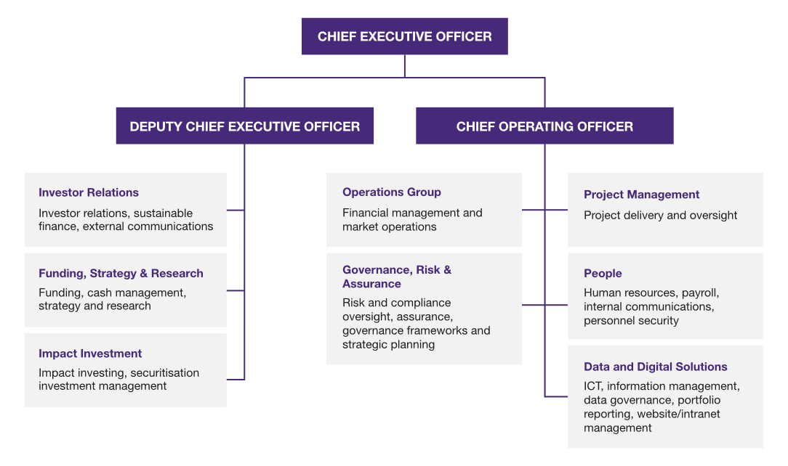

Part 2: Performance statements
A. Statement of preparation 15
B. Financial risk management 16
C. Approach to assessing performance 20
D. The operating environment 22
Performance assessment: Purpose 1 23
Performance assessment: Purpose 2 41
Performance assessment: Purpose 3 47
Performance assessment: Purpose 4 55

- Statement of preparation
As the accountable authority of the Australian Office of Financial Management (AOFM), I present the 2025–26 Annual Performance Statements of the AOFM, as required under paragraph 39(1)(a) of the Public Governance, Performance and Accountability Act 2013 (PGPA Act).
In my opinion, the Annual Performance Statements are based on properly maintained records, accurately reflect the performance of the agency, and comply with subsection 39(2) of the PGPA Act.
Anna Hughes
Chief Executive Officer
3 September 2026

- Financial risk management

Sovereign debt management requires us to manage a range of risks and other considerations
Sovereign debt issuance and cash management entails assessing interest rate, liquidity, forecasting and operational risks. Given the size of the government’s financial requirements, these risks are material to its overall fiscal position and balancing them requires careful judgement. These risks are influenced by a range of factors, primarily global market forces that are constantly changing.
The AOFM’s financial risk management framework supports decision making around how the agency engages with and mitigates risk. The framework also underpins our risk aware culture.
An efficient sovereign debt market improves the financial system’s resilience to economic and financial market shocks. Through our debt financing activities, the AOFM also supports the domestic financial system in which the issuance and trading of AGS play a central role. The AGS market provides key reference points on which to base the price of other capital market instruments, and market participants use it to manage interest rate risk.
The AOFM issues Treasury Bonds, Treasury Indexed Bonds and Treasury Notes
The AOFM issues 3 AGS debt instruments.
Treasury Bonds are medium- to long-term securities that pay a fixed annual rate of interest, and are the main instrument used to meet the Budget funding task.
Treasury Indexed Bonds (TIBs) are medium- to long-term securities that are linked to inflation.
Treasury Notes (T-Notes) are short-term debt securities used for within-year financing purposes and to provide ready access to large volumes of financing in times of unanticipated need. This can be especially important during times of general market stress.

What are the characteristics of securities issued by the AOFM?
Treasury Bonds are interest-bearing securities with maturities up to around 30 years. A fixed interest payment (coupon) is made twice each year for the life of the bond. At maturity, holders receive the bond’s face value.
Green Treasury Bonds are a subset of Treasury Bonds. Issuance proceeds are allocated to finance climate and environmental projects.
TIBs The face value of TIBs is adjusted for changes to the Consumer Price Index (CPI). Interest is paid quarterly, at a fixed rate, on the bond’s inflation-adjusted value. At maturity, the holders receive the inflation-adjusted value of the bond. The current longest maturity is 2050.
T-Notes are instruments with maturities up to one year. They do not pay coupons and are redeemed at face value at maturity.

The AOFM manages its assets and liabilities in separate portfolios
For risk management and reporting purposes, AOFM-managed assets and liabilities are split into multiple portfolios. Long-term financing is managed through the Long-Term Debt Portfolio (LTDP). Short-term debt and assets are in the Cash Management Portfolio (CMP). Assets managed by the AOFM for policy purposes – including the ABSF and loans to state and territory governments – are held in separate portfolios specific to each activity.

The LTDP comprises Treasury Bonds and TIBs
The AOFM influences the cost and risk profile of the LTDP through the maturity structure of bonds issued and the mix between nominal and inflation-linked bonds.
Balancing cost and risk considerations while avoiding adverse impacts on market functioning requires judgement. Issuing longer-term bonds typically involves higher debt servicing costs, but this is compensated by reduced volatility in future debt servicing costs and lower annual refinancing tasks. Shorter-term borrowing will typically incur lower costs but exposes the government to higher annual refinancing requirements and higher variability in debt servicing costs.
We develop a medium- to long-term view on appropriate portfolio management and translate it into annual issuance strategies based on research and close monitoring of financial market conditions. The research explores the cost and risk characteristics of alternative portfolio structures and issuance strategies under a range of scenarios.

The CMP comprises T-Notes and deposits with the Reserve Bank of Australia (RBA)
The CMP is primarily used to manage within-year timing mismatches between government receipts (mostly taxation) and payments. It is a fluctuating portfolio of short-term investments (deposits with the RBA) and short-term liabilities (T-Notes). The AOFM manages the portfolio to achieve an appropriate balance between cost, refinancing risk and liquidity risk.

Assets managed for policy purposes
In November 2018, the government announced plans to establish the ABSF to promote the development of – and increase competition within – the SME lending market. The ABSF aims to improve access to securitisation funding for smaller lenders that provide credit to the SME sector. Enabling legislation was enacted in April 2019.

Our primary cost measure is accrual debt servicing cost
Our cost and risk measures reflect considerations faced by all sovereign debt managers. The primary cost measure is accrual debt servicing cost, which includes interest payments made on AGS; realised market value gains and losses on repurchases; capital indexation of TIBs; and amortisation of issuance premiums and discounts. Accrual debt servicing cost excludes unrealised market value gains and losses. The effective yield of the portfolio is the total accrual debt servicing cost expressed as a percentage of total debt outstanding.
An alternative measure is fair value. Fair value measures of cost (which take into account unrealised gains and losses) are less relevant because the AOFM would usually only repurchase outstanding bonds when they are close to maturity – at which point their prices are not very sensitive to changes in interest rates.
How is interest for AGS determined?
The interest cost on AGS is set by the market at issuance, at competitive tenders run by the AOFM and in some cases at syndications. The interest rates (or yields) bid at tenders or syndications depend on the maturity and coupon rate of the specific security being issued, and on prevailing market conditions.
For Treasury Bonds and T₋Notes, the full life interest cost is locked in at the time of each issue. For TIBs, the interest cost depends on changes to the CPI over the life of the bond, so the full life interest cost is not known at the time the bond is issued.

- Approach to assessing performance

Our Executive Leadership Group monitors progress towards meeting performance targets
The AOFM’s annual performance planning cycle begins with our Corporate Plan. Our preparation includes reviewing our purposes, key activities and performance measures. The AOFM Executive Leadership Group monitors performance measures on a quarterly basis, and reports progress to the AOFM Audit and Risk Committee. Our 2025–26 Corporate Plan is available on the Australian Government Transparency Portal.
Our purposes are linked to key activities, which in turn are mapped to measures of performance. Overall agency performance is assessed through performance outcomes as reported below.
Table 1 shows the AOFM’s key activities, performance measures and associated targets, set out against an overarching purpose. Performance outcomes are reported below.

Table 1: Performance measures and targets
Performance measures |  |  |  |  |  | Target
PURPOSE 1 |  |  | Meet the government’s annual financing task while balancing costs and risks
1.1 |  | Establish and execute a debt management strategy | 1.1.1 |  | Issuance strategy: Conduct annual issuance in accordance with the debt management strategy. | All approved elements are met
 |  | Establish and execute a debt management strategy | 1.1.2 |  | New issuance yields: The weighted average issue yield at Treasury Bond and Treasury Indexed Bond tenders compared to prevailing mid-market secondary yields. | At or below mid-market yields
1.2 |  | Settle Australian Government Securities (AGS) issuance, coupon and redemption payments | 1.2.1 |  | AGS settlements: The number of times AGS issuance, coupon and redemption payments fail to occur in a complete, timely and accurate manner where the AOFM is responsible for the failure. | Zero
PURPOSE 2 |  |  | Ensure the government can always meet its cash outlay requirements
2.1 | Establish and execute a liquidity management strategy |  | 2.1.1 | Cash management strategy: Conduct annual cash management in accordance with the liquidity management strategy. |  |  | All approved elements are met
PURPOSE 3 |  |  | Conduct market-facing activities in a manner that supports a well-functioning AGS market
3.1 | Conduct a market engagement program |  | 3.1.1 | Annual investor relations plan: Conduct investor outreach in accordance with the annual investor relations plan. |  |  | All elements met
3.2 | Support financial market liquidity |  | 3.2.1 | Turnover ratio: Annual reported secondary market turnover for Treasury Bonds and Treasury Indexed Bonds as a proportion of debt on issue. |  |  | Greater than one
PURPOSE 4 |  |  | Meet the priorities of the ABSF
4.1 | Manage the Australian Business Securitisation Fund (ABSF) program |  | 4.1.1 | ABSF rate of return: The accrual earnings (net of losses) for a fiscal year divided by the average drawn (invested) amount in percentage point terms. |  |  | Greater than Bloomberg AusBond Treasury 0-1 Yr Index

- The operating environment
The global economic environment became more challenging during 2025–26. Uncertainty around international trade, ongoing regional conflicts, including in the Middle East, and volatility in commodity markets weighed on growth prospects and financial market sentiment. While inflation had returned to target ranges in many advanced economies by mid-2025, renewed price pressures emerged during the second half of the year, prompting central banks to adopt a more cautious approach to monetary policy.
At the beginning of 2025–26, trimmed mean inflation had fallen to 2.70 per cent, consistent with the RBA’s target band, after peaking at 6.8 per cent in the December 2022 quarter. The RBA had begun its rate-cutting cycle in February 2025 and concluded it in August 2025 with a final 25 basis point move when it lowered the cash rate to 3.60 per cent. However, late in 2025, market expectations of the RBA began to change quite rapidly. That change reflected stronger-than-expected private demand, a tight labour market and ongoing capacity pressures that all contributed to higher inflation outcomes.
In February 2026, the RBA raised interest rates to 3.85 per cent due to inflation remaining above target. Conflict in the Middle East and the closure of the Strait of Hormuz created supply constraints in oil that saw the price of Brent oil rise from $US70 to around $US120 on 31 March 2026. Headline inflation reached a peak of 4.6 per cent in March 2026 leading the RBA to increase rates again in March 2026 to 4.10 per cent and in May 2026 to 4.35 per cent. Inflation has since fallen to 3.8 per cent (trimmed mean inflation was 3.6 per cent) in June 2026.
Yields on Australian Government Bonds have shifted higher across the curve with the 10-year yield 56bps higher than a year ago. A much larger shift occurred at the 3-year yield, which rose by more than 100bps driven by changes in interest rates expectations.
Australian bond markets have remained functional and liquid throughout the year. Tender performance has been in line with previous years, and it was the second highest recorded year of secondary market turnover.


Performance assessment: Purpose 1
Meet the government’s annual financing task while balancing costs and risks

How Purpose 1 is achieved
The AOFM achieves the financing task by issuing AGS. This issuance is informed by a debt management strategy that balances portfolio risks and borrowing costs.
Debt management considerations include interest cost and interest cost variability over time, changes to investor demand, financial market conditions, the size of the financing task, and funding risk. Issuance decisions require making judgements to balance costs and risks.
Many risks are a product of market influences or events not within the control of the AOFM. Additionally, debt management decisions and fiscal outcomes in one period have flow-on effects into future periods, including on interest costs, annual financing and refinancing requirements, and overall debt levels. The AOFM also looks to ensure our actions support the integrity, liquidity, stability and functionality of the AGS market.
Effective debt management requires a long-term perspective on decision making. Smooth operational outcomes require decision making that considers prevailing market conditions.
We adjust the volume of AGS issuance in response to changing circumstances, such as changes to the financing requirement. The method of issuance balances considerations such as supporting AGS liquidity, managing execution risk and anticipating transaction costs. The majority of issuance is by competitive tender; syndicated issuance is generally reserved for executing higher-risk transactions due to large volumes, or to establish new bond lines.

Table 2: Summary of performance for Purpose 1
Performance measures |  | 2025–26 Performance
 |  | Target | Results
Key Activity 1.1 | Establish and execute a debt management strategy:  - to meet the Budget financing task  - that is consistent with a prudent sovereign debt management approach  - that anticipates the broad market outlook and attendant risks  - that considers borrowing cost and portfolio risks  - that includes delivering the Green Treasury Bond program  - through weekly issuance decisions that take prevailing conditions into account, support the market and reduce the risk of failed transactions.
1.1.1 | Issuance strategy: Conduct annual issuance in accordance with the debt management strategy. | All approved elements met | Met
1.1.2 | New issuance yields: The weighted average issue yield at Treasury Bond and Treasury Indexed Bond (TIB) tenders compared to prevailing mid-market secondary yields. | At or below mid-market yields | Met
Key Activity 1.2 | Settle AGS issuance, coupon and redemption payments:  - in a complete, timely and accurate manner.
1.2.1 | AGS settlements: Number of times AGS issuance, coupon and redemption payments fail to occur in a complete, timely and accurate manner, where the AOFM is responsible for the failure. | Zero | Met

Key Activity 1.1: Establish and execute a debt management strategy
The annual debt management strategy (the strategy) sets out the parameters for the AOFM’s Treasury Bond and TIB issuance activities. This includes the weighted average maturity (WAM) of issuance and the mix of funding instruments to be used. The AOFM Advisory Board is briefed on the strategy. The Secretary to the Treasury approves the strategy each year.
The 2025–26 debt management strategy was formulated in an environment of steeper yield curves and increased issuance, and, as such, set a target issuance WAM of 9 to 11 years. This was deemed to provide an appropriate balance between cost and risk, given the increasing refinancing task and higher costs for longer-term issuance, driven by the shape of the yield curve. The debt management strategy recommended issuance across the curve to facilitate liquidity, and the establishment of 2 new bond lines to support the 10-year Treasury Bond futures contract. A Green Treasury Bond was syndicated, reflecting the commitment of the AOFM to ongoing Green Treasury Bond issuance.
The AOFM makes weekly decisions on which securities to issue. These decisions take account of the debt management strategy; funding and cash requirements; market conditions; liaison with intermediaries and investors; relative value between different bond lines; and the size of existing bond lines. Issuance of AGS occurs through competitive tenders and occasionally by syndication. Effective issuance decisions informed by these factors, should support strong participation in tenders, reflected in healthy coverage ratios and bids that are consistent with prevailing secondary market mid-market yields.

The debt management strategy focuses on the Long-Term Debt Portfolio
The effective yield of the Long-Term Debt Portfolio (LTDP) was 2.80 per cent for 2025–‍26, 33 basis points higher than in 2024–25. Total debt servicing costs were higher than 2024–25, due to the higher average volume of bonds on issue and the rotation between maturing debt (issued when yields were lower) and more recently issued higher-cost debt at prevailing market rates.

Table 3: Debt servicing costs
 | Debt servicing costs |  | Book volume |  | Effective yield
 | 2025–26 | 2024–25 | 2025–26 | 2024–25 | 2025–26 | 2024–25
 | ($m) |  | ($m) |  | (%p.a.)
Contribution by instrument
Treasury Bonds | (23,712) | (20,455) | (879,208) | (852,291) | 2.70 | 2.40
TIBs | (2,477) | (1,993) | (54,630) | (55,983) | 4.53 | 3.56
Total | (26,189) | (22,448) | (933,838) | (908,274) | 2.80 | 2.47
Represented by
Interest costs | (26,189) | (22,426) | (933,838) | (908,274) | 2.80 | 2.47
Cost of repurchases | - | (22) | - | - | - | -
Total | (26,189) | (22,448) | (933,838) | (908,274) | 2.80 | 2.47

Treasury Bonds
Treasury Bonds are the main instrument the AOFM uses to meet the government’s financing requirements.
In 2025–26, we issued $119.7 billion of Treasury Bonds, with $81.2 billion issued by tender and $38.5 billion by syndication. Net issuance was $40.9 billion. Issuance was higher in 2025–26 than in 2024–25, reflecting a larger financing task.
During the year, we established 2 new benchmark bond lines: an October 2036 Treasury Bond and an October 2037 Treasury Bond. A June 2036 Green Treasury Bond was also established in accordance with the strategy. All new lines were launched by syndication, and 40.8 per cent of total Treasury Bond issuance for the year was into these 3 new lines.

Chart 1 shows the AOFM’s syndication and tender issuance of Treasury Bonds over the past decade. Chart 2 shows Treasury Bonds outstanding as at 30 June 2026, and issuance during 2025‍–‍26.
Chart 1: Treasury Bonds – issuance by financial year
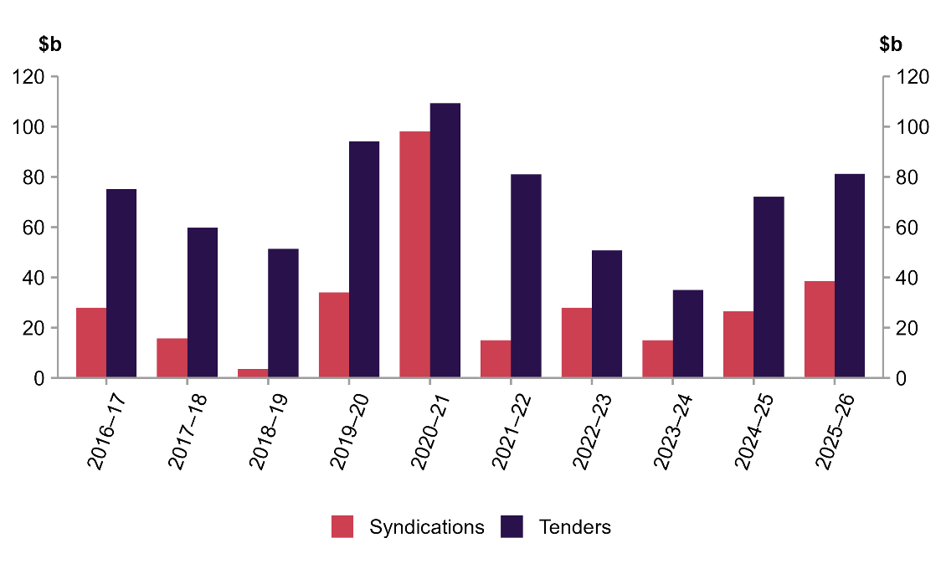
Chart 2: Treasury Bonds outstanding as at 30 June 2026, and issuance during 2025–26
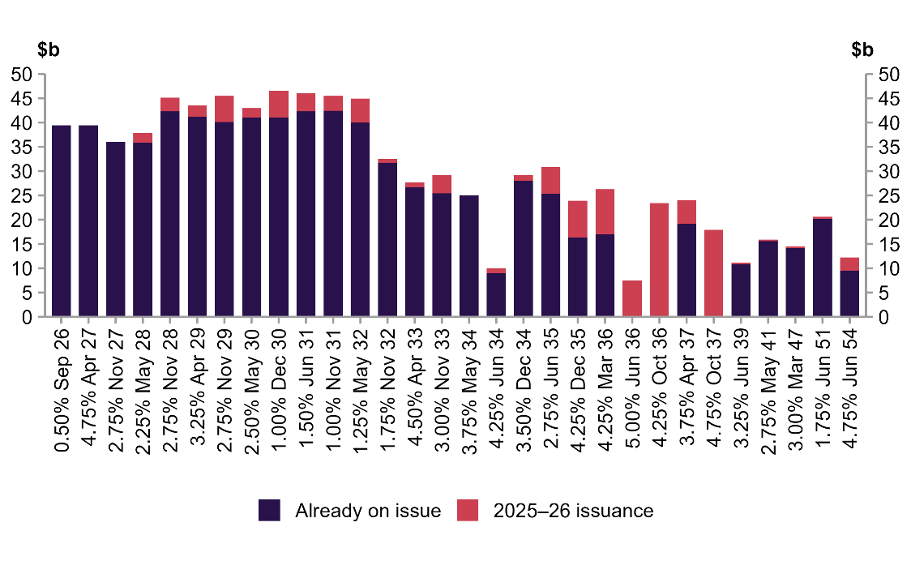

Green Treasury Bonds
Green Treasury Bonds are identical to standard Treasury Bonds, except that the proceeds of issuance are allocated to Eligible Green Expenditures. These must align strongly with one or more of the program’s 3 key green goals:
- climate change mitigation
- climate change adaptation
- improved environmental outcomes.
The second Green Treasury Bond was issued in May 2026. The new June 2036 bond attracted strong demand from investors. The final order book totalled over $24 billion, which was slightly higher than the inaugural green bond.
In 2025–26, the AOFM issued $8.5 billion of Green Treasury Bonds, which is made up of $7.5 billion from the June 2036 Treasury Bond issued via syndication and $1 billion issued via tender into the June 2034 Treasury Bond.
The second Australian Government Green Treasury Bond Allocation and Impact Report was published in March 2026. The report details how proceeds from Green Treasury Bonds were allocated to eligible Australian Government expenditures (Chart 3). Climate and environmental impacts of the expenditures are also described. The ‘Report Snapshot’ provides a short summary of the report and is available on the AOFM website.

Chart 3: Allocations to the 3 green goals
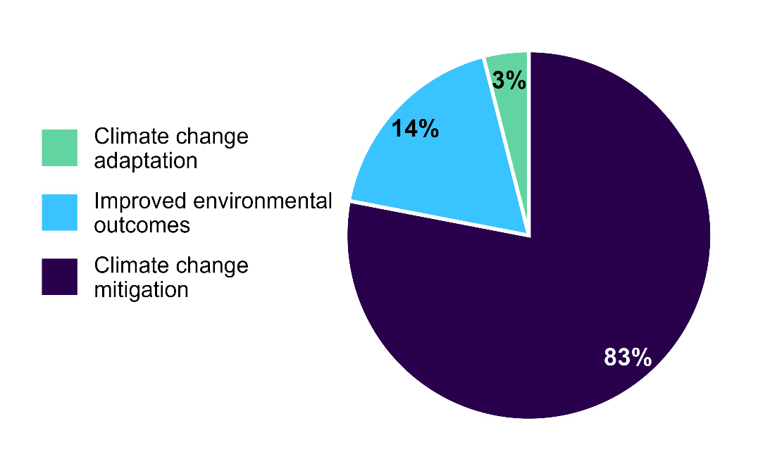

The debt servicing cost of Treasury Bonds was 2.70 per cent in 2025–26, 30 basis points ($3.3 billion) higher than in 2024–25.
Chart 4 shows the Treasury Bond portfolio (as at 30 June 2026) by the financial year in which the bonds were issued, and the average issuance yield for each year. The average yield for Treasury Bond issuance rose to 4.5 per cent in 2025–26.
Chart 4: Treasury Bond portfolio and average yield by issuance year
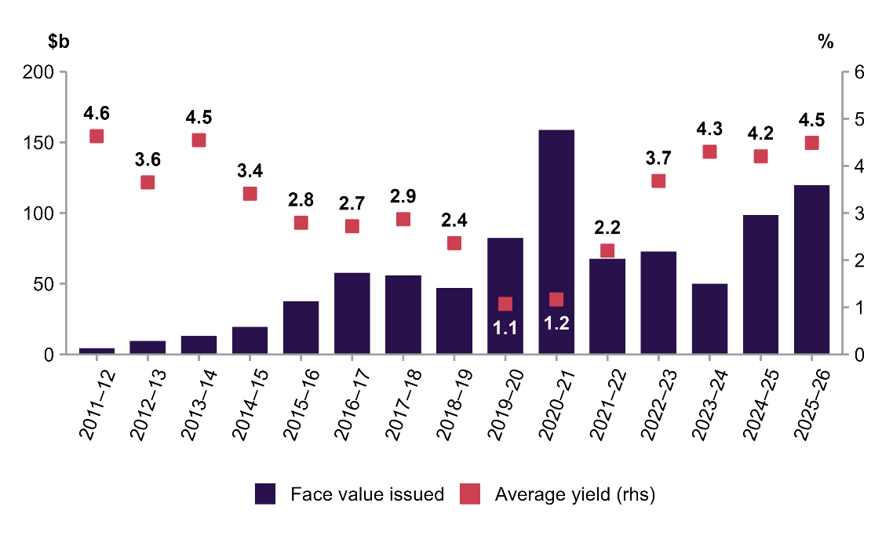
The average maturity of the Treasury Bond portfolio remained at 6.5 years in 2025–26.
Chart 5: Treasury Bond portfolio average maturity and cost of funds
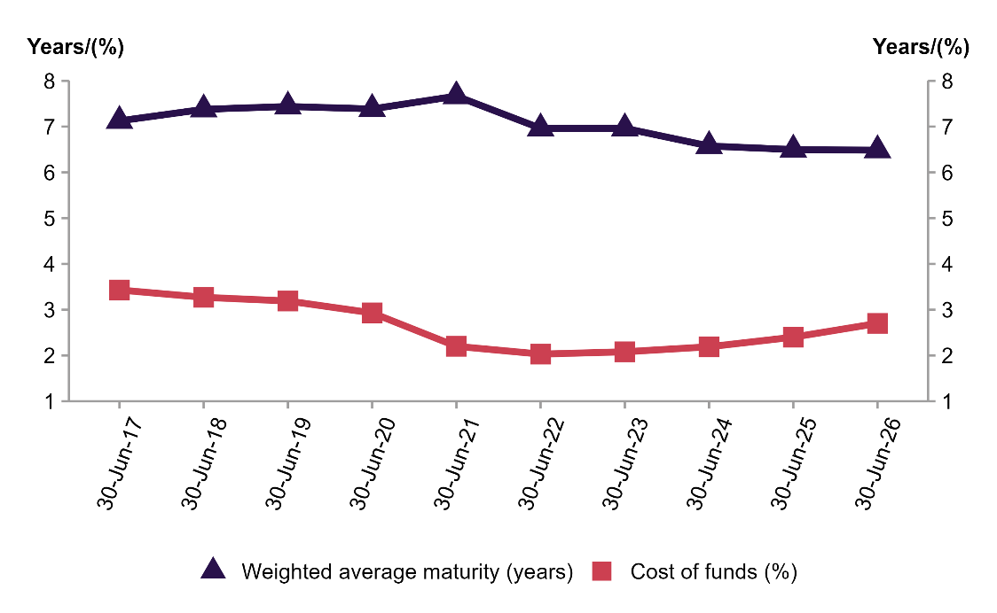
The Treasury Bond portfolio’s risk levels in terms of exposure to future refinancing are shown in Chart 6. As at 30 June 2026, the portfolio was structured with 27 per cent and 47 per cent of bonds needing to be refinanced over the next 3 and 5 years respectively.
Chart 6: Treasury Bond portfolio – maturity profile
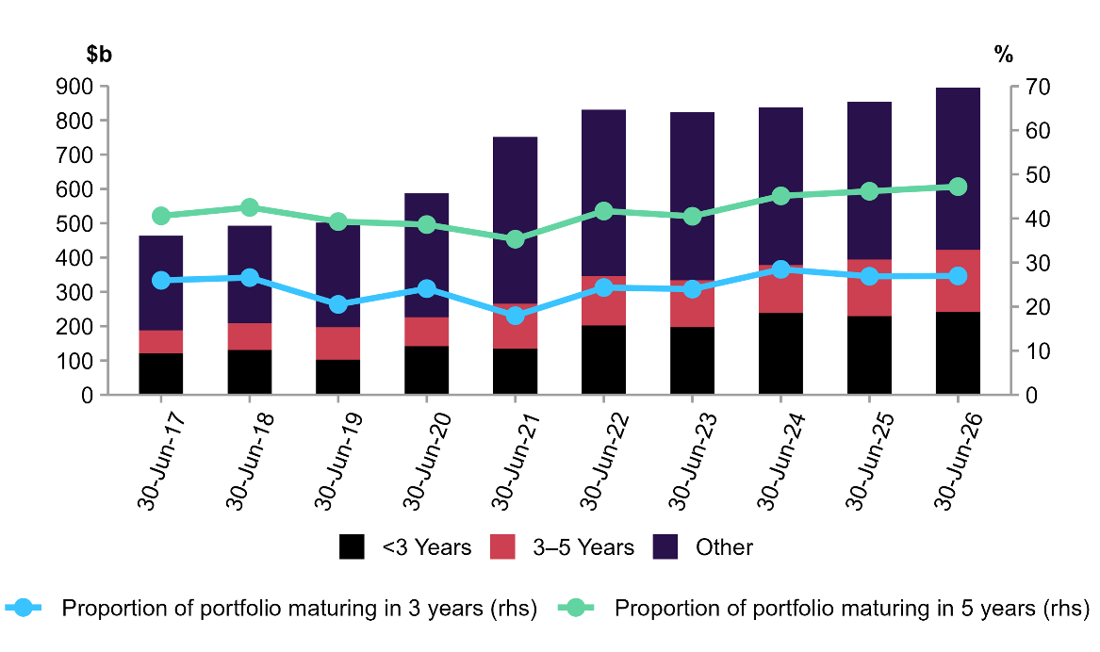
More than half of all outstanding Treasury Bonds were issued with an original maturity of 9 to 12 years (see Chart 7).
The concentration of issuance into this bracket is consistent with the AOFM debt strategy and contributed significantly to diversifying the investor base and reducing interest rate and refinancing risks.
Chart 7: Treasury Bond portfolio composition by original maturity as at 30 June 2026
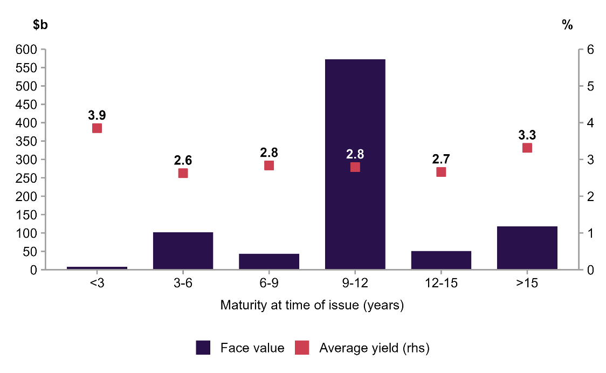
The WAM of Treasury Bond issuance in 2025–26 was 9.5 years, longer than the 2024‍–‍25 issuance WAM of 9.1 years. The average issuance yield in 2025–26 was higher than in 2024–25, partly due to the longer issuance WAM (see Chart 8).
Chart 8: Treasury Bond issuance – average yield and maturity
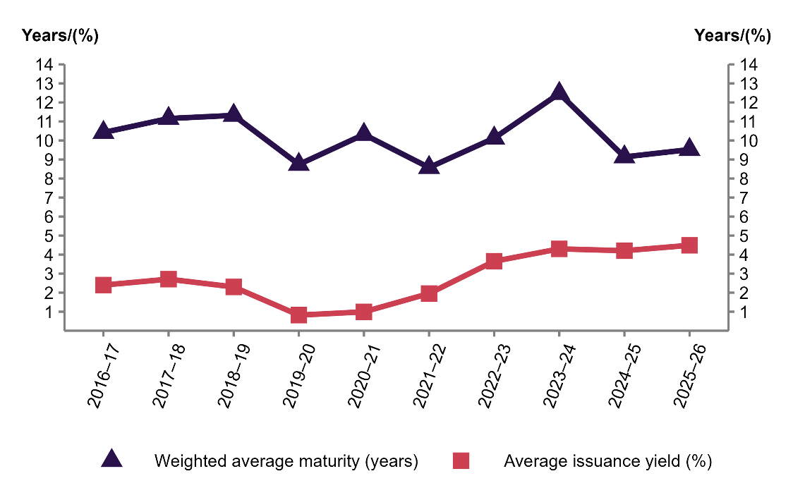

Treasury Indexed Bonds
The AOFM issues sufficient TIBs to meet investor demand and to support the functioning of the inflation market.
TIB issuance for the year was $3.0 billion, slightly higher than in 2024–25 (see Chart 9). Two tenders were held in most months.
Chart 9: TIB issuance by financial year (face value)
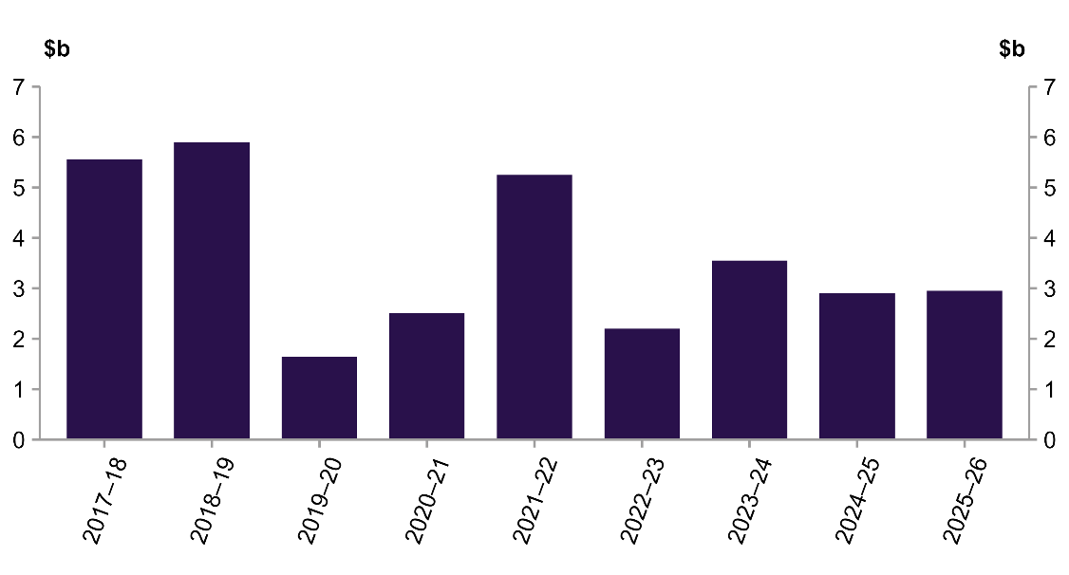

Performance for Key Activity 1.1

Indicator 1.1.1: Issuance strategy
The AOFM met all targets outlined in the 2025–26 issuance strategy.

The issuance strategy indicator is used to measure consistency between the AOFM’s operations and the debt management strategy.
The approved targets, indicators and results are listed in the following table.
Table 4: Key elements of the 2025–26 debt management strategy
Measure | Target | Indicator | Result
Annual Treasury Bond issuance ($b) | Around 120 | 119.7 | Met
Annual TIB issuance ($b) | Around 3 | 3.0 | Met
Number of new Treasury Bond lines | Up to 4 | 3 | Met
WAM of Treasury Bond issuance | 9–11 years | 9.5 years | Met

Indicator 1.1.2: New issuance yields
The AOFM met this target by maintaining tender issuance yields at or below secondary mid-market yields throughout 2025–26.

Average tender yields were 0.6 basis points (bps) below secondary mid-market yields for Treasury Bonds and 1.5 bps below for TIBs in 2025–26. This was marginally lower than the 2024–25 results (0.7 bps and 1.6 bps respectively).

Treasury Bonds
Treasury Bond tenders were well supported by the market in 2025–26.
Tender strength was reflected in bond tender issuance yields relative to secondary market yields and in tender coverage ratios. At all Treasury Bond tenders during 2025‍‍‌–‍26, the weighted average issue yield was below prevailing secondary market yields – a positive outcome relative to mid-market pricing – while bids received were on average 3.63 times the amount being offered.
Table 5 summarises the results of Treasury Bond tenders conducted during the year. These averages are grouped by time to maturity.
Table 5: Summary of Treasury Bond tender results
Maturity (years) | Face value amount allocated ($m) | Average spread to secondary market yield (bps) | Average times covered
0–2 | – | – | –
2–5 | 17,300 | –0.9 | 3.86
5–9 | 21,100 | –0.7 | 3.91
9–12 | 38,700 | –0.4 | 3.40
12+ | 4,100 | –0.6 | 3.45
Total/Average | 81,200 | –0.6 | 3.63

Treasury Indexed Bonds
TIB tenders were well supported by the market in 2025–26.
The average issue yield was 1.5 bps less than prevailing secondary market yields in 2025‍–‍26 compared to 1.6 bps in 2024‍–‍25. Table 6 summarises the results of the TIB tenders conducted throughout the year.
Table 6: Summary of TIB tender results
Maturity (years) | Face value amount allocated ($m) | Average spread to secondary market yield (bps) | Average times covered
0–5 | 550 | –1.6 | 4.32
5–10 | 1,950 | –1.4 | 3.92
10–20 | 400 | –1.6 | 3.85
20+ | 50 | –2.2 | 5.84
Total/Average | 2,950 | –1.5 | 4.07

Key Activity 1.2: Settle AGS issuance, coupon and redemption payments
Austraclear is an electronic securities settlement and depository system for Australian dollar–denominated debt market securities and is central to the settlement of AGS transactions.
It is important that these transactions settle on time. The system uses a real-time payment and delivery function for simultaneous gross settlement of transactions. The exchange of securities and cash only occurs when the buyer’s funds are available in their Austraclear account and securities are also available in the seller’s Austraclear account. If we buy securities back from the market, cash is delivered to successful counterparties in return for the securities. AGS bought back from the market are then cancelled.
The vast majority of AGS on issue are held in Austraclear. The AOFM uses the system to make coupon and redemption payments to the holders of those securities.
Computershare, the AOFM’s debt registrar, is responsible for facilitating payments to the holders of securities held outside Austraclear.

Performance for Key Activity 1.2

Indicator 1.2.1: AGS settlements
The AOFM met this measure, with AGS issuance transactions settled and all coupon and redemption payments processed completely, accurately and on time.

All tender and syndication issuance during 2025‍–‍26 was successfully settled in a complete, timely and accurate manner.
The following box shows settlement values.
In 2025–26, the AOFM settled:
- 93 Treasury Bond tenders, totalling $75.7 billion
- 3 Treasury Bond syndications of $38.7 billion
- 22 TIB tenders, totalling $3.9 billion
- 112 T-Note tenders, totalling $127.5 billion.

It is critical for the AOFM to ensure the Australian Government is at all times assessed in financial markets as behaving in a manner fully consistent with its AAA sovereign credit rating. This means all financial (repayment) obligations are always met. All AGS coupon and redemption payments for Austraclear-held and non-Austraclear-held securities were successfully settled in a complete, timely and accurate manner in 2025‍–‍26.

In 2025–26, the AOFM made:
- 61 Treasury Bond coupon payments, totalling $24.7 billion
- 2 Treasury Bond redemption payments of $78.8 billion
- 25 TIB coupon payments, totalling $783.8 million
- 1 TIB redemption payment, totalling $6.1 billion
- 20 T-Note redemption payments, totalling $126.0 billion.

Performance assessment: Purpose 2
Ensure the government can always meet its cash outlay requirements

How Purpose 2 is achieved
To ensure the government can always meet its cash outlay requirements, the AOFM uses forecasts of payments and receipts to project the government’s cash position, then implements strategies to manage short-term assets and liabilities to reduce liquidity risk.
The AOFM faces 2 sources of liquidity risk.
- Forecasting risk is the risk that the forecast asset balance is incorrect due to realised cash flows not matching forecasts.
- Funding risk is the risk of prevailing market conditions preventing the planned volume of funds from being raised. Funding risk includes refinancing risk.
The AOFM has minimal appetite for liquidity risk. The AOFM manages liquidity risk by:
- maintaining accurate cash flow forecasts informed by liaison with spending agencies, the Australian Taxation Office and the Reserve Bank of Australia (RBA)
- holding a precautionary liquidity buffer
- carefully planning the timing of AGS issuance and maturities
- maintaining access to the short-term money market by:
  - regularly issuing T-Notes
  - having a floor on the volume of T-Notes on issue (to maintain investor engagement).
- maintaining access to an overdraft facility at the RBA (considered a measure of last resort).
Table 7: Performance measures for Key Activity 2.1
Performance measures |  | 2025–26 Performance
 |  | Target | Results
Key Activity 2.1 | Establish and execute a liquidity management strategy:  - that considers the broad outlook for funding market conditions  - that defines an appropriate liquidity buffer  - designed to maintain access to the Treasury Note market  - to always meet government expenditure requirements  - to meet minimum liquidity requirements.
2.1.1 | Cash management: Conduct annual cash management in accordance with the liquidity management strategy. | All approved elements met within tolerance | Met

Key Activity 2.1: Establish and execute a liquidity management strategy
The liquidity management strategy describes the AOFM’s approach to managing liquidity risk through the year. The AOFM Advisory Board is briefed on the liquidity management strategy, and the Secretary to the Treasury approves the strategy each year.
The key elements of the 2025–26 strategy were:
- maintaining a $30 billion liquidity buffer to manage the forecasting risk associated with large, unexpected cash requirements (or shortfalls in revenue collections) and the funding risk associated with sudden and severe market constraints on the AOFM’s capacity to issue AGS
- making a commitment to maintain at least $25 billion of T-Notes on issue throughout the year, to ensure the market remains relevant to a wide range of investors and is accessible and scalable to meet funding requirements
- not using the RBA overdraft facility and holding all assets in the Cash Management Account (CMA) at the RBA.
Chart 10 shows the movement in cash balances managed by the AOFM, together with the volume of T-Notes on issue during 2025–26. The AOFM started 2025–26 with cash balances of $58 billion and T-Notes on issue of $33 billion and ended 2025–26 with $62 billion and $36 billion respectively.

Chart 10: CMA balance and Treasury Notes on issue for 2025–26
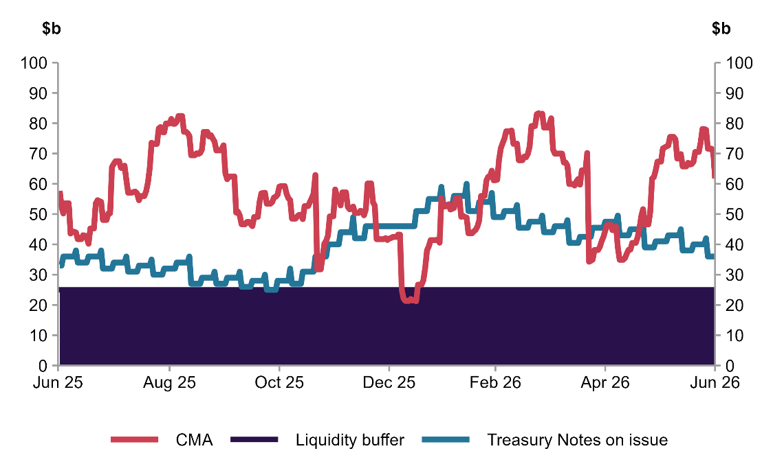

Liquidity management focuses on the Cash Management Portfolio
The instruments used for liquidity purposes are captured in the Cash Management Portfolio (CMP). The CMP made a net return of 4.22 per cent for 2025–26.
All cash management investments were held in the CMA at the RBA. The CMA earns an interest rate equivalent to that earned by the RBA in its open-market operations. The volume of assets in the CMA ranged from a low of $21.2 billion to a peak of $83.3 billion in 2025–26.
The volume of T-Notes on issue during 2025–26 ranged from $25 billion to $60 billion.

Table 8: CMP returns (debt servicing costs)
 | Return  (debt servicing costs) |  | Book volume |  | Effective yield
 | 2025–26 | 2024–25 | 2025–26 | 2024–25 | 2025–26 | 2024–25
 | ($m) |  | ($m) |  | (%p.a.)
Contribution by instrument
Deposits with RBA | 2,239 | 2,786 | 56,735 | 64,902 | 3.95 | 4.29
T-Notes | (1,493) | (1,419) | (39,049) | (33,232) | 3.82 | 4.27
Total | 746 | 1,367 | 17,686 | 31,670 | 4.22 | 4.32

Performance for Key Activity 2.1

Indicator 2.1.1 Cash management strategy
The AOFM met this overall target by achieving all approved targets outlined in the 2025–26 Liquidity Strategy.

The CMA balance briefly fell below the targeted buffer level for 13 days in January 2026. The liquidity buffer operated within operational expectations, and the RBA overdraft facility was not utilised in 2025–26.
Table 9: Key elements of the 2025–26 Liquidity Management Strategy
Measure | Target | Indicator | Result
Maintain a liquidity buffer | Around $30 billion | $21.2 billion | Met within tolerance
Minimum Treasury Notes on issue | >=$25 billion | $25 billion | Met
Prescribed cash management asset type | RBA only | CMA | Met
Usage of overdraft facility | 0 | 0 | Met

Performance assessment: Purpose 3
Conduct market-facing activities in a manner that supports a well-functioning Australian Government Securities (AGS) market

How Purpose 3 is achieved
The AOFM regularly engages with intermediaries and investors to ensure a comprehensive understanding of market-related issues. This helps achieve our core goals. We monitor aspects including changing global circumstances, major government fiscal announcements, influences on global capital flows, changing investor preferences and the performance of intermediaries, particularly in the primary AGS market.
Table 10: Summary of performance for Purpose 3
Performance measures |  | 2025–26 Performance
 |  | Target | Results
Key Activity 3.1 | Conduct a market engagement program:  - in accordance with an annually revised plan  - through periodic engagement with financial market intermediaries and key investors (domestic and offshore)
3.1.1 | Annual investor relations plan: Conduct investor outreach in accordance with the annual investor relations plan: | All elements met: | Met
 | - One-on-one engagement with investors | 100
 | - Presentations at investment forums (large and small) | 6–8
 | - Investor insight publications | Up to 4
Key Activity 3.2 | Support financial market liquidity:  - by monitoring secondary market activity  - through regular weekly issuance, having considered market conditions  - by maintaining a securities lending facility.
3.2.1 | Turnover ratio: Annual reported secondary market turnover for Treasury Bonds and Treasury Indexed Bonds (TIBs) as a proportion of debt on issue. | Greater than 1 | Met

Key Activity 3.1: Conduct a market engagement program
Why is market engagement important?
Regular market engagement provides valuable market insights that inform the AOFM’s decision-making and enhance our understanding of:
- investor sentiment and market perceptions
- demand for AGS, including emerging trends
- intermediaries’ relationships with and knowledge of investors
- broader market dynamics and conditions.
A deeper understanding of our investor base allows us to identify key investors in the AGS market and assess their level of influence. These insights inform the development of a targeted investor engagement program, guide decisions around weekly bond issuance, and influence the scaling of investor bids when bond syndications are oversubscribed.
The AOFM engages with intermediaries and investors through direct interactions and targeted communications. This engagement, primarily conducted by the front office and the CEO, includes regular dialogue with banks, investors and other market participants.

The AOFM’s approach to investor engagement employs several methods. The main methods of engagement are investor meetings, and participation at industry forums that target our investor base. The market engagement program is underpinned by an overarching investor relations strategy and an annual investor relations plan. The timing of engagement can vary, but typically we begin a cycle of investor meetings soon after the Australian Government releases its Budget updates.

Performance for Key Activity 3.1

Indicator 3.1: Annual investor relations plan
The AOFM met this target by conducting investor outreach in accordance with the annual investor relations plan.

Summary of 2025–26 investor engagement activities
The AOFM carried out its 2025–26 investor engagement activities consistent with our investor relations plan. Throughout the year, we met with investors both domestically and across several offshore regions including Asia, the United Kingdom, Western Europe and Scandinavia. Proposed investor engagement in North America and Eastern Europe were postponed due to the conflict in the Middle East.
The AOFM also met with several sovereign Debt Management Offices across the year to further broaden its knowledge of its peers and to provide insight into the Australian Government Securities market.
The AOFM participated in a range of industry events throughout the year. These included the Asian Development Bank (ADB) Regional Forum on Investment Management of Foreign Exchange Reserves; KangaNews’s inaugural Australasian Fixed Income in Asia Forum; and several bank hosted fixed income conferences, investor tours and roundtable discussions.
We published 3 editions of the AOFM’s ‘Investor Insights’ series during the year. These editions covered the role of hedge funds in the AGS market, AOFM buybacks and recent trends in the AGS investor base. The Investor Insights publications allow the AOFM to provide investors with deeper transparency and context around these topics. These publications are available on the AOFM’s website.

Table 11: Summary of investor relations activities in 2025–26
Activity | Details
Investor meetings (domestic and offshore) | 111
Presentations: large engagements | 5 Presentations  - ADB Regional Forum on Investment Management of Foreign Exchange Reserves  - KangaNews Australasian Fixed Income in Asia Forum  - 3 bank investor conferences
Presentations: small engagements | 2 Presentations  - KangaNews Annual Sovereign Roundtable  - Overseas investor presentation
AOFM staff participation in investor relations activities | - CEO  - Deputy CEO  - Head of Investor Relations  - Head of Funding, Strategy and Research  - Manager – Investor Relations  - Manager – Market Intelligence  - Senior Analyst – Investor Relations
Hosting banks: meetings, investor trips, conferences, roundtables | - ANZ  - Bank of America  - Barrenjoey  - Commonwealth Bank Australia  - NAB  - Royal Bank of Canada  - UBS  - Westpac

Key Activity 3.2: Support financial market liquidity
Market liquidity is important to the AOFM, intermediaries and investors. Smooth functioning of the AGS market relies on strong liquidity. Higher liquidity should result in better outcomes for AOFM issuance.
While there is no single definition of liquidity, it can be considered as the ability to buy and sell meaningful volumes of AGS as needed, without affecting the price.
Ample liquidity should be reflected in narrow bid–ask spreads, the confidence to take positions in AGS and high levels of turnover. The AOFM supports liquidity by monitoring market demand, which informs regular issuance across the yield curve.
We also encourage market liquidity by supporting Treasury Bond futures contracts. Regularly issuing and trading the underlying bonds enhances the liquidity of the futures contracts, which is important for managing interest rate risk in Australia.
Additionally, the AOFM offers a securities lending facility, which enables smooth intermediation and reduces the risk of failed settlements. The facility was used 88 times in 2025‍–‍26 (based on transaction end dates), with counterparties borrowing a total face value of around $4.2 billion.

Performance for Key Activity 3.2
One indicator of market liquidity is the amount of secondary market turnover. The AOFM collects monthly survey turnover data for Treasury Bonds and TIBs from intermediaries.

Indicator 3.2: Turnover ratio
The AOFM met its target for annual secondary market turnover in Treasury Bonds and Treasury Indexed Bonds (TIBs), with turnover exceeding the volume of debt on issue.

Chart 11 shows secondary market turnover for Treasury Bonds and TIBs. The turnover ratio was 2.2 after adjusting turnover for the volume of debt on issue. This indicates regular trading of AGS.
In absolute terms, Treasury Bond turnover in 2025–26 was $2.0 trillion, an increase of around $400 billion from 2024–25. TIB turnover was around $50 billion in 2025‍–‍26, an increase of around $10 billion from 2024‍–‍25.
Chart 11: Annual turnover for Treasury Bonds and Treasury Indexed Bonds
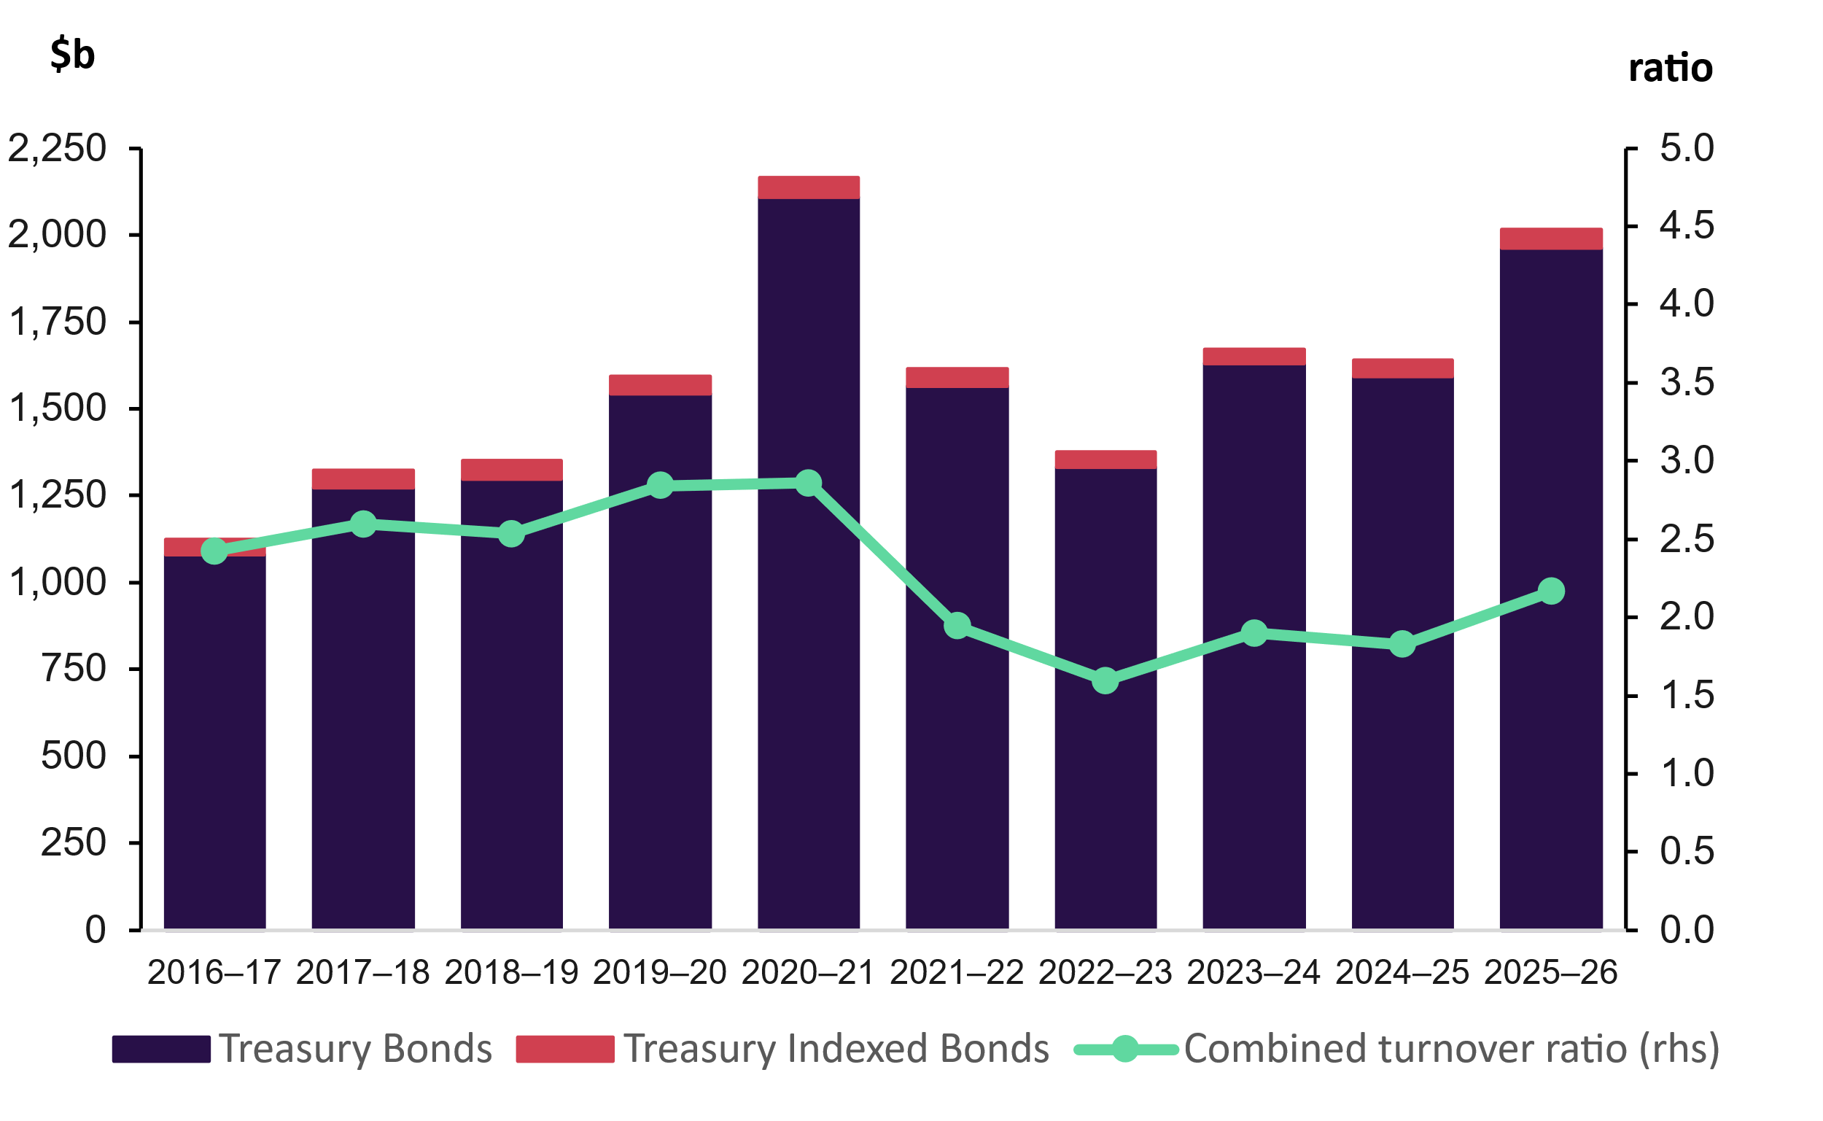

Performance assessment: Purpose 4
Meet the priorities of the Australian Business Securitisation Fund (ABSF)

How Purpose 4 is achieved

Australian Business Securitisation Fund
The Australian Business Securitisation Fund (ABSF) was established in 2019 to increase the availability and reduce the cost of credit provided to SMEs by lenders who source funds through securitisation. The AOFM seeks to achieve this objective through creating an investment environment conducive to growing institutional investment into this segment of the Australian securitisation market.
There are 2 key dimensions to our strategy.
The first is to assist with establishing a track record for developing types of SME lending. This has involved helping to standardise the reporting format for loan performance data presented to rating agencies and investors. This can make the credit assessment process more efficient and facilitates the creation of proxy measures for both less well-developed segments of the SME lending market and for new lenders entering the market. In time, this is expected to attract new capital to the sector, supporting greater competition in pricing.
We further promote the development of a track record by sponsoring the adoption of the Australian Securitisation Forum’s SME data template through the ABSF. We ask ABSF warehouse facility proponents to commit to implementing the template in a timely manner as a condition of ABSF investment. In return for this commitment, we are prepared to temporarily accept a below-market rate of return to subsidise reasonable template implementation costs. At 30 June 2026, data reported to the AOFM (primarily through the template format) from ABSF investment covered more than 70,000 SME borrowers, on aggregate lending close to $8 billion.
The second key dimension to our strategy is to support the development of the market for publicly issued asset-backed securities (ABS) collateralised by underdeveloped types of SME lending. We do this by partially underwriting suitable ABS transactions to reduce execution risk. This ensures the record of public term ABS issues from lenders to SMEs continues to grow over time, including ratings agency reporting and more accessible data. It is expected that as the body of public information builds, more investors will engage with this market, promoting competition in pricing.

Table 12: Summary of performance for Purpose 4
Performance Measures |  | 2025–26 Performance
 |  | Target | Results
Key Activity 4.1 | Manage the ABSF program by:  - seeking ABSF proposals from relevant market participants  - investing in suitable proposals  - meeting subscription notices  - monitoring investment performance.
4.1.1 | ABSF rate of return: The accrual earnings (net of losses) for a fiscal year divided by the average drawn (invested) amount in percentage point terms. | Greater than Bloomberg AusBond Treasury 0-1 Yr Index | Met

Key Activity 4.1 Manage the ABSF program
Why is managing the ABSF important?
The ABSF is an opportunity to build a systematic performance track record for lenders to SMEs in less well-developed segments of the SME finance market. A track record of lending is important, as it informs wholesale investors, rating agencies and other parties of the risks associated with SME lenders and their SME customers. Over time, a better understanding of these risks should support improved price formation and capital access for SME lenders sourcing wholesale finance. Within a competitive SME lending market, it is anticipated that this will have pass-through benefits for SME borrowers.
Such a track record could be reasonably expected to develop organically, but it may be slow to develop, constraining SME lenders’ access to finance. Working with industry through the Australian Securitisation Forum (ASF), the AOFM has supported the development of a standardised data reporting format for SME lenders. In addition, the AOFM also has some capacity, through the ABSF, to offer a subsidy to SME lenders warehouses funded by ABSF investment. This subsidy offsets the costs incurred when an SME lender develops its reporting such that it aligns with the ASF SME loan data template.
The AOFM is also using the ABSF to support development through underwriting public term asset-backed securitisations comprising a non-trivial proportion of SME receivables sourced from less well-developed segments of the SME lending market. This ensures that these transactions can come to market with a public rating from one or more rating agencies. Public ratings, and specifically, progressively higher ratings and the removal of rating caps over time, are a further source of investor confidence.
Jointly, a standardised reporting format through investments that drive reporting in that format, along with the underwriting of public term transactions with public ratings, should accelerate investor funding of SME lenders and lead to better financing opportunities for SME borrowers.

Performance for Key Activity 4.1

Indicator 4.1.1 ABSF rate of return
The AOFM exceeded the performance benchmark for the ABSF during 2025‍–‍26.

The ABSF’s return benchmark is set out in the ABSF Investment Mandate Directions (2019). The ABSF achieved a gross return on average drawn funds of 6.10 per cent for the financial year ending 30 June 2026, compared to a benchmark return of 3.60 per cent.
The key drivers for the ABSF’s financial performance are the floating interest rate benchmark (one-month Bank Bill Swap Rate) used as a coupon reference and the average margin that ABSF investments earn over this benchmark.
In 2025–26, the ABSF returned a margin of approximately 1.93 percentage points over the floating interest rate benchmark. This margin declined over the
2025–26 financial year. The decline was an intentional change, with the AOFM continuing to manage out lower-rated investments to improve the overall credit profile of the ABSF. As lower-rated investments pay investors a higher margin than more highly rated investments, reducing exposure to lower-rated investments will lead to a reduction in the overall margin, lowering the effective return to the ABSF.
When pricing investments, the AOFM seeks to do so at a market rate, less any subsidy applied to reduce the cost of adopting the ASF SME loan data template. In doing so, the AOFM seeks to avoid distorting the competitive landscape in the SME lending market and crowding out private sector investment from this segment of the market.

Part 3: Management and accountability
A. Corporate governance 63
B. Our people 75
C. Purchasing and procurement 86
D. Freedom of information 92
E. Financial performance 93
F. Australian Public Service Net Zero 2030 Greenhouse Gas Emissions Inventory 96
G. Appendix – 2025–26 Commonwealth Climate Disclosure 99

- Corporate governance
Effective sovereign debt management requires a strong focus on corporate governance and risk management.

The AOFM is a listed non-corporate Commonwealth entity under the PGPA Act and is legally and financially part of the Commonwealth.
The AOFM’s CEO is responsible for directing the AOFM’s operations and is accountable to the Secretary to the Treasury and the Treasurer. The Treasurer is responsible for administering the Commonwealth’s borrowing legislation, and the Treasury is responsible for ‘borrowing money on the public credit of the Commonwealth’.
As such, the Secretary to the Treasury is accountable for debt management and advising the Treasurer on debt management policy, drawing on the resources of the AOFM and Treasury for this purpose. The AOFM’s officials have been delegated powers and authorisations by the Treasurer for the purposes of debt management, including debt issuance.
The AOFM’s corporate governance framework further supports accountability, transparency and integrity. The key components of our corporate governance framework are:
- corporate planning, policies, assurance and performance monitoring against legislative instruments governing the AOFM’s activities
- internal committees to support decision making on a range of significant or whole-of-agency matters
- review of the financial risk management policy, and debt management and liquidity management strategies, by the Advisory Board and approval by the Secretary to the Treasury
- oversight by the Audit and Risk Committee, which is composed of independent members, including the Chair.

Governing legislation
Our activities are governed by a number of legislative instruments including the main instruments shown in Table 13.
Table 13: List of legislative instruments
Legislation | Purpose
PGPA Act | To establish a system of governance and accountability for public resources, with an emphasis on planning, performance and reporting.
Public Service Act 1999 (PS Act) | To provide for the establishment and management of the Australian Public Service (APS), including matters arising from terms and conditions of employment; codes of conduct; and engagement, termination and retirement of APS employees.  The AOFM’s staff are employees of the Department of the Treasury under the PS Act, and the Secretary to the Treasury has delegated its powers under the Act to the AOFM CEO in relation to AOFM staff.
Commonwealth Inscribed Stock Act 1911 | The Australian Government’s primary vehicle for borrowing money denominated in Australian currency on behalf of the Commonwealth of Australia, through the creation and issuance of stock and securities.  Under the Act, the Treasurer is required to set a direction as to the maximum total face value of stock and securities that may be on issue under the Act and other borrowing legislation.  On 7 October 2020, the then Treasurer issued an amended direction permitting borrowings up to $1.2 trillion.
Loan Securities Act 1919 | To authorise the issue of securities in relation to loans and for other purposes.  Under the Act, the Treasurer may from time to time enter into securities lending arrangements on behalf of the Commonwealth.  The total face value of stock and securities on loan by the Treasurer at any time under securities lending arrangements entered into must not exceed $5 billion.
Australian Business Securitisation Fund Act 2019 | To provide for investments in authorised debt securities and other eligible expenditures to meet the purpose of the Act.  Pursuant to the Act, on 10 April 2019 the then Treasurer issued rules setting out additional requirements for a debt security to constitute an authorised debt security and to prescribe those officials that may be eligible delegates under the Act.
Structured Finance Support (Coronavirus Economic Response Package) Act 2020 | To provide for investments in authorised debt securities, and other investments and other eligible expenditures, to meet the purposes of the Act.  Pursuant to the Act, on 25 March 2020 the then Treasurer issued rules that set out additional requirements for a debt security to constitute an authorised debt security and to prescribe those officials that may be eligible delegates under the Act.

Committees and oversight bodies
During 2025–26, the following committees and oversight bodies provided advice and support for decision-making.
Table 14: List of AOFM committees and oversight bodies
Committee/oversight body name | Purpose and membership
Advisory Board (I) | A Treasury oversight body that assisted the Secretary to the Treasury (the Secretary) to assess the AOFM’s proposed debt management, liquidity management and investment strategies, and advised the Secretary on matters relating to debt and investment markets.  Further detail on the board composition and key activities is provided below.
Audit and Risk Committee (I) | Provided independent advice to the CEO on the appropriateness of the AOFM’s governance, enterprise risk management, internal control, and financial and performance reporting arrangements.  Membership comprised 3 external members, one of whom was Chair. Further detail on the committee composition and key activities is provided below.
Executive Board (M) | Provided support to the CEO, as the AOFM’s accountable authority, to lead the agency to deliver its purposes and meet its strategic objectives. Ensured the compliance of the AOFM with legislative requirements and government policies.  Set the agency’s strategic direction, provided oversight of all governance arrangements, and made decisions on key issues.  Membership comprised of the CEO (Chair), Deputy CEO and Chief Operating Officer (COO).
Executive Leadership Group (M) | Supported cross-organisational collaboration through the consideration of strategic issues, cross-team initiatives, and organisational problem solving/consultation. Facilitated knowledge sharing and environment scanning and consistent agency-wide information flow.  Tracked progress against established performance targets and strategic objectives, monitored financial performance and compliance, and received regular reporting on a range of corporate functions.  Membership comprised the CEO (Chair), Deputy CEO, and COO and all business unit heads.

Committee/oversight body name | Purpose and membership
Operations Committee (M) | Provided advice to the CEO and Executive Board to ensure a coordinated and consistent approach to the administration of the AOFM and the continuous improvement of AOFM’s operations and performance. Provided oversight and guidance for projects across the breadth of the AOFM and the implementation of some enabling operational activities.  Monitored projects, risks and issues. Provided oversight of people matters, corporate reporting activities, and compliance with legislation, government policies and frameworks.  Membership comprised the COO (Chair), Chief Financial Officer (CFO), Chief Risk and Assurance Officer (CRAO); Chief People Officer and the Treasury Information Technology Security Adviser.
Cash Management Meeting (M) | Monitored liquidity risk, forecasting performance and other considerations in managing the government’s cash portfolio.  Membership comprised the CEO, Deputy CEO, Head of Funding Strategy and Research (Chair), and other staff with relevant functional responsibilities.
Portfolio Strategy Meeting (M) | Advised on general issuance and portfolio management issues over the medium to long-term (one year and longer) and discussed other research or issues relevant to the AOFM.  Gathered perspectives from across the agency for consideration as part of developing strategies and planning future work. Enabled transparency and the opportunity for appropriate internal challenge of work being undertaken relating to issuance and portfolio management.  Membership comprised the CEO, Deputy CEO, Head of Funding Strategy and Research (Chair), Head of Investor Relations, and Head of Investments. All AOFM staff are included as contributors and observers.
(I) Independent Committee
(M) Management Committee

Advisory Board
The Advisory Board was established by the Treasury to advise the Secretary to the Treasury on all aspects of the AOFM’s operations that bear on the debt program, including the financial risk management policy. Membership comprised the Secretary (Chair), Deputy Secretary to the Treasury’s Fiscal Group, the AOFM CEO and 5 external members.
The accountability of the Advisory Board was to the Secretary to the Treasury, who was the Chair. The Advisory Board did not possess executive powers or decision-making authority and did not advise on governance matters related to the AOFM.

Audit and Risk Committee
The AOFM Audit and Risk Committee provided independent advice to the CEO on the appropriateness of the AOFM’s financial and performance reporting, risk oversight and management, internal control environment and governance arrangements. The committee’s responsibilities and functions are outlined in the Audit and Risk Committee Charter.
The committee’s key activities during 2025–26 included:
- advising on the preparation and review of the AOFM’s financial statements and annual performance statement
- considering developments in the AOFM’s risk profile and compliance performance, as reported through quarterly risk, assurance and internal audit reports
- reviewing the appropriateness of fraud and corruption control strategies and monitoring activities
- monitoring implementation of audit recommendations.
The Audit and Risk Committee met 4 times and conducted closed sessions with internal and external auditors during 2025–26. Table 15 provides information about committee membership.

Table 15: Audit and Risk Committee for 2025–26
Members | Qualifications, skills and experience | Number of meetings attended | Total number of meetings held | Total annual remuneration (GST incl)  (a) | Additional information (including role on committee)
Cath Ingram | Bachelor of Arts in Accounting, Fellow of Chartered Accountants Australia and New Zealand, Fellow of the Institute of Public Accountants and Certificate IV in Fraud Investigations. Registered company auditor for over 20 years and experienced internal auditor and risk management practitioner. Public and private sector experience in governance, risk and assurance over large IT-enabled programs. | 4 | 4 | $29,463.32 | Independent member (Chair)
Don Cross | Bachelor of Arts, Fellow of Chartered Accountants Australia and New Zealand, Certified Practising Accountant, Master of Business Administration. A background in financial statement audit, internal audit, management assurance, and performance and program management. Background, skills and experience leveraged as Chair or member of audit and risk committees for Australian Government departments and corporate Commonwealth entities, providing policy, regulatory and service delivery functions. | 4 | 4 | $22,502.84 | Independent member
Honor McFadyen | Bachelor of Economics, GAICD. Over 30-year career in financial services in a variety of senior roles including Managing Director, Head of Debt Capital Markets at Deutsche Bank. Extensive experience across global capital markets, governance and stakeholder management. Chair of the E&P Financial Ltd Investment Committee and former Councillor and Vice-Chair of The Women’s College, Sydney University. | 4 | 4 | $22,502.84 | Independent member
- Remuneration includes superannuation and is GST inclusive.

Risk management
Risk management was integral to the AOFM’s culture, behaviours and activities in 2025–26. All staff demonstrated a strong risk-aware culture, including by managing risks within the AOFM’s risk appetite and tolerances, monitoring and reporting on risks and opportunities.
The AOFM provided staff with guidance and tools to support maturity uplift across a number of risk areas including integrity, privacy, security, climate risks and opportunity assessment. This strengthened organisational risk capability, embedded a more consistent approach to risk management, and supported alignment with the Commonwealth Risk Management Policy and the Climate Risks and Opportunity Management Program, enabling the AOFM to manage risks and opportunities in line with better practice.

The AOFM risk management framework follows a 3-lines model.
Line 1: All staff have a responsibility to manage risk; comply with regulations, standards and organisational policies; and employ the AOFM’s risk management practices.
Line 2: The Enterprise Risk and Assurance team manages our enterprise-level risk policies and provides oversight and assurance of Line 1 activities.
Line 3: The internal audit contracted service provider provides independent assessment of the effectiveness of specific internal controls and areas of risk management through completion of an annual audit work plan.
At the start of 2025–26, the AOFM collectively undertook a strengths, weakness, opportunities and threats (SWOT) analysis to identify strengths, weaknesses, opportunities and threats. This analysis informed internal corporate planning and risk management. The AOFM Enterprise Risk Management Strategy, which set out the key strategic risks and risk appetite levels, was endorsed by the ELG. The AOFM maintained oversight of our strategic, portfolio and operational risk profile through quarterly reviews of risks and opportunities, as well as incident and near-miss reporting. Reports were provided quarterly to the ELG and the Audit and Risk Committee.
Table 16 outlines the strategic risks and opportunities identified for 2025–26, together with the actions undertaken during the year to manage them.
Table 16: The Strategic Risks and Opportunity Profile
Key Risks | Management Action
The market loses confidence in our ability to meet our purpose | - The AOFM delivered an investor relations program that continued to foster confidence and cooperative engagement with a diverse investor base.  - This included regular industry engagement in support of the AGS and securitisation markets.  - The AOFM actively managed our public-facing website and data portal to support stability and transparency in AGS and securitisation markets.  - The AOFM also supported the Treasury-led independent review of the operations, capability and organisational effectiveness of the AOFM which found the AOFM to be effective and highly respected in the Australian sovereign debt market.
Compromise of one or more key suppliers severely impacts our ability to meet our operational responsibilities | - The AOFM continued to monitor its key suppliers, ensuring service levels and performance outcomes support AOFM to deliver.  - A project to renew the memorandum of understanding with Treasury commenced which will confirm key services.  - The project to uplift the Procurement and Contract Management Framework was finalised which will support improved contract lifecycle management.  - Business continuity (BC) plans and disaster recovery (DR) arrangements were confirmed with all suppliers, and this assurance was provided to the ARC.
Lack of knowledge management transfer mechanisms affects our future workforce capability | - The AOFM organisational restructure saw the realignment of functions across business units. This in turn supported the development of clearer procedures for all integral functions.  - Functions that are identified as priority processes to the AOFM's capability were identified and business continuity procedures were updated to ensure these were covered.  - A number of staff took on cross-functional roles which enabled cross-skilling and resiliency of priority processes.
Building a future-ready workforce | - The Future Ready AOFM organisational realignment was delivered successfully. The new structure better aligns our functions and capabilities with strategic priorities, supporting clearer accountability, stronger collaboration and more effective decision making.  - A number of activities were delivered under the AOFM Census Action Plan, with an agency-wide emphasis on career development and learning, and innovation and continuous improvement.  - Internal cross-skilling and collaboration opportunities were strengthened and brought about development opportunities, enhanced relationships and improved approaches to knowledge sharing.  - The Wellbeing Strategy and Action Plan continued to be implemented.
Embed change management | - Implementation of the new Consultation and Change Framework was supported by accessible information and supporting resources.  - Targeted change management training was delivered to relevant cohorts.  - 2025 APS Employee Census results demonstrated an improvement in employee perception and experience of the way change is managed and communicated.
Increase brand awareness | - A number of discussions were held with Treasury and other economic policy agencies to better articulate and communicate the AOFM brand.  - The investor relations program increased engagement with domestic and international Central Borrowing Authorities to share expertise and improve recognition.

Fraud and corruption prevention and control
The AOFM has minimal appetite for fraud and corruption and maintains a comprehensive framework of controls, monitoring and awareness activities to prevent, detect and respond to any instances of fraud or corruption.
Throughout 2025–26, the AOFM provided mandatory annual fraud and corruption awareness training to all staff, including new staff during their induction. The AOFM also held a presentation from the National Anti-Corruption Commission on fraud and corruption, including common risk areas and prevention strategies.
The AOFM fraud and corruption control plan provides strategies for the identification, evaluation, mitigation, monitoring and investigation of fraud and corruption risk and related matters. The plan includes AOFM fraud risk assessments and management actions to treat fraud risk vulnerabilities.
Fraud and corruption controls are tested as part of our annual assurance testing program. We identified no instances of fraud or suspected fraud in 2025–26. We report on fraud and corruption matters to the Treasurer, the National Anti-Corruption Commission, and the Australian Institute of Criminology.

Business continuity
Business continuity management is integral to the AOFM’s risk management arrangements because we are an operational agency with time-critical core activities.
Business continuity arrangements include multiple levels of redundancy that anticipate situations in which day-to-day business systems or staff are not available to perform critical tasks. The most time-critical functions covered by business continuity arrangements relate to issuance tenders and settlements; AGS payment obligations (coupons and maturity redemptions); AOFM support for budget preparation; and changes to documentation or transactions relating to the ABSF.
In 2025–26, a secure business continuity environment independent of the corporate network continued to provide redundancy for time-critical business processes. We reviewed our third-party systems and improved training and testing to provide assurance over business resiliency.

Assurance
At AOFM, effective risk management is evidenced through our assurance testing which monitors the operation and effectiveness of key internal controls. Our compliance with external obligations, internal policies and business procedures, were monitored through Line 1 key control indicators and were then verified by Line 2 assurance and compliance activities. The assurance framework, including assurance targets was endorsed by the Audit and Risk Committee for the year as part of setting the annual assurance strategy.
In 2025–26, assurance and compliance activities identified no significant assurance exceptions. Four minor assurance exceptions were remediated on identification, 2 around information access controls for internal staff, one related to staff travel and one related to a delay in the business continuity testing from 2024–25 which was subsequently undertaken in September 2025.

Internal audit
In 2025–26, the AOFM continued to use Synergy as our internal audit provider. Internal audit coverage was more flexible this year to support changes to the AOFM’s business and risk contexts. The Audit and Risk Committee endorsed the original annual audit plan and subsequent revisions for CEO approval.
The internal auditor completed 4 reviews in 2025–26, which included an assessment of:
- the compliance of the revised AOFM Procurement Framework with the Commonwealth Procurement Rules and section 23 of the PGPA Act, and whether it addresses the compliance elements from Recommendation 1 of the 2024–25 Procurement internal audit.
- the adequacy of the Treasury payroll MoU to facilitate the delivery and assurance of accurate payroll processing outcomes, and effectiveness of the AOFM’s governance arrangements over payroll services.
- the AOFM’s enterprise performance measures and information, publications, framework and implementation in supporting compliance with the requirements of the PGPA Act, PGPA Rule and relevant Department of Finance and ANAO guidance.
- the design of AOFM’s integrity framework to support accountability, transparency and the promotion of a pro-integrity culture within AOFM.
Eight internal audit findings and 17 recommendations were identified. At 30 June 2026, 7 recommendations remained outstanding but not overdue.

Integrity and ethical standards
As a public service entity, the AOFM expects the highest standard of behaviour and ethical conduct from our staff. We have policies and procedures in place that align with the Australian Public Service Code of Conduct and APS Values to ensure ethical standards are upheld in accordance with the Public Service Act 1999.
We continue to strengthen and embed our pro-integrity culture and practices through a program of improvements guided by the APS Integrity Taskforce Action Plan and Integrity Good Practice Guide, and the Commonwealth Integrity Maturity Framework.

Significant non-compliance with finance law
No significant instances of non-compliance with the finance law were reported to the responsible minister in 2025–26.

External scrutiny

Independent Review of the AOFM
In February 2026, the Secretary to the Treasury commissioned the Independent Review of the Australian Office of Financial Management, following a request from the CEO of the AOFM.
The review found the AOFM is effectively meeting the Commonwealth’s financing needs and delivering a highly respected debt management program. The review confirmed the AOFM’s strong capability to deliver and expressed confidence in its ability to meet its mandate.
The review made 6 recommendations, which have been accepted by the AOFM and the Treasury. Activities to address all 6 recommendations have commenced, with 2 recommendations closed in 2025–26.
Additional improvement opportunities noted by the review will be considered and addressed where appropriate.
The AOFM thanks Dr Guy Debelle and his team for completing the review.

- Our people
At the AOFM, our people are central to our success. Our high-performing and inclusive culture is underpinned by a commitment to employee wellbeing, learning and career development, integrity, collaboration and continuous improvement. As we continue to evolve and expand capability across the agency, we strengthen our ability to attract, develop and retain the expertise required to meet current priorities and future challenges.

Managing and developing employees
During 2025–26, we strengthened our commitment to employee development by expanding our focus on career development and capability. Career development was embedded within performance and development plans, helping employees connect their learning and development activities with their longer-term career aspirations. The introduction of the Career Development Guide equipped employees and supervisors with practical resources to support meaningful career conversations and informed development planning.
We continued to invest in opportunities that broaden employee skills, capability and organisational knowledge while strengthening collaboration across the agency. Through cross-skilling, secondments, job shadowing, cross-team projects and working groups, employees expanded their experience, developed new capabilities and built professional networks. These opportunities supported individual growth and enhanced team capability.
Change management training was delivered for employees and leaders, building organisational capability to navigate change effectively and supporting a consistent approach aligned with our change framework. Work commenced on the development of a Strategic Workforce Plan (People Plan) that will set out our future people priorities. The People Plan is expected to be finalised in 2026–27, with implementation to commence soon after finalisation.
With the introduction of 2 SES leadership positions in 2024–25, a SES Performance and Development Guideline was developed, aligned with the APS Performance Leadership Framework, setting performance and behavioural expectations of SES leaders.

Work health and safety
Health, safety and wellbeing remained a priority throughout 2025–26. Key achievements included progressing implementation of the Wellbeing Strategy, finalising the Work Health and Safety Policy, and reviewing support and guidance for workplace responsibility roles. This included the appointment of additional first aid officers, who were also trained in Mental Health First Aid.
The AOFM continued to support employee wellbeing through annual influenza vaccinations, a confidential counselling service through an Employee Assistance Program, and a broad range of wellbeing resources.
No notifiable incidents were reported to Comcare, no work health and safety investigations were conducted, and no notices were given to the AOFM under Part 10 of the Work Health and Safety Act 2011.

Employment arrangements
The AOFM Enterprise Agreement 2024–2027 (EA) sets out the terms and conditions of employment for non-SES employees.
In specific and limited circumstances, terms and conditions of the EA are supplemented by an individual flexibility arrangement. At 30 June 2026, 4 individual flexibility arrangements were in place.
The terms and conditions of SES employees are set out in individual determinations made under section 24(1) of the Public Service Act 1999.

Table 17: Employment arrangements for APS employees (headcount) 2025‍–‍26
Employment arrangement | SES | Non-SES | Total
AOFM Enterprise Agreement 2024-2027 | 0 | 42 | 42
Section 24(1) determination | 3 | 0 | 3
Total | 3(a) | 42 | 45
- The AOFM CEO is under separate employment arrangements from other AOFM SES.

The AOFM workforce
At 30 June 2026, the AOFM employed 45 employees (headcount), including one non-ongoing employee and one employee on secondment. The following tables provide detailed breakdowns for 2025–26 (as at 30 June 2026).

Table 18: APS ongoing employees by classification (headcount) 2025–26
 | Man/Male |  |  | Woman/Female |  |  | Non-binary |  |  | Prefers not to answer |  |  | Uses a different term |  |  |  | Total
 | Full  time | Part  Time | Total | Full  time | Part  Time | Total | Full  time | Part  Time | Total | Full  time | Part  Time | Total | Full  time | Part  Time | Total | Full  time | Part  Time
SES 3 | - | - | - | 1 | - | 1 | - | - | - | - | - | - | - | - | - | 1 | -
SES 2 | - | - | - | - | - | - | - | - | - | - | - | - | - | - | - | - | -
SES 1 | - | - | - | 2 | - | 2 | - | - | - | - | - | - | - | - | - | 2 | -
EL 2 | 4 | - | 4 | 2 | - | 2 | - | - | - | - | - | - | - | - | - | 6 | -
EL 1 | 4 | - | 4 | 8 | 2 | 10 | - | - | - | - | - | - | - | - | - | 12 | 2
APS 6 | 10 | - | 10 | 5 | - | 5 | - | - | - | - | - | - | - | - | - | 15 | -
APS 5 | 4 | - | 4 | 1 | 1 | 2 | - | - | - | - | - | - | - | - | - | 5 | 1
APS 4 | - | - | - | 1 | - | 1 | - | - | - | - | - | - | - | - | - | 1 | -
APS 3 | - | - | - | - | - | - | - | - | - | - | - | - | - | - | - | - | -
APS 2 | - | - | - | - | - | - | - | - | - | - | - | - | - | - | - | - | -
APS 1 | - | - | - | - | - | - | - | - | - | - | - | - | - | - | - | - | -
Other | - | - | - | - | - | - | - | - | - | - | - | - | - | - | - | - | -
Total | 22 | - | 22 | 20 | 3 | 23 | - | - | - | - | - | - | - | - | - | 42 | 3
Table 19: APS non ongoing employees by classification (headcount) 2025–26
 |  | Man/Male |  |  | Woman/Female |  | Non-binary |  |  | Prefers not to answer |  | Uses a different term |  |  | Total
 | Full  time | Part  Time | Total | Full  time | Part  Time | Total | Full  time | Part  Time | Total | Full  time | Part  Time | Total | Full  time | Part  Time | Total | Full  time | Part  Time
SES 3 | - | - | - | - | - | - | - | - | - | - | - | - | - | - | - | - | -
SES 2 | - | - | - | - | - | - | - | - | - | - | - | - | - | - | - | - | -
SES 1 | - | - | - | - | - | - | - | - | - | - | - | - | - | - | - | - | -
EL 2 | - | - | - | - | - | - | - | - | - | - | - | - | - | - | - | - | -
EL 1 | - | - | - | 1 | - | - | - | - | - | - | - | - | - | - | - | 1 | -
APS 6 | - | - | - | - | - | - | - | - | - | - | - | - | - | - | - | - | -
APS 5 | - | - | - | - | - | - | - | - | - | - | - | - | - | - | - | - | -
APS 4 | - | - | - | - | - | - | - | - | - | - | - | - | - | - | - | - | -
APS 3 | - | - | - | - | - | - | - | - | - | - | - | - | - | - | - | - | -
APS 2 | - | - | - | - | - | - | - | - | - | - | - | - | - | - | - | - | -
APS 1 | - | - | - | - | - | - | - | - | - | - | - | - | - | - | - | - | -
Other | - | - | - | - | - | - | - | - | - | - | - | - | - | - | - | - | -
Total | - | - | - | 1 | - | - | - | - | - | - | - | - | - | - | - | 1 | -

Table 20: APS ongoing and non-ongoing employees by full and part-time status (headcount) 2025–26
Ongoing |  |  |  | Non-ongoing |  |  | Total
 | Full time | Part time | Total ongoing | Full time | Part time | Total non-ongoing
SES 3 | 1 | - | - | - | - | - | 1
SES 2 | - | - | - | - | - | - | -
SES 1 | 2 | - | 2 | - | - | - | 2
EL 2 | 6 | - | 6 | - | - | - | 6
EL 1 | 11 | 2 | 13 | 1 | - | 1 | 14
APS 6 | 15 | - | 15 | - | - | - | 15
APS 5 | 5 | 1 | 6 | - | - | - | 6
APS 4 | 1 | - | 1 | - | - | - | 1
APS 3 | - | - | - | - | - | - | -
APS 2 | - | - | - | - | - | - | -
APS 1 | - | - | - | - | - | - | -
Other | - | - | - | - | - | - | -
Total | 41 | 3 | 44 | 1 | - | 1 | 45

Table 21: APS ongoing and non-ongoing employees by location (headcount) 2025–26
Location | Ongoing | Non-ongoing | Total
NSW | 9 | - | 9
QLD | - | - | -
SA | - | - | -
Tas | - | - | -
Vic | - | - | -
WA | - | - | -
ACT | 35 | 1 | 36
NT | - | - | -
External Territories | - | - | -
Overseas | - | - | -
Total | 44 | 1 | 45

As a small workforce, the AOFM does not collect information about gender or level by state, as individuals may be identifiable.

Staffing changes
Five ongoing employees and 3 non-ongoing employees separated during 2025‍–‍26, reflecting an annualised turnover rate of 16 per cent. There were a further 8 agency-initiated separations in 2025–26, which are not included in turnover calculations. Seven ongoing employees commenced during the year. Each of these employees brought with them supplementary skills and experience that ensured the AOFM could continue to deliver on its purposes.
The AOFM did not employ any First Nations people in 2025–26.

Disability reporting mechanism
Australia’s Disability Strategy 2021–2031 (the Strategy) is a national framework signed by all governments in Australia. It sets out a plan for continuous improvement in the lives of people with disability in Australia.
The Strategy’s vision is for an inclusive Australia that ensures people with disability can fulfil their potential as equal members of society. The Strategy outlines practical changes to assist people with disability.
In line with Australia’s commitments under the United Nations Convention on the Rights of Persons with Disabilities, the Strategy helps protect, promote and realise the human rights of people with disability.
The Australian Public Service (APS) Disability Employment Strategy 2020–2025 aims to increase employment of people with disability across the APS to 7 per cent by 2025. Disability reporting is included in the APS Commission’s State of the Service reports and the APS Statistical Bulletin. These reports are available at apsc.gov.au.

Remuneration of employees
The salary rates for AOFM employees are outlined in Attachment A of the EA and are provided in Table 22.
Performance-linked bonuses are not available to AOFM employees.
Table 22: AOFM salary range by classification, 2025–26 (as at 30 June 2026)
Classification | Minimum salary | Maximum salary
SES 3 | $385,346 | $451,300
SES 1 | $287,827 | $336,930
EL 2 | $226,321 | $282,901
EL 1 | $155,317 | $194,146
APS 6 | $116,418 | $145,522
APS 5 | $95,250 | $119,063
APS 4 | $88,085 | $97,872
APS 3 | $78,298 | $85,638
APS 2 | $66,943 | $74,381
APS 1 | $59,505 | $65,083
Minimum/Maximum range | $59,505 | $451,300

Non-salary benefits
In addition to remuneration, the AOFM provides employees with non-salary benefits including superannuation; support for professional development including professional memberships; access to flexible working arrangements; and wellbeing initiatives such as access to an employee assistance program and annual influenza vaccinations.

Remuneration of key management personnel and highly paid staff

Key management personnel
Key management personnel (KMP) are those persons having authority and responsibility for planning, directing and controlling the activities of the AOFM, directly or indirectly. The Chief Executive Officer (CEO), the Deputy CEO, the Chief Operating Officer (COO), the Secretary to the Treasury and the Treasurer have been determined to be KMP for the AOFM. The AOFM’s CEO is appointed by the Secretary to the Treasury.
Remuneration for the AOFM SES positions is governed by the APS Executive Remuneration Management Policy (CEO) and the Treasury (CEO) and AOFM (Deputy CEO and COO) SES performance frameworks. Executive remuneration is reported in accordance with the Public Governance, Performance and Accountability Rule 2014 (the PGPA Rule).

Table 23: Remuneration for KMP
 |  | Short-term benefits  ($) |  |  | Post-employment  ($) | Other long-term benefits  ($) |  | Termination benefits ($) | Total remuneration
Name | Position title | Base salary | Bonuses | Other benefits | Superannuation | Long service leave | Other long-term benefits | Termination benefits | Total remuneration
Anna Hughes | CEO | 391,632 | - | 1,178 | 70,501 | 35,867 | - | - | 499,178
Katina Kikitis | Deputy CEO | 328,957 | - | - | 51,064 | 8,423 | - | - | 388,444
Julia Hendrikson | COO | 338,370 | - | - | 50,619 | 8,443 | - | - | 397,432

Other highly paid staff
Table 24: Remuneration for highly paid staff
 |  | Short-term benefits  ($) |  |  | Post-employment  ($) |  |  | Termination benefits  ($) | Total ($)
Total remuneration bands | Number | Average base salary | Average bonuses | Average other benefits | Average superannuation | Average long service leave | Average other benefits | Average termination benefits | Average total remuneration
$270,001 – $295,000 | 2 | 219,418 | - | - | 31,023 | -11,151 | 5,040 | 38,461 | 282,791
$320,001 – $345,000 | 4 | 268,749 | - | - | 46,022 | 7,850 | 10,092 | - | 332,713
$395,001 – $420,000 | 1 | 319,597 | - | - | 59,380 | 8,200 | 18,146 | - | 405,323

- Purchasing and procurement
Under the Public Governance, Performance and Accountability Act 2013 (PGPA Act), the CEO, as the AOFM’s accountable authority, is responsible for promoting the proper use and management of public resources. This responsibility includes establishing appropriate policies, procedures and systems for procurement.
During 2025–26, the AOFM conducted procurement activities in accordance with the applicable Commonwealth Procurement Rules (CPRs). The AOFM applied the CPRs through its Accountable Authority Instructions and supporting internal policies and procedures.
The AOFM reported on AusTender contracts and amendments valued at $10,000 or more GST inclusive, in accordance with the Commonwealth reporting requirements. The AOFM also publishes its Annual Procurement Plan on AusTender to provide potential suppliers with early notice of planned procurement opportunities. The plan was updated as required during the year.

Reportable consultancy
The AOFM engages consultants where it requires specialist expertise or independent research, review or assessment.
Before engaging consultants, we consider the skills, experience and resources required for the task, the skills available internally and the cost-effectiveness of engaging external expertise. Decisions to engage consultants are made in accordance with the PGPA Act and related rules, including the CPRs and relevant internal policies.
During 2025–26, the AOFM entered into 5 new reportable consultancy contracts, with total actual expenditure amounting to $188,656. In addition, there was one consultancy contract from a previous period with total actual expenditure of $171,344. A summary is provided in the table below.
This annual report contains information about actual expenditure on reportable consultancy contracts. Information on the value of reportable consultancy contracts is available on the AusTender website.

Contracts
Table 25: Reportable consultancy contracts 2025–26
Reportable consultancy contracts | Number | Expenditure $’000
New contracts entered into during the reporting period | 5 | 189
Ending contracts entered into during a previous reporting period | 1 | 171
Total | 6 | 360

Additional information
Table 26 lists the names of the organisations that received reportable consultancy contracts in 2025–26 and the total amount of funding each organisation received.
Table 26: Organisations receiving a share of reportable consultancy contract expenditure
Organisation | Organisation ABN | Expenditure $’000
Synergy Group Australia | 65 119 369 827 | 171
Elm Communications Canberra Pty Ltd | 64 646 493 987 | 62
Clayton Utz | 35 740 217 343 | 58
Mallesons | 22 041 424 954 | 55
RLW Consulting | 65 867 197 722 | 13
Total |  | 360

Reportable non-consultancy
During 2025–26, the AOFM entered into 22 new reportable non-consultancy contracts, with total actual expenditure of $34,286,098. Of these contracts, 9 remained active and ongoing at the end of the reporting period and accounted for $368,148 of total expenditure.
A summary is provided in the following table. This annual report represents the actual expenditure associated with reportable contracts. Information about the total value of these contracts is available on the AusTender website.

Contracts
Table 27: Reportable non-consultancy contracts 2025–26
Reportable non-consultancy contracts | Number | Expenditure $’000
New contracts entered into during the reporting period. | 22 | 34,286
Ongoing contracts entered into during the previous reporting period. | 9 | 368
Total | 31 | 34,654

Additional information
The following organisations received the 5 largest shares of the AOFM’s procurement expenditure on non-consultancy contracts in 2025–26.
Table 28 also identifies the 4 organisations that received one or more non-consultancy contract payments totalling at least 5 per cent of the AOFM’s total non-consultancy expenditure, together with the total amount received. All payments to suppliers identified in Table 28 relate to the syndicated issuance of Australian Government Securities during 2025–26.
Table 28: Organisations receiving a share of reportable non consultancy contract expenditure 2025–26
Organisation | Organisation ABN | Expenditure $’000
Westpac Banking Corporation | 33 007 457 141 | 8,470
Commonwealth Bank of Australia | 48 123 123 124 | 5,170
National Australia Bank | 12 004 044 937 | 4,950
UBS AG Australia Branch | 47 088 129 613 | 4,950
Deutsche Bank AG, Sydney Branch | 13 064 165 162 | 3,520
J.P. Morgan Securities Australia Limited | 61 003 245 234 | 3,520
Barrenjoey Markets Pty Limited | 66 636 976 059 | 3,300

Australian National Audit Office access clauses and exempt contracts
Of the contracts entered into during 2025–26 with a value of $100,000 or more (inclusive of GST), all included provisions allowing the Auditor-General access to the contractor’s premises. No contract or standing offer was exempt from publication on AusTender on the basis that it would disclose exempt matters under the Freedom of Information Act 1982 (FOI Act).

Exempt contracts
The PGPA Rule requires that if any contract in excess of $10,000 (inclusive of GST) or any standing offer has been exempted by the accountable authority from being published on AusTender on the basis that it would disclose exempt matters under the FOI Act, the fact that the contract has been exempted and the value of the contract or standing offer must be reported, to the extent that doing so does not in itself disclose the exempt matters.
The exempt contracts provision addresses the requirement to document, in entities’ annual reports, any contracts entered into during the reporting period, where the contract details were not published in AusTender. This requirement also covers standing offers.
An accountable authority may direct in writing that contract details are not to be reported on AusTender if they would be subject to an exemption under the FOI Act and the accountable authority considers that the information is genuinely sensitive, and harm is likely to be caused by its disclosure.

Strategic Commissioning Framework
In 2025–26, there was one instance of outsourcing of core work, outside of the Strategic Commissioning Framework’s limited circumstances. This instance provided operational human resources support for a limited period of time, at a cost of $22,694 (GST excl.). This work was brought in-house through the upskilling of existing employees and expanding capacity through the recruitment of an additional employee.

Procurement initiatives to support small business
The AOFM supports small business participation in the Commonwealth Government procurement market. Small and Medium Enterprise (SME) participation statistics are available on the Department of Finance’s website through the Statistics on Australian Government Procurement Contracts page.
Consistent with paragraphs 5.5 to 5.9 of the Commonwealth Procurement Rules (CPRs), the AOFM applies procurement practices that provide SMEs with appropriate opportunities to compete for Commonwealth business and ensures that SMEs are not unfairly disadvantaged throughout the procurement process.
The AOFM supports SME participation through a range of procurement practices, including:
- maintaining procurement guidance, tools and templates that help staff conduct procurements transparently, promote fair competition and comply with the CPRs;
- applying the Small Business Engagement Principles by communicating procurement requirements in clear and accessible language and seeking to minimise unnecessary administrative burden on suppliers;
- adopting procurement approaches that are proportionate to the value, complexity and risk of the procurement, while supporting effective competition and value for money; and
- facilitating the timely processing and payment of supplier invoices through established financial management and payment processes, including the use of corporate payment card arrangements where appropriate.
The AOFM recognises the importance of ensuring that small businesses are paid on time. Further information on Australian Government payment performance and payment time reporting is available through the Payment Time Reporting Regulator.

Advertising campaigns and market research
During 2025–26, the AOFM did not conduct any advertising campaigns. A report on Campaign Advertising by Australian Government Departments and Agencies, prepared by the Department of Finance, provides details of campaigns where expenditure was greater than $250,000 (excluding GST).

- Freedom of information
The Australian Office of Financial Management’s Information Publication Scheme statement, pursuant to Part II of the Freedom of Information Act 1982, is available at www.aofm.gov.au/about/access-information/information-publication-scheme.
Further information about the Information Public Scheme is available at the Office of the Australian Information Commissioner website (www.oaic.gov.au).

- Financial performance

Administered resourcing
In 2025–26, the AOFM managed $256.12 billion in administered resourcing, including $239.12 billion in special appropriations and $17 billion in special accounts. The AOFM’s administered resourcing is available for payments under the program administered by the AOFM on behalf of the Australian Government.
The AOFM’s total administered net payments in 2025–26 were $239.3 billion (2024‍–‍25: $220.6 billion). Of this total, $208.1 billion was for payments for AGS and $27.3 billion was for interest payments on AGS.
The AOFM’s total administered revenue was $2.32 billion (2024–25: $2.87 billion) primarily from interest on cash deposits.

Departmental resourcing
The AOFM received $16.575 million in departmental operating appropriations in 2025‍–‍26. The AOFM’s departmental resourcing is controlled by the AOFM Chief Executive Officer and is provided for the day-to-day operations of the AOFM.
The AOFM reported a net cash operating surplus of $1.16 million in 2025–‍26 (2024‍–‍25: $0.08 million). The AOFM has a sound financial position and can meet its debt obligations as and when they fall due.
Further details on the AOFM’s financial resources and expenses are presented in Table 29 and Table 30 following.

Table 29: Agency resource statement
 | Current available appropriation  $’000  (a) | Payments made  $’000  (b) | Balance remaining  $’000  (a)-(b)
Departmental
Annual appropriations - ordinary annual services¹ | 16,765 | - | 16,765
Prior year appropriations available - ordinary annual services | 36,183 | 16,328 | 19,855
Total departmental resourcing | 52,948 | 16,328 | 36,620
Administered
Total administered special appropriations | 239,121,321 | 239,121,321 | -
Opening balance - special accounts | 16,968,431 | - | 16,968,431
Special account receipts | 36,476 | - | 36,476
less payments to corporate entities from special appropriations | - | 163,590 | 163,590
Total administered resourcing | 256,126,228 | 239,284,911 | 16,841,317
Total resourcing and payments for the AOFM | 256,179,176 | 239,301,239 | 16,877,937
Note: Details of appropriations are disclosed in Note H of the Financial Statements.
1 Appropriation Act (No. 1) 2025–2026 and Supply Act (No. 1) 2025–2026

Table 30: AOFM resource statement and resources for outcomes
Outcome 1: The advancement of macroeconomic growth and stability, and the effective operation of financial markets, through issuing debt, and investing in financial assets and managing debt, investment and cash for the Australian Government.
 | Budget^{(a)} 2025–26  $'000  (a) | Actual expenses  2025–26  $'000  (b) | Variation  2025–26  $'000  (a) - (b)
Program 1.1: Australian Office of Financial Management
Administered expenses
Special appropriations:
Commonwealth Inscribed Stock Act 1911 | 28,418,980 | 27,714,499 | 704,481
Australian Business Securitisation Fund Act 2019 | - | 446 | (446)
Structured Finance Support (Coronavirus Economic Response Package) Act 2020 | - | 9 | (9)
Financial Agreement Act 1994 | 10,007 | 11 | 9,996
Special accounts | - | - | -
Expenses not requiring appropriation in the Budget year^{(b)} | 1,812 | 882 | 930
Administered total | 28,430,799 | 27,715,847 | 714,952
Departmental expenses
Departmental appropriation and other receipts | 16,228 | 15,121 | 1,107
Expenses not requiring appropriation in the Budget year^{(c)} | 848 | 836 | 12
Departmental total | 17,076 | 15,957 | 1,119
Total expenses for Program 1.1 | 28,447,875 | 27,731,804 | 716,071
- The Budget figure for 2025–26 is the original budget expense as presented in the 2025–26 Portfolio Budget Statements.
- Departmental ‘Expenses not requiring appropriation’ includes depreciation and amortisation, interest on make good and other resources received free of charge (Australian National Audit Office).
- Administered ‘Expenses not requiring appropriation’ represents expected credit loss expenses on investments in structured finance securities, and accrual losses on repurchase of debt prior to maturity. Note in the Budget papers: expected credit loss expenses are reported against expenses, while in the Annual Financial Statements they are reported as an offset to interest revenue.

- Australian Public Service Net Zero 2030 greenhouse gas emissions inventory
As part of the Net Zero in Government Operations Strategy, and the reporting requirements under section 516A of the Environment Protection and Biodiversity Conservation Act 1999, all Commonwealth entities and Commonwealth companies are required to report on their operational greenhouse gas emissions.
The Greenhouse Gas Emissions Inventory and Electricity Greenhouse Gas Emissions tables present greenhouse gas emissions over the 2025–26 financial year. The greenhouse gas emissions reported are calculated as Carbon Dioxide Equivalents (CO2-e) and in line with the 2025–26 Emissions Reporting Framework. This is consistent with a Whole-of-Australian Government approach, outlined in the Net Zero in Government Operations Strategy and Commonwealth Climate Disclosure requirements.
Table 31: 2025–26 Greenhouse Gas Emissions Inventory – location based method
Emissions source | Scope 1  (t CO2-e) | Scope 2  (t CO2-e) | Scope 3  (t CO2-e) | Total  (t CO2-e)
Electricity (a) | N/A | - | - | -
Natural gas (b) | - | N/A | - | -
Solid waste (c) | N/A | N/A | - | -
Refrigerants (d) | - | N/A | - | -
Fleet and other vehicles (e) | - | N/A | - | -
Domestic commercial flights |  | N/A | 13.54 | 13.54
Domestic hire car (f) | N/A | N/A | - | -
Domestic travel accommodation | N/A | N/A | 5.86 | 5.86
Other energy | - | N/A | - | -
Total | - | - | 19.4 | 19.4
- The AOFM is wholly located within tenancies managed by Treasury. The AOFM’s electricity emissions and emissions from the transmission and distribution of electricity are recorded as part of Treasury emissions figures and appear in the Treasury 2025–26 Annual Report.
- The AOFM’s natural gas emissions are recorded as part of Treasury’s emissions figures and appear in the Treasury 2025–26 Annual Report.
- The AOFM’s solid waste emissions are recorded as part of Treasury’s emissions figures and appear in the Treasury 2025–26 Annual Report.
- Optional for 2025–26. Not reported. See Emissions Reporting Framework for more details.
- The AOFM does not own or control fleet vehicles.
- None were used in 2025–26.
Table 32: 2025–26 electricity greenhouse gas emissions (a)
Electricity emissions | Scope 2  (t CO2-e) | Scope 3  (t CO2-e) | Total  (t CO2-e) | Electricity  (kWh)
Location-based electricity emissions | - | - | - | -
Market-based electricity emissions | - | - | - | -
Total renewable electricity consumed
Renewable power percentage | N/A | N/A | N/A | -
Jurisdictional renewable power percentage | N/A | N/A | N/A | -
Green power | N/A | N/A | N/A | -
Large-scale generation | N/A | N/A | N/A | -
Behind-the-meter solar | N/A | N/A | N/A | -
Total renewable electricity produced | - | - | - | -
Large-scale generation certificates | N/A | N/A | N/A | -
Behind-the-meter-solar | N/A | N/A | N/A | -
Total | - | - | - | -
- The AOFM is wholly located within tenancies managed by Treasury. Electricity emissions, total renewable electricity consumed and total renewable electricity produced are unable to be separated and are included in the Department of Treasury’s emissions reporting tables. See the 2025–26 Treasury Annual Report for further details.

Progress towards the APS Net Zero 2030 target
Table 33: Progress towards the APS Net Zero 2030 target
APS Net Zero 2030 target emission sources | 2025–26  t CO2-e | 2026–27  t CO2-e | Percentage change since 2025–26
Total Scope 1 | - | - | -
Natural gas | - | - | -
Fleet and other vehicles | - | - | -
Refrigerants | - | - | -
Other energy | - | - | -
Total Scope 2 | - | - | -
Electricity (market based) | - | - | -
Total Scope 1 and Scope 2 | - | - | -

The AOFM is part of the APS Net Zero by 2030 target, as per the Net Zero in Government Operations Strategy. AOFM’s scope 1 and 2 emissions are included and aggregated in the Treasury’s emissions tables. AOFM reports only Scope 3 emissions, which are the most challenging to identify and measure. Currently, the APS Net Zero by 2030 target does not include Scope 3 emissions.
Our strategy to reduce emissions is set out in our publicly available Emissions Reduction Plan. The AOFM relies on Treasury to undertake actions in relation to electricity and buildings on our behalf. This year we made progress in line with the Emissions Reduction Plan, including:
- identifying a suitable Chief Sustainability Officer within the agency.
These and other proposed actions in the Emissions Reduction Plan will support the APS Net Zero by 2030 target.
- Appendix – 2025–26 Commonwealth Climate Disclosure
Table 34: AOFM material climate related risks and opportunities
Risk or Opportunity Statement | Risk/Opportunity | Timeframe | Risk type
The costs of transition and the physical impacts of climate change may increase the AOFM’s funding task impacting on our ability to meet our key purpose of funding government programs and policy implementation. AOFM will continue to monitor potential impacts of changes in interest rates or changes to Australia’s credit rating. | Risk | Long-term | Physical/  Transition
The AOFM aims to support confidence in the Australian debt and securitisation markets despite increased uncertainty in global and domestic economic conditions caused by extreme weather events or changes in government policy. AOFM does this through transparent engagement with investors in the AGS market and the ABSF. | Risk | Short–medium term | Physical/  Transition
The Green Treasury Bond program will continue to assist in financing Australia’s transition policy of a net-zero emissions economy. Clear and transparent investment allocation reporting in green public projects provides confidence in Australia’s commitment to emissions reduction. | Opportunity | Short–medium term | Transition
Safe and reliable access to IT networks, systems, infrastructure and assets may be disrupted during a major business continuity event caused by extreme weather conditions. The AOFM will continue to manage any potential impacts to the effective functioning of the Australian Government Securities (AGS) market including suppliers involved in delivering services on our behalf. | Risk | Short–long term | Physical
Improving the health and safety of staff will increase resilience to direct impacts of climate change, including extreme weather events and indirect impacts such as increased chronic and acute health effects. | Opportunity | Short–long term | Physical

Table 35: AOFM climate disclosures
Core requirement | Overview | Description
G0 | Governance objective | Achieved through G1.
G1(a) | Identify Accountable Authority | The Chief Executive Officer (CEO) is the Accountable Authority of the AOFM under section 12 of the Public Governance, Performance and Accountability Act 2013 (PGPA Act). See ‘Organisational structure’ in Part 1 of this annual report.
G1(a)i | Responsibilities of Accountable Authority | The CEO is ultimately accountable for the AOFM’s management of risk, including climate-related risks and opportunities. See ‘Corporate governance’ in Part 3 of this annual report.
G1(a)ii | Skills and competencies | Each period, the CEO reviews and approves the AOFM Corporate Plan, which includes approaches to enhance human capital, and organisational and people capability. The AOFM is currently drafting a Strategic Workforce Plan that aims to identify position criticality and potential gaps between demand and supply to ensure workforce capability, including for emissions accounting and climate risk and opportunity management.  In the current reporting period, members of the Governance, Risk and Assurance team have completed Climate Risk and Opportunity Management Program (CROMP) training and are actively engaged in the CROMP community of practice. Team members have also participated in the Net Zero in Government Operations GovTEAMS community.  All staff at AOFM have completed in-house climate risk and opportunity assessment training in addition to enterprise risk management training.
G1(a)iii | Informing accountable authority | The AOFM business units undertake quarterly risk reviews, which include a review of climate risks and opportunities. The outcomes are synthesised and analysed by the Governance, Risk and Assurance Team and are discussed at the Executive Leadership Group meetings. These are then reported to the CEO and the ARC quarterly.
G1(a)iv | Strategy and risk management | AOFM’s climate governance is underpinned by its Enterprise Risk Management Framework, established in accordance with the CROMP, Commonwealth Risk Management Policy (2023) and the Public Governance, Performance and Accountability Act 2013 (PGPA Act). The CEO establishes and maintains internal systems for oversight and management of risk, including climate-related risks.  The CEO oversees the agency’s strategy and risk management processes, including making decisions in relation to climate-related risks and opportunities, overseeing the setting of targets, reviewing the AOFM Emissions Reduction Plan and reviewing its Emissions Reporting results in the Annual Report.  In the current period, we have integrated climate risk management actions across a range of internal policies relating to travel, accommodation and procurement to ensure climate risks and opportunities are considered in spending decisions. See ‘Risk management’ in Part 3 of this annual report.
G1(a)v | Setting targets | The AOFM Emissions Reduction Plan (ERP) outlines its interim and 2030 climate-related targets. The AOFM monitors and reports progress to the CEO through the annual reporting process and annual update of its ERP, and as needed through the quarterly ARC meetings.
G1(a)vi | Risk oversight | The CEO is accountable for the AOFM’s system of risk oversight and management. The CEO approves the AOFM’s Enterprise Risk Management Framework, which includes monitoring of climate risks and opportunities, including their controls and actions; as well as the Financial Risk Management Policy, which sets out how the AOFM manages financial risks related to debt management and cash management.  The CRAO provides monthly reporting of incidents and issues to the CEO and the Executive Leadership Group (ELG). Quarterly risk and performance reports are provided to the CEO, the ELG and the ARC. These reports include updates on actions taken to manage the physical and transition climate risks and opportunities including:  - Green Treasury Bond issuance summaries and status of the Australian Government Green Treasury Bond Allocation and Impact Report  - monitoring of the investor relations program  - analysis of business continuity resilience reporting from third-party suppliers.  The AOFM has regular checkpoints with the CEO and ELG throughout the year to review progress against the AOFM Emissions Reduction Plan.  The ARC provides independent advice to the CEO on the appropriateness of AOFM’s risk management arrangements including climate-related risks and emissions reporting as part of its overall assessment and advice.  See ‘Australian Public Service Net Zero 2030 Greenhouse Gas Emissions Inventory’ in Part 3 of this annual report.  See also ‘Corporate governance’ in Part 3 of this annual report.
G1(b) | Controls and procedures | Climate-related risks and opportunities are managed through existing AOFM policies and procedures.  See ‘Risk management’ in Part 3 of this annual report.
G2(a) | Regard to CROMP approach | The AOFM has embedded climate risk in existing frameworks to ensure we align to the Australian Government’s Approach to Climate Risks and Opportunity Management in the Public Sector 2024–26.  See ‘Risk management’ in Part 3 of this annual report.
G2(b) | Alignment with other policies | AOFM aligns with the Net Zero in Government Operations Strategy and Commonwealth Risk Management Policy.
S0 | Strategy objective | Achieved through S1.
S1(a) | Material information on climate risks and opportunities | Achieved through S2–3.
S1(b) | Operational model effects | Achieved through S4.
S1 (c) | Effects on ability to deliver public policy | Climate-related risks may influence the AOFM’s ability to perform its core public policy function of raising funding for government through the orderly and cost-effective issuance of Australian Government Securities (AGS).  Physical climate risks may lead to increased and more volatile government funding requirements in the short term due to higher expenditure on disaster response, reconstruction, and insurance support programs.  Climate-induced sovereign credit downgrades could increase worldwide due to the macroeconomic impacts of rising temperatures which may impact refinancing. Given the effectiveness, stability and predictability of Australian policymaking reforms to reduce dependence on sectors at risk from longer-term energy transition, and policies to mitigate the adverse physical effects of climate change, The AOFM are likely to maintain its sovereign credit rating. This may increase the perceived value of AGS and reduce its borrowing costs relative to other sovereign issuers.  AOFM integrates these considerations into risk management, market monitoring and business continuity planning to support continued effective delivery of public policy financing and securitisation.
S1 (d) | Effects on strategy and decision making | AOFM evaluates how climate-related risks affect the medium to long-term funding program and integrates relevant considerations into updates to internal policies, the Corporate Plan and the AOFM Emissions Reduction Plan (ERP).  Transition risks such as shifts in global policy, investor expectations, or sovereign risk perceptions may also influence the cost of financing, investor demand and liquidity conditions.  These factors may result in larger or more variable funding tasks, requiring flexible issuance strategies. The AOFM’s Debt Management Strategy and Liquidity Management Strategy actively monitor the impact of climate-related physical and transition drivers on the AGS market to ensure issuance decisions effectively manage costs and risks.
S1(f) | Climate Scenario Analysis | During 2025–26, AOFM undertook climate-related scenario analysis using the CROMP methodology. The analysis examined both a 1.5°C scenario and a ≥2.5°C scenario for the present day, 2030 and 2050 timeframes, assessing how physical and transition climate drivers could affect funding task variability, AGS market functioning, sovereign risk premiums, operational resilience, and liquidity conditions.  The analysis drew on government climate projections, long-term emissions modelling and published sovereign climate risk research. The analysis showed in the short term at both the low and high emissions scenarios, that there was a high probability that government funding needs would continue to increase due to meet disaster response.  External analysis of the long-term impact of high emissions scenarios shows that Australia is among the least vulnerable and better prepared sovereign issuers when it comes to climate change impacts on fiscal stability. This supports AOFM’s policy delivery purposes through market confidence in AGS and the ABSF. Activities such as the introduction of monthly CPI-linked TIBs to allow for international standardisation will enhance resiliency of the AGS market.
S2(a)i | Progressive implementation schedule | In year 1, the scope covers the AOFM’s entity’s organisational risks and opportunities.
S2(a)ii | Progressive implementation schedule | In year 2, the scope covers our entity’s policy-related risks and opportunities  A focus on policy delivery introduced more detailed analysis of external factors influencing AOFM’s ability to deliver on our key purposes, including the use of external comparative analysis to assess Australia’s vulnerability to climate risks relative to other sovereign issuers.
S2(b) | Physical and transition risks | See Table 34: AOFM material climate-related risks and opportunities, in AOFM Climate Statement above.
S2(c) | Time horizon specification | The relevant timeframes include short-term (2030), medium-term (2050) and long-term (2090). The physical and transition drivers of AOFM’s risks and opportunities are already having an impact on our organisation and will continue to do so over the short to long term.
S2(d) | Time horizon definition | Time horizons align with the recommendations in the Climate Risk Management Guide: Organisation Application Guide
S3(a) | Climate Risks and Opportunity Management Program or alternative methodology | In 2025–26, the AOFM embedded climate risks and opportunity management into our existing enterprise risk management procedures and business planning. These procedures align directly to the CROMP and the CROMP methodology.
S4(a) | Current and anticipated effects on operational model | Current and anticipated effects of climate-related risks predominantly include physical risks such as disruptions to business continuity when conducting AGS market activities, and AOFM personnel health and safety. The AOFM will continue to work with Treasury to co-manage the Australian Government Green Bond Program to provide funds for eligible green projects and to understand the impact that climate change will have on government funding needs and the liquidity of the AGS and securitisation markets.
S4(b) | Concentration of effects | The AOFM relies on a number of key systems and external market participants to deliver the funding needs of government. Climate-related risks will predominantly affect activities through impacts on business continuity of key systems for the AOFM and our key suppliers in Canberra and Sydney.  For example, the ASX is a key supplier for the AOFM’s settlement system and central securities depository for the wholesale debt market. The ASX has risk mitigation strategies in place to manage the resilience of its primary data centre, reducing the likelihood and impact of system outages.  It also set a goal of achieving net zero for Scope 1 and Scope 2 emissions and encourages listed companies to undertake Task Force on Climate-related Financial Disclosures reporting through the ASX Corporate Governance Council’s Principles and Recommendations.
S5 | Effects on public policy | AOFM’s key policy purposes are to ensure funding for government programs and policy implementation, foster a liquid debt market and increase availability of credit for small and medium enterprises. Climate-related risks may affect the AOFM’s ability to deliver on these purposes.  Policy-related climate risks arise when climate impacts increase the need for government expenditure, affecting the volume, timing and volatility of funding that AOFM must raise through AGS issuance.  However, if Australia delivers well-designed transition policies these may strengthen Australia’s sovereign risk profile and lift investor appetite for AGS, including via the Australian Government Green Bond Program, which channels capital to eligible green projects to support national transition priorities, potentially broadening Australia’s investor base.
S5(a) | Description of effects on public policy | Extreme climate events can create sudden increases in financing needs, requiring the AOFM to adjust issuance operations rapidly.  Market disruptions caused by physical climate events can also affect trading, liquidity and operational continuity.  Macroeconomic impacts of rising temperatures could also affect financing and refinancing ability through impacts to the attractiveness of AGS.
S5(b) | Concentration of effects on public policy | Climate-related fiscal pressures may materially alter the funding program, requiring larger or more frequent issuance operations.  These dynamics can affect AGS market conditions, making AOFM’s ability to maintain orderly operations critical to supporting the implementation of government policies in climate-impacted sectors
S5(c)i | Information sources used | AOFM’s evaluation uses information drawn from:  - The CROMP Organisation Application Guide.  - National climate projections and Australia’s Long-Term Emissions Reduction Plan modelling.  - Sovereign bond climate risk literature from London Stock Exchange Group, Bank for International Settlements, RBA and academic research.  - Internal market analysis and AGS liquidity assessments.  - Engagement with Treasury and financial market participants.  This ensures that assessments are based on reasonable, supportable and proportionate information relevant to AOFM’s mandate
S5(c)ii | Approach used | The approach aligns with the CROMP framework and AOFM’s enterprise risk management structure.  Assessments were conducted through quarterly risk reviews, scenario analysis, cross-agency engagement and internal workshops.  This proportional approach ensures climate-related effects on public policy delivery are identified and integrated into funding strategy, operational planning and risk oversight
S6 | Effects on strategy and decision making | AOFM is strengthening its response to climate-related risks and opportunities through greater integration of climate-relevant indicators into market monitoring, enhanced supplier resilience expectations and updates to our debt and liquidity management strategies for AGS.  AOFM also continues to support the Australian Government Green Bond Program and incorporates climate-related insights into forward funding task assessments and operational planning to preserve orderly AGS market functioning during climate-affected periods.  Environmental social governance considerations including climate resiliency are also incorporated into the investment selection guidelines for the ABSF.
S6(a)i | Current and anticipated changes to the entity’s operational model | In the current period, operational changes included enhanced climate-related risk monitoring particularly of our third-party suppliers and the resilience of our key systems, updates to procurement and travel practices to reduce our Scope 3 emissions, improved business continuity planning and wellbeing program to manage the impacts of severe climate events on staff work, health and safety. We also appointed a formal Chief Sustainability Officer to allow for clear accountability and expanded climate capability across the agency through CROMP training and related initiatives.
S6(a)ii | Current and anticipated changes to the entity’s public policy delivery | The introduction and expansion of the Australian Government Green Bond Program represent the most significant development in AOFM’s role supporting public policy delivery.  In addition, climate driven volatility in the funding task may require greater operational flexibility, adjustments to issuance strategy and increased market engagement to ensure smooth execution of government financing requirements
S6(a)iii | Emission Reduction Plan | The ERP outlines AOFM’s commitments to reducing operational emissions consistent with APS-wide objectives  The ERP forms part of AOFM’s broader transition planning.
S6(a)iv | Climate-related target | AOFM will meet its climate-related targets through annual emissions monitoring, adoption of low emissions operational practices, improvements to data capture processes and ongoing implementation of ERP measures.  Progress is assessed annually and integrated into the Corporate Plan and Annual Report
S6(a)v | Monitoring of climate-related risks and opportunities | Monitoring occurs through AOFM’s quarterly risk review process, ongoing scenario analysis, and tracking of key climate-related indicators within market intelligence activities.  This approach helps identify emerging risks to AGS market operations and informs responsive adjustments to funding strategy or operational planning
S6(c) | Planned mitigation and adaptation efforts | Mitigation and adaptation actions include reducing operational emissions where feasible, strengthening supplier resilience requirements, enhancing business continuity arrangements for extreme weather risks and supporting the resilience of AGS markets through informed issuance practices.  These actions align with the ERP and broader APS Net Zero objectives.
S14 | Climate-related scenario analysis | Scenario analysis assessed how differing climate pathways could influence sovereign financing conditions, funding task volatility, liquidity, and operational resilience.  The analysis supports long-term planning and strengthens AOFM’s understanding of potential future conditions that may affect AGS issuance and market functioning.
S14(a)i | Key inputs used | The analysis used the CROMP documentation to provide data on different physical and transition climate risk drivers at the Low (1.5°C) and High (≥2.5°C) emissions scenarios for the present day, 2030 and 2050 timeframes. The analysis looked at how physical and transition climate drivers could affect funding task variability, AGS market functioning, sovereign risk premiums, operational resilience, and liquidity conditions.  Inputs also included Australia’s Long-Term Emissions Reduction Plan modelling, sovereign climate risk literature, AGS market performance data and internal assessments of operational dependencies and supplier continuity.  The operational scope considered in the analysis was primarily focused on the organisation’s issuance, settlement, securitisation and enabling functions.
S14(a)ii | Key assumptions | The key assumptions followed those described in CROMP with regard to technical climate analysis for both the low and high emissions scenarios.  Broader policy assumptions for the 2050 timeframe at both emissions scenarios were that the Australian emissions reduction policy targets would remain stable at ‘net zero’; that Australian Government funding needs not related to climate change would broadly follow historical trajectories with some peak periods of economic stimulus; and that interest rates would be effectively managed through fiscal policy.
S14(a)iii | Reporting period | The climate-related scenario analysis was carried out in 2025‍–‍26.
R0 | Risk management objective | Achieved through R1.
R1(a)i | Risk assessment inputs and parameters | The AOFM climate-related risks and opportunities cover the full scope of our operations. The AOFM uses the CROMP methodology for key inputs into the climate drivers, emissions scenarios and timeframes for our climate risk assessments. We have used the low and high emissions scenarios and the 2030 and 2050 timeframes to assess climate risks and opportunities.  We have built on the CROMP Organisation Application Guide by using Australia’s Long-Term Emissions Reduction Plan: Modelling and Analysis to inform our debt and liquidity management strategies.  This modelling specifically calls out a capital risk premium of between 100 and 150 basis points if Australia did not adopt a net zero by 2050 target.  Other research suggests that abatement costs could push Australia to higher default probability in some scenarios. Credit rating agencies analyse adaptation and mitigation activities for use in sovereign credit ratings and Australia has mature mitigation and adaptation programs that ensure our real economy is more resilient to climate risks and likely to continue to maintain our AAA rating.  We have leveraged prior-period results to inform the current-period climate risk assessments, with the underlying inputs and parameters remaining unchanged.  See ‘Risk management’ in Part 3 of this annual report.
R1(a)ii | Nature, likelihood and magnitude of effects | The effects of our identified climate-related risks were assessed using the likelihood and consequence evaluation criteria from our existing Enterprise Risk Management Framework.  AOFM has embedded climate risks as part of existing procedures for 2025–26.
R1(a)iii | Prioritising climate-related risks | All risks to our organisation, including climate-related risks, were prioritised based on their residual risk rating against our Enterprise Risk Management Framework, including our risk appetite and tolerances statements.
R1(a)iv | Managing climate-related risks | Climate risks and opportunities are managed using AOFM’s existing governance structure and risk processes, policies and guidance. The AOFM has a mature business continuity management plan that is reviewed and tested annually. This includes oversight and assurance of our key suppliers’ business continuity arrangements.  The AOFM manages funding risk by avoiding concentration of debt maturities and by conducting its market activities in a way that supports a well-functioning bond market. This increases the resilience of the market and reduces the risk that the market is constrained by climate risk drivers
R1(a)v | Monitoring climate-related risks | Climate risks and opportunities are monitored through the AOFM’s existing risk monitoring and assurance processes. Enterprise-level risks are monitored through key risk and control indicators and reported quarterly to executive leadership, the CEO and ARC.  The AOFM’s system of risk management includes a second-line assurance function that monitors controls and a third-line internal audit function.
R1(a)vi | Changes to risk management processes | There have been only minor changes to the risk management process this period. AOFM continues to embed CROMP concepts in our Enterprise Risk Management Framework and identify climate risks and opportunities as part of our quarterly risk review process. We have increased the oversight of our third-party suppliers, consolidating and centralising reporting on business continuity for all our key systems. Climate scenarios and analysis have also informed our debt and liquidity management strategies.
R1(b) | Risk management processes | The AOFM manages climate risks and opportunities using our Enterprise Risk Management Framework, which guides those actions taken in R1(a).
R1(c) | Integration of processes | AOFM’s Enterprise Risk Management Framework embeds concepts from the CROMP, and climate risks and opportunities are identified, assessed, prioritised, managed and monitored in an integrated way.
R2(a) | CROMP | The AOFM manages climate risks and opportunities using our existing governance structure and risk processes, policies and guidance for 2025–26. The 2025–26 Enterprise Risk Management Framework and guidance incorporate CROMP.
M0 | Metrics and targets objective | Achieved through M1.
M1 | Information on greenhouse gases | a) N/A.  b) Achieved through M3.  c) Achieved through M5–9.
M2 (a) – (d) | Cross Industry Risks and Opportunities | The AOFM is opting out of the M2 cross-industry metrics for 2025‍–‍26.
M3 | Climate-related metrics | See Table 31; Greenhouse Gas Emissions Inventory – location-based method, 2025–26. This summarises AOFM’s emissions reporting for the period.  Refer to the AOFM Emissions Reduction Plan
M5 | Climate-related targets | As per the APS Net Zero 2030 Factsheet.  As per the AOFM Emissions Reduction Plan.  AOFM is part of the APS Net Zero by 2030 target as per the Net Zero in Government Operations Strategy.  Note: AOFM baseline emissions were already 0, as only Scope 3 emissions have been reported. Scope 3 emissions are currently not included in the APS Net Zero by 2030 target.
M6 | Approach to reviewing and monitoring targets | As per the APS Net Zero 2030 Factsheet.  As per the AOFM Emissions Reduction Plan.
M7 | Performance against each climate-related target | AOFM has met its climate-related targets.  Performance against climate-related targets is monitored through the ERP and annual emissions reporting processes.  Progress includes maintaining low operational emissions, improving organisational climate capability and updating internal policies to support APS Net Zero objectives.  Trend analysis will continue to mature as additional reporting periods accumulate.
M8 | Target scope | As per the APS Net Zero 2030 Factsheet.  As per the AOFM Emissions Reduction Plan.
M9 | Voluntary and obligatory targets | As per the APS Net Zero 2030 Factsheet.  As per the AOFM Emissions Reduction Plan.

Part 4: Annual financial statements
Statement by the Chief Executive Officer and Chief Financial Officer 113
Administered financial statements 114
Departmental financial statements 153
Financial performance 158
Overview 174

Statement by the Chief Executive Officer and Chief Financial Officer
In our opinion, the attached financial statements for the year ended 30 June 2026 comply with subsection 42(2) of the Public Governance, Performance and Accountability Act 2013 (PGPA Act), and are based on properly maintained financial records as per subsection 41(2) of the PGPA Act.
In our opinion, at the date of this statement, there are reasonable grounds to believe that the Australian Office of Financial Management will be able to pay its debts as and when they fall due.

Signed | Signed  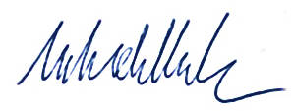
A Hughes  Chief Executive Officer  28 August 2026 | M Koh  Chief Financial Officer  28 August 2026

Administered financial statements
Administered assets, liabilities, revenue, and expenses are those items that an entity does not control but for which it has management responsibility on behalf of the Government, and which are subject to prescriptive rules or conditions established by legislation, or Australian Government policy. These items include debt issued to finance the Government’s fiscal requirements, investments for policy purposes and investments of funds surplus to the Government’s immediate financing needs.
Administered schedules | Page
Comprehensive income | 115
Assets and liabilities | 117
Reconciliation | 119
Cash flow | 120
Notes
1: Financial risk management | 122
2: Treasury Bonds | 131
3: Treasury Indexed Bonds | 133
4: Treasury Notes | 136
5: Cash held in the cash management account | 138
6: Investments in structured finance securities | 139
7: Loans to state and territory governments | 143
8: Cash flow reconciliation | 144
9: Appropriations | 145
10: Administered budget variances | 148
11: Securities lending facility | 150
12: Managing uncertainties | 151
13: Events after the reporting period | 151
Other information | 152

Administered schedule of comprehensive income
For the period ended 30 June 2026
 | Notes | 2026  ($million) | 2025  ($million) | Budget  2026 ($million)
EXPENSES
Interest expense:
Treasury Bonds | 2 | 23,712 | 20,455 | 24,243
Treasury Indexed Bonds | 3 | 2,478 | 1,971 | 2,130
Treasury Notes | 4 | 1,493 | 1,419 | 2,046
Total interest expense |  | 27,683 | 23,845 | 28,419
Other expenses:
Debt repurchases |  | - | 22 | -
Supplier expenses |  | 33 | 23 | 12
Total other expenses |  | 33 | 46 | 12
Total expenses |  | 27,716 | 23,890 | 28,431
INCOME
Interest:
Loans to state and territory governments |  | 64 | 69 | 64
Cash and deposits | 5 | 2,239 | 2,786 | 1,914
Structured finance securities | 6 | 15 | 16 | 60
Total income |  | 2,318 | 2,871 | 2,038
(Deficit) before re-measurements |  | (25,398) | (21,019) | (26,393)
RE-MEASUREMENTS (net market revaluation)

Treasury Bonds |  | 16,652 | (26,917) | (12,557)
Treasury Indexed Bonds |  | 1,093 | 222 | (562)
Treasury Notes |  | 9 | (8) | -
Total re-measurements |  | 17,754 | (26,703) | (13,119)
(Deficit) |  | (7,644) | (47,722) | (39,512)
The above schedule should be read in conjunction with the accompanying notes.
Note 10 explains significant variances between actuals and the original budget as presented in the 2025–26 Portfolio Budget Statements.
Interest expense and interest revenue are determined using the effective interest method.
‘Debt repurchases’ represents the total proceeds paid from repurchasing debt before maturity less the amortised cost carrying value of the debt using the effective interest method. The AOFM conducts these transactions at market rates.
‘Deficit before re-measurements’ records a financial result that is consistent with an accrual (or amortised cost) basis of accounting under the historic cost accounting convention. This is most relevant to the AOFM’s role in managing the debt portfolio, which is predominantly issued and held to maturity, and where portfolio restructuring is performed for debt management purposes, rather than for profit making purposes.
‘Re-measurements’ provides information on the unrealised changes in the market valuation of the portfolio of administered financial assets and financial liabilities (which are carried at fair value through profit or loss) during the financial year. This is an implicit cost or revenue that is relevant for assessing changes in financial risk exposures and changes to the value of transactions managed from year to year. The revaluation effect will net to zero over the life of a financial instrument.

Administered schedule of assets and liabilities
As at 30 June 2026
 | Notes | 2026  ($million) | 2025  ($million) | Budget  2026 ($million)
FINANCIAL ASSETS
Cash held in the Official Public Account (OPA) |  | 1 | 1 | 1
Cash held in the cash management account (a) | 5 | 61,735 | 68,379 | 60,698
Assets at amortised cost:
Structured finance securities | 6 | 361 | 219 | 878
Loans to state and territory governments | 7 | 1,004 | 1,089 | 1,004
Accrued interest on cash management account | 5 | 259 | 230 | 146
Total assets administered on behalf of Government |  | 63,360 | 69,918 | 62,727
FINANCIAL LIABILITIES
Interest bearing liabilities at fair value:
Treasury Bonds | 2 | 819,134 | 801,142 | 859,939
Treasury Indexed Bonds | 3 | 51,365 | 53,047 | 52,563
Treasury Notes | 4 | 35,776 | 32,827 | 55,942
Interest bearing liabilities at amortised cost:
Other debt |  | 5 | 5 | 5
Total liabilities administered on behalf of Government |  | 906,280 | 887,021 | 968,449
Net position (b) |  | (842,920) | (817,103) | (905,722)
The above schedule should be read in conjunction with the accompanying notes.
Note 10 explains significant variances between actuals and the original budget as presented in the 2025–26 Portfolio Budget Statements.
- Cash held in the cash management account contains Debt Retirement Reserve Trust Account (DRRTA), Australian Business Securitisation Fund (ABSF) and Structured Finance Support Fund (SFSF) special account balances. Refer to Note 9: Appropriations for detailed disclosure.
- The administered schedule of assets and liabilities reports a negative equity position. This reflects the Commonwealth’s debt obligations as managed by the AOFM. However, the schedule does not recognise the broader asset base of the Commonwealth which, in economic terms, underpins and supports these obligations.
The Treasurer issued the Commonwealth Inscribed Stock (Maximum Total Face Value of Stock and Securities) Direction 2020. The Direction permits the AOFM to borrow to $1,200 billion in face value terms under the Commonwealth Inscribed Stock Act 1911.
As at 30 June 2026, the face value on issue was $987 billion. The schedule above reports the carrying value of debt in fair value (synonymous with market value) terms, being $906 billion. An increase in interest rates over the course of the past 5 years has led the fair value of the debt portfolio to be below its face value as at 30 June 2025 and 30 June 2026. This is due to increases in interest rates reducing the market price of fixed income instruments.
Financial assets and financial liabilities denoted as being measured at amortised cost are measured at fair value on initial recognition and at amortised cost on subsequent measurement using the effective interest method. Changes in carrying value, including amortisation of premiums or discounts, are recognised in interest revenue (for assets) and interest expense (for liabilities).
Financial assets and financial liabilities denoted as being measured at fair value are measured at fair value on initial recognition and through profit or loss on subsequent measurement. Changes in carrying value are attributed between changes in amortised cost and other changes. Changes in carrying value attributable to amortised cost, including amortisation of premiums or discounts, are recognised in interest revenue (for assets) and interest expense (for liabilities). Other changes in carrying value (including unrealised changes in valuation due to a change in interest rates) are recognised in re-measurements.

Administered reconciliation schedule
For the period ended 30 June 2026
 | Notes | 2026  ($million) | 2025  ($million)
Opening assets less liabilities as at 1 July |  | (817,103) | (756,898)
(Deficit) |  | (7,644) | (47,722)
Transfers from/(to) the Australian Government
Appropriation transfers from Official Public Account
Special appropriations (unlimited) | 9 | 239,121 | 220,424
Cash management account transfers |  | (6,644) | (17,172)
Appropriation transfers to Official Public Account
Transfers to OPA |  | (250,777) | (215,615)
Change in special account balances |  | 127 | (120)
Closing assets less liabilities as at 30 June |  | (842,920) | (817,103)
The above schedule should be read in conjunction with the accompanying notes.

Accounting policy
Administered Cash Transfers to and from the Official Public Account
Revenue collected by the AOFM for use by the Government rather than the AOFM is administered revenue. Collections are transferred to the Official Public Account (OPA) maintained by the Department of Finance. Conversely, cash is drawn from the OPA to make payments under Parliamentary appropriation on behalf of Government. These transfers to and from the OPA are adjustments to the administered cash held by the AOFM on behalf of the Government and reported as such in the administered cash flow statement and in the administered reconciliation schedule.

Administered cash flow statement
For the period ended 30 June 2026
 | Notes | 2026  ($million) | 2025  ($million) | Budget  2026 ($million)
OPERATING ACTIVITIES
Cash received
Interest receipts |  | 2,338 | 2,960 | 2,026
Other receipts |  | 1 | - | -
GST refunds from ATO |  | 2 | 2 | -
Total cash received |  | 2,341 | 2,962 | 2,026
Cash used
Interest paid on Treasury Bonds | 2 | (23,547) | (21,328) | (24,129)
Interest paid on Treasury Indexed Bonds | 3 | (2,295) | (1,871) | (2,302)
Interest paid on Treasury Notes |  | (1,412) | (1,389) | (2,032)
Interest paid on other debt instruments |  | (61) | (35) | -
Other payments |  | (35) | (25) | (10)
Total cash used |  | (27,350) | (24,648) | (28,473)
Net cash used by operating activities | 8 | (25,009) | (21,686) | (26,447)
INVESTING ACTIVITIES
Cash received
Securities lending principal receipts |  | 2,481 | 901 | -
Capital proceeds from structured finance securities |  | 21 | 293 | 162
State and territory loan repayments |  | 97 | 92 | 97
Total cash received |  | 2,599 | 1,286 | 259
Cash used
Acquisition of structured finance securities |  | (163) | (189) | -
Securities lending principal payments |  | (2,481) | (901) | (313)
Total cash used |  | (2,644) | (1,090) | (313)
Net cash from investing activities |  | (45) | 196 | (54)
The above schedule should be read in conjunction with the accompanying notes.

For the period ended 30 June 2026 (continued)
 | Notes | 2026  ($million) | 2025  ($million) | Budget  2026 ($million)
FINANCING ACTIVITIES
Cash received
Proceeds from borrowings |  | 244,590 | 210,732 | 740,849
Other receipts |  | 130 | 106 | -
Total cash received |  | 244,720 | 210,838 | 740,849
Cash used
Repayment of borrowings |  | (208,007) | (193,933) | (669,189)
Other payments |  | (130) | (105) | -
Total cash used |  | (208,137) | (194,038) | (669,189)
Net cash from financing activities |  | 36,583 | 16,800 | 71,660
Cash from Official Public Account
Cash management account transfers |  | - | - | 142
Appropriations – unlimited special | 9 | 239,121 | 220,424 | 699,048
Appropriations – special accounts |  | 163 | 189 | 313
Total cash from Official Public Account |  | 239,284 | 220,613 | 699,503
Cash to Official Public Account
Cash management account transfers |  | (6,644) | (17,172) | (1,914)
Receipts to OPA – special accounts |  | (36) | (309) | (221)
Receipts to OPA – other |  | (250,777) | (215,615) | (742,385)
Total cash to Official Public Account |  | (257,457) | (233,096) | (744,520)
Net (decrease)/increase in cash held |  | (6,644) | (17,173) | 142
Cash at the beginning of the reporting period |  | 68,380 | 85,553 | 60,557
Cash held at the end of the reporting period |  | 61,736 | 68,380 | 60,699
The above schedule should be read in conjunction with the accompanying notes.

Note 1: Financial risk management
The Government is exposed to financial risks arising from its portfolio of financial assets and liabilities – interest rate risk, inflation risk, credit risk, liquidity risk and refinancing risk. The AOFM – overseen by the CEO and senior management – manages these risks within a financial risk management framework. This framework comprises directions from the Treasurer, as well as policies and limits approved by the Secretary of the Treasury.

Interest rate risk
Interest rate risk refers to the risk that the fair value of future cash flows of a financial instrument will fluctuate because of changes in market interest rates.
In its ordinary course of business, the AOFM’s primary measure of interest rate risk is the accrual basis of accounting under the historic cost accounting convention. Fair value measures of interest rate risk are considered to be secondary.
Financial instruments with a fixed interest rate expose the portfolio to changes in fair value with changes in interest rates, while financial instruments at floating interest rates expose the portfolio to changes in debt servicing costs with changes in interest rates. The extent to which the AOFM can match the repricing profile of financial liabilities with financial assets is limited due to the significant differences in the volumes and the need for assets to be available for cash management or other purposes. The interest rate exposure is predominately to fixed interest instruments.
The AOFM does not use financial derivatives such as interest rate swaps to manage interest rate risk.
Interest exposure of assets and liabilities
 | 2026  ($million) | 2025  ($million)
Fixed interest rate exposures
Assets | 1,263 | 1,319
Liabilities | (906,275) | (887,016)
Floating interest rate or non-interest-bearing exposures
Assets | 62,097 | 68,599
Liabilities | (5) | (5)

The following sensitivity analysis illustrates the interest rate risk sensitivity of administered financial instruments and the financial impact on profit or loss and equity to financial positions held as at period end.
A sensitivity of 99 basis points (132 basis points for 2024–25) has been used for domestic interest rates as per standard parameters mandated by the Department of Finance.
Sensitivity of 30 June balances to a 99 basis points rise in interest rates (2024‍–‍25: 132 basis points)
 | 2026  ($million) | 2025  ($million)
Financial Liabilities
Changes in fair value:
Treasury Bonds | 40,124 | 52,337
Treasury Indexed Bonds | 3,424 | 4,667
Treasury Notes | 49 | 62
Financial Assets
Changes in interest revenue:
Structured finance securities | 4 | 3

Sensitivity of 30 June balances to a 99 basis points fall in interest rates (2024‍–‍25: ‍132 basis points)
 | 2026  ($million) | 2025  ($million)
Financial Liabilities
Changes in fair value:
Treasury Bonds | (43,850) | (59,108)
Treasury Indexed Bonds | (3,850) | (5,517)
Treasury Notes | (50) | (63)
Financial Assets
Changes in interest revenue:
Structured finance securities | (4) | (3)

In undertaking the sensitivity analysis, a parallel shift in interest rates (real and nominal) is applied to instruments with all other variables held constant.
For fixed rate instruments, a shift in market interest rates on balances at 30 June only influences those instruments carried at fair value, by altering their fair value carrying amount. Fixed rate instruments carried at fair value include Treasury Bonds and Treasury Indexed Bonds.
For floating rate instruments, the impact on interest revenue or interest expense represents an annualised estimate calculated as if the positions as at 30 June were outstanding for the entire year.
Cash and cash equivalents are excluded from the analysis.

Interest rate benchmarks
Interest rate benchmarks are referenced in a wide range of financial products and are vital for supporting the smooth operation of financial markets.
In Australia, the bank bill swap rate (BBSW) is the major interest rate benchmark for Australian dollar (AUD) denominated debt instruments of tenors from one month to 6 months. In structured finance contracts, the basis for determining contractual interest flows remains the 1-month BBSW. This has not changed as a result of the financial benchmark reforms. However, contractual fall-backs are in place should BBSW cease to be a suitable reference rate in the future.

Inflation risk
Treasury Indexed Bonds have their principal value indexed on a quarterly basis following the release of the ‘All groups Australian Consumer Price Index’ (CPI). Interest is paid quarterly at a fixed rate on the accreted principal value. Accordingly, these debt instruments expose the Government to inflation risk on interest payments, and on the value of principal payable on redemption. There is a 6 month lag between the calculation period for the CPI and its impact on the value of interest and principal.

Treasury Indexed Bonds index values for next interest payment as at 30 June (Per $100 of face value)
 | First issued | 2026 | 2025 | 2024
21 Nov 27 – 0.75% | Aug 2017 | 132.14 | 127.24 | 124.22
20 Sep 30 – 2.50% | Sep 2010 | 153.77 | 148.06 | 144.55
21 Nov 32 – 0.25% | Aug 2021 | 123.90 | 119.30 | 116.47
21 Aug 35 – 2.00% | Sep 2013 | 142.55 | 137.25 | 133.99
21 Aug 40 – 1.25% | Aug 2015 | 136.78 | 131.70 | 128.57
21 Feb 50 – 1.00% | Sep 2018 | 129.63 | 124.82 | 121.86

Credit risk
Credit risk is the risk of non-performance (including partial performance) by a counterparty to a financial contract, leading to a financial loss for the creditor.
The AOFM’s investment activity comprises balances used for cash management purposes and structured (securitisation) finance securities to support the purposes of the ABSF.
Cash management investments are restricted to deposits with the RBA through a cash management account. Cash deposits with the RBA are considered to carry zero credit risk.
For current and proposed investments in structured finance securities, where an investment is rated by a credit rating agency, the AOFM may use that assessment. Alternatively, the AOFM will evaluate the credit risk internally using available resources and information and may engage an advisor to support a credit risk assessment.
The AOFM also conducts post-trade performance monitoring, including defaults, prepayment rates, losses, profitability, and level of credit enhancement. The actual historical performance of loan pools may guide revisions to expected future performance. The AOFM uses this information to gauge whether credit risk has increased significantly since acquisition; and to provide an estimate as to expected future credit losses (either for the next 12 months or full life to maturity, depending on the circumstances).
The maximum credit exposure of structured (securitisation) finance securities acquired is the principal outstanding, plus the total amount of undrawn commitments remaining over the life of the respective facilities. However, the likely amount of loss arising from undrawn commitments may be less than the total amount committed, as the commitments are contingent on the maintenance of specific standards.
The table below shows the credit exposure to structured (securitisation) finance facilities as at period end:
Credit exposure to structured (securitisation) finance facilities as at 30 June 2026
Exposure by fund | Current  exposure ($million) | Undrawn  commitments ($million) | Total credit  committed ($million)
Australian Business Securitisation Fund (ABSF)
Public term transactions (a) | 90 | - | 90
Private warehouse transactions (b) | 271 | 161 | 432
Total | 361 | 161 | 522

Credit exposure to structured (securitisation) finance facilities as at 30 June 2025
Exposure by fund | Current  exposure ($million) | Undrawn  commitments ($million) | Total credit  committed ($million)
Australian Business Securitisation Fund (ABSF)
Public term transactions (a) | 46 | - | 46
Private warehouse transactions (b) | 173 | 174 | 347
Total | 219 | 174 | 393
        - Debt securities (backed by underlying collateral) issued by way of public offer by special purpose vehicles for the purposes of funding their lending activities.
        - Temporary lines of credit (backed by underlying collateral) provided to special purpose vehicles for the purposes of funding their lending activities.
Under Commonwealth-State financing arrangements between 1945 and 1989, the Australian Government made concessional loans (not evidenced by the issuance of debt securities) to State and Northern Territory governments for specific purposes. As at 30 June 2026, the principal outstanding on these loans was $1,082 million.

Composition of loans to state and territory governments as at 30 June 2026
Principal outstanding | 2026  ($million) | 2025  ($million)
New South Wales | 465 | 515
Western Australia | 218 | 236
Queensland | 156 | 172
South Australia | 132 | 139
Northern Territory | 111 | 117
Total | 1,082 | 1,179

The maximum exposure to credit risk is the principal value of loans outstanding.
Credit exposure to state and territory governments by credit rating
Principal value | 2026  ($million) | 2025  ($million)
Aaa / AAA | 218 | 236
Aa1 / AA+ | 753 | 826
Aa3 / AA- | 111 | 117
Total | 1,082 | 1,179

Where a counterparty has a split rating between the rating agencies (S&P and Moody’s), the AOFM’s exposure is allocated to the lower credit rating.
To protect the Australian Government’s financial position with respect to securities lending arrangements (which allows market participants to borrow Treasury Bonds and Treasury Indexed Bonds not readily available from other sources), the market value of the collateral taken from counterparties is greater than the market value of the securities lent. There is a right to seek additional collateral if there is a decline in the relative values. As at 30 June 2026, there were no open securities lending transactions.

Liquidity risk and refinancing risk
The AOFM manages liquidity risk by maintaining a cash buffer and by maintaining access to the Treasury Note market.
The Government also has access to an overdraft facility held by the Department of Finance with the RBA which can be called on at any time. The overdraft facility is to cover temporary, unexpected shortfalls of cash and has a limit of $10 billion. The overdraft facility is undrawn at the reporting date.
Refinancing risk is the risk that when maturing debt needs to be funded by debt issuance, it may have to be refinanced at a higher cost or market conditions may prevent sufficient funds from being raised in an orderly manner.
The AOFM seeks to manage refinancing risk by avoiding excessive short-dated borrowing, spacing of maturity dates, avoiding overly large bond maturities in any one year and maintaining access to the Treasury Note market.
The following table discloses the undiscounted value of the contractual maturities of financial liabilities as at the reporting date, including estimated future interest payments. Interest payments and the principal value on redemption of Treasury Indexed Bonds are based on capital values as at period end.
Future undiscounted cash outflows of liabilities as at 30 June 2026
 | Treasury Bonds ($million) | Treasury Indexed  Bonds ($million) | Treasury  Notes  & Other ($million) | Total ($million)
Principal payments:
within 1 year | 78,799 | - | 35,486 | 114,285
1 to 5 years | 343,600 | 22,156 | - | 365,756
5 to 10 years | 332,550 | 19,711 | - | 352,261
10 to 15 years | 92,400 | 8,207 | - | 100,607
15 years+ | 47,300 | 5,963 | - | 53,263
Total Principal | 894,649 | 56,037 | 35,486 | 986,172
Interest payments:
within 1 year | 24,319 | 788 | 514 | 25,621
1 to 5 years | 74,259 | 2,662 | - | 76,921
5 to 10 years | 54,023 | 1,777 | - | 55,800
10 to 15 years | 12,826 | 734 | - | 13,560
15 years+ | 13,749 | 521 | - | 14,270
Total Interest | 179,176 | 6,482 | 514 | 186,172
Future undiscounted cash outflows of liabilities as at 30 June 2025
 | Treasury Bonds ($million) | Treasury Indexed  Bonds ($million) | Treasury  Notes  & Other ($million) | Total  ($million)
Principal payments:
within 1 year | 78,800 | 6,135 | 32,615 | 117,550
1 to 5 years | 315,299 | 9,352 | - | 324,651
5 to 10 years | 336,850 | 18,282 | - | 355,132
10 to 15 years | 63,300 | 8,921 | - | 72,221
15 years+ | 59,500 | 13,450 | - | 72,950
Total Principal | 853,749 | 56,140 | 32,615 | 942,504
Interest payments:
within 1 year | 21,858 | 740 | 391 | 22,989
1 to 5 years | 66,475 | 2,602 | - | 69,077
5 to 10 years | 44,039 | 1,776 | - | 45,815
10 to 15 years | 12,212 | 814 | - | 13,026
15 years+ | 13,617 | 578 | - | 14,195
Total Interest | 158,201 | 6,510 | 391 | 165,102

Fair value reported
Fair value is the price that would be received to sell an asset or paid to transfer a liability, in an orderly transaction between market participants. This is the quoted market price if one is available.
AASB 13 Fair Value Measurement requires assets and liabilities measured at fair value to be disclosed according to their position in a fair value hierarchy. The hierarchy has 3 levels:
Level 1 is based on quoted prices in active markets for identical instruments;
Level 2 is based on quoted prices or other observable market data not included in Level 1;
Level 3 is based on significant inputs to valuation other than observable market data.
Fair value hierarchy for assets and liabilities as at 30 June 2026
 | Carried at fair value ($million) |  |  | Carried at amortised cost ($million)
 | Level 1 | Level 2 | Level 3 | Carried at amortised cost ($million)
Liabilities | (906,275) | - | - | (5)
Assets | - | - | - | 63,360

Fair value hierarchy for assets and liabilities as at 30 June 2025
 | Carried at fair value ($million) |  |  | Carried at amortised cost ($million)
 | Level 1 | Level 2 | Level 3 | Carried at amortised cost ($million)
Liabilities | (887,016) | - | - | (5)
Assets | - | - | - | 69,918

Note 2: Treasury Bonds
Treasury Bonds are denominated in Australian dollars and pay a fixed coupon semi-annually in arrears. Treasury Bonds are redeemable at face value on maturity. There are no options available to either the Australian Government or the holders of the securities to exchange or convert Treasury Bonds. There are also no options available to either party for early redemption.
The AOFM issues Treasury Bonds primarily through a competitive auction process to registered bidders. Based on market conditions, the AOFM may consider syndicated issuance to reduce the execution risk in meeting Government financing needs.
The AOFM’s buyback activities are based on a transaction entered by the AOFM and the bondholder. If the AOFM buys back bonds, it does so at prevailing market prices and then cancels them.
For details of Green Treasury Bonds, see the annual report.
Accounting policy
The AOFM monitors the cost and risk of Treasury Bonds on issue primarily on an accrual basis, but also on a fair value basis. The AOFM has designated Treasury Bonds to be carried at fair value through profit or loss under AASB 9 Financial Instruments.
The fair value of Treasury Bonds is determined by reference to observable market rates for these instruments. As such, they are included as Level 1 financial instruments in the fair value hierarchy.

Key aggregates
Interest expense
 | 2026  ($million) | 2025  ($million)
Treasury Bonds
Interest paid / payable | 23,832 | 21,459
Amortisation of net premiums | (120) | (1,004)
Total interest expense | 23,712 | 20,455

The interest expense on the Treasury Bond portfolio has risen over time due to higher borrowing levels, and more recently due to the higher interest rate environment applicable to long-term debt issuance. The accrual yield for 2025–26 was 2.70 per cent, 30 basis points higher than the 2024–25 accrual yield of 2.40 per cent.
Carrying values – administered liabilities
 | 2026  ($million) | 2025  ($million)
Treasury Bonds
Face value | 894,649 | 853,749
Accrued interest | 3,094 | 2,809
Unamortised net premiums | (12,069) | (5,529)
Market value adjustment | (66,540) | (49,887)
Carrying value | 819,134 | 801,142

At 30 June 2026, the weighted average market yield on Treasury Bonds was 4.55 per cent (30 June 2025: 3.67 per cent).
At 30 June 2026, the weighted average (nominal) issuance yield on Treasury Bonds was 2.73 per cent (30 June 2025: 2.54 per cent).
These figures are weighted by aggregate (total) value.
Changes in principal value (face value) for the period
 | 2026  ($million) | 2025  ($million)
Treasury Bonds
Issuance | 119,700 | 98,600
Maturities | (78,800) | (82,800)
Total change in principal value | 40,900 | 15,800

Interest paid – cash flow statement
 | 2026  ($million) | 2025  ($million)
Treasury Bonds
Coupons paid | 24,694 | 22,162
Interest received on issuance | (1,147) | (834)
Interest paid | 23,547 | 21,328

Note 3: Treasury Indexed Bonds
Treasury Indexed Bonds are denominated in Australian dollars and are capital indexed with the principal value of the bond adjusted by reference to movements in the CPI.
Interest payments are made quarterly in arrears, at a fixed rate, on the adjusted capital value. At maturity, investors receive the adjusted capital value of the security.
The AOFM issues Treasury Indexed Bonds primarily through a competitive auction process. Based on market conditions, the AOFM may consider a syndicated issuance to reduce the execution risk in meeting Government financing needs.
Accounting policy
The AOFM monitors the cost and risk on Treasury Indexed Bonds primarily on an accrual basis, but also on a fair value basis. The AOFM has designated Treasury Indexed Bonds to be carried at fair value through profit or loss under AASB 9 Financial Instruments.
The fair value of Treasury Indexed Bonds is determined by reference to observable market rates for these instruments. As such, they are included as Level 1 financial instruments in the fair value hierarchy.
Capital accretion is recognised in interest expense over time with each quarterly release of the CPI.
As future inflation rates are uncertain and it is not appropriate for the AOFM to express a view on the inflation outlook, an estimate of the adjusted capital value on maturity of each series of Treasury Indexed Bonds is not disclosed in the financial statements.

Key aggregates
Interest expense
 | 2026  ($million) | 2025  ($million)
Interest paid / payable | 780 | 885
Capital accretion and amortisation of net premiums | 1,698 | 1,086
Interest expense | 2,478 | 1,971

The interest expense on the Treasury Indexed Bond portfolio has risen more recently due to the higher inflationary environment. The accrual yield for 2025–26 was 4.53 per cent, 97 basis points higher than the 2024–25 accrual yield of 3.56 per cent.
Carrying values – administered liabilities
 | 2026  ($million) | 2025  ($million)
Principal (adjusted capital value):
Face value | 40,792 | 41,885
Capital accretion (to next coupon) | 15,245 | 14,256
Principal value | 56,037 | 56,141
Accrued interest | 62 | 61
Unamortised net premiums | 144 | 632
Market value adjustment | (4,878) | (3,787)
Carrying value | 51,365 | 53,047

At 30 June 2026, the weighted average market (real) yield on Treasury Indexed Bonds was 2.14 per cent (30 June 2025: 1.71 per cent). At 30 June 2026, the weighted average (real) issuance yield on Treasury Indexed Bonds was 1.35 per cent (30 June 2025: 0.99 per cent).
These figures are weighted by aggregate (total) value.

Changes in principal value for the period
 | 2026  ($million) | 2025  ($million)
Changes in face value due to:
Issuance | 2,950 | 2,900
Debt repurchased | - | (2,000)
Maturities | (4,042) | -
Changes in capital accretion due to:
Issuance | 1,070 | 823
Debt repurchased | - | (993)
Maturities | (2,093) | -
Accretion for the period | 2,011 | 1,309
Change in principal value | (104) | 2,039

Interest paid – cash flow statement
 | 2026  ($million) | 2025  ($million)
Coupons paid | 784 | 867
Interest received on issuance | (6) | (3)
Interest paid on repurchase | - | 19
Accretion since issuance (paid on redemption) | 1,517 | 988
Interest paid | 2,295 | 1,871

Note 4: Treasury Notes
Treasury Notes are short term discount instruments, denominated in Australian dollars and repayable at face value on maturity.
Treasury Notes are used to accommodate within-year cash requirements. The AOFM conducts issuance of Treasury Notes via competitive tenders.
Accounting policy
The AOFM monitors the cost and risk on Treasury Notes primarily on an accrual basis, but also on a fair value basis. The AOFM has designated Treasury Notes to be carried at fair value through profit or loss under AASB 9 Financial Instruments.
The fair value of Treasury Notes is determined by reference to observable market rates for these instruments. As such, they are included as Level 1 financial instruments in the fair value hierarchy.

Key aggregates
Interest expense
 | 2026  ($million) | 2025  ($million)
Interest paid / payable | 1,493 | 1,419
Interest expense | 1,493 | 1,419

The accrual yield on the Treasury Note portfolio was 3.82 per cent for 2025–26, 45 basis points lower than the 2024–25 accrual yield of 4.27 per cent. This decrease was due to the lower interest rate environment on short-term debt.

Carrying values – administered liabilities
 | 2026  ($million) | 2025  ($million)
Face value | 36,000 | 33,000
Unexpired interest discount | (224) | (181)
Market value adjustment | - | 8
Carrying value | 35,776 | 32,827

Changes in principal value (face value) for the period
 | 2026  ($million) | 2025  ($million)
Issuance | 129,000 | 115,500
Maturities | (126,000) | (110,500)
Change in principal value | 3,000 | 5,000

Note 5: Cash held in the cash management account (CMA)
The CMA was created under the authority of section 53 of the Public Governance, Performance and Accountability Act 2013. The CMA resides outside the OPA and earns a market rate of interest. The agreement is structured so that excess OPA balances (above an agreed minimum threshold) are swept to the CMA at the end of each day and returned to the OPA at the start of the next day. The cash balance of the OPA is reported by the Department of Finance.
Accounting policy
The balances held in the cash management account are effectively ‘at call’ and classified as ‘cash’ in the administered schedule of assets and liabilities.

Key aggregates
Interest revenue
 | 2026  ($million) | 2025  ($million)
Interest received / receivable | 2,239 | 2,786
Interest revenue | 2,239 | 2,786

Carrying values – administered assets
 | 2026  ($million) | 2025  ($million)
Face value | 61,735 | 68,379
Accrued interest (a) | 259 | 230
Carrying value | 61,994 | 68,609
- The accrued interest on the cash management account is reported separately to the principal value of the cash balance on the administered schedule of assets and liabilities.

Note 6: Investments in structured finance securities
Investments acquired by the AOFM through the ABSF and SFSF represent debt securities in structured finance vehicles, and are either public term securitisations, private warehouse financing facilities, or the debt securities issued by the Forbearance SPV. The contractual cash flows received on these debt securities represent payments of principal and interest on outstanding principal. This is consistent with a basic lending arrangement.
During 2024–25, the SFSF exited its remaining warehouse commitments, remaining Forbearance SPV amounts were repaid and remaining public market investments were sold. The SFSF does not hold any public market investments, warehouse commitments or outstanding Forbearance SPV balances as at 30 June 2026.
Accounting policy
The AOFM recognises these investments at fair value on initial recognition. The AOFM’s business model is to hold these investments primarily to collect the contractual cash flows, and as such they are carried at amortised cost on subsequent measurement using the effective interest method.
Periodically, actual historical performance of each investment is used to revise expected future performance. This information is used to gauge whether credit risk has increased significantly since acquisition, and to provide a revised estimate as to the expected future credit losses. Where relevant, the impairment provision is revised accordingly.
Impairments on these investments are required to be measured on an expected credit loss (ECL) basis under AASB 9. The process of calculating the forward-looking loss allowance for both the 12-month ECL and lifetime ECL categories requires the use of significant estimates and judgements of the probability of default, loss given default, exposure at default, and economic conditions.

Key aggregates
Interest revenue
 | 2026  ($million) | 2025  ($million)
Australian Business Securitisation Fund (ABSF):
Interest and fees received / receivable | 16 | 12
Impairment provision (expenses) | (1) | -
ABSF Sub-total | 15 | 12
Structured Finance Securitisation Fund (SFSF):
Interest and fees received / receivable (a) | - | 4
SFSF Sub-total | - | 4
Total interest revenue | 15 | 16
(a) Includes earnings from debt securities issued by the Forbearance SPV.

Carrying values – administered assets
 | 2026  ($million) | 2025  ($million)
Australian Business Securitisation Fund (ABSF)
Face value | 361 | 219
Accrued interest | 1 | 1
Expected credit loss provision | (1) | (1)
Total | 361 | 219
Expected to be received (a):
Within one year | 117 | 64
In one to five years | 154 | 65
In more than five years | 90 | 90
Carrying value by expected recovery | 361 | 219
Ageing:
Not overdue | 361 | 219
Carrying value by ageing | 361 | 219
(a) The maturity profile is based on the weighted average life of each investment and disregarding estimated principal repayments (the timing and quantum of which are uncertain) prior to that time.

Change in principal value (face value) of investments for the period
 | 2026  ($million) | 2025  ($million)
Australian Business Securitisation Fund (ABSF)
Acquisitions | 163 | 189
Redemptions | (21) | (132)
Total change in principal value for ABSF | 142 | 58
Structured Finance Support Fund (SFSF) (a)
Redemptions | - | (161)
Total change in principal value for SFSF | - | (161)
        - Includes debt securities issued by the Forbearance SPV.

The Forbearance SPV
The AOFM forbearance SPV is a single special purpose vehicle funded by AOFM through the Structured Finance Support Fund. The provision of liquidity funding to participating trust vehicles ceased on 31 March 2021.
In 2024–25 the remaining Forbearance SPV amounts were repaid. No further activity is expected.
Interest revenue earned from the Forbearance SPV in 2025–26 was $nil (2024‍–‍25: $0.1 million).
Change in principal value (face value) of investments for the period
 | 2026  ($million) | 2025  ($million)
Forbearance SPV
Redemptions | - | (8)
Total change in principal value | - | (8)

Note 7: Loans to state and territory governments
Loans to state and territory governments predominantly comprise concessional housing advances and specific purpose capital advances made between 1945 and 1989 under Commonwealth – State financing arrangements. These loans are structured with annual repayments, which incorporate principal and interest.
Accounting policy
Loans to state and territory governments are measured at fair value on initial recognition and at amortised cost on subsequent measurement using the effective interest method. The expected credit loss is estimated to be nil on these loans due to the federal financial relations system between the Commonwealth and the states and the territories.

Key aggregates
Carrying values – administered assets
 | 2026  ($million) | 2025  ($million)
Face value | 1,082 | 1,179
Unamortised net discounts | (78) | (90)
Carrying value | 1,004 | 1,089
Expected to be received:
Within one year | 90 | 85
In one to five years | 335 | 347
In more than five years | 579 | 657
Carrying value by expected recovery | 1,004 | 1,089
Ageing:
Not overdue | 1,004 | 1,089
Carrying value by ageing | 1,004 | 1,089

The fair value of these loans was $1,069 million at 30 June 2026 (2024‍–‍25: $1,211 million). Data from Treasury Bonds is used in estimating fair value.

Note 8: Cash flow reconciliation
The following table reconciles the deficit reported in the Schedule of Comprehensive Income to net cash flows from operating activities reported in the Cash Flow Statement.
Reconciliation of net cash from operating activities
 | 2026  ($million) | 2025  ($million)
(Deficit) | (7,644) | (47,722)
Adjustments for non-cash items:
Amortisation and capital accretion of debt instruments | 1,578 | 82
Amortisation of financial assets | (11) | (12)
Impairment provision expenses (revenues) | 2 | -
Re-measurements | (17,753) | 26,703
Adjustments for cash items:
Capital accretion costs on redemption of debt | (1,518) | (988)
Debt repurchases | - | 22
Accrual adjustments:
Interest accruals on debt | 368 | 163
Interest accruals on assets | (31) | 66
Net cash from operating activities | (25,009) | (21,686)

Note 9: Appropriations
Administered special appropriations – unlimited
 | 2026  ($’000) | 2025  ($’000)
Commonwealth Inscribed Stock Act 1911
s13AA – payment of principal and interest on money raised by Stock issued under the Act and payments on depository interests in Stock issued under the Act | 236,603,538 | 216,471,364
s13A – payment of costs and expenses incurred in relation to issuing and managing debt and depository interests | 34,934 | 24,984
s13B – payment of costs and expenses incurred in repurchasing debt prior to maturity | 60 | 3,026,482
Financial Agreement Act 1994
s5 – debt redemption assistance and payment of interest to bond holders on behalf of the State and Northern Territory governments on public debt under the Act (a) | 11 | 12
Loan Securities Act 1919

s5BA – payment of money to enter into securities lending arrangements | 2,482,777 | 901,368
Public Governance, Performance and Accountability Act 2013
s77 – repayment of money paid to the Commonwealth | - | -
Total | 239,121,320 | 220,424,209
- The 2025–26 amount includes $6,974 paid into the Debt Retirement Reserve Trust Account
(2024–25: $7,465).

The following administered special appropriations were not drawn upon in the current or prior year:
- Australian National Railways Commission Sale Act 1997, ss 67AH(4), 67AW
- Loans Redemption and Conversion Act 1921, s5
- Loans Securities Act 1919, ss4, 5B(2)
- Moomba–Sydney Pipeline System Sale Act 1994, s19(3)
- Public Governance, Performance and Accountability Act 2013, ss58(7)
- Treasury Bills Act 1914, s6
Special account – Australian Business Securitisation Fund (ABSF)
 | 2026  ($’000) | 2025  ($’000)
Opening balance | 1,833,651 | 1,880,005
Investments made | (163,135) | (189,295)
Management expenses | (446) | (414)
Capital proceeds received from investments | 20,686 | 131,505
Interest and commitment fees received | 15,767 | 11,851
Closing balance | 1,706,523 | 1,833,651
Balance represented by:
Cash – held in the CMA | 1,706,523 | 1,833,651

The purpose of the ABSF is to increase the availability and reduce the cost of credit provided to small and medium enterprises. This is achieved by the Commonwealth investing in debt securities in accordance with the Australian Business Securitisation Fund Act 2019. The ABSF was established under the Australian Business Securitisation Fund Act 2019 and has received total funding of $2 billion.

Special account – Structured Finance Support Fund (SFSF)
 | 2026  ($’000) | 2025  ($’000)
Opening balance | 15,134,601 | 14,968,674
Other payments | (9) | (3)
Capital proceeds received from investments | - | 161,692
Interest and commitment fees received | 16 | 4,238
Closing balance | 15,134,608 | 15,134,601
Balance represented by:
Cash – held in the Official Public Account (CMA) | 15,134,608 | 15,134,601

Receipts and payments reported above are inclusive of receipts from and payments to the Forbearance SPV.

Receipts from and payments to the Forbearance SPV are as follows:
Forbearance SPV – receipts and payments
 | 2026  ($’000) | 2025  ($’000)
Capital proceeds received from investments | - | 8,176
Interest received | 16 | 163
Other receipts | - | 78
Net cash inflows (outflows) for the Forbearance SPV | 16 | 8,417

In 2024–25 the SFSF exited its remaining warehouse commitments. The remaining Forbearance SPV amounts were repaid and remaining public market investments were sold. No further activity is expected in the fund.
Special account – Debt Retirement Reserve Trust Account (DRRTA)
 | 2026  ($’000) | 2025  ($’000)
Opening balance | 178 | 171
Commonwealth contributions and interest paid | 7 | 7
State contributions | - | -
Closing balance | 185 | 178
Balance represented by:
Cash – held in the Official Public Account | 185 | 178

The purpose of the DRRTA is to fund the redemption of the state and territory debt governed by the Financial Agreement Act 1994. Monies standing to the credit of the DRRTA are held on behalf of New South Wales and Victoria. These monies are held for the purposes prescribed by the Financial Agreement Act 1994. The account was established under the Public Governance, Performance and Accountability Act 2013.

Note 10: Administered budget variances
The projections of debt issuance and asset holdings are a consequence of the expenditure, investment and revenue decisions and assumptions made by the Government in producing its Budget together with estimates of debt to mature during the period. As part of the Budget process, the AOFM receives an estimate of the aggregated annual financing task for the Budget year and forward years from the Treasury. The annual financing task, plus the volume of maturing AGS and planned early repurchases of AGS (that would otherwise mature in a future year), are central to determining the size of the planned issuance program in each year.
The volume of AGS that needs to be issued in face value terms to generate the required level of financing will depend on the level of AGS yields and the chosen maturities and mix of debt to be issued. These decisions are based on the debt management strategy, which takes into account longer term portfolio considerations.
It is assumed that the future AGS yields for different tenors will be the same as the prevailing market rates at the time the Budget estimates are prepared.
The following provides explanations for significant variances between AOFM’s original Budget estimates, as published in the 2025–26 Portfolio Budget Statements, and the actual financial performance and position for the year.

Explanations of major variances | Affected line items
Interest expense for Treasury Bonds was $531 million lower than forecast at the 2025‍–‍26 Budget due to lower issuance during the year. | Interest expense: Treasury Bonds – Administered schedule of comprehensive income
Interest expense for Treasury Indexed Bonds was $348 million higher than forecast at the 2025–26 Budget due to higher capital accretion (indexation) recognised based on higher inflation rates. | Interest expense: Treasury Indexed Bonds – Administered schedule of comprehensive income
Interest expense for Treasury Notes was $553 million lower than forecast at the 2025‍–‍26 Budget due to lower issuance during the year. | Interest expense: Treasury Notes – Administered schedule of comprehensive income
Interest income from cash and deposits was $325 million higher than forecast at the 2025‍–‍26 Budget due to higher than expected balances held in the cash management account during the year.  The cash held in the cash management account was $1 billion higher at year end than forecast at the 2025–26 Budget. | Interest income: Cash and deposits – Administered schedule of comprehensive income  Financial assets: Cash held in the cash management account – Administered schedule of assets and liabilities
There was a net re-measurement gain on Treasury Bonds of $16.7 billion compared to a loss of $12.6 billion forecast at the 2025–26 Budget. This was due to higher market rates at year end decreasing the valuation.  The fair value of Treasury Bonds at 30 June 2026 was $41 billion lower than forecast at the 2025–26 Budget. | Re-measurements: Treasury Bonds – Administered schedule of comprehensive income  Interest bearing liabilities at fair value: Treasury Bonds – Administered schedule of assets and liabilities
There was a net re-measurement gain on Treasury Indexed Bonds of $1.1 billion compared to a loss of $0.6 billion forecast at the 2025–26 Budget. This was due to higher market rates at year end decreasing the valuation.  The fair value of Treasury Indexed Bonds at 30 June 2026 was $1.2 billion lower than forecast at the 2025–26 Budget. | Re-measurements: Treasury Indexed Bonds – Administered schedule of comprehensive income  Interest bearing liabilities at fair value: Treasury Indexed Bonds – Administered schedule of assets and liabilities

Note 11: Securities lending facility
The AOFM has a securities lending facility for Treasury Bonds and Treasury Indexed Bonds, which is operated by the RBA.
The purpose of the facility is to enhance the efficiency of the bond markets by allowing market participants to borrow Treasury Bonds and Treasury Indexed Bonds when they are not readily available. Bonds are lent on an intra-day or overnight basis.
Counterparties borrowing bonds through the facility must provide collateral in the form of cash or acceptable securities.
Transactions completed during the period
 | Number |  | Face value
 | 2026 | 2025 | 2026  ($million) | 2025  ($million)
Overnight:
Treasury Bonds | 88 | 16 | 4,243 | 767
Treasury Indexed Bonds | - | 2 | - | 284
Total | 88 | 18 | 4,243 | 1,051

No transactions were open as at 30 June 2026.
Separate to the securities lending facility, bond market participants can borrow Treasury Bonds and Treasury Indexed Bonds from the RBA’s holdings.

Note 12: Managing uncertainties
Administered – contingent assets and liabilities
 | Other |  | Total
 | 2026  ($million) | 2025  ($million) | 2026  ($million) | 2025  ($million)
Contingent assets
New contingent assets recognised | 10 | - | 10 | -
Total | 10 | - | 10 | -

The above table includes a contingent asset of $9,979,687 (2025: nil) relating to an ex-gratia payment proposed by Australia and New Zealand Banking Group Limited (ANZ) in connection with ASIC v ANZ [2025] FCA 1592.
As at 30 June 2026, no agreement had been reached between ANZ and the Commonwealth in relation to the proposed payment and, accordingly, no asset has been recognised in the financial statements.
The estimated value of the contingent asset is based on the amount calculated by ANZ as revenue earned in its role as duration manager for a bond transaction undertaken in April 2023.
There were no administered contingent liabilities as at 30 June 2026.

Note 13: Events after the reporting period
Note 12 discloses a contingent asset of $9,979,687 at 30 June 2026 relating to a proposed ex-gratia payment from ANZ. Subsequent to the reporting date, a deed was executed between the Commonwealth and ANZ providing for payment. As the deed was entered into after 30 June 2026, no asset or income has been recognised in the financial statements.
The estimated financial effect is an increase in revenue and cash to the OPA of $9,979,687 in the subsequent reporting period.

Other information
Current/non-current distinction for assets and liabilities
 | 2026  ($million)  $’000 | 2025  ($million)  $’000
Assets expected to be recovered in:

No more than 12 months

Cash held in the OPA | 1 | 1
Cash held in the cash management account | 61,735 | 68,379
Structured finance securities | 117 | 64
Loans to State and Territory governments | 90 | 85
Accrued interest on cash management account | 259 | 230
Total no more than 12 months | 62,202 | 68,759
More than 12 months

Structured finance securities | 244 | 155
Loans to State and Territory governments | 914 | 1,004
Total more than 12 months | 1,158 | 1,159
Total assets | 63,360 | 69,918
Liabilities expected to be recovered in:

No more than 12 months

Treasury Bonds | 78,946 | 78,926
Treasury Indexed Bonds | - | 6,130
Treasury Notes | 35,776 | 32,827
Other debt | 5 | 5
Total no more than 12 months | 114,727 | 117,888
More than 12 months

Treasury Bonds | 740,188 | 722,216
Treasury Indexed Bonds | 51,365 | 46,917
Total more than 12 months | 791,553 | 769,133
Total liabilities | 906,280 | 887,021

Departmental financial statements
Statements | Page
Comprehensive income | 154
Financial position | 155
Changes in equity | 156
Cash flow | 157
Notes to the statements
A: Expenses | 158
B: Receivables | 159
C: Property, plant, and equipment | 160
D: Employee provisions | 165
E: Lease liabilities | 168
F: Other provisions | 169
G: Cash flow reconciliation | 170
H: Appropriations | 171
I: Departmental budget variances | 173
Overview | 174
Managing uncertainties | 176
Financial Instruments | 176
Other information | 178

Departmental statement of comprehensive income
For the period ended 30 June 2026
Notes |  | 2026  $’000 | 2025  $’000 | Budget  2026  $’000
NET COST OF SERVICES
EXPENSES
Employee benefits | A | 10,644 | 10,808 | 10,240
Supplier expenses | A | 4,679 | 5,650 | 6,171
Depreciation and amortisation | C | 564 | 586 | 598
Interest on lease liabilities |  | 48 | 50 | 67
Interest on make-good liability | F | 22 | 20 | -
Total expenses |  | 15,957 | 17,114 | 17,076
OWN-SOURCE INCOME
Other revenue |  | 6 | 269 | 25
Resources received free of charge |  | 250 | 250 | 250
Total own-source income |  | 256 | 519 | 275
Net cost of services |  | (15,701) | (16,595) | (16,801)
APPROPRIATION FUNDING
Revenue from Government |  | 16,575 | 16,357 | 16,468
Total appropriation funding |  | 16,575 | 16,357 | 16,468
Surplus/(Deficit) |  | 874 | (238) | (333)
OTHER COMPREHENSIVE INCOME
Changes in asset revaluation reserve |  | 406 | - | -
Total comprehensive income/(loss) |  | 1,280 | (238) | (333)
The above statement should be read in conjunction with the accompanying notes.
Note I explains significant variances between actuals and the original budget as presented in the 2025–26 Portfolio Budget Statements.

Departmental statement of financial position
As at 30 June 2026
Notes |  | 2026  $’000 | 2025  $’000 | Budget  2026  $’000
ASSETS
Financial assets:
Cash and cash equivalents |  | 577 | 207 | 100
Receivables | B | 34,067 | 36,256 | 36,578
Non-financial assets:
Property, plant, and equipment¹ | C | 4,571 | 5,046 | 4,878
Software | C | 170 | 235 | 158
Supplier prepayments |  | 464 | 230 | 494
Total assets |  | 39,849 | 41,974 | 42,208
LIABILITIES
Payables:
Supplier payables |  | 851 | 778 | 828
Salary and superannuation |  | 302 | 292 | 941
Provisions:
Employee provisions | D | 2,488 | 2,667 | 2,598
Lease liabilities | E | 3,244 | 3,519 | 3,123
Other provisions | F | 204 | 623 | 645
Total liabilities |  | 7,089 | 7,879 | 8,135
Net assets |  | 32,760 | 34,095 | 34,073
EQUITY
Retained surplus |  | 44,034 | 45,381 | 44,948
Asset revaluation reserve |  | 1,121 | 715 | 715
Contributed equity |  | (12,395) | (12,001) | (11,590)
Total equity |  | 32,760 | 34,095 | 34,073
The above statement should be read in conjunction with the accompanying notes.
Note I explains significant variances between actuals and the original budget as presented in the 2025–26 Portfolio Budget Statements.
1 Right-of-use assets are included in property, plant and equipment.

Departmental statement of changes in equity
For the period ended 30 June 2026
Notes |  | 2026  $’000 | 2025  $’000 | Budget  2026  $’000
RETAINED EARNINGS
Opening balance |  | 45,381 | 45,619 | 45,281
Surplus/(Deficit) for the period |  | 874 | (238) | (333)
Appropriations extinguished | H | (2,225) | - | -
Adjustment for rounding |  | 4 | - | -
Closing balance as at 30 June |  | 44,034 | 45,381 | 44,948
ASSET REVALUATION RESERVE
Opening balance |  | 715 | 715 | 715
Revaluation of assets at 30 June 2026 |  | 406 | - | -
Closing balance as at 30 June |  | 1,121 | 715 | 715
CONTRIBUTED EQUITY
Opening balance as at 1 July |  | (12,001) | (12,406) | (12,001)
Departmental capital budget (DCB) |  | 411 | 405 | 411
DCB reclassified as operating | H | (411) | - | -
Appropriations extinguished | H | (394) | - | -
Closing balance as at 30 June |  | (12,395) | (12,001) | (11,590)
Total equity |  | 32,760 | 34,095 | 34,073
The above statement should be read in conjunction with the accompanying notes.
Note I explains significant variances between actuals and the original budget as presented in the 2025–26 Portfolio Budget Statements.

Accounting Policy
Equity Injections
Amounts appropriated which are designated as ‘equity injections’ for a year (less any formal reductions) and Departmental Capital Budgets (DCB) are recognised directly in contributed equity in that year.

Departmental cash flow statement
For the period ended 30 June 2026
Notes |  | 2026  $’000 | 2025  $’000 | Budget  2026  $’000
OPERATING ACTIVITIES
Appropriations |  | 16,268 | 17,285 | 16,468
GST received |  | 12 | 11 | -
Services and other |  | 179 | 981 | 25
Employees |  | (10,395) | (11,081) | (10,240)
Suppliers |  | (5,181) | (6,240) | (5,942)
Interest paid on leases |  | (48) | (52) | (46)
Section 74 receipts transferred to OPA |  | (191) | (532) | (25)
Net cash from operating activities | G | 644 | 372 | 265
INVESTING ACTIVITIES
Purchase of assets |  | (60) | (318) | (411)
Net cash (used by) investing activities |  | (60) | (318) | (411)
FINANCING ACTIVITIES
Contributed equity |  | 60 | 318 | 411
Principal payments of lease liabilities |  | (274) | (265) | (265)
Net cash (used by) financing activities |  | (214) | 53 | 146
Net increase/(decrease) in cash held |  | 370 | 107 | -
Cash at the beginning of the reporting period |  | 207 | 100 | 100
Cash at the end of the reporting period |  | 577 | 207 | 100
The above statement should be read in conjunction with the accompanying notes.
Note I explains significant variances between actuals and the original budget as presented in the 2025–26 Portfolio Budget Statements.

Financial performance

Note A: Expenses
Employee benefits
 | 2026  $’000 | 2025  $’000
Wages and salaries | 7,587 | 7,494
Superannuation | 1,330 | 1,339
Leave | 930 | 886
Separation and redundancies | 629 | 764
Other | 168 | 325
Total | 10,644 | 10,808

Accounting Policy
Accounting policies for employee related expenses are at Note D Employee Provisions.
Supplier expenses
 | 2026  $’000 | 2025  $’000
Corporate support services | 1,364 | 1,352
Internal and external audit services | 421 | 440
Legal | 114 | 112
Market data services | 613 | 707
Travel | 405 | 509
Treasury management system | 724 | 740
Website and software | 215 | 395
Recruitment | 53 | 237
Trust management expenses ¹ | - | 66
Other | 770 | 1,092
Total | 4,679 | 5,650
1 These expenses are wholly attributable to the operation of the Forbearance SPV.
The AOFM has no short-term lease commitments as at 30 June 2026 (2025: nil).
Remuneration for the financial statements audit is $250,000 in 2025–26 (2025: $250,000).

Note B: Receivables
Receivables
 | 2026  $’000 | 2025  $’000
Goods and services | 6 | 15
Appropriations receivables | 34,060 | 36,240
Other | 1 | 1
Total | 34,067 | 36,256
Credit terms for goods and services were within 28 days (2025: 28 days)

Accounting policy
Receivables are measured at fair value on initial recognition and at amortised cost on subsequent measurement.
Appropriation receivables are recognised at their nominal amounts. Appropriation receivables are appropriations controlled by the AOFM but held in the OPA under the Government’s ‘just in time’ drawdown arrangements.

Note C: Property, plant, and equipment
Reconciliation of the opening and closing balances of property, plant and equipment and intangibles for 2026
 | Buildings | Leasehold improvements | Plant and equipment | Software | Total
 | $’000 | $’000 | $’000 | $’000 | $’000
As at 1 July 2025
Gross book value | 4,952 | 2,582 | 310 | 1,968 | 9,813
Accumulated depreciation, amortisation and impairment | (1,761) | (978) | (59) | (1,733) | (4,531)
Total as at 1 July 2025 | 3,191 | 1,604 | 251 | 235 | 5,281
Purchase | - | - | 52 | 8 | 60
Revaluations and impairments recognised in other comprehensive income | - | (47) | 11 | - | (36)
Depreciation and amortisation | (309) | (152) | (30) | (73) | (564)
Total as at 1 July 2026 | 2,882 | 1,405 | 284 | 170 | 4,741
Total as at 30 June 2026 represented by
Gross book value | 4,952 | 1,405 | 284 | 1,976 | 8,617
Accumulated depreciation, amortisation and impairment | (2,070) | - | - | (1,806) | (3,876)
Total as at 30 June 2026 | 2,882 | 1,405 | 284 | 170 | 4,741
Carrying amount of right-of-use assets | 2,882

Note C: Property, plant, and equipment (cont.)
Reconciliation of the opening and closing balances of property, plant and equipment and intangibles for 2025
 | Buildings | Leasehold improvements | Plant and equipment | Software | Total
 | $’000 | $’000 | $’000 | $’000 | $’000
As at 1 July 2024
Gross book value | 4,820 | 2,582 | 264 | 1,696 | 9,362
Accumulated depreciation, amortisation and impairment | (1,462) | (826) | (33) | (1,624) | (3,945)
Total as at 1 July 2024 | 3,358 | 1,756 | 231 | 72 | 5,417
Purchase | - | - | 46 | 272 | 318
Depreciation and amortisation | (299) | (152) | (26) | (109) | (586)
Revaluation of right-of-use asset due to rent review | 132 | - | - | - | 132
Total as at 1 July 2025 | 3,191 | 1,604 | 251 | 235 | 5,281
Total as at 30 June 2025 represented by
Gross book value | 4,952 | 2,582 | 310 | 1,968 | 9,813
Accumulated depreciation, amortisation and impairment | (1,761) | (978) | (59) | (1,733) | (4,531)
Total as at 30 June 2025 | 3,191 | 1,604 | 251 | 235 | 5,281
Carrying amount of right-of-use assets | 3,191

Accounting policy
Assets are recorded at cost on acquisition except as stated below. The cost of acquisition includes the fair value of assets transferred in exchange and liabilities undertaken. Assets are initially measured at their fair value plus transaction costs where appropriate.
Assets acquired at no cost, or for nominal consideration, are initially recognised as assets and income at their fair value at the date of acquisition, unless acquired as a consequence of restructuring of administrative arrangements. In the latter case, assets are initially recognised as contributions by owners at the amounts at which they are recognised in the transferor’s accounts immediately prior to the restructuring.
Asset recognition threshold
Purchases of property, plant and equipment are recognised initially in the statement of financial position, except for purchases costing less than the threshold which are expensed in the year of acquisition (other than where they form part of a group of similar items which are significant in total).
The asset thresholds are listed under ‘Depreciation’.
The initial cost of an asset includes an estimate of the cost of dismantling and removing the item and restoring the site on which it is located. This is particularly relevant to ‘make good’ provisions in leasehold improvements taken up by the AOFM where there exists an obligation to make good. These costs are included in the value of the AOFM’s leasehold improvements with a corresponding provision for the ‘make good’ recognised.
Leased Right-of-Use (ROU) Assets
Leased ROU assets are capitalised at the commencement date of the lease and comprise of the initial lease liability amount, initial direct costs incurred when entering into the lease less any lease incentives received. These assets are accounted for as separate asset classes to corresponding assets owned outright but included in the same column where the corresponding assets would be presented if they were owned.
On initial adoption of AASB 16 the AOFM adjusted the ROU assets at the date of initial application by the amount of any provision for onerous leases recognised immediately before the date of initial application. Following initial application, an impairment review is undertaken for any right of use lease asset that shows indicators of impairment and an impairment loss is recognised against any right of use lease asset that is impaired. Leased ROU assets continue to be measured at cost after initial recognition.

Revaluations
Following initial recognition at cost, property, plant, and equipment (excluding ROU assets) are carried at fair value (or an amount not materially different from fair value) less subsequent depreciation and accumulated impairment losses. Valuations are conducted with sufficient frequency to ensure that the carrying amounts of assets do not materially differ from the assets’ fair value as at the reporting date. The regularity of independent valuations depended upon the volatility of movements in market values for the relevant assets.
Revaluation adjustments are made on a class basis. Any revaluation increment is credited to equity under the heading of asset revaluation reserve except to the extent that it reversed a previous revaluation decrement of the same asset class that was previously recognised in the surplus/deficit.
Revaluation decrements for an asset class are recognised directly in the surplus/deficit except to the extent that they reversed a previous revaluation increment for that class.
Any accumulated depreciation as at the revaluation date is eliminated against the gross carrying amount of the asset and the asset restated to the revalued amount.
Intangibles
Intangible assets comprise of software. Software assets are carried at cost less accumulated amortisation and accumulated impairment losses, except for assets costing less than the relevant asset recognition threshold. All software assets were assessed for indicators of impairment at 30 June 2026.
Depreciation
Depreciable property, plant and equipment assets are written-off to their estimated useful lives to the AOFM using, in all cases, the straight-line method of depreciation. Leasehold improvements are amortised on a straight-line basis over the lesser of the estimated useful life of the improvements and the unexpired period of the lease.
Depreciation rates (useful lives), residual values and methods are reviewed at each reporting date and necessary adjustments are recognised in the current, or current and future reporting periods, as appropriate. The depreciation rates for ROU assets are based on the commencement date to the earlier of the end of the useful life of the ROU asset or the end of the lease term.

Depreciation rates applying to each class of depreciable asset are based on the following useful lives and methods:
 | Threshold |  | Useful lives
 | 2026 | 2025 | 2026 | 2025
Leasehold improvements | $10,000 | $10,000 | Lease term | Lease term
Furniture and fittings | $1,000 | $1,000 | Lease term | Lease term
Artwork | $1,000 | $1,000 | 100 years | 100 years
ICT equipment | $1,000 | $1,000 | 3-5 years | 3-5 years
Software | $10,000 | $10,000 | 3-10 years | 3-10 years

Impairment
All assets have been assessed for impairment at 30 June 2026. Where indications of impairment exist, the asset recoverable amount is estimated and an impairment adjustment made if the asset recoverable amount is less than its carrying amount. The recoverable amount of an asset is the higher of its fair value less costs of disposal and its value in use. Value in use is the present value of the future cash flows expected to be derived from the asset. Where the future economic benefit of an asset is not primarily dependent on the asset’s ability to generate future cash flows, and the asset would be replaced if the AOFM were deprived of the asset, its value in use is taken to be its depreciated replacement cost.
Derecognition
An item of property, plant and equipment is derecognised upon disposal or when no further future economic benefits are expected from its use or disposal.

Note D: Employee provisions
 | 2026  $’000 | 2025  $’000
Leave | 2,488 | 2,602
Other | - | 65
Total | 2,488 | 2,667
Employee provisions expected to be settled
No more than 12 months | 864 | 1,018
More than 12 months | 1,624 | 1,649
Total employee provisions | 2,488 | 2,667

Accounting policy
Liabilities for short-term employee benefits and termination benefits expected within twelve months of the end of reporting period are measured at their nominal amounts. Other long-term employee benefits are measured as net total of the present value of the defined benefit obligation at the end of the reporting period minus the fair value at the end of the reporting period of plan assets (if any) out of which the obligations are to be settled directly.
Leave
The liability for employee benefits includes provision for annual leave and long service leave. The leave liabilities are calculated on the basis of employees’ remuneration at the estimated salary rates that will be applied at the time the leave is taken, including the AOFM’s employer superannuation contribution rates to the extent that the leave is likely to be taken during service rather than paid out on termination.
The liability for long service leave has been determined by the ‘shorthand method’ outlined in the Resource Management Guide No. 125 – Commonwealth Entities Financial Statements Guide and the recommended probability factors have been applied, along with a discount factor which is the combination of a salary growth rate and the Government 10-year bond rate. The estimate of the present value of the liability takes into account attrition rates and pay increases through promotion and inflation.
Superannuation
The AOFM’s staff are members of the Commonwealth Superannuation Scheme (CSS), the Public Sector Superannuation Scheme (PSS), or the PSS accumulation plan (PSSap), or other superannuation funds held outside the Australian Government.
The CSS and PSS are defined benefit schemes for the Australian Government. The PSSap is a defined contribution scheme.
The liability for defined benefits is recognised in the financial statements of the Australian Government and is settled by the Australian Government in due course. This liability is reported in the Department of Finance’s administered schedules and notes.
The AOFM makes employer contributions to the employees’ defined benefit superannuation scheme at rates determined by an actuary to be sufficient to meet the current cost to the Government. The AOFM accounts for the contributions as if they were contributions to defined contributions plans.

Key Management Personnel Remuneration
Key management personnel (KMP) are those persons having authority and responsibility for planning, directing and controlling the activities of the AOFM, directly or indirectly. The Chief Executive Officer (CEO), the Deputy CEO, the Chief Operating Officer (COO), the Secretary to the Treasury and the Treasurer have been determined to be KMP for the AOFM. The AOFM’s CEO is appointed by the Secretary to the Treasury.
In 2024–25, 2 new SES positions were created: Deputy CEO and COO. These new positions were filled from June 2025 and May 2025 respectively. Both positions were determined as KMP however due to the positions being held for less than 3 months each, their remuneration was excluded from reporting in 2024–25.
The remuneration of employees acting in a KMP role are included for the relevant period if they hold the position continuously for more than three months.

 | 2026  $’000 | 2025  $’000
Short-term employee benefits | 1,060 | 326
Post employment benefits | 172 | 68
Other long-term employee benefits | 53 | 9
Total key management personnel remuneration expenses¹ | 1,285 | 403
The total number of key management personnel included in the above table is 3 (2025: 1).
1 The above KMP remuneration excludes the remuneration and other benefits of the Secretary to the Treasury and the Treasurer. The remuneration of the Secretary to the Treasury and the Treasurer are set by the Remuneration Tribunal and are not paid by the AOFM.

Related Party Disclosures

Related party relationships:
The AOFM is an Australian Government controlled entity. The AOFM’s related parties are Key Management Personnel (KMP) including the Secretary to the Treasury, the Treasurer and other Australian Government entities.

Transactions with related parties:
Given the breadth of Australian Government activities, related parties may transact with the Government sector in the same capacity as ordinary citizens. Such transactions include the payment or refund of taxes, receipt of a Medicare rebate or higher education loans. These transactions have not been separately disclosed in this note.
There are no transactions with Key Management Personnel (KMP) besides remuneration disclosed above and travel allowances paid in the ordinary course of business.
The AOFM transacts with other Australian Government controlled entities consistent with normal day-to-day business operations provided under normal terms and conditions, including provision of advice and other services, payment of workers compensation, insurance premiums and superannuation. Giving consideration to relationships with related entities, and transactions entered into during the reporting period by the AOFM, it has been determined that there are no related party transactions to be separately disclosed.
There are no related party transactions by Ministers requiring disclosure by the AOFM in 2026 (2025: nil).

Note E: Lease liabilities
Lease liabilities
 | 2026  $’000 | 2025  $’000
Lease liabilities | 3,244 | 3,519
Total | 3,244 | 3,519

Maturity analysis – contractual undiscounted cash flows
 | 2026  $’000 | 2025  $’000
Undiscounted cash flows:
Less than 1 year | 328 | 323
One to five years | 1,409 | 1,373
More than five years | 1,742 | 2,105
Total | 3,479 | 3,801

Total cash outflow for leases for the year ended 30 June 2026 was $0.323 million (2025: $0.317 million).
The AOFM’s significant leasing arrangement is for office accommodation at Parkes, ACT. This lease expires 22 December 2035 and rent payable has a 3% annual increase.
The above lease disclosures should be read in conjunction with Note C.
Accounting policy
Leases
A lease is defined as ‘a contract, or part of a contract. That conveys the right to use an asset (the underlying asset) for a period of time in exchange for consideration’.
Once it has been determined that a contract is, or contains a lease, the lease liability is initially measured at the present value of the lease payments unpaid at the commencement date, discounted using the interest rate implicit in the lease, if that rate is readily determinable, or the AOFM’s incremental borrowing rate.
Subsequent to initial measurement, the liability will be reduced for payments made and increased for interest. It is remeasured to reflect any reassessment or modification to the lease. When the lease liability is remeasured, the corresponding adjustment is reflected in the right-of-use asset or profit and loss depending on the nature of the reassessment or modification.

Note F: Other provisions
Other provisions are for the restoration costs of the AOFM’s leasehold premises on expiry of its lease. During the year, the AOFM exercised the final 5-year lease extension option with the lease for its office premises now ending on 21 December 2035. The present value of the make-good provision was assessed as at 30 June 2026 in accordance with advice from an independent expert.
Other provisions
 | 2026  $’000 | 2025  $’000
Make-good on leasehold premises | 204 | 623
Total | 204 | 623

Reconciliation of movements in other provisions ($’000)
 | 2026  $’000 | 2025  $’000
Opening balance | 623 | 603
Interest expense on make-good provision | 22 | 20
Revaluation | (441) | -
Total | 204 | 623

Note G: Cash flow reconciliation
The following table reconciles the AOFM’s operating cash flows as presented in the Cash Flow Statement to its net cost of services presented in the Statement of Comprehensive Income.
Reconciliation of cash as per statement of financial position and cash flow statement
 | 2026  $’000 | 2025  $’000
Net cost of services | (15,701) | (16,595)
Revenue from Government | 16,575 | 16,357
Adjustments for non-cash items:
Depreciation and amortisation | 564 | 586
Appropriations extinguished | (2,225) | -
Interest on make-good liability | 22 | 20
Change in receivables for capital budget | (450) | 89
Movement in assets:
Decrease in receivables | 2,189 | 322
(Increase)/Decrease in supplier prepayments | (234) | 264
Movement in liabilities:
Increase/(Decrease) in supplier payables | 73 | (91)
Increase in salary and superannuation | 10 | 28
(Decrease) in employee provisions | (179) | (608)
Net cash from operating activities | 644 | 372

Note H: Appropriations

Annual appropriations
Annual appropriations for 2026
 | Annual  Appropriation $’000 | Adjustments to  appropriation $’000 | Total appropriation  $’000 | Appropriation applied in 2026 (current and prior years) $’000 | Variance³ $’000
Annual appropriations:
Ordinary annual services | 16,164 | 601² | 16,765 | 15,898 | 867
Capital budget⁴ | 411 | (411)¹ | - | 60 | (60)
Total | 16,575 | 190 | 16,765 | 15,958 | 807
1 Amount withheld under section 51 of the PGPA Act due to reclassification of capital budget to ordinary appropriation.
2 Current year annual appropriations adjustments include PGPA Act section 74 receipts and capital budget reclassified to ordinary appropriation.
3 The variances were due to savings in supplier costs including travel.
4 Capital budgets are appropriated through Appropriation Act No. 1 and Supply Act No. 1. They form part of ordinary annual services and are not separately identified in the Appropriation Acts.
Annual appropriations for 2025
 | Annual  Appropriation $’000 | Adjustments to  appropriation $’000 | Total appropriation $’000 | Appropriation applied in 2025 (current and prior years) $’000 | Variance² $’000
Annual appropriations:
Ordinary annual services | 16,357 | 532¹ | 16,889 | 17,285 | (396)
Capital budget³ | 405 | - | 405 | 318 | 87
Total | 16,762 | 532 | 17,294 | 17,603 | (309)
1 Current year annual appropriations adjustments include PGPA Act section 74 receipts.
2 The variances were due to higher than planned staff costs including redundancies and terminations.
3 Capital budgets are appropriated through Appropriation Act No. 1. They form part of ordinary annual services and are not separately identified in the Appropriation Acts.

Unspent annual appropriations
 | 2026  $’000 | 2025  $’000
Supply Act (No. 3) 2022–23 – DCB¹ | - | 58
Appropriation Act (No. 1) 2023–24² | 2,225 | 18,493
Appropriation Act (No. 1) 2023–24 – DCB² | 335 | 395
Appropriation Act (No. 1) 2024–25 | 16,889 | 16,889
Appropriation Act (No. 1) 2024–25 – DCB | 405 | 405
Appropriation Act (No. 1) 2025–26 | 9,351 | -
Supply Act (No. 1) 2025–26 | 6,950 | -
Appropriation Act (No. 1) 2025–26 – DCB³ | 239 | -
Supply Act (No. 1) 2025–26 – DCB³ | 172 | -
Appropriation Act (No. 3) 2025–26 | 464 | -
Total | 37,030 | 36,240
- Supply Act (No. 3) 2022–23 lapsed on 1 July 2025 in accordance with the repeal clause of the Supply Act.
- Appropriation Act (No. 1) 2023–24 will lapse on 1 July 2026 in accordance with the repeal clause of the Appropriation Act.
- Amounts withheld under section 51 of the PGPA Act due to the reclassification of DCB to operating appropriation.
Net cash appropriation arrangements
 | 2026  $’000 | 2025  $’000
Total comprehensive income as per  Statement of comprehensive income | 874 | (238)
Plus: depreciation/amortisation of assets funded  through appropriations¹ | 255 | 287
Plus: depreciation of right-of-use assets ² | 309 | 299
Less: lease principal repayments ² | (275) | (265)
Net cash operating surplus | 1,163 | 83
1 From 2010–11, the Australian Government introduced net cash appropriation arrangements where revenue appropriations for depreciation/amortisation expenses of non-corporate Commonwealth entities and selected corporate Commonwealth entities were replaced with a separate capital budget provided through equity appropriations. Capital budgets are to be appropriated in the period when cash payment for capital expenditure is required.
2 The inclusion of depreciation expenses related to ROU leased assets and the lease liability principal repayment amount reflects the impact of AASB16 Leases, which does not directly reflect a change in appropriation arrangements.

Note I: Departmental budget variances
The following table provides explanations for significant variances between the AOFM’s original budget estimates, as published in the 2025–26 Portfolio Budget Statements, and the actual financial performance and position for the year. The budget is not audited.
Explanations of major variances | Affected line items
Employee expenses were $0.4 million higher than forecast at the 2025–26 Budget due to staff termination costs. | Employee benefits – Departmental statement of comprehensive income
Supplier expenses were $1.5 million less than forecast at the 2025–26 Budget due to efficiencies identified and travel unable to be undertaken for geopolitical reasons. | Supplier expenses – Departmental statement of comprehensive income
Receivables were $2.5 million less than forecast at the 2025–26 Budget due to $2.6 million of unspent 2023-24 operating and capital appropriation lapsing on 1 July 2026. | Receivables – Departmental statement of financial position  Appropriations extinguished – Departmental statement of changes in equity
Salary and superannuation liabilities were $0.6 million less than forecast at the 2025–26 Budget due to lower staffing levels. | Salary and superannuation liabilities – Departmental statement of financial position

Overview
The AOFM is an Australian Government controlled, not-for-profit entity. The AOFM is a listed entity under the Public Governance, Performance and Accountability Rule 2014.
The outcome of the AOFM is the advancement of macroeconomic growth and stability, and the effective operation of financial markets, through issuing debt, investing in financial assets and managing debt, investments and cash for the Australian Government. The AOFM is structured to achieve this outcome.
The continued existence of the AOFM in its present form and with its present program is dependent on Government policy and on continuing funding by Parliament for the AOFM’s administration and activities.
Entity activities contributing toward the outcome are classified as either departmental or administered. Departmental activities involve the use of assets, liabilities, income and expenses controlled or incurred by the entity in its own right. Administered activities involve the management or oversight by the entity, on behalf of the Government, of items controlled or incurred by the Government.

Basis of preparation of the financial statements
The financial statements are general purpose financial statements and are required by section 42 of the Public Governance, Performance and Accountability Act 2013.
The financial statements have been prepared in accordance with:
- Public Governance, Performance and Accountability (Financial Reporting) Rule 2015 (FRR); and
- Australian Accounting Standards and Interpretations issued by the Australian Accounting Standards Board (AASB) that apply for the reporting period.
The financial statements have been prepared on an accrual basis and in accordance with the historical cost convention, except for certain assets and liabilities at fair value or on a discounted cash flow basis. Except where stated, no allowance is made for the effect of changing prices on the results or the financial position. The financial statements are presented in Australian dollars.

New Australian Accounting Standards
During 2025–26 the AOFM adopted all applicable Australian Accounting Standards that became effective during the reporting period. These did not have a material impact on the AOFM’s accounts.

Taxation
The AOFM is exempt from all forms of taxation except Fringe Benefits Tax (FBT) and Goods and Services Tax (GST).
Reporting of administered activities
Administered revenue, expenses, assets, liabilities and cash flows are disclosed in the administered schedules and related notes.
Except where otherwise stated, administered items are accounted for on the same basis and using the same policies as for departmental items, including the application of Australian Accounting Standards.

Events after the reporting period
There were no events occurring after 30 June 2026 that would have a material impact on the departmental financial statements.

Managing uncertainties

Contingent assets and liabilities
At 30 June 2026, the AOFM had no departmental contingent assets or liabilities (2025: nil).
Accounting Policy
Contingent liabilities and contingent assets are not recognised in the statement of financial position but are reported in the notes. They may arise from uncertainty as to the existence of a liability or asset or represent an asset or liability in respect of which the amount cannot be reliably measured. Contingent assets are disclosed when settlement is probable but not virtually certain and contingent liabilities are disclosed when settlement is greater than remote.

Financial instruments
 | 2026  $’000 | 2025  $’000
Financial assets
Cash | 577 | 207
Goods and services receivable | 6 | 15
Total financial assets | 583 | 222
Financial liabilities
Trade creditors and accruals | 851 | 778
Total financial liabilities | 851 | 778

Accounting Policy
In accordance with AASB9 Financial Instruments, the AOFM classifies its financial assets in the following categories:
- financial assets at fair value through profit or loss;
- financial assets at fair value through other comprehensive income; and
- financial assets measured at amortised cost.
The classification depends on both the AOFM’s business model for managing the financial assets and contractual cash flow characteristics at the time of initial recognition. Financial assets are recognised when the AOFM becomes a party to the contract and, as a consequence, has a legal right to receive or a legal obligation to pay cash and derecognised when the contractual rights to the cash flows from the financial asset expire or are transferred upon trade date.
Impairment of Financial Assets
Financial assets are assessed for impairment at the end of each reporting period based on Expected Credit Losses, using the general approach which measures the loss allowance based on an amount equal to lifetime expected credit losses where risk has significantly increased, or an amount equal to 12‐month expected credit losses if risk has not increased.
The simplified approach for trade, contract and lease receivables is used. This approach always measures the loss allowance as the amount equal to the lifetime expected credit losses.
A write–off constitutes a derecognition event where the write–off directly reduces the gross carrying amount of the financial asset.
Financial liabilities
Financial liabilities are classified as either financial liabilities ‘at fair value through profit or loss’ or other financial liabilities. Financial liabilities are recognised and derecognised upon ‘trade date’. Supplier payables are recognised at amortised cost. Liabilities are recognised to the extent that the goods or service have been received (and irrespective of having been invoiced).

Other information
Current/non-current distinction for assets and liabilities
 | 2026  $’000 | 2025  $’000
Assets expected to be recovered in:
No more than 12 months

Cash and cash equivalents | 577 | 207
Receivables | 17,301 | 18,962
Prepayments | 464 | 230
Total no more than 12 months | 18,342 | 19,399
More than 12 months

Receivables | 16,766 | 17,294
Property, plant, and equipment | 4,741 | 5,281
Total more than 12 months | 21,507 | 22,575
Total assets | 39,849 | 41,974
Liabilities expected to be recovered in:

No more than 12 months

Supplier payables | 851 | 778
Employee payables | 302 | 292
Employee provisions | 864 | 1,018
Lease liabilities | 328 | 323
Total no more than 12 months | 2,345 | 2,411
More than 12 months

Employee provisions | 1,624 | 1,649
Lease liabilities | 2,916 | 3,196
Other provisions | 204 | 623
Total more than 12 months | 4,744 | 5,468
Total liabilities | 7,089 | 7,879

ANAO Audit opinion
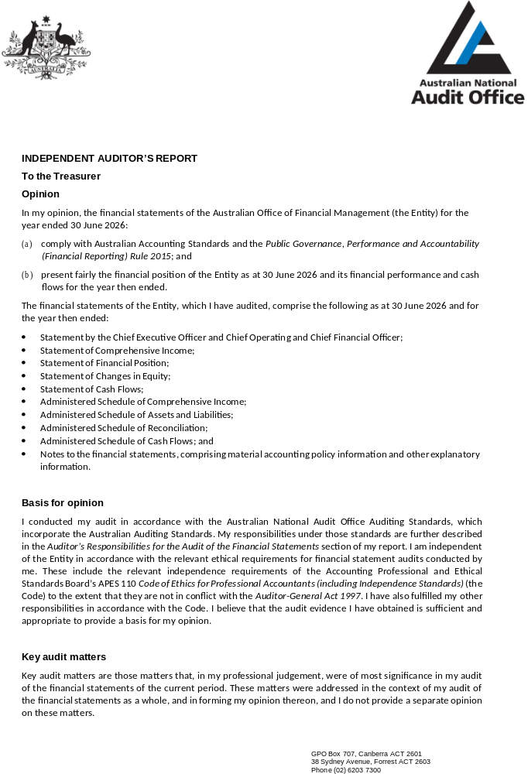
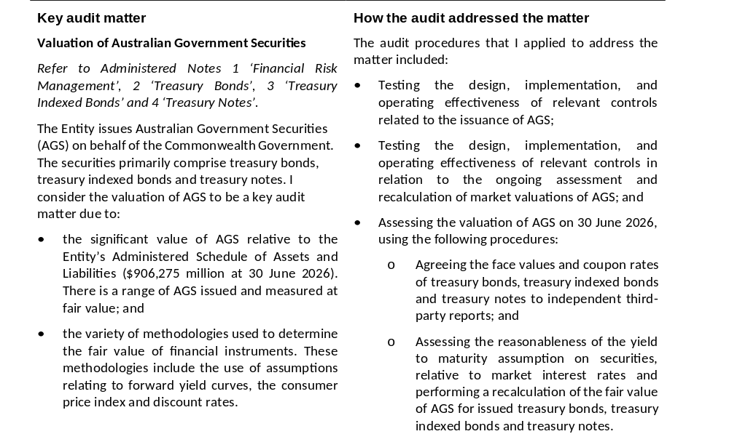
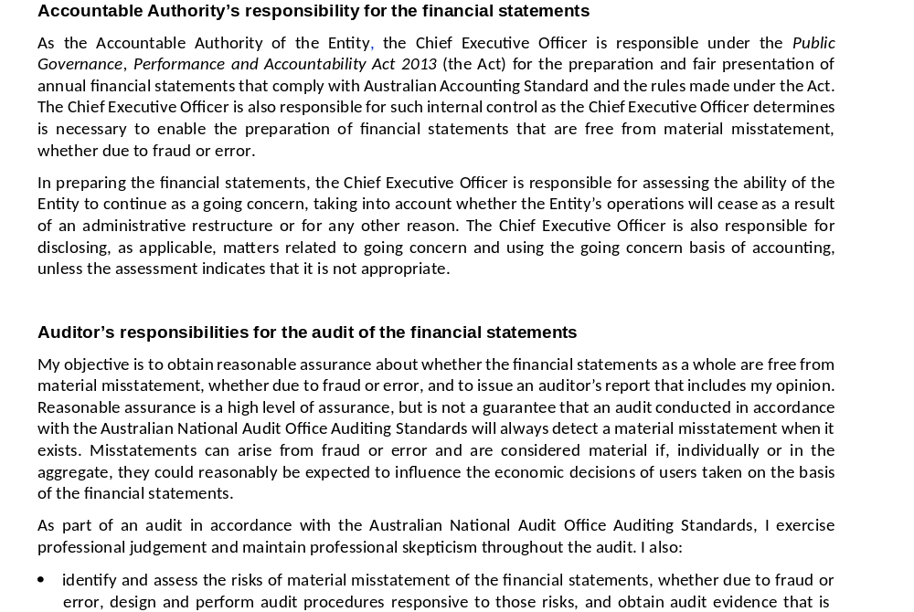
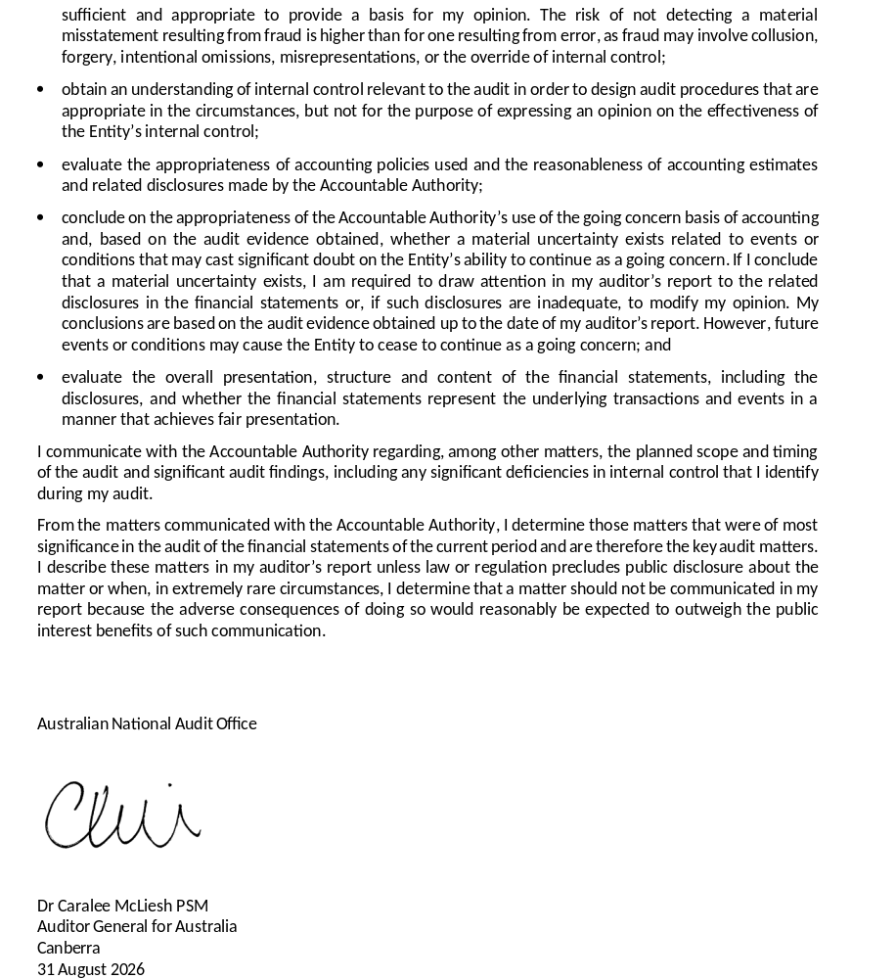

Part 5: Aids to access
Glossary of abbreviations 185
Compliance with annual report requirements 188
Alphabetical index 195

Glossary of abbreviations
Acronym | Definition
AASB | Australian Accounting Standards Board
ABN | Australian Business Number
ABS | asset-backed securities
ABSF | Australian Business Securitisation Fund
ACT | Australian Capital Territory
ADB | Asian Development Bank
AGS | Australian Government Securities
ANAO | Australian National Audit Office
ANZ | Australia and New Zealand Banking Group Limited
AOFM | Australian Office of Financial Management
APS | Australian Public Service
ARC | Audit and Risk Committee
ASF | Australian Securitisation Forum
ASX | Australian Securities Exchange
BBSW | Bank bill swap rate
bps | basis points
CEO | Chief Executive Officer
CMA | cash management account
CMP | Cash Management Portfolio
COO | Chief Operating Officer
CPI | Consumer Price Index
CPRs | Commonwealth Procurement Rules
CRAO | Chief Risk and Assurance Officer
CROMP | Climate Risk and Opportunity Management Program
CSS | Commonwealth Superannuation Scheme
DCB | departmental capital budget
DRRTA | Debt Retirement Reserve Trust Account
EA | Enterprise Agreement
ECL | expected credit losses
ELG | Executive Leadership Group
ERP | Emissions Reduction Plan
FOI Act | Freedom of Information Act 1982
GST | Goods and Services Tax
ISSN | International Standard Serial Number
IT | Information Technology
KMP | Key management personnel
LTDP | Long-Term Debt Portfolio
MYEFO | Mid-Year Economic and Fiscal Outlook
NAB | National Australia Bank
NSW | New South Wales
NT | Northern Territory
OPA | Official Public Account
PGPA Act | Public Governance, Performance and Accountability Act 2013
PGPA Rule | Public Governance, Performance and Accountability Rule 2014
PS Act | Public Service Act 1999
Qld | Queensland
RBA | Reserve Bank of Australia
SA | South Australia
SES | Senior Executive Service
SFSF | Structured Finance Support Fund
SMEs | small and medium enterprises
SPV | special purpose vehicle
Tas | Tasmania
TIBs | Treasury Indexed Bonds
T-Notes | Treasury Notes
Vic | Victoria
WA | Western Australia
WAM | weighted average maturity

Compliance with annual report requirements
PGPA rule reference | Part of report | Description | Requirement
17AD(g) | Letter of transmittal
17AI | Letter of transmittal | A copy of the letter of transmittal signed and dated by accountable authority on date final text approved, with statement that the report has been prepared in accordance with section 46 of the Act and any enabling legislation that specifies additional requirements in relation to the annual report. | Mandatory
17AD(h) | Aids to access
17AJ(a) | Table of contents | Table of contents (print only). | Mandatory
17AJ(b) | Part 5 | Alphabetical index (print only). | Mandatory
17AJ(c) | Part 5 | Glossary of abbreviations and acronyms. | Mandatory
17AJ(d) | Part 5 | List of requirements. | Mandatory
17AJ(e) | About this report | Details of contact officer. | Mandatory
17AJ(f) | About this report | Entity’s website address. | Mandatory
17AJ(g) | About this report | Electronic address of report. | Mandatory
17AD(a) | Review by accountable authority
17AD(a) | Part 1 (A) | A review by the accountable authority of the entity. | Mandatory
17AD(b) | Overview of the entity
17AE(1)(a)(i) | Part 1 (B) | A description of the role and functions of the entity. | Mandatory
17AE(1)(a)(ii) | Part 1 (C) | A description of the organisational structure of the entity. | Mandatory
17AE(1)(a)(iii) | Part 1 (B) | A description of the outcomes and programmes administered by the entity. | Mandatory
17AE(1)(a)(iv) | Part 1 (B) | A description of the purposes of the entity as included in corporate plan. | Mandatory
17AE(1)(aa)(i) | Part 2 (A) | Name of the accountable authority or each member of the accountable authority. | Mandatory
17AE(1)(aa)(ii) | Part 2 (A) | Position title of the accountable authority or each member of the accountable authority. | Mandatory
17AE(1)(aa)  (iii) | Part 1 (C) | Period as the accountable authority or member of the accountable authority within the reporting period. | Mandatory
17AE(1)(b) | Not applicable | An outline of the structure of the portfolio of the entity. | Portfolio departments – mandatory
17AE(2) | Not applicable | Where the outcomes and programs administered by the entity differ from any Portfolio Budget Statement, Portfolio Additional Estimates Statement or other portfolio estimates statement that was prepared for the entity for the period, include details of variation and reasons for change. | If applicable,  mandatory
17AD(c) | Report on the performance of the entity
 | Annual performance statements
17AD(c)(i); 16F | Part 2 (C) | Annual performance statement in accordance with paragraph 39(1)(b) of the Act and section 16F of the Rule. | Mandatory
17AD(c)(ii) | Report on financial performance
17AF(1)(a) | Part 2 – Performance assessment by purpose | A discussion and analysis of the entity’s financial performance. | Mandatory
17AF(1)(b) | Part 3 (E) | A table summarising the total resources and total payments of the entity. | Mandatory
17AF(2) | Part 4 (Notes 10 and I) | If there may be significant changes in the financial results during or after the previous or current reporting period, information on those changes, including: the cause of any operating loss of the entity; how the entity has responded to the loss and the actions that have been taken in relation to the loss; and any matter or circumstances that it can reasonably be anticipated will have a significant impact on the entity’s future operation or financial results. | If applicable,  mandatory
17AD(d) | Management and Accountability
 | Corporate Governance
17AG(2)(a) | Part 3 (A) | Information on compliance with section 10 (fraud systems). | Mandatory
17AG(2)(b)(i) | Letter of transmittal | A certification by accountable authority that fraud risk assessments and fraud control plans have been prepared. | Mandatory
17AG(2)(b)(ii) | Letter of transmittal | A certification by accountable authority that appropriate mechanisms for preventing, detecting incidents of, investigating or otherwise dealing with, and recording or reporting fraud that meet the specific needs of the entity are in place. | Mandatory
17AG(2)(b)(iii) | Letter of transmittal | A certification by accountable authority that all reasonable measures have been taken to deal appropriately with fraud relating to the entity. | Mandatory
17AG(2)(c) | Part 3 (A) | An outline of structures and processes in place for the entity to implement principles and objectives of corporate governance. | Mandatory
17AG(2)(d) – (e) | Not applicable | A statement of significant issues reported to Minister under paragraph 19(1)(e) of the Act that relates to noncompliance with Finance law and action taken to remedy non-compliance. | If applicable,  mandatory
 | Audit Committee
17AG(2A)(a) | Part 3 (A) | A direct electronic address of the charter determining the functions of the entity’s audit committee. | Mandatory
17AG(2A)(b) | Part 3 (A) | The name of each member of the entity’s audit committee. | Mandatory
17AG(2A)(c) | Part 3 (A) | The qualifications, knowledge, skills or experience of each member of the entity’s audit committee. | Mandatory
17AG(2A)(d) | Part 3 (A) | Information about the attendance of each member of the entity’s audit committee at committee meetings. | Mandatory
17AG(2A)(e) | Part 3 (A) | The remuneration of each member of the entity’s audit committee. | Mandatory
 | External scrutiny
17AG(3) | Part 3 (A) | Information on the most significant developments in external scrutiny and the entity’s response to the scrutiny. | Mandatory
17AG(3)(a) | Not applicable | Information on judicial decisions and decisions of administrative tribunals and by the Australian Information Commissioner that may have a significant effect on the operations of the entity. | If applicable,  mandatory
17AG(3)(b) | Not applicable | Information on any reports on operations of the entity by the Auditor-General (other than report under section 43 of the Act), a Parliamentary Committee, or the Commonwealth Ombudsman. | If applicable,  mandatory
17AG(3)(c) | Not applicable | Information on any capability reviews on the entity that were released during the period. | If applicable,  mandatory
 | Management of Human Resources
17AG(4)(a) | Part 3 (B) | An assessment of the entity’s effectiveness in managing and developing employees to achieve entity objectives. | Mandatory
17AG(4)(aa) | Part 3 (B) | Statistics on the entity’s employees on an ongoing and non-ongoing basis, including the following:  (a) statistics on full-time employees  (b) statistics on part-time employees  (c) statistics on gender  (d) statistics on staff location | Mandatory
17AG(4)(b) | Part 3 (B) | Statistics on the entity’s APS employees on an ongoing and non-ongoing basis; including the following:  statistics on staffing classification level  statistics on full-time employees  statistics on part-time employees  statistics on gender  statistics on staff location  statistics on employees who identify as Indigenous. | Mandatory
17AG(4)(c) | Part 3 (B) | Information on any enterprise agreements, individual flexibility arrangements, Australian workplace agreements, common law contracts and determinations under subsection 24(1) of the Public Service Act 1999. | Mandatory
17AG(4)(c)(i) | Part 3 (B) | Information on the number of SES and non-SES employees covered by agreements etc identified in paragraph 17AG(4)(c). | Mandatory
17AG(4)(c)(ii) | Part 3 (B) | The salary ranges available for APS employees by classification level. | Mandatory
17AG(4)(c)(iii) | Part 3 (B) | A description of non-salary benefits provided to employees. | Mandatory
17AG(4)(d)(i) | Part 3 (B) | Information on the number of employees at each classification level who received performance pay. | If applicable,  mandatory
17AG(4)(d)(ii) | Part 3 (B) | Information on aggregate amounts of performance pay at each classification level. | If applicable,  mandatory
17AG(4)(d)(iii) | Part 3 (B) | Information on the average amount of performance payment, and range of such payments, at each classification level. | If applicable,  mandatory
17AG(4)(d)(iv) | Part 3 (B) | Information on aggregate amount of performance payments. | If applicable,  mandatory
 | Assets Management
17AG(5) | Not applicable | An assessment of effectiveness of assets management where asset management is a significant part of the entity’s activities. | If applicable, mandatory
 | Purchasing
17AG(6) | Part 3 (C) | An assessment of entity performance against the Commonwealth Procurement Rules. | Mandatory
 | Reportable consultancy contracts
17AG(7)(a) | Part 3 (C) | A summary statement detailing the number of new reportable consultancy contracts entered into during the period; the total actual expenditure on all such contracts (inclusive of GST); the number of ongoing reportable consultancy contracts that were entered into during a previous reporting period; and the total actual expenditure in the reporting period on those ongoing contracts (inclusive of GST). | Mandatory
17AG(7)(b) | Part 3 (C) | A statement that ‘During [reporting period], [specified number] new reportable consultancy contracts were entered into involving total actual expenditure of $[specified million]. In addition, [specified number] ongoing reportable consultancy contracts were active during the period, involving total actual expenditure of $[specified million].’ | Mandatory
17AG(7)(c) | Part 3 (C) | A summary of the policies and procedures for selecting and engaging consultants and the main categories of purposes for which consultants were selected and engaged. | Mandatory
17AG(7)(d) | Part 3 (C) | A statement that ‘Annual reports contain information about actual expenditure on reportable consultancy contracts. Information on the value of reportable consultancy contracts is available on the AusTender website.’ | Mandatory
 | Reportable non-consultancy contracts
17AG(7A)(a) | Part 3 (C) | A summary statement detailing the number of new reportable non-consultancy contracts entered into during the period; the total actual expenditure on such contracts (inclusive of GST); the number of ongoing reportable non-consultancy contracts that were entered into during a previous reporting period; and the total actual expenditure in the reporting period on those ongoing contracts (inclusive of GST). | Mandatory
17AG(7A)(b) | Part 3 (C) | A statement that ‘Annual reports contain information about actual expenditure on reportable non-consultancy contracts. Information on the value of reportable non-consultancy contracts is available on the AusTender website.’ | Mandatory
17AD(daa) | Additional information about organisations receiving amounts under reportable consultancy contracts or reportable non-consultancy contracts
17AGA | Part 3 (C) | Additional information, in accordance with section 17AGA, about organisations receiving amounts under reportable consultancy contracts or reportable non-consultancy contracts. | Mandatory
 | Australian National Audit Office access clauses
17AG(8) | Part 3 (C) | If an entity entered into a contract with a value of more than $100,000 (inclusive of GST) and the contract did not provide the Auditor-General with access to the contractor’s premises, the report must include the name of the contractor, purpose and value of the contract, and the reason why a clause allowing access was not included in the contract. | If applicable, mandatory
 | Exempt contracts
17AG(9) | Part 3 (C) | If an entity entered into a contract or there is a standing offer with a value greater than $10,000 (inclusive of GST) which has been exempted from being published in AusTender because it would disclose exempt matters under the FOI Act, the annual report must include a statement that the contract or standing offer has been exempted, and the value of the contract or standing offer, to the extent that doing so does not disclose the exempt matters. | If applicable, mandatory
 | Small business
17AG(10)(a) | Part 3 (C) | A statement that ‘[Name of entity] supports small business participation in the Commonwealth Government procurement market. Small and medium enterprises (SME) and small enterprise participation statistics are available on the Department of Finance’s website.’ | Mandatory
17AG(10)(b) | Part 3 (C) | An outline of the ways in which the procurement practices of the entity support small and medium enterprises. | Mandatory
17AG(10)(c) | Part 3 (C) | If the entity is considered by the Department administered by the Finance Minister as material in nature – a statement that ‘[Name of entity] recognises the importance of ensuring that small businesses are paid on time. The results of the Survey of Australian Government Payments to Small Business are available on the Treasury’s website.’ | If applicable, mandatory
 | Financial statements
17AD(e) | Part 4 | Inclusion of the annual financial statements in accordance with subsection 43(4) of the Act. | Mandatory
 | Executive Remuneration
17AD(da) | Part 3 (C) | Information about executive remuneration in accordance with Subdivision C of Division 3A of Part 2–3 of the Rule. | Mandatory
17AD(f) | Other mandatory information
17AH(1)(a)(i) | Part 3 (C) | If the entity conducted advertising campaigns, a statement that ‘During [reporting period], the [name of entity] conducted the following advertising campaigns: [name of advertising campaigns undertaken]. Further information on those advertising campaigns is available at [address of entity’s website] and in the reports on Australian Government advertising prepared by the Department of Finance. Those reports are available on the Department of Finance’s website.’ | If applicable, mandatory
17AH(1)(a)(ii) | Part 3 (C) | If the entity did not conduct advertising campaigns, a statement to that effect. | If applicable, mandatory
17AH(1)(b) | Part 3 (C) | A statement that ‘Information on grants awarded by [name of entity] during [reporting period] is available at [address of entity’s website].’ | If applicable, mandatory
17AH(1)(c) | Part 3 (B) | Outline of mechanisms of disability reporting, including reference to website for further information. | Mandatory
17AH(1)(d) | Part 3 (D) | Website reference to where the entity’s Information Publication Scheme statement pursuant to Part II of FOI Act can be found. | Mandatory
17AH(1)(e) | Not applicable | Correction of material errors in previous annual report | If applicable, mandatory
17AH(2) | Not applicable | Information required by other legislation | Mandatory

Alphabetical index
A
accountable authority 11, 15, 86, 100
accrual debt servicing cost 18
administered financial statements 113–151
administered resourcing 93–94
advertising campaigns 91
Advisory Board 27, 44, 65–66
agency resource statement 94
annual appropriations 170–171
appropriations 94, 118, 144–146, 156, 170–171
APS Integrity Taskforce Action Plan 73
APS Net Zero 2030 96–98
artificial intelligence (AI) 6
Asian Development Bank (ADB) 51–52
asset-backed securities (ABS) 57, 59
asset recognition threshold 161
asset revaluation reserve 154–155, 162
assets and liabilities 116–117, 151, 154, 177
assurance 72
Audit and Risk Committee (ARC) 20, 63, 65, 67–70, 72–73, 101
AusTender 86, 88–90
Austraclear 38–39
Australia and New Zealand Banking Group Limited (ANZ) 5, 52, 150
Australian Accounting Standards Board (AASB) 173–174
Australian Bureau of Statistics 3
Australian Business Securitisation Fund (ABSF) iv, 4, 8, 17–18, 55, 57–60, 124–125, 138–141, 145
Australian Business Securitisation Fund Act 2019 64, 95, 145
Australian Government Securities (AGS) see also Treasury Bonds; Treasury Indexed Bonds (TIBs); Treasury Notes (T-Notes)
accrual debt servicing cost 18
debt management strategy 9, 27
issuance 3–4, 28–30, 35, 39
issuance strategy 26–27, 36
Purpose 3 47–54
Australian National Audit Office (ANAO) 89, 178–180
Australian Public Service Code of Conduct 73
Australian Securitisation Forum (ASF) 59
Australia's Disability Strategy 2021–2031 81–82
B
Banjo Loans 4
Bank Bill Swap Rate (BBSW) 60, 123
budget process 9, 147
business continuity 72
C
Career Development Guide 75
cash flow reconciliation 143, 169
cash flow statement 119–120, 156
Cash Management Account (CMA) 44–46, 137
Cash Management Meeting 66
Cash Management Portfolio (CMP) 17–18, 45–46
cash outlay requirements 41–46
Census Action Plan 71
Chief Executive Officer
review 3–6
role 11, 63, 65, 83, 86, 100
statement 15, 112
Chief Financial Officer 112
Chief Operating Officer 5, 11–12, 65, 83
Chief Sustainability Officer 98
climate change 30–31, 99–110
Climate Risk and Opportunity Management Program (CROMP) 69, 100–109
Comcare 76
committees and oversight bodies 65–66
Commonwealth Inscribed Stock Act 1911 64, 95, 117, 144
Commonwealth Procurement Rules (CPRs) 73, 86, 90–91
compliance with annual report requirements 186–189
Computershare 38
competitive tender 10, 19, 25, 27, 130, 132, 135 Consumer Price Index (CPI) 3, 17, 123–124
contingent assets and liabilities 150, 175
core responsibilities 7–8
corporate governance 63–74
Corporate Plan 20
coupon payments 38–40
credit rating 39, 124, 126
credit risk 124–126
Cross, Don 68
cross-skilling of staff 5, 71, 75
D
Debelle, Dr Guy 74
debt issuance program 3, 27–29
debt management strategy 9, 25, 27, 36
debt registrar 38
Debt Retirement Reserve Trust Account (DRRTA) 146
debt servicing costs 27–28, 32
delegated powers 63
departmental financial statements 152–177
departmental resourcing 93–94
depreciation 153, 162–163
Deputy Chief Executive Officer 5, 11, 65, 83
derecognition 163, 176
disability reporting 81–82
diversifying the investor base 34
diversity (value) 8
E
electricity greenhouse gas emissions 97
Elm Communications Canberra Pty Ltd 87
Employee Assistance Program 76, 83
employee benefits 157
employee provisions 164–165
employee remuneration 82–85, 157
employee statistics 77–81
Enterprise Agreement (EA) 76–77
Enterprise Risk and Assurance team 70
Enterprise Risk Management Framework 69–70, 101, 108–109
Environment Protection and Biodiversity Conservation Act 1999 96
equity injections 155
ethical standards 73
events after the reporting period 150, 174
excellence (value) 8
Executive Board 65
Executive Leadership Group (ELG) 20, 65, 70, 100–101
exempt contracts 90
external scrutiny 74
F
fair value 18, 117, 129, 151
Federal Court of Australia (FCA) 5, 150
financial instruments 175–176
financial performance 93–95, 157–172
financial risk management 16–19, 121–129
financial statements 111–180
financing the Budget 9–10
First Nations employees 81
flexible working 83
forbearance Special Purpose Vehicle (fSPV) 140–141
forecasting risk 43–44
fraud and corruption prevention and control 71–72
Freedom of Information Act 1982 (FOI Act) 92
Front Office 11, 50
full-time/part-time employees 80
funding risk 25, 43–44
Funding, Strategy and Research team 3
future-ready workforce 71
G
glossary of abbreviations 183–185
Goods and Services Tax (GST) 174
governing legislation 64
Green Treasury Bonds 3, 17, 30–31
greenhouse gas emissions 96–98
H
highly paid staff 83, 85
Hughes, Anna 3–6, 11, 15, 112
human resources 12
I
impairment 159–163, 176
independent auditor's report 178–180
Independent Review of the AOFM 4–5, 74
inflation 22, 35, 123–124
Ingram, Cath 68
intangible assets 162
integrity and ethical standards 73
Integrity Framework 6, 73
interest costs 25, 28
interest rate benchmarks 123
interest rate risk 16, 121–123
interest rates 10, 18–19, 22, 121–123
internal audit 70, 73
Investor Insights 51
investor relations 4, 49–52
issuance strategy 26–27, 36 see also Purpose 1
J
J.P. Morgan Securities Australia Limited 89
K
KangaNews 51–52
key management personnel (KMP) 83–84, 165–166
Kikitis, Katina 84
Koh, M. 112
L
Laddr 4
lease liabilities 167–168
legislative instruments 64
liquidity buffer 43–44, 46
liquidity management strategy 43–44, 46
liquidity risk 43–44, 127–128
Loan Securities Act 1919 64, 144
location of employees 81
Long-Term Debt Portfolio (LTDP) 17, 27
M
market engagement program 49–51
market liquidity 53–54
maturity profile 33
McFadyen, Honor 69
McLiesh, Dr Caralee, PSM 180
Mid-Year Economic and Fiscal Outlook (MYEFO) 9
Middle East conflict 3–4, 22, 51
N
National Anti-Corruption Commission 71–72
National Australia Bank (NAB) 52, 89
Net Zero in Government Operations Strategy 96, 98
non-salary benefits 83
O
Official Public Account (OPA) 118, 137, 145–146
operating environment 22
Operations Committee 66
organisational structure 11–12
outcome 9, 173
overdraft facility 43–44, 46, 127
oversight bodies 65–66
P
performance framework 20–21
portfolio v
procurement framework 73, 86–91
professional development 75, 83
property, plant and equipment 159–163
Public Governance, Performance and Accountability Act 2013 (PGPA Act) ii, 15, 64, 86, 112, 137, 144, 146, 173
Public Governance, Performance and Accountability Rule 2014 (PGPA Rule) i, 83, 90, 173, 186–189
Public Service Act 1999 (PS Act) 64, 73, 76
purchasing and procurement 86–91
Purpose 1 21, 23–40
Purpose 2 21, 41–46
Purpose 3 21, 47–54
Purpose 4 21, 55, 57–60
purposes 8
R
receivables 158
reconciliation schedule 118
redemption payments 39–40
refinancing risk 18, 33–34, 43, 127–128
related party disclosures 166
remuneration 82–85, 164–166
reportable consultancy 86–87
reportable non-consultancy 88–89
Reserve Bank of Australia (RBA) 18, 43–46, 124, 127
resource statement 94–95
revaluations 159, 162
risk-aware culture 16, 69
risk management 69–73
RLW Consulting 87
ROU (Leased Right-of-Use) assets 161
Royal Bank of Canada 52

S
salary rates 82
Secretary to the Treasury 27, 44, 63, 65, 83
securities lending facility 53, 149
settlements 38–40
small to medium enterprise (SME) lending market 4, 57–60
sovereign credit rating 39
sovereign debt market 3, 7, 16
special appropriations 93–95, 118, 144
staffing changes 81
Statement of Preparation 15
strategic risks and opportunities 70–71
Strategic Workforce Plan 5, 75
structured finance securities see Australian Business Securitisation Fund (ABSF)
Structured Finance Support Fund (SFSF) 140–141, 145
superannuation 83, 164–165
supplier expenses 157
syndications 3, 10, 27–30, 39, 89
Synergy 73
T
targets 21
taxation 174
tenders 10, 25, 27, 37–39
Treasurer 63, 72, 83
Treasury Bonds
average maturity 32–33
debt management strategy 27–34
futures contracts 27, 53
issuance 3, 28–30, 36
note to the administered financial statements 130–131
portfolio 32–34
secondary market turnover 53–54
syndications 3, 10, 27–30, 39
Treasury Indexed Bonds (TIBs)
debt management strategy 27, 35–36
issuance 3, 35–36, 39
note to the administered financial statements 132–134
secondary market turnover 53–54
Treasury Notes (T-Notes)
cash management role 43–46
issuance 39
note to the administered financial statements 135–136
Treasury Portfolio Budget Statement 9
trust (value) 8
turnover ratio 49, 53
U
UBS 52
V
values 8
W
weighted average maturity (WAM) 27, 34, 36
Wellbeing Strategy 71, 76
Westpac 52, 89
work health and safety 76
Work Health and Safety Act 2011 76
workforce 75–85
cross-skilling of staff 5, 71, 75
Employee Assistance Program 76, 83
employee provisions 164–165
employee statistics 77–81
First Nations employees 81
flexible working 83
full-time/part-time employees 80
future-ready workforce 71
highly paid staff 83, 85
location of employees 81
professional development 75, 83
remuneration 82–85, 164–166
staffing changes 81
wellbeing 71, 76
work health and safety 76

Refinancing risk, also referred to as ‘rollover risk’ or ‘repricing risk’, is the risk that borrowing to replace maturing debt occurs on unfavourable terms (or is not possible at all).
www.transparency.gov.au/portfolio-entities-companies/treasury/australian-office-of-financial-management-aofm
www.aofm.gov.au/securities/green-bond-program
AOFM Investor Insights are available at aofm.gov.au/investors/wholesale-investors/investor-insights
Such as unsecured term loan, unsecured line-of-credit and unsecured overdraft products.
The ABSF has experienced no credit losses since inception.
As per Administrative Arrangement Orders issued by the Governor-General of the Commonwealth of Australia.
The Audit and Risk Committee Charter is available at aofm.gov.au/about/compliance-reports/audit-and-risk-committee-charter
The Procurement Plan is available at tenders.gov.au.
Information on the value of reportable consultancy contracts is available at tenders.gov.au.
The Emissions Reduction Plan is available at aofm.gov.au/publications/emissions-reduction-plan
Read the Climate Risk Management guide at dcceew.gov.au/sites/default/files/documents/climate-risk-management-organisation-application-guide.pdf
Australia’s Long-term Emissions Reduction Plan is available at dcceew.gov.au/sites/default/files/documents/australias-long-term-emissions-reduction-plan-modelling.‌pdf
Anticipating the climate change risks for sovereign bonds Rising Temperatures, Falling Ratings: The Effect of Climate Change on Sovereign Creditworthiness The Impact of Physical Climate Risks and Adaptation on Sovereign Credit Ratings
The APS Net Zero 2030 Factsheet is available at finance.gov.au/sites/default/files/2025-02/APS-Net-Zero-2030-Target-Factsheet.docx

